Agenda item: ADM 1 | Document C26/98-E
Agenda item: ADM 1 | 14 April 2026
Agenda item: ADM 1 | Original: English
Contribution by Saudi Arabia (Kingdom of) and Morocco (Kingdom of)
ENHANCING SATELLITE NETWORK FILING (SNF) COST RECOVERY AND ADDRESSING PROCESSING DELAYS IN THE RADIOCOMMUNICATION BUREAU
Purpose
This contribution aims to review and strengthen the current satellite network filing (SNF) cost-recovery framework in light of increasing workload, financial imbalances, and operational challenges faced by the Radiocommunication Bureau (BR). It seeks to ensure that the methodology aligns with the principles of PP Resolution 91 and Decision 482 (Modified 2025), while improving proportionality, predictability, and efficiency.
In addition, it highlights the growing issue of delays in processing satellite network filings and their regulatory, operational, and financial implications for Member States, and proposes measures to restore balance between workload and available resources.
Action required by the Council
The Council is invited to consider the views and proposals contained in this contribution.
_______________
References
Resolution 91(Rev. Guadalajara, 2010) of the Plenipotentiary Conference; Council Decision 482 (CO1, last amended C25); Council Documents C26/16 and C26/19

Introduction
We appreciate the Secretariat for the preparation of the annual Report C26/16 and the draft methodology C26/19 and for its continued efforts to improve satellite network filing (SNF) cost recovery. We also acknowledge the work of the Council Working Group on financial and human resources (CWG‑FHR) on this topic
Member States are seeing a surge in the number and complexity of SNF submissions, particularly large non‑geostationary constellations. These trends have increased the workload of the Radiocommunication Bureau (BR), reduced the predictability of the filing process and created financial pressure on the SNF cost‑recovery system. The annual report shows that processing costs significantly exceed revenues and that delayed revenues and backlogs are growing.
In this context, any revision to the cost‑recovery methodology must adhere to the principles established by the ITU Plenipotentiary Conference (PP) and Council. PP Resolution 91 calls for cost recovery on a prepaid basis that covers the direct and indirect costs of providing the service, applies a proportional allocation methodology, takes into account the special needs of developing countries and offers all Member States an adequate level of service free of charge. Decision 482 (Modified 2025) implements these principles for SNF and grants each Member State one free satellite network filing per year.
This contribution addresses the operational and financial aspects of SNF cost recovery and puts forward proposals aimed at enhancing predictability, proportionality, and overall consistency of the cost-recovery framework.

Discussion

1 SNF cost recovery
The annual report highlights a significant gap between the costs and revenues associated with satellite network filings (SNF), with processing costs substantially exceeding the revenues generated under the current fee framework. Even after accounting for free entitlements and deferred revenues, a notable shortfall remains, indicating that SNF processing is effectively subsidised by the ITU regular budget, contrary to the cost-recovery mandate in PP Resolution 91. In addition, a considerable number of coordination requests remain pending invoicing due to resource constraints, further underscoring the need to improve both the fee framework and operational capacity. In this context, Member States reaffirm that cost recovery should cover all direct costs and a proportionate share of indirect costs, based on clearly attributable methodologies, while ensuring that fees remain linked to the services provided and do not subsidise unrelated ITU activities. While we note the proposed introduction of an activity-based costing approach as a positive step towards better reflecting the actual processing effort associated with satellite network filings, we remain concerned regarding the allocation of indirect costs in the proposed methodology, particularly where a clear and demonstrable link to SNF activities is not established. In this regard, we emphasize the importance of clearly distinguishing between costs directly attributable to SNF and broader institutional costs, ensuring that only SNF-related costs, together with an appropriate and proportionate share of overhead, are recovered through SNF fees, in line with the principles of PP Resolution 91.

2 Free entitlements
Decision 482 provides that each Member State is entitled to one satellite network filing (SNF) per year without charge (free entitlement) and allows the notifying administration to determine which filing benefits from this entitlement. While this mechanism was introduced to support equitable access, we note that its current implementation may give rise to unintended consequences, including the potential misuse of free entitlements.
In this regard, we recall that PP Resolution 91 explicitly provides for maintaining an adequate level of service free of charge, reflecting the Union’s objective of ensuring equitable access for all Member States. We note, however, that the proposed methodology in C26/19 incorporates the cost of free entitlements within the overall fee base, effectively redistributing this cost to fee-paying users. We consider that such an approach does not clearly reflect the policy nature of free entitlement as established under PP Resolution 91, nor does it demonstrate a direct causal link between the cost and the users subject to cost recovery. Accordingly, we are of the view that any adjustments related to free entitlement should be addressed through targeted and proportionate measures within the entitlement framework itself, in order to preserve the balance between cost recovery and equitable access as set out in PP Resolution 91.

3 Indirect costs
We recall that PP Resolution 91 establishes that cost recovery should be applied in a manner that ensures a clear link between the service provided and the costs recovered. In this context, we note that the proposed methodology relies on aggregated cost pools and proxy-based allocations, particularly staff-related and space-based drivers, rather than on measurable activity-level drivers. As such, it does not sufficiently demonstrate the level of cost attribution required to ensure appropriate allocation, as envisaged under PP Resolution 91.
Furthermore, we note that PP Resolution 91 emphasizes that cost recovery should be applied to specific products or services. The proposed inclusion of broad institutional cost elements, beyond those directly attributable to satellite network filing activities, risks weakening the link between the fee and the service provided, and may not fully align with this principle.
In addition, we note that the reliance on staff-related allocation drivers, including those linked to SNF activities, may introduce compounding effects in the attribution of indirect costs. In such cases, increases in SNF-related staffing levels may lead to a compounded increase in allocated indirect costs across multiple cost pools, even where the underlying workload or system usage associated with satellite network filings remains unchanged. This raises concerns regarding the accuracy and proportionality of the resulting cost recovery levels.
While the inclusion of indirect costs may be consistent with PP Resolution 91, we consider that, in its current form, the proposed allocation methodology does not sufficiently establish a clear and demonstrable causal link between the costs attributed and the actual consumption of satellite network filing services.

4 Enhancements to the proposed methodology
We note that coordination requests remain unprocessed for extended periods, significantly exceeding the regulatory timelines, primarily due to increasing workload and resource constraints. This has led to a growing backlog of filings and reduced the time available for administrations to bring networks into use, thereby increasing regulatory uncertainty. In this context, we consider that the SNF cost-recovery methodology should be complemented by effective workload forecasting and capacity planning, ensuring that fee levels support the Bureau in recruiting and retaining the necessary expertise and in investing in tools and systems to improve efficiency. At the same time, we emphasise the importance of maintaining predictable and stable fee levels, as frequent or significant adjustments may undermine planning for administrations and operators. We therefore see value in introducing structured and transparent adjustment mechanisms, including multi-year approaches to smooth variations and provide greater predictability, as well as safeguards to mitigate sudden financial impacts. We also note that the continued growth of large non-GSO constellations is a key driver of increased workload and complexity, and in this regard, we consider that additional improvements to the methodology could be beneficial, including enhancing transparency through regular reporting on costs and workload, strengthening oversight through the Council, introducing clear performance indicators such as processing times and backlog levels, and ensuring that any fee adjustments are implemented in a gradual and proportionate manner, taking into account the needs of administrations with limited resources.

5 Delays in processing satellite network filings
During the 33rd meeting of the Radiocommunication Advisory Group (RAG), several issues related to the processing of satellite network filings were highlighted, particularly in light of the growing impact of delays on administrations and operators. Delays in the publication and processing of filings have become a practical challenge, directly affecting the ability of administrations to complete regulatory procedures within the timeframes set out in Article 9.38 of the Radio Regulations, including those related to network deployment and international coordination. In this regard, the RAG, as reflected in the Chair’s note to the Council (Circular No. 281), underscored the increasing difficulty faced by the Radiocommunication Bureau in meeting the prescribed processing timelines, resulting in reduced implementation periods and increased regulatory uncertainty for administrations. The report of the Director of the Radiocommunication Bureau further indicates that these challenges arise amid growing operational and financial pressures, driven by limited human resources and the increasing volume and complexity of space service filings. Available data demonstrates a clear gap between regulatory requirements and current operational capacity, as coordination requests that should be processed within four months are now taking approximately fourteen months, reflecting a significant imbalance between workload and available resources. In this context, this contribution aims to highlight the practical and organizational implications of these delays, supported by data and examples, and to call for appropriate support from the Council to enable the Bureau to address these challenges and improve operational efficiency in line with regulatory requirements.
Available data indicates a clear gap between the regulatory requirements set out in the Radio Regulations and the current operational capacity of the Radiocommunication Bureau. Under RR No. 9.38, coordination requests should be processed within four months; however, actual processing times have reached approximately fourteen months, as also confirmed in Circular Letter No. 281, reflecting a significant imbalance between increasing workload and available resources.
Figure 1
Publication of Coordination Requests (CR/C) for satellite networks (last 15 months)
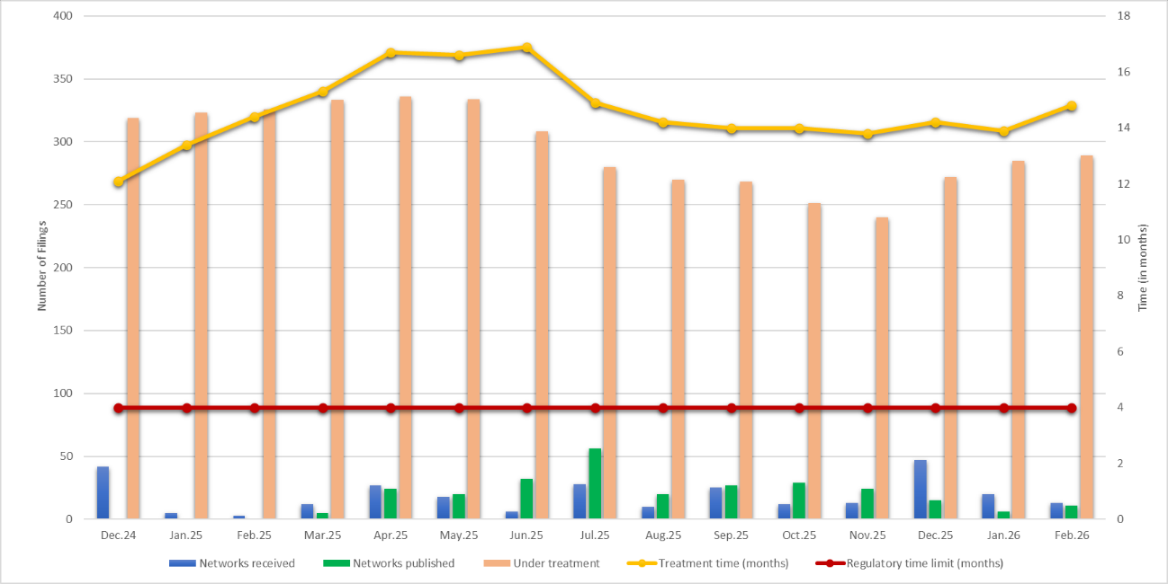
(Data compiled from Space Services Statistics, see website)
As illustrated in Figure 1, while the number of filings under processing remains high, some reduction has been observed due to operational efforts; nevertheless, the continued high volume of incoming requests and the insufficient number of published filings have prevented a sustained reduction in the backlog. Processing times remain in the range of 13 to 17 months, well above the regulatory limit. These challenges arise in the context of staffing constraints and unfilled vacancies, alongside broader budgetary limitations, while the satellite sector continues to grow rapidly in volume and complexity, driven by expanding systems, new services, and increased integration with terrestrial networks, placing continuous pressure on the Bureau’s operational capacity.
Table 1
Saudi Arabian satellite networks affected by processing delays
(Data compiled from the Satellite Network Systems (SNS) database of
the Radiocommunication Bureau)

A) Published files
Processing time (months) | Publication date | BR IFIC No. | Publication No. | Filing type | Date received | Orbit type | Network | Filing No.
14.03 | 2025-09-16 | 3055 | 6292 | CR/C | 2024-07-22 | GSO | SAUDISAT_45.5E | 124520150
14.20 | 2025-09-30 | 3056 | 6299 | CR/C | 2024-07-31 | GSO | SAUDISAT_51.9E | 124520158
14.27 | 2025-09-16 | 3055 | 6289 | CR/C | 2024-07-15 | GSO | SAUDISAT_7.9E | 124520137

B Files in processing*
Processing time (months) | Publication date | BR IFIC No. | Publication No. | Filing type | Date received | Orbit type | Network | Filing No.
10.8 | Under processing | Not published | Not published | CR/C | 2025-05-20 | GSO | ARABSAT-12F-44.5E | 125520067
10.8 | Under processing | Not published | Not published | CR/C | 2025-05-20 | GSO | ARABSAT-12G-1E | 125520066
10.8 | Under processing | Not published | Not published | CR/C | 2025-05-20 | GSO | ARABSAT-12N-14.7E | 125520065
10.8 | Under processing | Not published | Not published | CR/C | 2025-05-20 | GSO | ARABSAT-12Q-58.5E | 125520064
10.8 | Under processing | Not published | Not published | CR/C | 2025-05-20 | GSO | ARABSAT-12Y-9W | 125520063
10.8 | Under processing | Not published | Not published | CR/C | 2025-05-20 | GSO | ARABSAT-12P-67.5E | 125520062
4.9 | Under processing | Not published | Not published | CR/C | 2025-11-13 | GSO | SAUDISAT_19E_A | 125520159
* Since the files are still being processed, the processing time has been calculated up to April 2026.

Table 1 further provides practical examples demonstrating that both published and pending filings have experienced significant delays, confirming that the issue is ongoing and affects the entire processing cycle. These delays have direct regulatory implications, notably reducing the time available for administrations and operators to complete coordination procedures and bring networks into use within the required timeframe, thereby increasing the risk of non-compliance. The impact also extends to operational and investment aspects, including delays in deployment plans, reduced coordination opportunities, and increased uncertainty due to evolving technical and regulatory conditions.
Financially, deferred revenues have reached significant levels, with many filings still pending invoicing, directly affecting cost-recovery mechanisms. Moreover, these constraints may also impact the Bureau’s ability to support other radiocommunication activities, including study groups and capacity-building efforts. Overall, this situation highlights the need for a comprehensive response to address both current challenges and the expected continued growth in demand for orbital and frequency resources.

Proposal
In light of the above, we propose that the Council:
1 to ensure that all costs related to the SNF are recovered through SNF fees themselves, so sustaining the service without drawing from other ITU resources as per PP Resolution 91;
2 to ensure that the allocation of indirect costs remains clearly attributable, proportionate, and supported by verifiable allocation methodologies, consistent with the principles set out in PP Resolution 91;
3 to support that any adjustments to the free entitlement framework be targeted and proportionate, addressing potential misuse while preserving equitable access;
4 to invites the Secretariat to further enhance the proposed methodology, combining activity-based costing with detailed workload analysis, to improve efficiency and ensure that fees reflect actual processing effort across different categories of filings; including the provision of enhanced supporting data to the Council on demand forecasting, filing trends, and workload evolution, particularly with respect to large non-GSO systems and recent WRC decisions;
5 to consider taking appropriate measures to address the growing impact on administrations resulting from delays in processing satellite network files, and to ensure their continued ability to comply with the regulatory requirements stipulated in the Radio Regulations;
6 to support measures to address delays in the processing of satellite network filings, and to enable the BR to enhance its operational efficiency including and restore a balance between workload and processing capacity;
7 to support the BR's ability to address existing backlogs and move closer to compliance with regulatory requirements, thereby strengthening the stability of the international regulatory environment and serving the interests of Member States.

______________

