Agenda item: PL-2 | Document C26/32-E
Agenda item: PL-2 | 9 March 2026
Agenda item: PL-2 | Original: English
Report by the Secretary-General
DRAFT FINANCIAL PLAN FOR 2028-2031
Purpose
This document presents the draft financial plan for 2028-2031.
Action required by the Council
The Council is invited to examine the draft financial plan for 2028-2031 and provide advice and guidance for subsequent transmittal of the latter to the 2026 Plenipotentiary Conference.
Relevant link(s) with the Strategic Plan
This document provides the financial limits that will be applied to the implementation of the Strategic Plan 2028-2031.
Financial implications
This document provides the financial limits that will be applied to the implementation of the Strategic Plan 2028-2031.
_______________
References
Decision 5 (Rev. Bucharest, 2022) of the Plenipotentiary Conference; No. 51 of the Constitution.

1. Introduction
1.1 The purpose of the draft financial plan for 2028-2031 is to provide a tool for the 2026 Plenipotentiary Conference to establish the basis for preparing the 2028-2029 and 2030-2031 budgets of the Union. By setting the amount of the contributory unit for the 2028-2031 timeframe and considering all relevant aspects of the work of the Union in the period concerned (Article 8, No. 51 of the Constitution), it determines related financial limits, until the next plenipotentiary conference.
1.2 The financial plan provides a framework which identifies for Member States their financial commitments to the Union for the 2028-2031 period, based on the approved amount of the contributory unit, and the way in which their financial contribution to the Union will be allocated across membership’s priorities for the Union which have been expressed through the strategic plan.
1.3 According to Article 28, No. 161B of the Constitution, and following the Secretary-General’s proposal, the Council has fixed the provisional amount of the contributory unit at CHF 318 000.
1.4 By a revised Decision 5, on revenue and expenses for the Union for the period 2028-2031, the 2026 Plenipotentiary Conference will establish, through the Strategic and Financial Plan 2028-2031, the framework and the directives under which the two biennial budgets for 2028-2029 and 2030-2031 shall be developed. The financial plan 2028-2031, as revised and approved by the Plenipotentiary Conference 2026, shall be contained in Annex 1 to Decision 5.
2. Strategic Plan
2.1 This draft financial plan for 2028-2031 will be presented and discussed during the joint meeting of the Council Working Group on financial and human resources (CWG-FHR) and Council Working Group on strategic and financial plans (CWG-SFP) in April 2026. These discussions will allow Council to review the projected financial plan for the Union and to consider the resources within which the strategic plan for the period 2028–2031 will be implemented.
2.2 The development of the strategic plan is undertaken in accordance with Article 11, No. 74A of the ITU Constitution and Article 4, No. 62A of the ITU Convention, which mandate the Secretary-General, with the assistance of the Coordination Committee, to provide Member States and Sector Members with the information required for preparing the Union’s policies and strategic plan, while the Council initiates the preparation of the draft plan before the Plenipotentiary Conference. Through Council Resolution 1428 (C24), the Council delegated the development of the draft Strategic and Financial Plans to the Council Working Group on strategic and financial plans (CWG-SFP), where Member States and Sector Members participate on an equal footing. This draft financial plan is aligned with the priorities set out in the present draft of the strategic plan, and will be revised as needed to ensure full alignment with the final approved strategic plan 2028-2031.
2.3 The financial plan implements a results-based approach and allocates funds from expected regular-budget revenues available to the secretariat in 2028-2031 to priorities set out in the strategic plan.
2.4 The financial plan and the strategic plan will be translated into specific financial allocations to the Bureaux and the General Secretariat through the Operational Plan process thereby providing funding for their work to achieve the expected outcomes, based on their respective contributions to achieving each priority. This will ensure a clear correspondence between planned activities and the resources required to deliver them.
2.5 The draft financial plan is therefore guided by several key parameters and determinants, including:
- the strategic goals and priorities defined in the strategic plan;
- the level of the contributory unit approved by Member States;
- the projected level of revenue available to the Union during the planning period, which establishes the overall ceiling for planned expenses; and
- the previous approved budgets and fiscal performance of the Sectors, Bureaux and the General Secretariat.
2.7 Within this framework, the financial plan establishes the overall resource envelope available to the Union for the period 2028-2031. Consequently, the implementation of the strategic plan will need to be achieved within these financial parameters, requiring prioritization of activities and efficient use of resources to ensure that the Union’s priorities are delivered in a financially sustainable manner.
3 Bases and assumptions
3.1 For assessed contributions (Member States, Sector Members, Associates and Academia), the revenue level is based on the information available as of 1 January 2026. Assessed contributions represent more than three-quarters of the Union’s revenue. Any change in the number of contributory units paid by Member States will impact the 2028-2031 revenue forecast, and thus the expenses forecast in the financial plan will have to be adjusted accordingly.
3.2 The amount of the contributory unit has remained unchanged since 2006 at KCHF 318 per unit, which corresponds to zero-nominal growth. During the period January 2006 until January 2026 the Geneva Consumer Price Index (CPI) increased by 10.5 per cent. If the contributory unit had been indexed to the Geneva CPI, the amount of the contributory unit would now amount to KCHF 351.4, an increase of KCHF 33.4 (zero-real growth). Such an increase to assessed contributions would have amounted to MCHF 54.6 for the 4-year period, which would have adequately funded the strategic priorities. Following the decision to retain the contributory unit at its current level, the draft financial plan would not be able to accommodate full funding at the levels proposed by the Bureaux and General Secretariat in pursuit of the strategic priorities. This is necessary to ensure that planned spending is limited to anticipated revenues. Section 5 provides information related to some funding constraints that the ITU will face in implementing this financial plan.
3.3 For cost recovery and other revenues, projections in the draft financial plan for 2028-2031 are broadly aligned with the actual revenue earned by ITU during the 2024-2025 biennium and the budgeted projected revenues for the 2026-2027 biennium. It is worth noting that predictions for Satellite Network Filing (SNF) revenue include a moderate increase. While SNF revenue is projected to be at marginally higher levels than 2024-2025 (CHF 16.2 million) in 2028-2029 (CHF 20 million), an additional moderate uptick in revenues is anticipated in 2030-2031 (CHF 25 million) reflecting larger processing volumes which will be achieved through planned system investments and operational adjustments. However, this recovery is not expected to result in a return to the higher budgeted revenue levels observed in previous strategic plan cycles.
3.4 Based on the foregoing the estimated revenues for the 2028-2031 present a static picture. It is expected (as reflected in Table 1 below) that ITU’s revenues will remain at similar levels to those observed during the 2024-2025 biennium, with little or no growth, and a moderate risk of small to moderate decreases in specific years, depending on market volatility for cost recovery items. Table 1 below provides the breakdown of all revenue together with the comparison to 2026-2027 approved budget and 2024-2025 actual results.
Table 1 – Revenue by Source of funds (2024 to 2031)
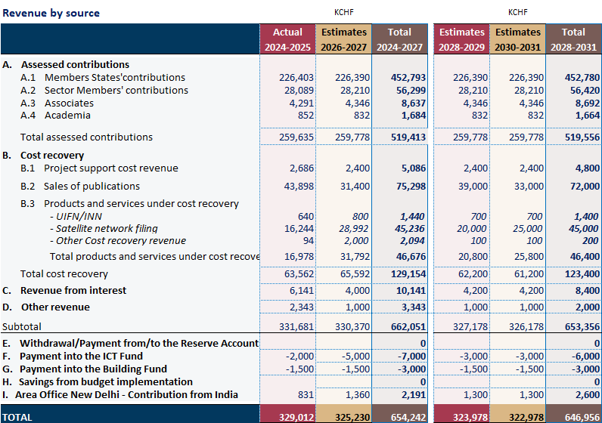
4 Use of Financial Resources
4.1 On the expense side, it is anticipated that ITU will be subject to increased costs, due to inflation, salary increases, rising health care costs and other inflationary factors. Accordingly, implementation of the financial plan through budgets in 2028-2029 and 2030-2031 will require careful prioritization to ensure continuity of core mandates and statutory functions, at increasing costs, within static revenues.
4.2 The implementation of efficiency measures will be needed to ensure balanced biennial budgets for 2028-2029 and 2030-2031, within the overall limits in the draft financial plan for 2028-2031. To ensure budget discipline and long-term financial sustainability, a set of structural efficiency measures will be required during the 2028-2031 period, including the following:
- Workforce costs must remain aligned with the available financial envelope and current projections indicate that a moderate reduction in overall staffing levels will be necessary to maintain expenses within the anticipated revenues in the context of zero nominal revenue growth and increasing costs. The secretariat will employ various methods including strategic vacancy management, agreed separation programmes, natural attrition and targeted redeployment.
- The ongoing modernization of core enterprise systems — including SAP S/4HANA, Microsoft Dynamics (CRM), Cvent and related digital platforms — must translate into measurable operational efficiencies. These investments are expected to reduce manual processes, eliminate parallel tracking systems, strengthen data integrity and standardize end-to-end workflows across finance, HR, procurement and project management. Over time, this digital transformation should enable leaner administrative structures and improved cost control.
- Expenditure on travel, meetings and other events will require continued discipline. Expanded use of virtual and hybrid ITU meetings and events, increased virtual participation by ITU staff in global meetings and events, strengthened mission prioritization, and tighter oversight of discretionary travel will be necessary to ensure that mission expenditure remains aligned with strategic objectives. The modernization of event management and conference systems should also support more efficient use of resources and improved planning of meetings.
- Finally, procurement rationalization and cross-sector synergies will be further pursued, including consolidation of contracts, reduction of duplicative services and enhanced coordination of support functions across the secretariat.
These measures are not temporary adjustments but must form part of a broader effort to align the Union’s cost structure with a more constrained revenue trajectory for 2028-2031. Maintaining financial balance under these conditions will require sustained management discipline and full realization of the efficiency gains associated with current transformation initiatives.
4.3 As discussed in section 2.2 above, this draft financial plan 2028-2031 is presented in alignment with the development of the strategic plan 2028-2031. The Council has delegated the development of the draft Strategic and Financial Plans to the CWG-SFP. The financial resources available during the 2028-2031 period, as set out in this document, will be applied to achieve the strategic goals and priorities as identified in the strategic plan 2028-2031. That strategic plan remains under development, but the secretariat has identified the alignment of the current products and services provided, and workstreams undertaken, by ITU with the draft new priorities and outcomes being proposed in the draft strategic plan (based on 2026 workplans). Based on this alignment, the secretariat has proposed an allocation of the financial resources to these draft priorities. The proposed allocations are presented in Table 2 below. The costs required to deliver on the enablers identified in the draft strategic plan are included in the costs to deliver the priorities.
4.4 While the secretariat has proposed allocations, it is recognised that the priorities in the current draft are subject to change by membership. Also, membership may wish to adjust the level of importance attributed to the specific priorities by adjustment of the proportion of ITU’s resources which is allocated to each priority. The allocations proposed in the draft financial plan 2028-2031 may therefore be adjusted as determined by membership during the upcoming CWG-SFP meeting or at the Plenipotentiary Conference 2026, prior to finalisation and approval of the document.
Table 2 – Summary of Priorities by biennium
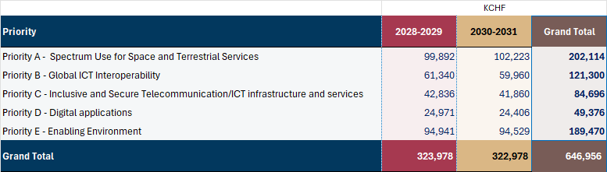
5 Financial Constraints
5.1 Having regard to the lack of growth in revenues anticipated for the 2028-2031 period, and anticipated increasing expenses of the Union, certain initiatives that would improve ITU’s effectiveness and possibly impact achievement of the strategic goals will not be able to be funded within the financial plan. These initiatives include the following:
- Funding provisions to support the financial implications of future World Conferences: During the four-year period leading up to the present Council, three world conferences have produced new or amended resolutions which those conferences have assessed would require additional funding for implementation. These have totaled more than CHF 15 million, all of which was outside the budgetary envelope set out in the relevant financial plans (2020-2023, and 2024-2027).
- Stable Funding to support AI initiatives: Building on the AI Fund, established in 2025 following the Council decision to allocate respective resources, it would have been suitable to include an allocation in the 2028-2031 financial plan to address the sustainability of ITU’s AI for Good platform and implementation of other AI-related mandates, supporting programme delivery, partnerships and technical dialogue on ethical and inclusive AI. This need is mostly met through voluntary funding complemented by ad hoc allocations from savings, however a financial plan allocation would allow for improved effectiveness.
- Investment in ICT infrastructure and services: It has not been possible to include an allocation to ensure the full cohesive implementation of ITU’s ongoing digital transformation agenda, including securing full funding for spectrum management software, modern corporate digital systems, AI and data foundations to enable sector system modernization. These initiatives represent not only system replacements, but a structured opportunity to address these challenges through business process re-engineering, architectural modernization, and strengthened governance.
- Business Continuity: During the four-year period the secretariat will need to ensure business continuity of operations and conferencing at its headquarters premises. This involves preparatory work to accommodate staff relocation to the two remaining premises building. In addition, while every effort is made to reduce the disturbances caused by the construction on conferencing, mitigation strategies will need to be implemented. A holistic business continuity plan has been elaborated with relevant internal stakeholders ensuring conferencing and workplace needs are addressed as well as essential support services ranging from security and IT, to health, wellbeing, and building operations. Based on the plan additional funding would be required to further minimize the impact on ITU’s day-to-day activities during the new HQ building construction.
_________________

