Agenda item: ADM | Revision 1 to  Document C26/28-E
Agenda item: ADM | 29 April 2026
Agenda item: ADM | Original: English
Report by the Secretary-General
DRAFT OPERATIONAL PLAN FOR THE UNION FOR 2027
Purpose
This document presents the draft ITU operational plan for the Union for 2027, prepared in accordance with No. 87A of Article 5 of the ITU Convention. It includes links to the operational plans for the Bureaux in accordance with the ITU Convention. The TSB and BR plans have been presented to the applicable advisory groups, while the BDT plan will be presented to the forthcoming meeting of TDAG.
The ITU Strategic and Financial Plans 2024-2027 were approved by the ITU 2022 Plenipotentiary Conference (PP-22), and 2027 will be the final year during which ITU will implement that Strategic and Financial Plan. ITU has not yet approved Strategic and Financial Plans for 2028-2031, pursuant to which the operational plans for 2028-2030 would be developed. Accordingly, this plan provides detailed operational information for the year 2027.
Action required by the Council
The Council is invited to review the document C26/28 (Rev.1) and approve the draft resolution of the ITU operational plan for the Union for 2027, presented in Annex 1 to this document.
Relevant link(s) with the Strategic Plan
The operational plan for 2027 sets forth details for the five thematic priorities and the 43 outputs of the Union as laid down in the Strategic Plan 2024-2027
Financial implications
The operational plan for 2027 is consistent with the financial limits set by the Plenipotentiary Conference in Decision 5 (Rev. Bucharest, 2022).
_______________
References
Resolution 71 (Rev. Bucharest, 2022), CV 87A, 181A, 205A, 223A

Annex 1

1 Outline of the operational plan for 2027 by thematic priorities, outputs, and Sector
1.1 The draft operational plan for 2027 addresses the implementation of the five thematic priorities and forty-three outputs set by the Strategic and Financial Plans 2024-2027, approved by the 2022 Plenipotentiary Conference. It provides a detailed analysis of the use of ITU’s resources, across the General Secretariat and the Sectors, in implementing those thematic priorities and outputs for 2027.
1.2 The structure of the draft operational plan for 2027 stands as follows:
FIGURE 1
Draft operational plan structure 2027
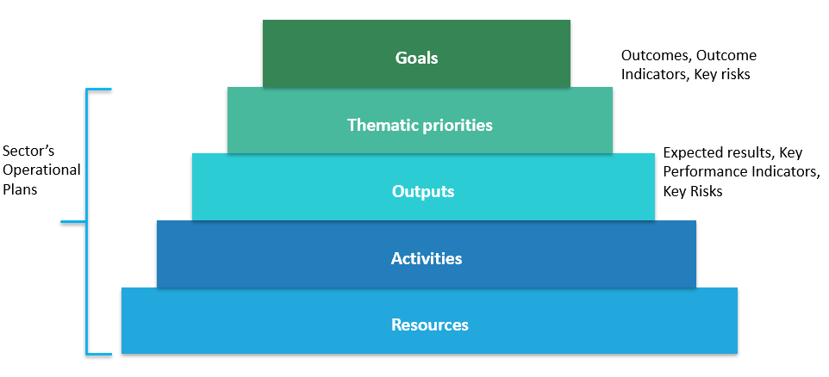

2 Thematic priorities and outputs
2.1 Table 1 provides the 2027 costs breakdown by thematic priority and Sector.

Table 1
2027 costs breakdown by thematic priority and Sector

2.2 Table 2 provides the breakdown of 2027 full costs by output.
TABLE 2
2027 Breakdown of full costs by output

Output | 2027 full costs (KCHF)
I1 - PP | 4 089
I2 - Council and WG | 5 619
I3 - WTPF | 779
I4 - WSIS | 1 751
I5 - Youth and Gender | 1 921
I6 - Commitment to environmental sustainability | 1 535
I7 - Partnerships and internal cooperation | 5 837
I8 - Resource mobilization | 2 507
I9 - Organizational and human resources excellence and innovation | 2 763
R1 - Processing of space notices | 20 995
R2 - Processing of terrestrial notices | 9 094
R3 - WRC’s outputs (Final Acts) | 11 005
R4 - CPM’s output (CPM Report) | 5 859
R5 - RRB’s outputs (Rules of Procedure and Decisions) | 3 020
R6 - Software | 1 119
R7 - ITU-R publications | 4 620
R8 - ITU-R study groups’ outputs | 4 006
R9 - RA outputs | 3 322
R10 - RAG outputs | 1 193
R11 - Technical Assistance | 2 392
R12 - ITU-R Seminars | 3 514
T1 - WTSA | 553
T2 - WTSA Regional consultation sessions | 219
T3 - TSAG | 1 703
T4 - ITU-T General assistance & Cooperation | 1 631
T5 - ITU-T Study Groups | 13 030
T6 - Bridging the standardization gap | 2 881
T7 - Training activities, including workshops and seminars | 4 275
T8 - ITU-T publications and database publications | 3 156
T9 - Allocation and management of international telecommunication numbering | 1 217
D1 - WTDC and Regional preparatory meetings | 2 241
D2 - TDAG | 2 511
D3 - ITU-D Study groups | 4 582
D4 - Resource mobilization and partnerships | 5 311
D5 - New product and service development | 5 964
D6 - Communications | 3 097
D7 - Capacity development | 3 783
D8 - Product and service delivery | 2 499
D9 - Statistics | 1 707
D10 - Publications (Flagship) | 3 003
D11 - Outreach and representation | 3 129
D12 - UN engagement | 3 710
D13 - Platforms (GSR, WTIS, RDF etc) | 2 970
TOTAL | 170 112

3 Cost structure and cost allocation methodology
3.1 The full cost allocation to each Results-Based Budget component, i.e. the thematic priorities and outputs, is based on the cost allocation methodology described in Council Decision 535.
3.2 The full cost structure stands as follows:
FIGURE 2
Full Cost Structure
3.3 The Planned Expenses (Financial Budget) are represented by the Categories of Expenses as follows:

Staff costs
– Category 1 Staff costs (salaries and allowances, etc.)
– Category 2 Other staff costs (pensions, health insurance, human resources development, etc.)

Non-staff costs
– Category 3 Travel on duty
– Category 4 Contractual services
– Category 5 Rental and maintenance of premises and equipment
– Category 6 Materials and supplies
– Category 7 Acquisition of premises, furniture, and equipment
– Category 8 Public and internal service utilities
– Category 9 Audit and inter-agency fees and miscellaneous.
3.4 The Documentation Costs represent services provided by the Conferences and Publications Department, which can be directly charged to an output on a number-of-page basis. Those services are:
– Translation (in the six official languages of the Union)
– Text processing (in the six official languages of the Union).
3.5 The Bureau / General Secretariat Support Costs represent the costs of staff and related expenses of the Bureaux (including the Office of the Director) and General Secretariat (Strategic Planning and Membership Department) that are reallocated to thematic priorities and outputs based upon work effort measurement (Time survey).
3.6 The Centralized Administrative Services Costs represent the costs of staff and related expenses of:
– the Office of the Secretary-General and Deputy Secretary-General
– the Human Resources Management Department
– the Financial Resources Management Department
that provide general administrative support to all thematic priorities and outputs of the Union. These costs are reallocated to outputs based on reallocation drivers.
3.7 The Centralized Support Services Costs represent the costs of staff and related expenses of:
– the Conferences and Publications Department (outside Documentation Costs)
– the Information Services Department
– ITU Common expenses
that provide general support to the thematic priorities and outputs of the Union. These costs are reallocated to outputs based on reallocation drivers.

4 Allocation to thematic priorities and outputs in 2027
4.1 The draft operational plan provides information for the implementation of the five thematic priorities and 43 outputs under implementation:
– 9 Inter-Sectoral outputs
– 12 Radiocommunication Sector outputs
– 9 Telecommunication Standardization Sector outputs
– 13 Telecommunication Development Sector outputs
4.2 For each thematic priority, the following information is provided:
– Description of the thematic priority
– Summary of the cost allocation for 2027
– Key outline of outcomes, outcomes indicators
– Key risks for 2027
– The 2027 costs of outputs contributing to the thematic priority.

FIGURE 3
2027 Allocation to thematic priority 1
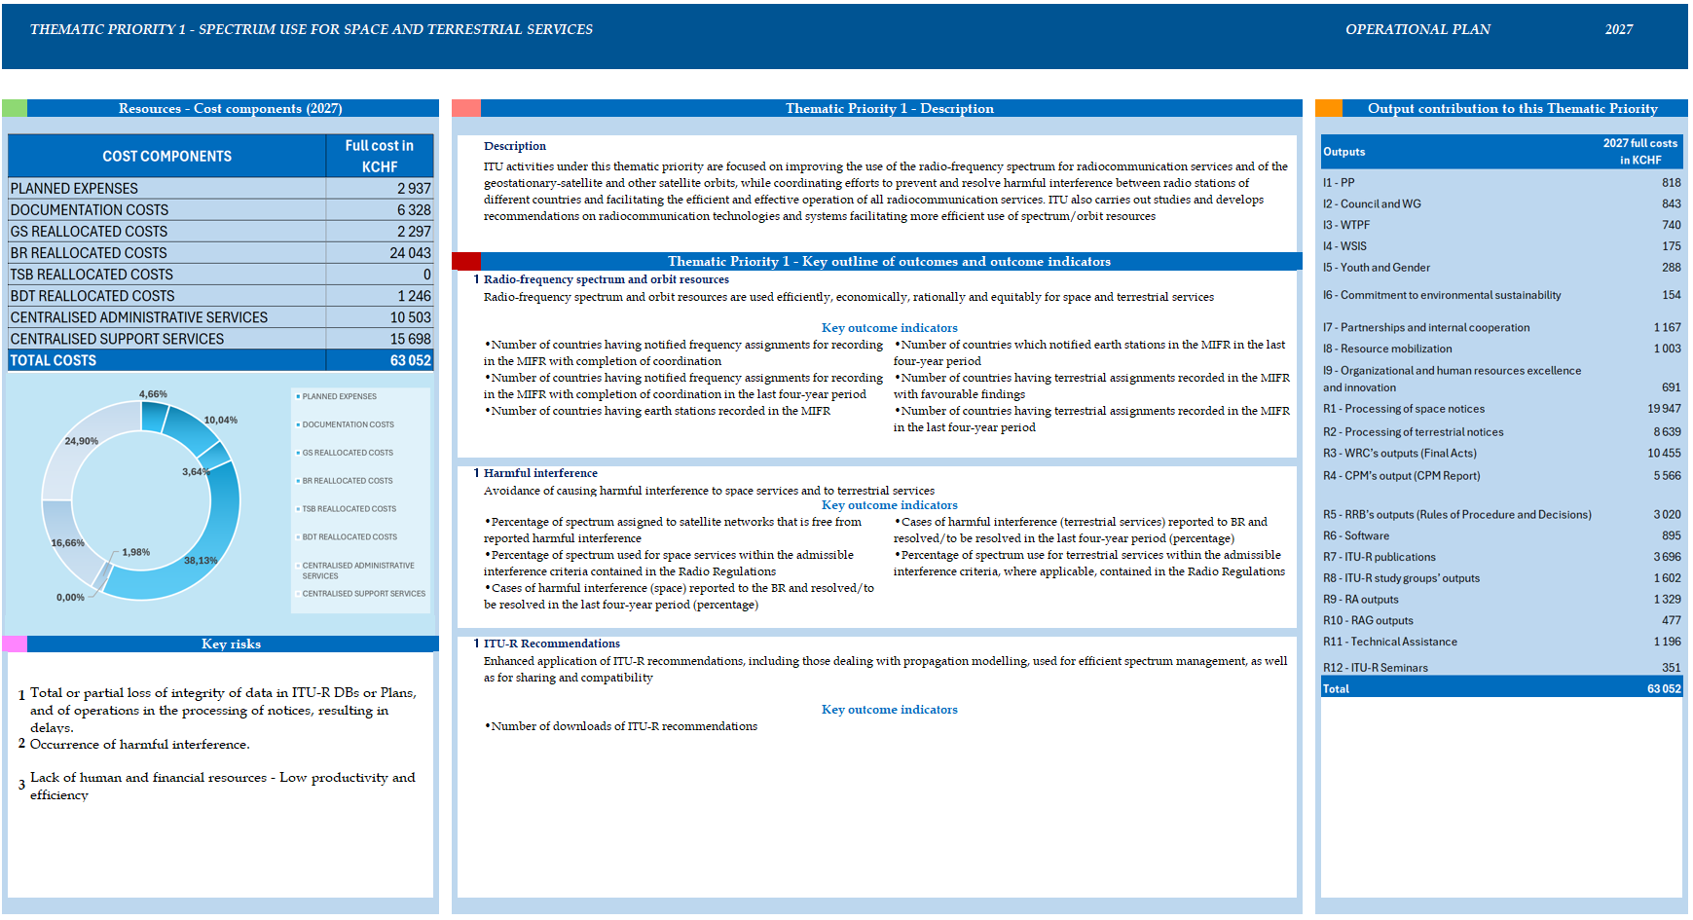
FIGURE 4
2027 Allocation to thematic priority 2
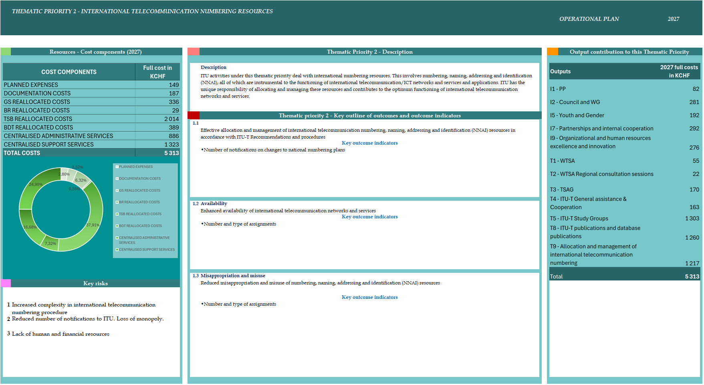

FIGURE 5
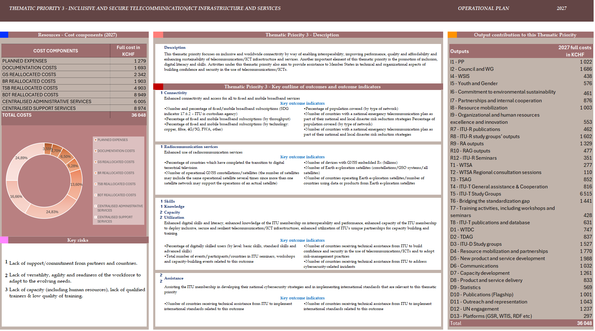
2027 Allocation to thematic priority 3

FIGURE 6
2027 Allocation to thematic priority 4
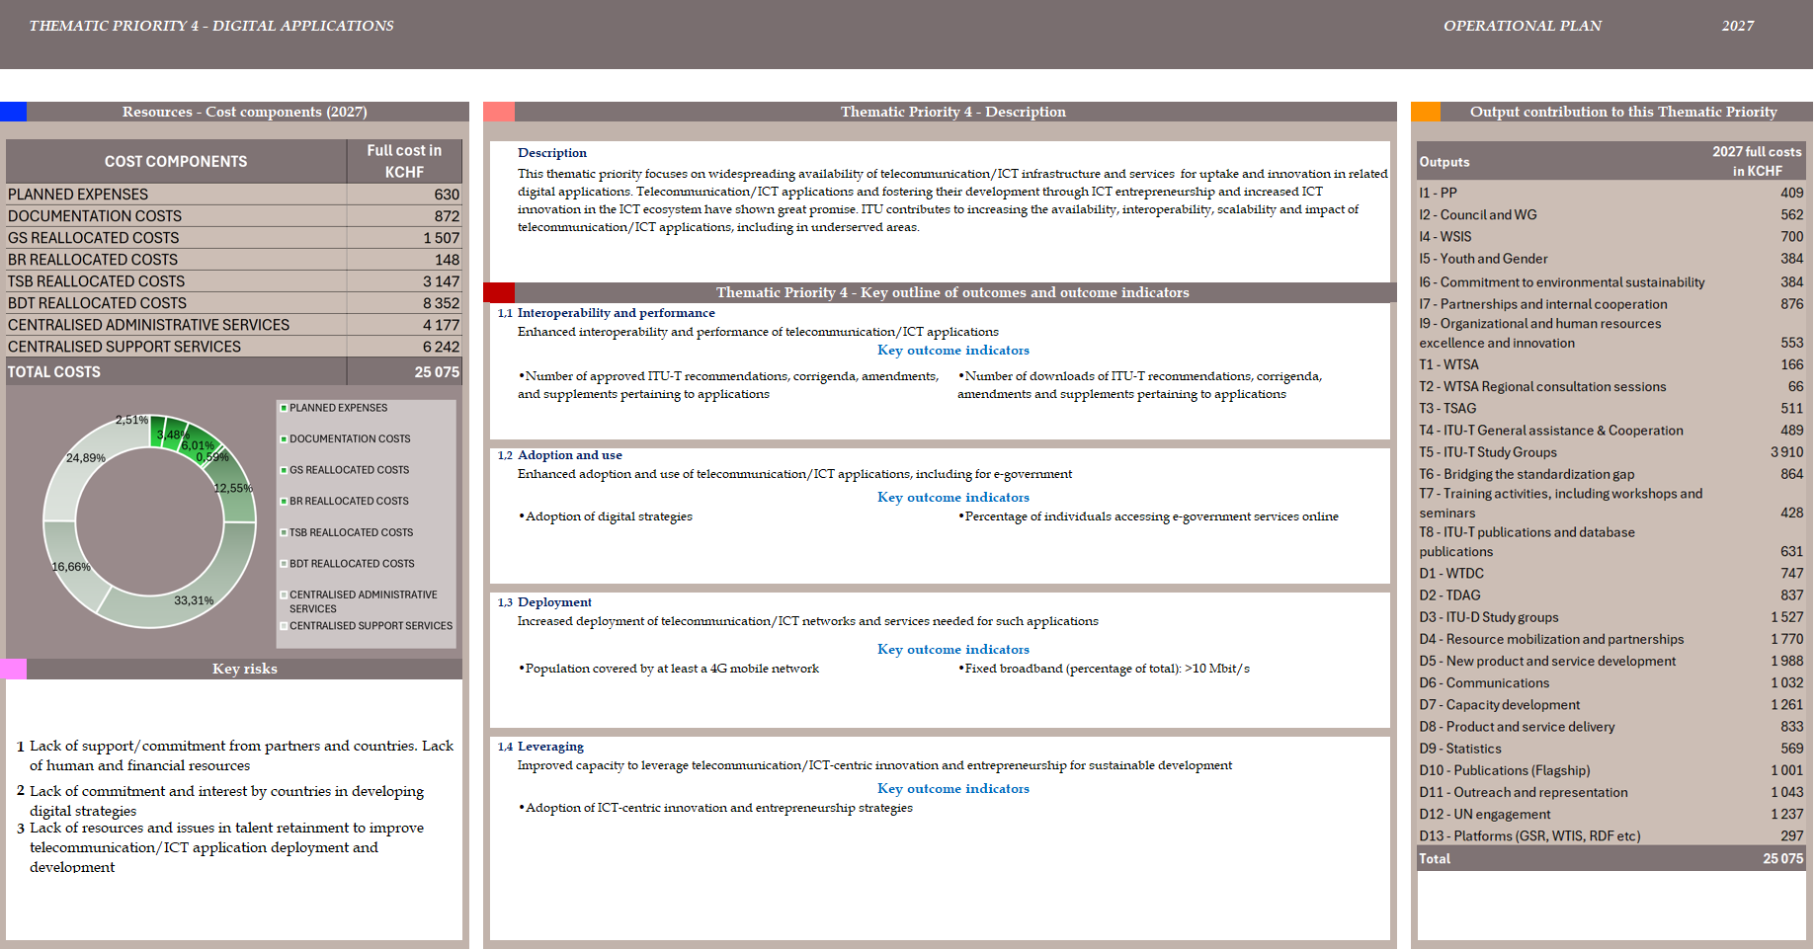
FIGURE 7
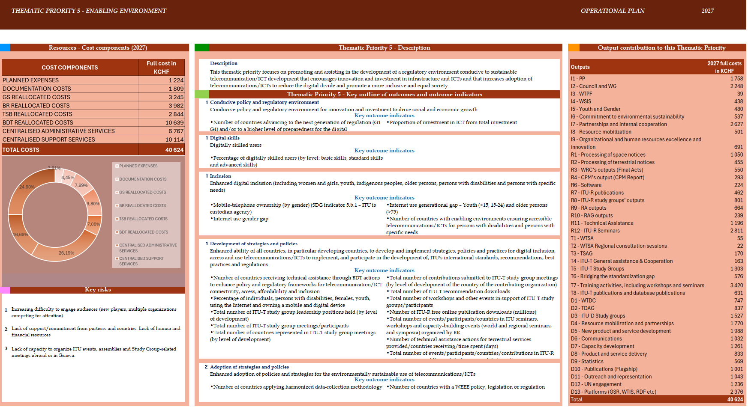
2027 Allocation to thematic priority 5

TABLE 3
2027 Intersectoral outputs
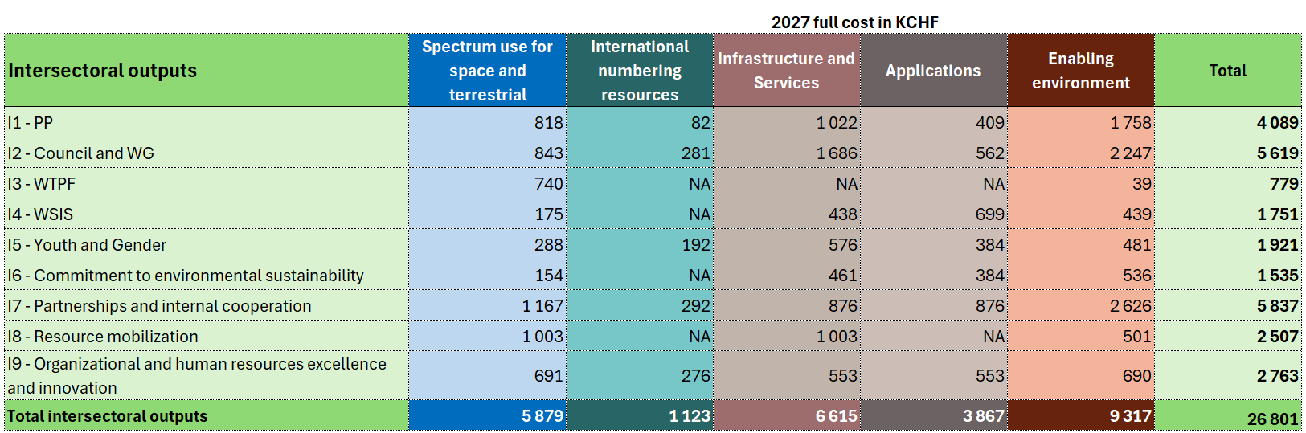

TABLE 4
2027 Radiocommunication Sector outputs
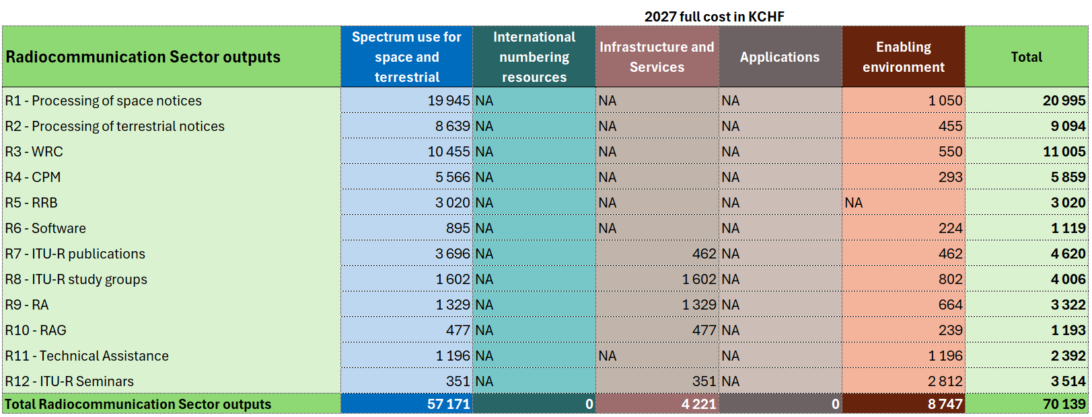

TABLE 5
Telecommunication Standardization Sector outputs
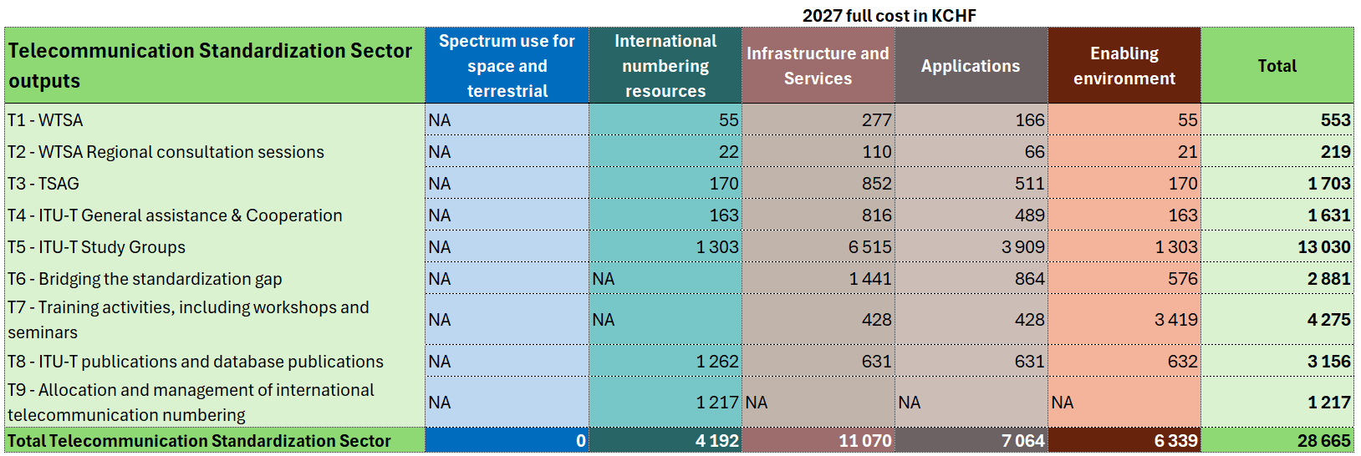

TABLE 6
Telecommunication Development Sector outputs
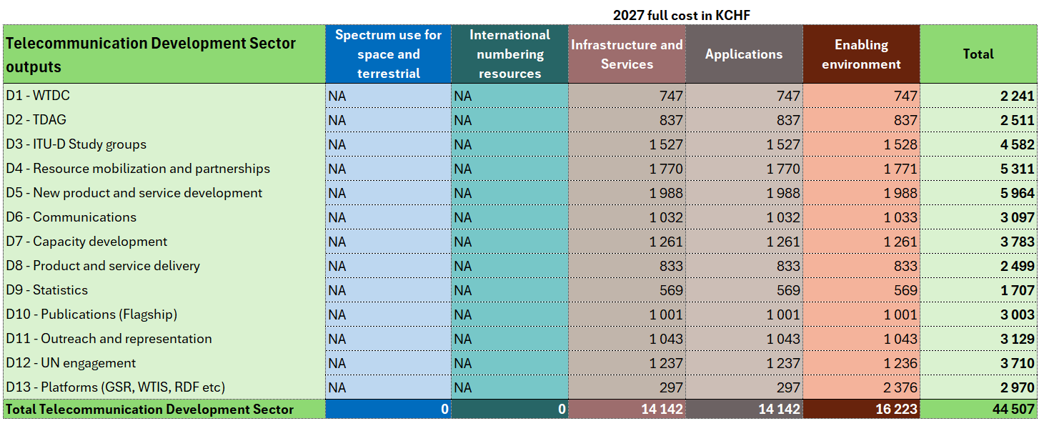

DRAFT RESOLUTION [...]
Operational plan for the Union for 2027
The ITU Council,
recognizing
the provisions of Articles 5, 11A, 12, 14A, 15 and 18 of the ITU Convention,
recalling
Resolution 71 (Rev. Bucharest, 2022) on the strategic plan for the Union for 2024-2027 and Resolution 151 (Rev. Bucharest, 2022) on the implementation of results-based management,
having considered
the operational plan for the Union for 2027 in Annex 1 of Document C26/28(Rev.1),
having also considered
the need for the Secretary-General and the Directors of the Bureaux to have some flexibility in the implementation of the corresponding elements of the operational plan to take into consideration any changes that may occur during the interval between two council sessions,
resolves
1 to approve the operational plan for the Union for 2027; and
2 to allow the Secretary-General and the Directors the necessary flexibility in the implementation of the corresponding elements of the operational plan for the Union for 2027.

__________________

