Agenda item: PL 2 | Document C26/28-E
Agenda item: PL 2 | 30 March 2026
Agenda item: PL 2 | Original: English
Report by the Secretary-General
DRAFT FOUR-YEAR ROLLING OPERATIONAL PLAN FOR THE UNION FOR 2027-2030
Purpose
This document presents the draft ITU operational plan for the Union for 2027-2030, prepared in accordance with No. 87A of Article 5 of the ITU Convention. It includes links to the operational plans for the Bureaux in accordance with the ITU Convention. The TSB and BR plans have been presented to the applicable advisory groups, while the BDT plan will be presented to the forthcoming meeting of TDAG.
The ITU Strategic and Financial Plans 2024-2027 were approved by the ITU 2022 Plenipotentiary Conference (PP-22), and 2027 will be the final year during which ITU will implement that Strategic and Financial Plan. ITU has not yet approved Strategic and Financial Plans for 2028-2031, pursuant to which the operational plans for 2028-2030 would be developed. Accordingly, this plan provides detailed operational information for the year 2027, and for the years 2028-2030 it provides a proposed resource allocation based on the draft Strategic Plan 2028-2031 under development.
Action required by the Council
The Council is invited to review and approve the draft ITU operational plan for the Union for 2027, to review and approve the outline operational plans for 2028-2030, and to adopt the draft resolution presented in Annex A to this document.
Relevant link(s) with the Strategic Plan
The operational plan for 2027 sets forth details for the five thematic priorities and the 43 outputs of the Union as laid down in the Strategic Plan 2024-2027, while the outline operational plans for 2028-2030 sets forth proposals for the allocation of resources to the 5 draft priorities and the 19 draft outcomes proposed in the current draft of the ITU Strategic Plan 2028-2031.
Financial implications
The operational plan for 2027 is consistent with the financial limits set by the Plenipotentiary Conference in Decision 5 (Rev. Bucharest, 2022). The outlines for 2028-2030 have no financial implications.
_______________
References
Resolution 71 (Rev. Bucharest, 2022), CV 87A, 181A, 205A, 223A

1 Outline of the operational plan for 2027 by thematic priorities, outputs, and Sector
1.1 The draft operational plan for 2027 addresses the implementation of the five thematic priorities and forty-three outputs set by the Strategic and Financial Plans 2024-2027, approved by the 2022 Plenipotentiary Conference. It provides a detailed analysis of the use of ITU’s resources, across the General Secretariat and the Sectors, in implementing those thematic priorities and outputs for 2027.
1.2 The structure of the draft operational plan for 2027 stands as follows:
FIGURE 1
Draft operational plan structure 2027
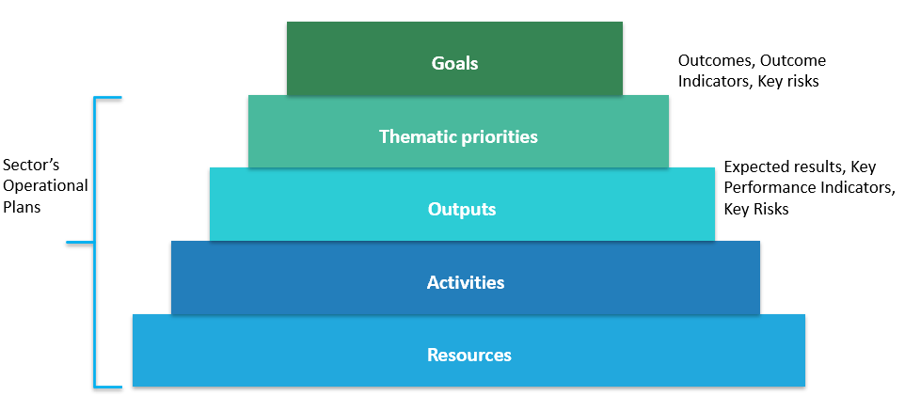

2 Thematic priorities and outputs
2.1 Table 1 provides the 2027 costs breakdown by thematic priority and Sector.

Table 1
2027 costs breakdown by thematic priority and Sector

2.2 Table 2 provides the breakdown of 2027 full costs by output.
TABLE 2
2027 Breakdown of full costs by output

Output | 2027 full costs (KCHF)
I1 - PP | 4 089
I2 - Council and WG | 5 619
I3 - WTPF | 779
I4 - WSIS | 1 751
I5 - Youth and Gender | 1 921
I6 - Commitment to environmental sustainability | 1 535
I7 - Partnerships and internal cooperation | 5 837
I8 - Resource mobilization | 2 507
I9 - Organizational and human resources excellence and innovation | 2 763
R1 - Processing of space notices | 20 995
R2 - Processing of terrestrial notices | 9 094
R3 - WRC’s outputs (Final Acts) | 11 005
R4 - CPM’s output (CPM Report) | 5 859
R5 - RRB’s outputs (Rules of Procedure and Decisions) | 3 020
R6 - Software | 1 119
R7 - ITU-R publications | 4 620
R8 - ITU-R study groups’ outputs | 4 006
R9 - RA outputs | 3 322
R10 - RAG outputs | 1 193
R11 - Technical Assistance | 2 392
R12 - ITU-R Seminars | 3 514
T1 - WTSA | 553
T2 - WTSA Regional consultation sessions | 219
T3 - TSAG | 1 703
T4 - ITU-T General assistance & Cooperation | 1 631
T5 - ITU-T Study Groups | 13 030
T6 - Bridging the standardization gap | 2 881
T7 - Training activities, including workshops and seminars | 4 275
T8 - ITU-T publications and database publications | 3 156
T9 - Allocation and management of international telecommunication numbering | 1 217
D1 - WTDC and Regional preparatory meetings | 2 241
D2 - TDAG | 2 511
D3 - ITU-D Study groups | 4 582
D4 - Resource mobilization and partnerships | 5 311
D5 - New product and service development | 5 964
D6 - Communications | 3 097
D7 - Capacity development | 3 783
D8 - Product and service delivery | 2 499
D9 - Statistics | 1 707
D10 - Publications (Flagship) | 3 003
D11 - Outreach and representation | 3 129
D12 - UN engagement | 3 710
D13 - Platforms (GSR, WTIS, RDF etc) | 2 970
TOTAL | 170 112

3 Cost structure and cost allocation methodology
3.1 The full cost allocation to each Results-Based Budget component, i.e. the thematic priorities and outputs, is based on the cost allocation methodology described in Council Decision 535.
3.2 The full cost structure stands as follows:
FIGURE 2
Full Cost Structure
3.3 The Planned Expenses (Financial Budget) are represented by the Categories of Expenses as follows:

Staff costs
– Category 1 Staff costs (salaries and allowances, etc.)
– Category 2 Other staff costs (pensions, health insurance, human resources development, etc.)

Non-staff costs
– Category 3 Travel on duty
– Category 4 Contractual services
– Category 5 Rental and maintenance of premises and equipment
– Category 6 Materials and supplies
– Category 7 Acquisition of premises, furniture, and equipment
– Category 8 Public and internal service utilities
– Category 9 Audit and inter-agency fees and miscellaneous.
3.4 The Documentation Costs represent services provided by the Conferences and Publications Department, which can be directly charged to an output on a number-of-page basis. Those services are:
– Translation (in the six official languages of the Union)
– Text processing (in the six official languages of the Union).
3.5 The Bureau / General Secretariat Support Costs represent the costs of staff and related expenses of the Bureaux (including the Office of the Director) and General Secretariat (Strategic Planning and Membership Department) that are reallocated to thematic priorities and outputs based upon work effort measurement (Time survey).
3.6 The Centralized Administrative Services Costs represent the costs of staff and related expenses of:
– the Office of the Secretary-General and Deputy Secretary-General
– the Human Resources Management Department
– the Financial Resources Management Department
that provide general administrative support to all thematic priorities and outputs of the Union. These costs are reallocated to outputs based on reallocation drivers.
3.7 The Centralized Support Services Costs represent the costs of staff and related expenses of:
– the Conferences and Publications Department (outside Documentation Costs)
– the Information Services Department
– ITU Common expenses
that provide general support to the thematic priorities and outputs of the Union. These costs are reallocated to outputs based on reallocation drivers.

4 Allocation to thematic priorities and outputs in 2027
4.1 The draft operational plan provides information for the implementation of the five thematic priorities and 43 outputs under implementation:
– 9 Inter-Sectoral outputs
– 12 Radiocommunication Sector outputs
– 9 Telecommunication Standardization Sector outputs
– 13 Telecommunication Development Sector outputs
4.2 For each thematic priority, the following information is provided:
– Description of the thematic priority
– Summary of the cost allocation for 2027
– Key outline of outcomes, outcomes indicators
– Key risks for 2027
– The 2027 costs of outputs contributing to the thematic priority.

FIGURE 3
2027 Allocation to thematic priority 1
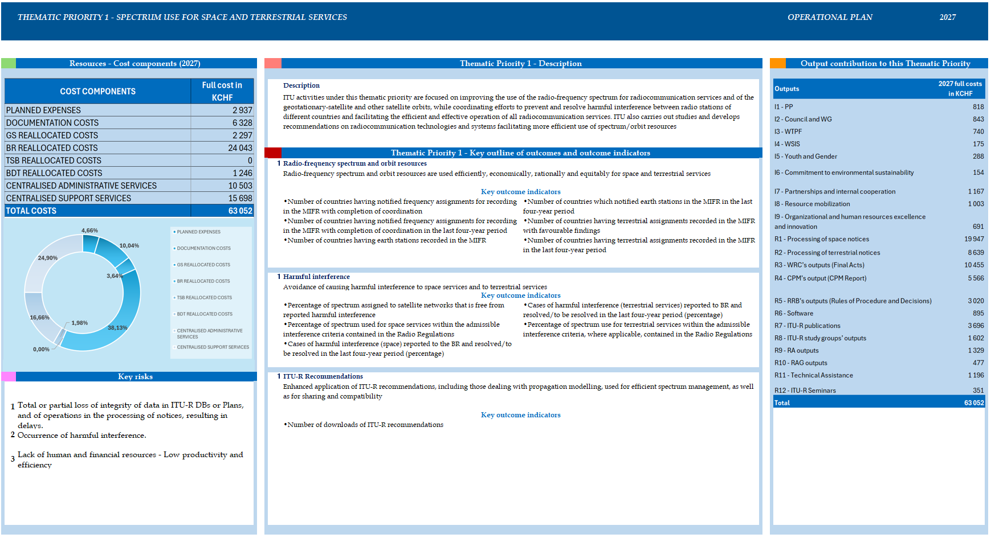
FIGURE 4
2027 Allocation to thematic priority 2
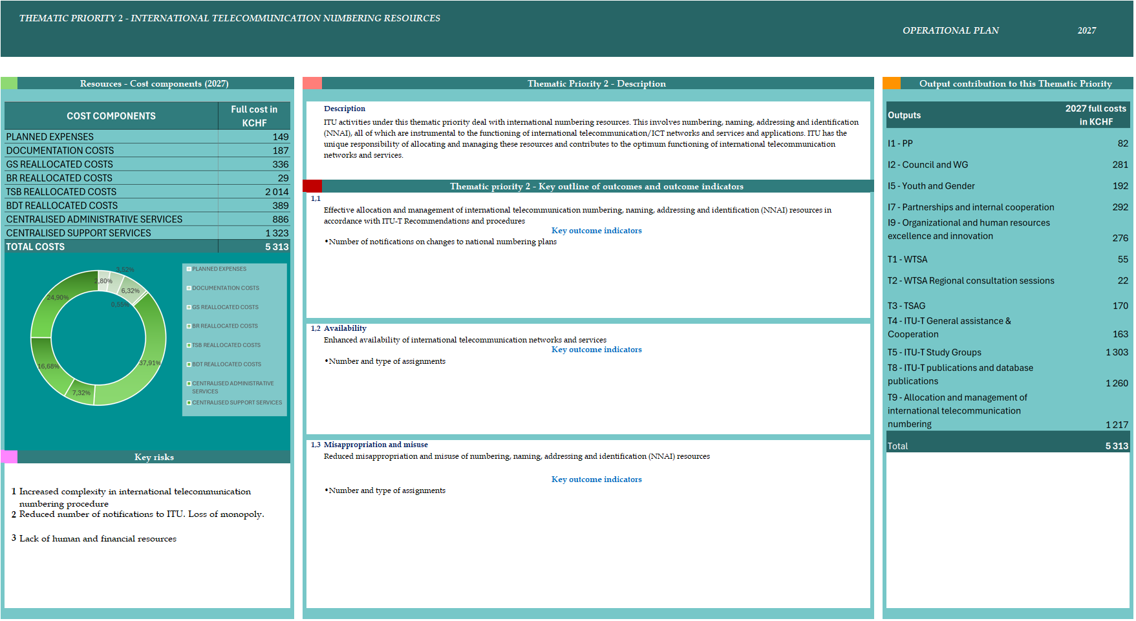

FIGURE 5
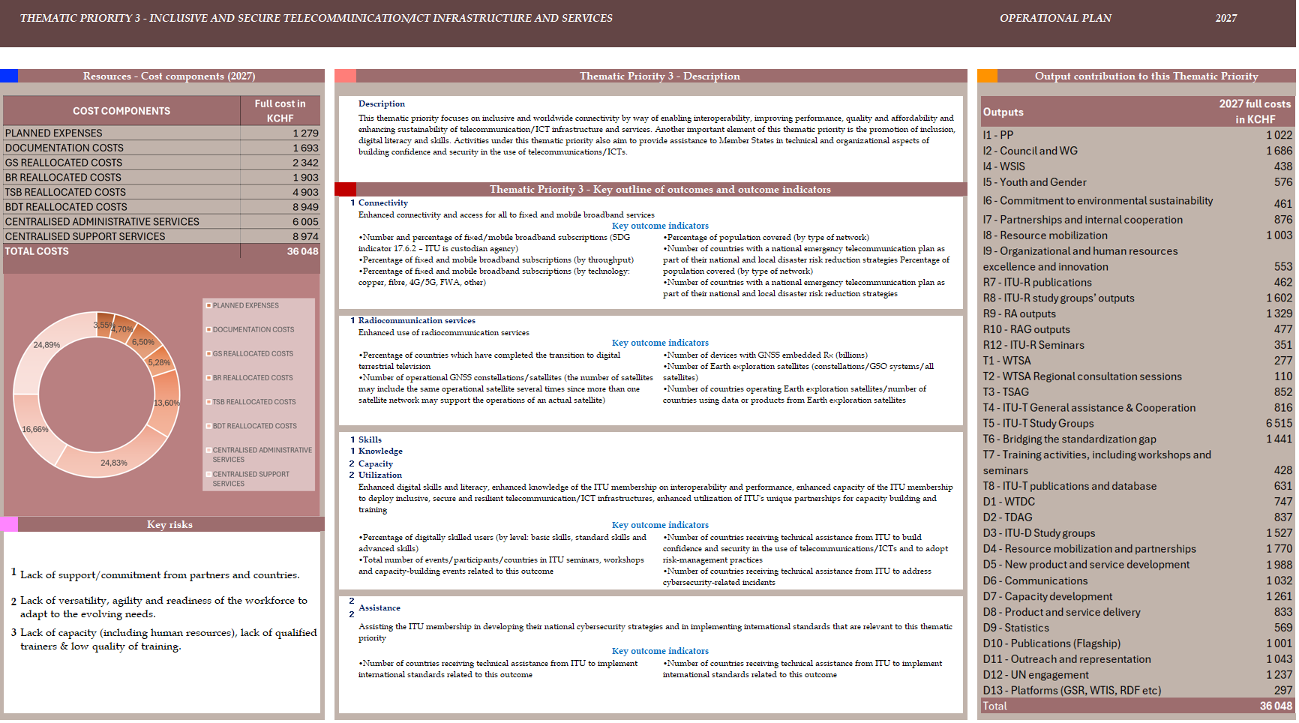
2027 Allocation to thematic priority 3

FIGURE 6
2027 Allocation to thematic priority 4
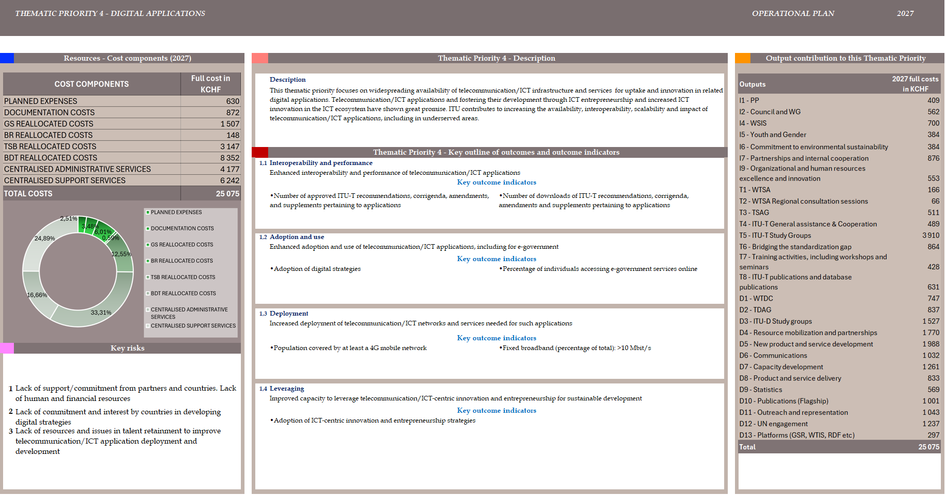
FIGURE 7
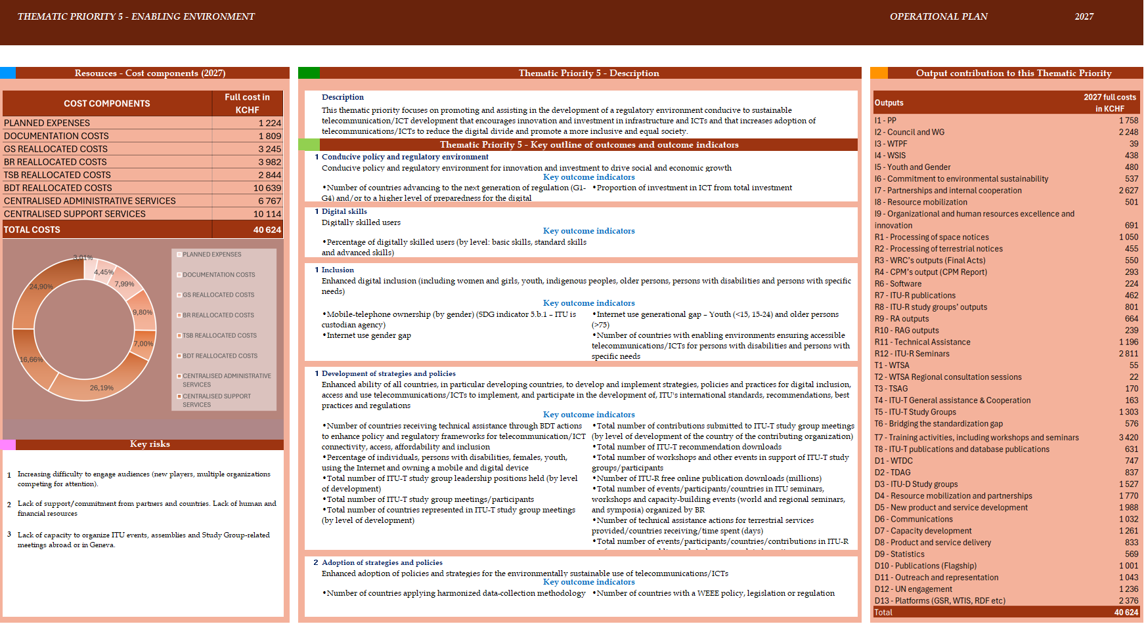
2027 Allocation to thematic priority 5

TABLE 3
2027 Intersectoral outputs
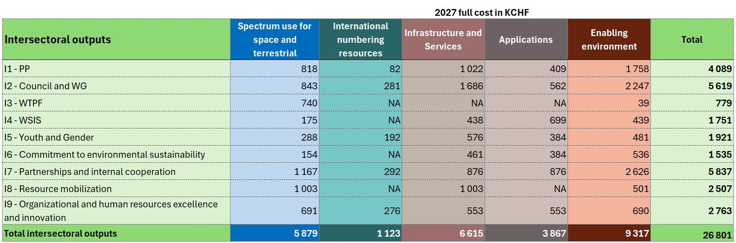

TABLE 4
2027 Radiocommunication Sector outputs
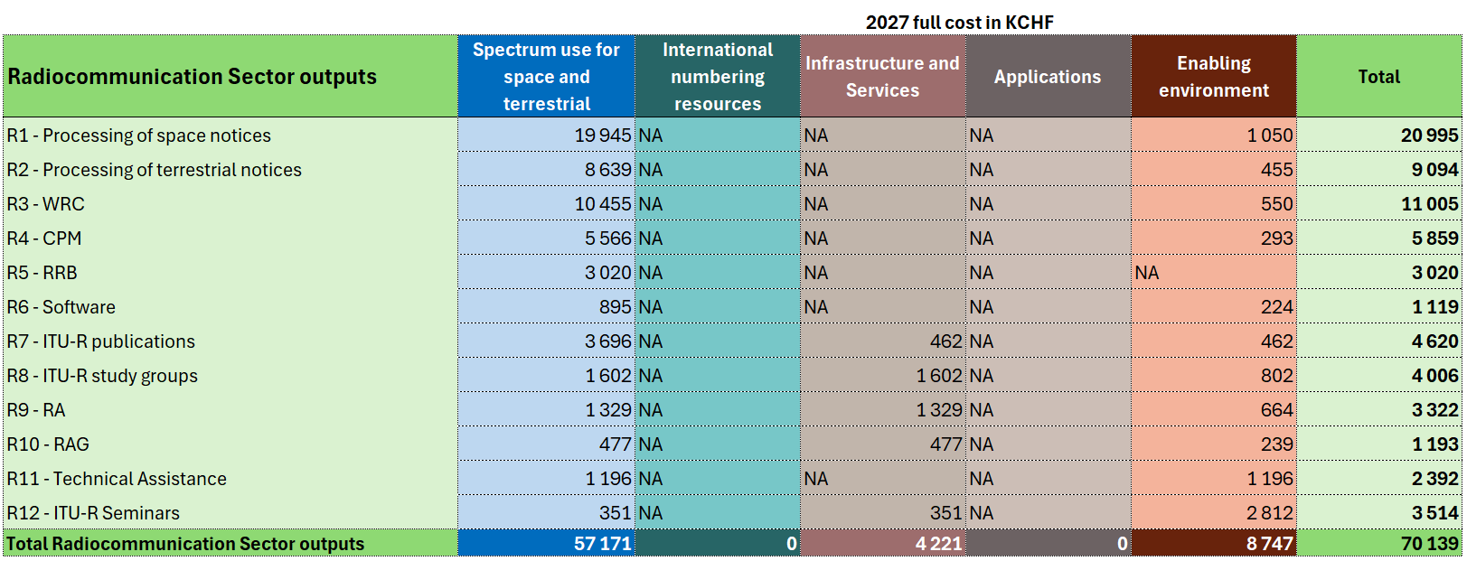

TABLE 5
Telecommunication Standardization Sector outputs
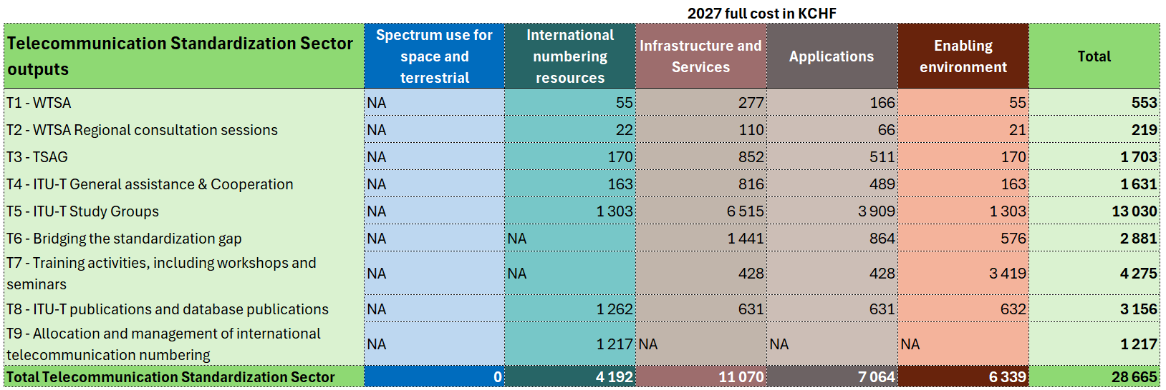

TABLE 6
Telecommunication Development Sector outputs
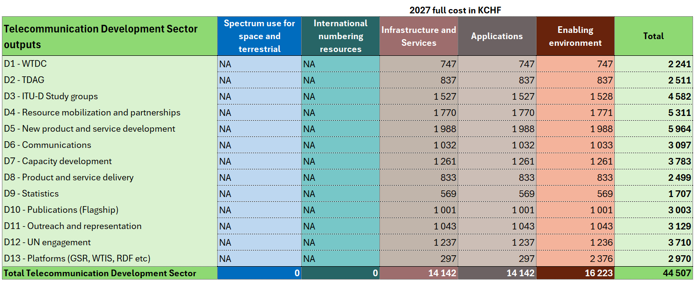

5 Operational Plans of the Bureaux
5.1 The draft operational plans for the Bureaux are prepared based on the ITU Strategic Plan, but also in alignment with the outcomes of each applicable world conference. They are aligned with the overall ITU Operational Plan as presented in this document. ITU’s new ITU-wide planning process help to achieve alignment across the drafts in preparation, however full alignment may require minor adjustment and alignment of the sectoral plan with the ITU operational plan, after the advisory groups have provided their inputs.
5.2 The TSB submitted the draft ITU-T operational plan 2026-2029 to the meeting of the Telecommunications Standardisation Advisory Group (TSAG) in January 2026. The plan detailed the alignment of the work of the TSB with the result-based management framework, key outputs (ITU-T standards development, bridging the standardization gap, international numbering resources, thought leadership, partnerships, and organizational excellence), along with associated (draft) key performance indicators, risk assessment, human resource allocation, and the structured multi-stage operational planning process including output registration, planning, corporate review, harmonization, approval, and monitoring. Feedback received for better alignment with No. 205A of the ITU Convention was subsequently incorporated and reviewed at the meeting of the TSAG Rapporteur Group on Industry Engagement and Strategic and Operational Planning (RG-IES) in February 2026. It should be noted that the secretariat is transitioning the methodology, and as such this initial version should be seen as subject to further adjustments.
5.2 The draft ITU-R Operational Plan 2027-2030 has been submitted by the BR to the next meeting of the Radiocommunications Advisory Group (RAG) which will take place from 30 March to 2 April 2026. The ITU-R plan sets forth details concerning the ITU-R outputs as well as the expected results, key performance indicators and risk assessment. The plan outlines that the ITU-R Sector will have a demanding schedule during the 2027-2030 timeframe. Besides the regular work of the ITU-R Study Groups, preparations for WRC-27 have already started and will continue through the CPM27-2 in 2027 and conclude with the commencement of the RA-27 and WRC-27. A new cycle of activities of the ITU-R Study Groups will begin in 2028.
5.3 The draft ITU-D Operational Plan 2026 was published for presentation to the meeting of the Telecommunications Development Advisory Group (TDAG) to be held from 7 to 10 April 2026. The plan is aligned with the structure of the Union’s Strategic Plan for 2024-2027. It follows the framework of the Baku Action Plan (BAP), setting out the ITU-D Priorities and supporting Enablers, together with the corresponding outcomes, products and services as well as the indicators used to measure the level of achievement level resulting from the activities of the Sector. The ITU planning process focused on defining a coherent framework for planning actions, ensuring full alignment with the BAP and overall strategic consistency. The actions proposed were developed through thorough consultations with Member States and are aligned with the priorities of each region.

6 Operational Planning for 2028 to 2030
6.1 As noted above, the current ITU Strategic and Financial Plans are valid for the period 2024-2027 only. The development of a new ITU Strategic Plan (for 2028-2031) is being undertaken in accordance with Article 11, No. 74A of the ITU Constitution and Article 4, No. 62A of the ITU Convention, which mandate the Secretary-General, with the assistance of the Coordination Committee, to provide Member States and Sector Members with the information required for preparing the Union’s policies and strategic plan, while the Council initiates the preparation of the draft plan before the Plenipotentiary Conference. Through Council Resolution 1428 (2024), the Council delegated the development of the draft Strategic and Financial Plans to the Council Working Group on strategic and financial plans (CWG-SFP), where Member States and Sector Members participate on an equal footing.
6.2 The draft Strategic and Financial plans for 2028-2031 will be presented and discussed during the joint meeting of the Council Working Group on financial and human resources (CWG-FHR) and Council Working Group on strategic and financial plans (CWG-SFP) in April 2026. These discussions will allow Council to review the draft plans prior to their consideration and approval at the 2026 Plenipotentiary Conference.
6.3 Once the Strategic and Financial Plans for 2028-2031 have been approved, the secretariat will conduct detailed operational planning and complete the draft four-year operational plan for 2028-2031 together with the biennial budget for 2028-2029, to be presented at Council 2027.
6.4 The current draft of ITU’s Strategic Plan 2028-2031 provides the following five draft “priorities”, which in turn comprise a total of 16 draft outcomes.
– Priority 1 - Spectrum Use for Space and Terrestrial Services
– Priority 2 - Global ICT Interoperability
– Priority 3 - Inclusive and Secure Telecommunication/ICT infrastructure and services
– Priority 4 - Digital Applications
– Priority 5 - Enabling Environment
6.5 While these are not yet approved and therefore have not been used for formal planning, the secretariat has conducted a preliminary mapping of ITU’s current outputs to the relevant draft, and using this mapping is able to estimate the percentage of ITU’s resources that would need to be allocated to each draft outcome and priority during the 2028-2030 period. The resulting estimated allocations for each year are illustrated in the charts below.
FIGURE 8
2028 Allocation of Resources by Priority

FIGURE 9
2028 Priority by Outcome 1: Spectrum Use for Space and Terrestrial Services

FIGURE 10
2028 Priority by Outcome 2: Global ICT Interoperability

FIGURE 11
2028 Priority by Outcome 3: Inclusive and Secure Telecommunication/ICT Infrastructure

FIGURE 12
2028 Priority by Outcome 4: Digital Applications

FIGURE 13
2028 Priority by Outcome 5: Enabling Environment

FIGURE 14
2029 allocation of resources by priority

FIGURE 15
2030 allocation of resources by priority

ANNEX A
DRAFT RESOLUTION [...]
Operational plan for the Union for 2027-2030
The ITU Council,
recognizing
the provisions of Articles 5, 11A, 12, 14A, 15 and 18 of the ITU Convention,
recalling
Resolution 71 (Rev. Bucharest, 2022) on the strategic plan for the Union for 2024-2027 and Resolution 151 (Rev. Bucharest, 2022) on the implementation of results-based management,
having considered
the operational plan for the Union for 2027-2030 (Document C26/28),
having also considered
the need for the Secretary-General and the Directors of the Bureaux to have some flexibility in the implementation of the corresponding elements of the operational plan to take into consideration any changes that may occur during the interval between two council sessions,
resolves
1 to approve the operational plan for the Union for 2027; and
2 to allow the Secretary-General and the Directors the necessary flexibility in the implementation of the corresponding elements of the operational plan for the Union for 2027.

ANNEX B
DRAFT ITU Results Framework – Priorities and outcomes (2028-2031)
 | Priority | Outcome | Outcome Indicator
1 | Spectrum use for space & terrestrial services | 1.1) Radio-frequency spectrum and orbit resources are used efficiently, economically, rationally and equitably  a) Space Services  b) Terrestrial Services | 1) Number of frequency assignments to space services that have been recorded in the MIFR under No. 11.31 only, on a yearly basis  - For geostationary satellite networks  - For non-geostationary satellite systems  2) Number of frequency assignments to space services that have been recorded in the MIFR under Nos. 11.31, 11.32 or 11.32A, on a yearly basis  - For geostationary satellite networks  - For non-geostationary satellite systems  3) Number of frequency assignments to space services that have been recorded in the MIFR under No. 11.41, on a yearly basis  - For geostationary satellite networks  - For non-geostationary satellite systems  4) Number of frequency assignments to space services that have been recorded in the MIFR under No. 4.4, on a yearly basis  - For geostationary satellite networks  - For non-geostationary satellite systems  5) Number of frequency assignments to space services that have been suppressed from the MIFR:  - Due to non-conformity with the RR  - At the initiative of notifying Administration  6) Number of countries having terrestrial assignments recorded in the MIFR in the last four-year period  7) Number of frequency assignments (terrestrial services non-planned and not subject to coordination) that have been recorded in the MIFR under No. 11.31, on a yearly basis  8) Number of frequency assignments (terrestrial services non-planned and subject to coordination) that have been recorded in the MIFR under Nos. 11.31 and 11.32, on a yearly basis  9) Number of frequency assignments (terrestrial services planned) that have been recorded in the MIFR under Nos. 11.31 and 11.34, on a yearly basis  10) Number of frequency assignments (terrestrial services) that have been recorded in the MIFR under No. 4.4, on a yearly basis  11) Number of frequency assignments (terrestrial services) that have been suppressed from the MIFR:  - Due to non-conformity with the RR  - At the initiative of notifying Administration
 |  | 1.2) Avoidance of causing harmful interference to  a) Space services  b) Terrestrial services | 1) Number of cases of harmful interference (to frequency assignments pertaining to space services) reported to the BR in the one year of the reporting period  2) Number of cases of harmful interference (to frequency assignments pertaining to space services) reported to the BR that are pending resolution  3) Number of cases of harmful interference (to assignments pertaining to terrestrial services) reported to the BR in the one year of the reporting period  4) Number of cases of harmful interference (to assignments pertaining to terrestrial services) reported to the BR that are pending resolution
2 | Global ICT Interoperability | 2.1) Increased Global Adoption and Impact of ITU-T Standards | 1) Number of ITU-T standards adopted as national standards or referenced in national/regional regulations  2) Number of Member States with a national standardization strategy  3) Number of ITU-T standards referenced by papers published in high standing academic publications.  4) Level of satisfaction with Recommendations and reports on radiocommunications and telecom/ICT matters that inter alia provide worldwide interoperability and compatibility, global connectivity, innovation and efficiency, timeliness of service and overall system economy.  5) Level of satisfaction with international technical standards for new and emerging telecom/ICTs, creating an enabling environment for their introduction and utilization.  6) Number of Member States having agencies responsible for new and emerging technologies that ITU-T addresses
 |  | 2.2) Enhanced Performance, Reliability and Coordination of Global Telecommunication Networks and Services | 1) Enhanced availability of international telecommunication networks and services  2) Effective allocation and management of international telecommunication numbering, naming, addressing and identification (NNAI) resources in accordance with ITU-T recommendations and procedures
3 | Inclusive and secure telecommunication / ICT infrastructure and services | 3.1) Improved broadband connectivity in developing countries, including LDCs, SIDS, LLDCs and countries with economies in transition, and countries with specific needs. | 1) Number of Member States with broadband plans  2) Number of operational GNSS constellations/satellites (the number of satellites may include the same operational satellite several times since more than one satellite network may support the operations of an actual satellite)  3) Number of devices with GNSS embedded Rx (billions)  4) Number of Earth exploration satellites (constellations/GSO systems/all satellites)  5) Number of countries operating Earth exploration satellites/number of countries using data or products from Earth exploration satellites
 |  | 3.2) Improved telecommunication/ICT infrastructure and service, in particular broadband coverage, quality of service and affordability of services and devices, and with regard to rural and underserved areas | 1) Percentage of individuals not using the Internet due to high cost as a share of national population  2) Percentage of rural population in LDCs, LLDCs, and SIDS covered by IMT-2000 (3G) networks or higher  3) Percentage of Member States with available data where at least 90% of the population in rural areas is covered by IMT-Advanced (4G) networks or higher
 |  | 3.3) Strengthened capacity of Member States to use telecommunications/ICTs for disaster risk reduction and management, to ensure availability of emergency telecommunications | 1) Number of countries Member States with a national emergency telecommunication plan as part of their national and local disaster risk reduction strategies
 |  | 3.4) Increased literacy and awareness of cybersecurity issues | 1) Number of countries having adopted cybersecurity strategies in their national development agenda.
 |  | 3.5) Strengthened capacity to respond to cyber incidents and cyberattacks | 1) Number of Member States with established and enhanced computer incident response teams (CIRTs)  2) Percentage of Members States whose national CIRTS (or equivalent) is a member or participant in relevant regional or global cooperation initiatives
 |  | 3.6) Increased child online protection | 1) Number of Member States with a child online protection policy/strategy  2) Number of Member States with online child support systems identified (e.g. helplines, referral systems)
4 | Digital Applications | 4.1) Enhanced capacity to accelerate digital transformation and sustainable development through the use of new and emerging telecommunications/ICTs and services | 1) Number of Member States having adopted a digital sector strategy at the national level.
 |  | 4.2) Improved digital skills and capabilities for digital transformation | 1) Percentage of individuals not using the Internet due to not knowing how to use it, as a share of national population  2) Percentage of men/women making calls using VoIP or messaging application  3) Percentage of men/women getting information about goods or services on the Internet
 |  | 4.3) Enhanced capacity to develop telecommunication/ ICT strategies and solutions on environmental sustainability | 1) Number of Member States having adopted an e-waste policy, legislation or regulation at national level
5 | Enabling Environment | 5.1) Strengthened capacity of Member States to enhance their telecommunication/ICT policy, legal and regulatory frameworks conducive to sustainable development and digital transformation | 1) Number of Member States advancing to the next generation of regulation (G1-G4) and/or to a higher level of preparedness for the digital transformation (G5)
 |  | 5.2) Strengthened capacity of Member States to produce and collect high quality, internationally comparable statistics which reflect developments and trends in telecommunications/ICTs, empowered by new and emerging technologies and services, based on agreed standards and methodologies | 1) Percentage of Member States that submitted valid data no older than two years for at least 80 per cent of the indicators of the ITU World Telecommunication Indicators short questionnaire.  2) Percentage of Member States submitting valid data no older than three years for at least 80 per cent of the indicators for the ITU’s household questionnaire.  3) Percentage of Member States that submitted valid sex disaggregated data no older than three years for the indicator ‘share of individuals using the Internet’  4) Percentage of Member States that submitted valid location disaggregated data (rural/urban) no older than three years for the indicator ‘share of individuals using the Internet’.  5) Percentage of Member States that submitted valid data no older than three years for at least five of the information and communication technologies (ICTs) skills listed in the questionnaire.
 |  | 5.3) Strengthened capacity of Member States to develop and update regulatory frameworks on space-based telecommunications/ICTs | 1) Number of Member States that have established space-based telecommunications/ICT regulatory frameworks
___________________

