Agenda item: ADM 1 | Document C26/19-E
Agenda item: ADM 1 | 19 March 2026
Agenda item: ADM 1 | Original: English
Report by the Secretary-General
SATELLITE NETWORK FILINGS – DRAFT METHODOLOGY
Purpose
This document outlines the secretariat’s proposed methodology for recovery of satellite network filings (SNF) costs. At recent meetings of the Council and the Council Working Group on finance and human resources (CWG-FHR), the secretariat advised delegates that since 2021, the revenue collected from SNF fees, based on the current methodology, has failed to recover the full costs of the work undertaken by the secretariat to process SNF. This situation has resulted from significant increases in the volume and complexity of filings, without corresponding and proportionate increases in the fees charged. In recent years, therefore, the cost of processing of SNF has been subsidized using ITU’s regular budget, contrary to the intention of Plenipotentiary Resolution 91 (Rev. Bucharest, 2022).
Following efforts by the secretariat to demonstrate this misalignment, delegates expressed concern that more detailed information is needed to support the costs in relation to the direct and indirect cost elements included and to allow for data-based decision-making. In 2025, the Council implemented an interim increase in SNF fees, which provided additional revenue to offset part of the imbalance for a 2-year period, and the secretariat, under the guidance of the CWG-FHR, was instructed to submit proposals for a revised framework.
The proposal in this document seeks to address the recent discussions and concerns by delegates, by proposing an activity-based costing model which will provide for a more accurate methodology for calculating costs across ITU, and aligning SNF fees with those costs, using cost causation principles.
Action required by the Council
The Council is requested to review and endorse the proposed methodology set out in this document.
Relevant link(s) with the Strategic Plan
Universal connectivity; spectrum for space and terrestrial services; development and application of the ITU Administrative Regulations; allocation and management of resources.
Financial implications
The overall total costs of SNF are calculated at CHF 15 753 700, of which direct costs amount to CHF 12 735 900 and the total indirect costs are CHF 3 017 800 (the details of which are set out in this document).
_______________
References
Documents C25/10 and C25/64; Council Decision 535 (Modified 2014); Resolution 91 (Rev. Guadalajara, 2010) of the Plenipotentiary Conference

1 Summary of current situation
At the January 2026 meeting of CWG-FHR, the secretariat presented Document CWG-FHR-22/2, which provided various principles for revisions to the methodology for recovering the costs associated with satellite network filings (SNF). These proposals were discussed in detail at the meeting. In this document the secretariat provides responses to the issues raised and provides a revised document taking into account the deliberations of CWG-FHR.
The overarching objective is to establish a transparent, equitable, and financially sustainable model that aligns contributions with actual usage and benefits, eliminates structural underfunding, and provides BR with the stable resources needed to modernize systems, reduce backlogs, and fulfil its mandate in an efficient and timely manner.
A detailed summary of the questions and concerns raised at that meeting, together with responses by the Secretariat is provided in Annex below.

2 Proposed methodology for SNF fee calculation

2.1 Overview of the methodology
Generally, recovery of the costs for any service requires consideration of the following key steps:
i) Establishment of the principles for cost recovery
ii) Determination of the cost components that will be eligible for recovery
iii) Calculation of the relevant costs using staff time and other resource estimates
iv) Establishment and application of a cost allocation methodology
v) Demand forecasting to estimate the service volumes for which fees will be charged
vi) Determination and approval of fees
vii) Periodic review and evaluation.
Each of these steps is explored in further detail in the subsections below.

2.2 Principles of cost recovery
The principles for the recovery of costs for ITU products and services are established in Resolution 91 (Rev. Guadalajara, 2010). Considering these principles, there remains a lack of clarity on the following matters which should be addressed by the Council to ensure a robust framework for SNF fees.

Full cost recovery
According to Resolution 91, resolves 4 i), the direct and indirect costs of processing SNF should be covered by SNF fees. This should include all costs incurred in delivering filings.
The secretariat suggests that this clearly establishes that the principle of full cost recovery should be applied to all SNF cost calculations, subject to ensuring that allocation of any indirect costs must be done using a consistent, transparent allocation methodology.

Treatment of free entitlements
Resolution 91 allows for an adequate level of products and services subject to cost recovery to be provided to all Member States free of charge, it is unclear whether the current framework for free entitlements is fully compliant with resolves 3 ii) and 4 vii).
This requirement is implemented by Council Decision 482, through “free entitlements”. The free entitlement is a benefit available to all Member States which allows one free filing per Member State per year, allowing the Member State to select which of its satellite networks will benefit from the free entitlement. A Member State with multiple filings (generally large, developed Member States) can select which of their filings is most complex (most expensive), thereby maximizing the benefit of the free entitlement to a disproportionate level compared to less frequently notifying administrations. A Member State with a single filing in a year can only use the benefit for that filing. It can be argued that this fails to properly account for the varied level of use of SNF by a few Member States (contrary to Resolution 91, resolves 3 ii)), and provides discriminatory use of the service contrary to the principle of “adequate level” established in Resolution 91, resolves 4 vii).
The free entitlement regime, in its uniformity, also does not take account of the special needs of developing countries, as required by Resolution 91, resolves 4 vi). These countries receive no special consideration and sometimes use their free entitlement in shared benefit arrangements with large multinational commercial satellite network providers, based in developed countries.
Some delegations argued during the January 2026 meetings of the CWG-FHR that the secretariat’s direct and indirect costs of processing the satellite network filings for which free entitlement is applied should be funded by the ITU regular budget and not using cost recovery methodology. Currently, since the total costs incurred by the secretariat to process SNF has not recovered in the past five years (by more than the cost of free filings) the cost of free filings is entirely funded by the Assessed Contributions of ITU membership, however the secretariat submits that this is inconsistent with PP Resolution 91.
A combined reading of PP Resolution 91 and Council Decision 482 indicates that the SNF service forms part of ITU’s cost-recovery regime and that the Council’s detailed implementation rules must be read consistently with that higher-level framework. Although Decision 482 grants each Member State a limited annual free entitlement for one filing, that entitlement should, in the secretariat’s view, be understood as a feature of the charging model rather than as a basis for excluding the related costs from the overall SNF cost-recovery calculation. On that basis, the secretariat interprets these provisions as providing that free entitlement costs, being costs incurred in processing SNF which is subject to cost recovery, should be included in the total costs recovered from SNF.
Based on the foregoing, the secretariat recommends that the Council consider:
– revising Decision 482 to remove the Member State’s ability to select the specific satellite network to which its free entitlement will apply and instead apply the free entitlement to the least expensive filing for the year. The implications of this proposal for 2024 would have amounted to an increase in revenue of CHF 989 166; or
– revising Decision 482 to limit the free entitlement to LDCs, SIDS, LLDCs and countries with economies in transition. The implication of this proposal for 2024 would have amounted to increased revenue from SNF of approximately CHF 772 000.
In either case, the secretariat believes that based on the provisions of PP Resolution 91, the expenses of the secretariat related to free entitlements should continue to be included in the calculation of direct and indirect costs to be recovered from SNF fees.

2.3 Determination of the cost components to be recovered
The cost components that are eligible for recovery, and the specific principles applied to determine allocation of costs are detailed under the following categories.

Direct costs
Direct costs represent the resources that are clearly and directly attributable to the processing of SNF. These include the staff costs within the Radiocommunication Bureau (BR) responsible for technical examination, coordination activities, regulatory processing, and related operational support. These costs are fully attributable to SNF activities and therefore form the core of the cost-recovery model. This is shown in the tables below.

SNF core systems and modernization capacity
Council 2025 approved the allocation of CHF 0.5 million per annum from fees collected from SNF to the ICT Capital Fund for BR software development for the period of 2026-2027.
While this proposed investment represents an important step, it does not fully cover the requirements for the continued development and enhancement of SNF-related systems. The continued capital funding of CHF 500,000 per year has therefore been included to ensure the delivery of critical functionalities and to support the evolving operational and regulatory demands associated with SNF processing.
ITU also incurs costs within ISD, FRMD and C&P, which are directly attributable to the processing of SNF. These include:
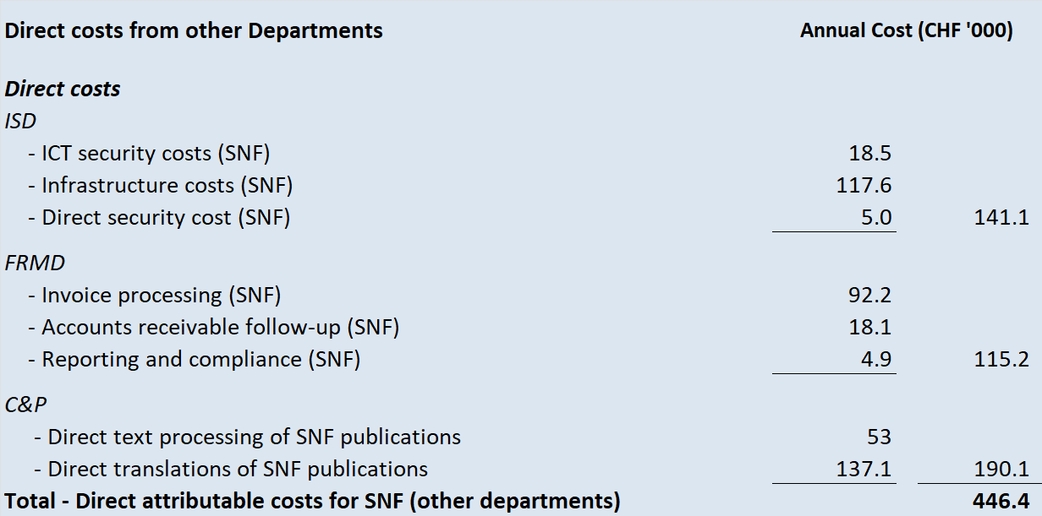

Indirect costs
In addition to direct costs, SNF activities rely on a range of corporate services that support the functioning of the organization as a whole. To ensure that the full cost of delivering SNF services is appropriately captured, relevant portions of these support services are allocated to SNF based on practical and measurable drivers that reflect actual usage for SNF processing.
The allocation bases have been determined through consultations with the relevant service departments and are designed to balance transparency, operational practicality, and data availability.
The principal support service allocations are summarized below:
– Senior leadership
A limited proportion of senior leadership time is included within the SNF cost framework to reflect high level strategic and operational decision making, and necessary membership engagement and oversight responsibilities undertaken by the Secretary-General and Deputy Secretary-General in relation to satellite network filings.
For the purposes of the costing model, this contribution has been conservatively estimated at 2 per cent (CHF 18.1 thousand) of leadership time, reflecting only those activities that are directly attributable to SNF-related matters. The associated costs are apportioned using the same principles applied to other indirect cost pools, ensuring consistency and proportionality within the overall methodology.
– Information Services Department (ISD)
ISD provides IT infrastructure, cybersecurity, enterprise systems, and technical support used by SNF staff. These costs are largely allocated based on SNF headcount relative to total ITU headcount, reflecting the general use of IT infrastructure by staff across the Union.
– Facilities Management
Facilities costs include building occupancy, workspace maintenance, utilities, and other premises-related services used by SNF staff. These costs are allocated based on the office space occupied by SNF staff (measured in square metres) relative to total ITU office space, which provides a practical representation of the consumption of facilities resources.
– Finance and Resource Management Department (FRMD)
In addition to the direct costs from FRMD related to SNF work noted above, there are other indirect costs noted below, namely, asset management and other financial support functions.
– Human Resources Management (HRMD), Legal (JUR) and Oversight (OU)
Human Resources (HRMD), legal and oversight functions supporting SNF activities—such as recruitment, contract administration, payroll processing, staff development, legal review, compliance, audit and governance support—are included within the indirect cost pools. These services are allocated using the same apportionment methodology applied to other corporate support services, namely based on the number of SNF staff relative to total ITU staff.
– Funding of ASHI liability
The apportionment of the ASHI liability is based on headcount of SNF staff to total staff across the Union.

2.4 Preliminary application of the proposed cost allocation methodology
The results of the analyses set out in sections above is summarized in the table below. The overall total costs of SNF are calculated at CHF 15,753,700, of which direct costs amount to CHF 12,735,900 and the total indirect costs are CHF 3,017,800.
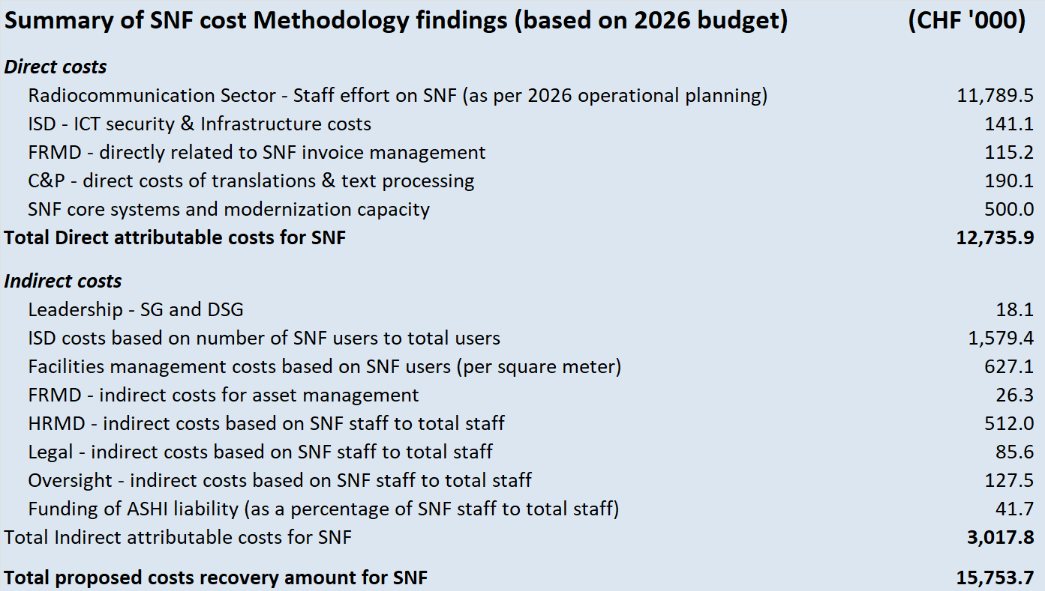
It should be noted that based on the foregoing indirect costs amount to 23.7 per cent of the total costs, consistent with the benchmarks of similar organizations conducted by the secretariat in Document CWG-FHR-22/2.

2.5 Demand forecasting to estimate service volumes for charged services
To support the application of Decision 482, the secretariat will strengthen demand forecasting by analysing historical filing trends, expected growth in constellation filings, and the distribution of activity across Member States. Forecasting should also consider complexity drivers that influence processing effort and the anticipated operational capacity of BR. This will ensure that fee calculations are based on a realistic estimate of the volume and nature of filings for which cost recovery will apply.

2.6 Determination of fees
In line with Decision 482 and the cost-recovery principles in Resolution 91, fees will be determined by applying full cost recovery to the forecasted demand. Costing models such as activity-based costing, the total direct, indirect, and capital costs will be allocated across filing categories according to the expected resource requirements. The fee schedule will incorporate the cost of processing free entitlements and will be presented transparently to allow Members to see how costs and demand translate into proposed fee levels.

2.7 Periodic review and evaluation

Changes in ITU costs
The secretariat proposes that the methodology and fees be reviewed at least every two years, with a four-year review in line with WRC decisions, to allow for changes in ITU costs, such as increased personnel expenses, technology upgrades, or evolving regulatory demands that may directly affect the underlying costs associated with SNF processing. As these costs fluctuate, it is essential to have a robust and transparent fee methodology that can adapt accordingly, ensuring fees remain justifiable to stakeholders. Establishing a clear process for regularly reviewing and updating the methodology will enable the secretariat to maintain consistency, fairness, and accountability in fee-setting. This approach supports alignment with recognized regulatory benchmarks and reinforces the validity of the cost-recovery principles underlying the SNF fee structure.

Revenue fluctuations
Another key challenge for ITU in recent years is that volumes of SNF have fluctuated from year to year, resulting in unpredictable revenue levels that jeopardize ITU’s financial stability. At the CWG-FHR in January 2026, the secretariat introduced a proposal for a true-up/true-down mechanism to address revenue fluctuations. A true-up/true-down mechanism would operate by conducting a review in which the total actual costs incurred in processing SNF filings are compared to the total SNF fee revenue collected for that period. If a surplus or deficit is identified — meaning fee income exceeds or falls short of the actual regulatory expenditure— an analysis would be performed to explain the variance. Given the complexity of such true-up / true-down model this proposal is not being pursed as a way forward to managing shortfalls or surpluses. The above-mentioned methodology and fees review every two should suffice to align revenues, budget and related costs going forward.

3 Implementation timelines
The proposed methodology is intended to take effect from 2028, following the expiry of the temporary fee increase approved at Council 2025. Accordingly, the review and final approval of a revised methodology and new final SNF fees need to be approved by Council 2027.
Annex: 1

ANNEX 1
Secretariat responses to comments at CWG-FHR December 2025 session
Category | Concern | Secretariat response | Proposal
Cost definitions & methodology | Lack of Clear Definitions and Methodology for Cost Recovery.  A major recurring concern was the absence of clear, audited, and transparent formulas for determining the SNF cost recovery model.  Delegates noted that for a decision to be made, a breakdown of cost components, including how costs are identified and allocated annually, would be needed. | Having received feedback from membership, noting that an ABC costing model was broadly acceptable, the secretariat has now applied the principles presented in Document CWG-FHR-22/2, and produced for the Council a detailed working of the actual costs for its consideration. | Details of the way in which the methodology will be applied, including identification of all cost components and how each will be treated, are provided in this Council document.
Cost definitions & methodology | Delegates noted that the allocation of indirect human resource costs was not clearly defined and understood.  Delegates stressed the needed for clear demonstration of the linkage between overhead and SNF delivery before inclusion. | The purpose of human resource management resources, financial resource management resources and other administrative resources, are to handle and support the necessary processes to enable ITU’s staff directly concerned with delivering products required by membership.  Each direct staff resource is hired, paid, has access to resources for matters such as determining and making benefits available and handling other ancillary tasks related to and necessary for their employment.  This administrative work is directly driven by each member of staff or the transactions initiated by work done in the organization.  Indirect costs are determined based on the most appropriate driver which in this case is the total number of SNF staff compared to the total staff of the Union.
Treatment of direct, indirect, and capital costs | Some delegates insisted all direct and indirect costs must be recovered by cost recovery, per Res. 91. | The secretariat considers the provisions of Res. 91 to be clear, and it clearly requires full recovery of both direct and indirect costs. In the absence of a change of the Resolution by a Plenipotentiary Conference, the secretariat cannot apply a model that does not meet this requirement. | The secretariat has proposed a methodology providing for full cost recovery, based on the provisions of Res. 91.
 | Capital expenses (e.g., depreciation of software systems) were particularly contentious. Delegates argued capital costs are not mentioned in Res. 91 and therefore should not be included. | The terms “Capital” and “Operating” expenses are based on accounting principles related to the manner in which the costs are accounted for. Capital expenses relate to the cost of assets that are used over multiple years and are accounted for across multiple years (depending on the useful life of the asset acquired) and impact the balance sheet of the organization, while operating expenses are accounted for immediately when incurred and impact the income statement. Capital costs create a depreciation expense in the income statement.  Direct and Indirect refer to the purpose of the spending. If spending is directly for the purpose of delivering SNF, it is a direct cost, whether it is a capital (long term) or operating (short term) expense. Similarly, if spending can be attributed to SNF indirectly (i.e. through providing support to a direct expense) it is an Indirect cost whether it is Capital or Operational.  Accordingly, Direct and Indirect costs each may include costs that are Capital or Operational.  Taking the example of depreciation of software systems, this is a Capital expense which would be direct if the software is acquired specifically for the purpose of processing SNF only, while the annualized cost of cyber-security software purchased for the whole of ITU might be included as an indirect expense. | Both Operating and Capital expenses will be included as Direct and Indirect costs depending on the purpose for which the cost was incurred, provided the item has sufficient proximity to SNF.
Free filing entitlements | Many delegates insisted that free filing entitlements are a core constitutional issue and must be funded by contributory units, not by cost recovery.  Others argued free filings should be funded through cost recovery as a result of Res. 91.  The delegates discussed concerns of misuse of free entitlements.  Some delegates noted that a small number of large multinational corporations benefit indirectly from free entitlements.  Calls were made to prevent misuse by aligning free filings with principles of equitable access.  Some delegates noted that free filings must support developing countries, especially, LDCs, LLDCs, and SIDS.  Some proposed regional satellite initiatives as eligible for free filings. | The free filing entitlement is an outcome of the principles laid out in Res. 91, to provide equitable access to all member states.  Ordinarily equitable access is provided by making specific provision for those members that are disadvantaged. However, the free filing entitlement allows for free filings by all member states, whether those member states have the means to pay the fees which represent the recovered costs or not. Further, the secretariat has noted that the Free Filings have often been applied to the most complex filings which therefore significantly impacts the extent to which the total costs have been recovered.  The question regarding whether funding of free filings should be from cost recovery. Currently, since the total costs incurred by the secretariat to process SNF has not recovered in the past five years (by more than the cost of free filings) the cost of free filings is entirely funded by the Assessed Contributions of ITU membership.  A combined reading of PP Res. 91 and Council Decision 482 indicates that the SNF service forms part of ITU’s cost-recovery regime and that the Council’s detailed implementation rules must be read consistently with that higher-level framework. Although Decision 482 grants each Member State a limited annual free entitlement for one filing, that entitlement should, in the secretariat’s view, be understood as a feature of the charging model rather than as a basis for excluding the related costs from the overall SNF cost-recovery calculation. On that basis, the secretariat considers that free entitlement costs should be included in the total costs recovered from SNF.  The secretariat had proposed two options:  1 to limit the filing to the first filing for the year, or  2 to apply the free filing to the cheapest filing by any filing administration in each year.  In the first instance, it was noted that this would not necessarily make a difference as multiple filing entities would simply ensure that they planned for the cheapest to be filed first.  For the second option, it was argued that this would eliminate the benefit of the free filing. The secretariat notes that this would only limit the benefit for the larger entities making multiple filings per year, who it can be argued it was not intended to benefit anyway. | The secretariat proposes that Council consider one of the following possible approaches to the free filing regime:  1. Apply the free filing entitlement to the cheapest filing by any filing administration in each year.  2. Limit the free entitlement to LDCs, SIDS, LLDCs and countries with economies in transition.  In each case, the secretariat believes that the correct approach is to include the cost of processing free entitlements in the overall costs of SNF, and recover the full costs from the SNF fees.
 | Scope of free filings:  – Proposal to limit free filings to complete satellite systems and exclude modifications.  – Questions about whether non-GSO filings should be eligible, given recent exclusions. | Limiting free filings to complete satellite systems and exclude modifications could be easily bypassed and ultimately counterproductive: instead of submitting modifications, complete satellite systems including the intended modifications would be submitted, which would bypass the measure but also uselessly increase the workload of the Radiocommunication Bureau.  Non-GSO filings are very diverse, ranging from small amateur academic projects to very complex single scientific satellites or large constellations of communication satellites. The revision of Decision 482 adopted by the 2025 session of the Council excludes from the application of free filings large and complex non-GSO filings. Since this exclusion has only entered into force on 1 January 2026, experience on the efficiency of the measure is still very limited. | The proposal to limit free filings to complete satellite systems and exclude modifications should not be pursued further.  Concerning the eligibility of non-GSO filings, the 2027 session of Council should review the first year of implementation of the decisions by Council 2025 and assess whether additional measures are necessary.
Predictability and stability of fees | Concerns were raised about the proposed “true-up, true-down” mechanism, due to perceived risk transfer to operators.  Some delegates requested:  – Multi-year planning frameworks  – Clear ceilings and floors  – Stable, auditable forecasting.  Delegates linked fee stability to market access predictability for both GSO and non-GSO operators. | These concerns are appreciated, yet the requirements of Res. 91, requiring full cost recovery, necessitate a mechanism for addressing the current fluctuations in the markets. The secretariat notes that this would benefit the industry in years where the recovery increases.  Given the level of complexity of this mechanism and the 2-year review of fees, revenue and budget the secretariat is proposing to drop this proposal. | The secretariat has proposed that the review be every two years, rather than annual, and has also proposed a cap of 10% on increases or decreases resulting from these reviews.
Need for greater transparency and audited data | The secretariat’s proposals should be based on audited operational data from BR | The proposals are based on ITU’s financial statements, including Human Resource data, which is audited, though ITU uses the most up to date information available and therefore they may be pre-audit. Using data from audited statements will result in the use of two-year-old financial data, which would not align with current market information.
 | How will efficiency improvements be measured and reported? | Efficiency improvements will result in less costs to produce greater outputs, therefore this would be reflected in the operational reports produced by the BR and presented annually to RAG.
 | How will the secretariat ensure that cost recovery does not become budget recovery? | Cost recovery is, by nature, partial budget recovery. The intent of cost recovery is that the part of the revenue which pays for SNF costs (which are in ITU’s budget) should not be greater than the expenses which ITU incurs for SNF processing.
 | Delegates requested annual statistics on:  – Use of free entitlements  – Financial implications of filings within large constellations  – Efficiency benchmarks and workflow improvements | Use of free entitlements  The average value of free filings is relatively stable over the last four years and could be used as a basis to assess the impact of the increase of countries applying for free entitlement (which is likely to increase together with the increase of the number of countries who submit filings) on the budget.  Financial implications of filings within large constellations  Before the entry into force of the 2025 version of Decision 482 on 1st January 2026, large constellations were the non-GSO filings with more 75 000 units. As reported to the Expert Group on Decision 482, the number of such satellite systems was low (3 received in 2021, 1 in 2022, 6 in 2023, 2 in 2024), which underestimated the number of filings requiring higher workload. This led the Expert Group to propose a new formula for the computation of units, which the Council adopted in 2025. Since this formula has entered into force on 1st January 2026, more time is necessary to assess whether the new formula appropriately reflects the processing workload.  Efficiency benchmarks and workflow improvements  Satellite network processing key performance indicators are regularly reported to the Radio Regulations Board and annually to the Radiocommunication Advisory Group. Most of these indicators correspond to regulatory requirements set forth in the Radio Regulations, which can only be modified by a competent World Radiocommunication Conference.  Similarly, workflow improvements through increased automation are reported annually to the Radiocommunication Advisory Group. These workflows being the implementation of regulatory procedures contained in the Radio Regulations, their improvement beyond increased automation requires that they are modified by a World Radiocommunication Conference. | The Secretariat will include in its annual report to Council on the implementation of Decision 482 any concern that may arise from the rise of free entitlements as well as from the new formula from computing units.  Concerning workflow improvements beyond increased automation, the Director of the Radiocommunication Bureau will report the identified issues and suggestions to solve them, to the next competent World Radiocommunication Conference or to the Radio Regulations Board.
  Free filings | Amount (CHF) | Number | Average value of free filings (CHF)
  2022 | 1 040 149.00 | 34 | 30 592.62
  2023 | 1 371 521.00 | 45 | 30 478.24
  2024 | 1 209 753.00 | 39 | 31 019.31
  2025 | 1 838 756.00 | 53 | 34 693.51
 | A widespread view was that SNF fees should directly support BR operations, not the General Secretariat. | ITU’s regular budget is collective across the Union, and therefore all regular budget funds collected by ITU support all of ITU. The Union’s regular budget (2025), the BR’s annual direct costs amount to CHF 30.145 million. Only CHF 8.7 million of that sum is recovered from SNF fees, while a further CHF 6.6 million is collected from ITU-R Sector members. Therefore, each year the Union’s Member States’ assessed contributions provide CHF 14.845 million of funding for BR direct costs.  SNF and the BR’s other work also generate expenses in the General Secretariat (ISD services, facilities management, Conference and publications services, HR, budget and finance related services, etc) which are allocated to cover a range of administrative and overhead costs of the BR. These are incurred by the General Secretariat, but are attributable to the work of the BR.
______________

