Document CWG-LANG-16/3
10 January 2025
English only
Report by the Secretary-General
REPORT ON THE IMPLEMENTATION OF THE GUIDE TO CURRENT AND FUTURE PRACTICES IN MULTILINGUALISM
Purpose
The guide to the current and future practices in the implementation of multilingualism in ITU was endorsed by the Council in its June 2024 meeting. This report is the first update to the Council Working Group on languages (CWG-LANG) on the implementation of the Guide, given that the use of new technologies in the provision of language services continues to evolve rapidly.
Action required
The Council Working Group on the use of the six languages of the Union is invited to review and endorse this report.
_______________
References
Guide to current and future practices in the implementation of multilingualism in ITU; Policy Framework on Multilingualism in ITU; ITU Multilingualism webpage; Document C22/INF/7

1 Background
The Guide to multilingualism adopted by the ITU Council in its 2024 session provides a full overview of the governance, current practice and future strategies for implementing multilingualism throughout ITU.
This document provides an update on the ongoing implementation of the strategies outlined in the Guide, including data on the use of ITU Translate for webpages and documents.
A revised version of the Guide and its implementation may be provided to future meetings of the Council Working Group on languages (CWG-LANG) in line with Resolution 1372 of the Council (modified 2024), which requires CWG-LANG to develop recommendations for the efficient and effective use of the six official languages of on an equal footing and analyse the adoption by ITU of alternative translation procedures.

2 Translation strategies
Central to ITU’s commitment to increasing access to information and content in all six official languages in a cost-effective and timely manner is the integration of human and machine intelligence. ITU’s language professionals continue to translate a wide range of documents, webpages and publications as outlined in Document C22/INF/7 on Measures and Principles on Interpretation and Translation (M&P). This work is supplemented and complemented by the use of ITU Translate machine translation on webpages and for documents.
2.1 Usage of ITU Translate on webpages
ITU Translate has been used on 2 045 unique webpages and triggered 859 427 times from November 2023 to November 2024.
Total translation requests for machine translation of a webpage using ITU Translate per target language (November 2023 – November 2024)
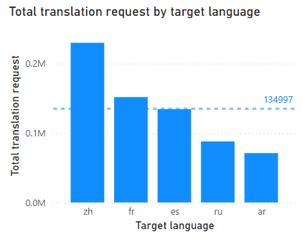

Top ten URLs translated by ITU Translate (November 2023 – November 2024)
1 https://www.itu.int/en/Pages/default.aspx
2 https://www.itu.int/en/about/Pages/default.aspx
3 https://www.itu.int/hub/pubs/
4 https://www.itu.int/hub/news/
5 https://www.itu.int/hub/membership/
6 https://www.itu.int/hub/membership/become-a-member/
7 https://council.itu.int/2024/en/
8 https://www.itu.int/wtisd/
9 https://www.itu.int/en/council/planning/Pages/default.aspx
10 https://www.itu.int/wtsa/2024/

2.2 Usage of ITU Translate on documents
Number of documents translated by ITU Translate per month
(November 2023 – November 2024)
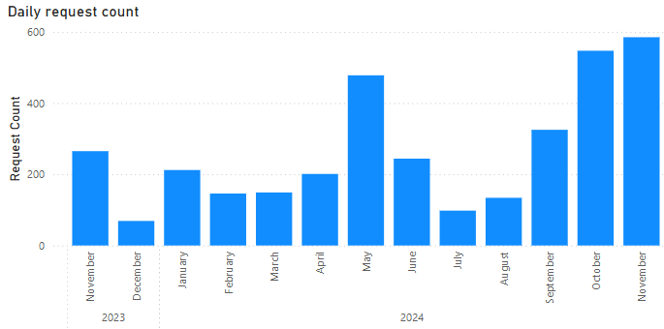
Documents translated by ITU Translate by language per month
(November 2023 – November 2024)
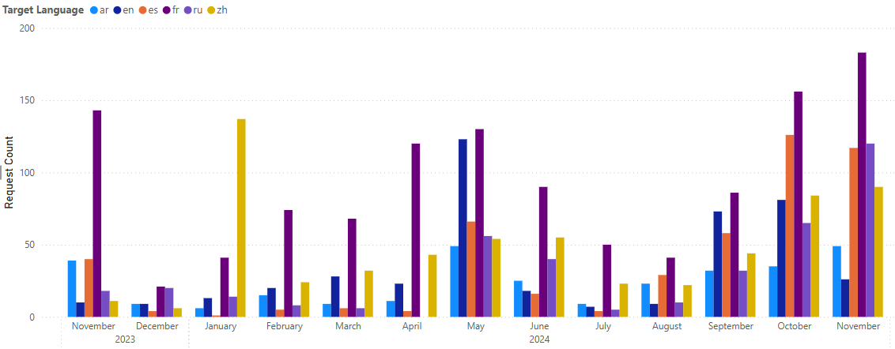
Machine translation of documents is provided on several different platforms: the Document Management System (DMS), either at the foot of each page or directly at the level of the document as of June 2024; ITU’s MyWorkSpace; and the professional translator platform, which may also be used internally by other ITU staff.
Document translation at the level of the DMS is provided as an interim measure for documents which have not yet been provided by the professional translation service and for documents which are not otherwise provided in translation (such as ITU Council information documents).

2.3 Improvements to ITU Translate
2.3.1 The ITU Translate machine translation has been migrated to the cloud to improve scalability, performance and security; the new commercial engine has been further trained on ITU material. A major ITU Translate update for webpage translation, document translation and post-editing is planned for 2025.
2.3.2 Following feedback from ITU sectors, a new ITU Translate workflow is being established, including post-editing, quality control and the use of the matrix to decide whether professional or machine translation is most appropriate.
2.3.3 The cost of using ITU Translate is closely monitored and provides a reliable index of usage trends on webpages and documents combined. The standard cost as charged by the service provider is USD 40 per million characters.

2.3.4 The tool continues to be improved through the ongoing provision of feedback from all users. Concrete feedback can be provided via the Disclaimer & Feedback button on each webpage with ITU Translate. The post-editing tool enables individual pages to be corrected in any language. Both sources are used in the continuous training of the machine translation engine.

3 Update to Measures and Principles
The Measures and Principles for Interpretation and Translation in ITU (M&P) is regularly reviewed. Updates are proposed by the General Secretariat and the Sectors and approved by sectoral advisory bodies, before submission to CWG-LANG and Council for endorsement.
Given the rapid evolution in the use of new technologies, a further update to the M&P is proposed. This will focus on webpages and documents and will:
• Ensure certain webpages/documents continue to be professionally translated to guarantee quality
• Enable the translation of additional webpages within budgetary limitations through the widespread adoption of machine translation with post-editing
• Enable the interim machine translation of documents/translation of any documents not otherwise available in official translations.

4 Additional areas
4.1 The Human Resources Management Department has implemented the UN Framework on languages through the provision of language training courses through UNOG, which is fully aligned with the UN Framework.
4.2 ITU is working to increase the number of publications available in HTML format and integrated with ITU Translate. This will enable greater access to publications, including improved visibility and searchability, as well as user-launched translations of publications into all official ITU languages.
4.3 The Regional Offices continue to make ITU content available in non-official languages including working with ICANN on universal acceptance to promote the use of non-alphabetic scripts such as Thai, Khmer, Tamil, and Nepali for Internet access, search and content. In addition, the ITU Child Online Protection guidelines are available in 25 non-official languages: Albanian, Amazigh, Amharic, Armenian, Aymara, Bosnian, Bulgarian, Croatian, Dutch, Hungarian, Indonesian Bahasa, Kyrgyz, Lithuanian, Maltese, Mongolian (including sign language), Nigerian, Quechua, Portuguese (Brazil), Romanian, Serbian, Swahili, Thai, Turkish, Ukrainian and Uzbek.
________________

