|  |  |
| --- | --- |
|  | **Document EG-DEC482-4/3** |
| **28 March 2025** |
| **English only** |
|  |  |
| Contribution from Global Satellite Operators Association (GSOA) | |
| CONSIDERATION OF POSSIBLE REVISIONS TO DECISION 482 | |
| **Purpose**  This document discusses the elements of proposals regarding Decision 482 related to cost recovery of satellite fillings.  **Action required**  The Expert Group on Decision 482 is invited to **consider** this document.  _______________  **References**  [*Decision 482*](https://www.itu.int/md/S24-CL-C-0135/en)*; Document* [*CWG-FHR-20/29*](https://www.itu.int/md/S25-CWGFHR20-C-0029/en) | |

**c)** **Whether specific fees should be paid for processing submissions related to earth stations in motion, while avoiding double invoicing**

In the Document [CWG-FHR-20/29](https://www.itu.int/md/S25-CWGFHR20-C-0029/en) submitted by the Secretary-General to the CWG-FHR as analysis of the outcome of the third meeting of the Expert Group on Decision 482, it was mentioned that no change can be proposed at this stage in reply to item c. GSOA agrees with this outcome and support NOC on this item.

**d)** **The cost of processing resubmissions of notification requests.**

In the same document CWG-FHR-20/29, while there are clear indications of the status on all other items, item d) was not referenced, and it is unclear the status of it. As per our understanding of the third meeting, the meeting agreed that the subsequent resubmissions under No. 11.46 to notices under categories N1 to N3 are subject to an additional fee equal to 80% of the flat fee of the initial submission when these require new technical examination. GSOA support this agreement.

**f) The costs of processing non-GSO filings having more than 75 000 units or, alternatively, whether the formula to compute units for such non-GSO satellite systems should take into account the impact of the number of different orbital altitudes, number of satellites, number of earth stations, or other characteristics affecting workload associated with the processing of non-GSO systems**

GSOA and the rest of the members of the Expert Group acknowledged that the size of a constellation, as depicted by the number of units, should reflect the amount of workload associated to a filing. Furthermore, the members of the Expert Group expressed concerns with large NGSO constellations, and their added complexity, as potentially not being accurately accounted for in the current computation of units.

In the Document [EG-DEC482-3/3](https://www.itu.int/md/S25-EG3DEC482-C-0003/en), submitted as an input to the last Expert Group meeting, the BR suggested that the number of units would be based on the following equation:

*Sum of (emissions * class of stations * forms of coord.) per assignment * number of shells*

Where a shell was defined by the BR as an orbit, or set of orbital planes, that differ/s in orbit perigee, apogee or inclination amongst the rest of orbital planes.

During the same Expert Group meeting, GSOA, as well as several other participants, highlighted that using the formula (above) suggested by the BR would introduce the concept of “forms of coordination” at the unit computation, while the same concept would already be used to determine the category and subsequent “flat fee” of a filing. During the meeting, GSOA also highlighted difficulties with the definition of a shells/ “set of orbital planes” due to potentially not capturing the tolerances agreed as an outcome to WRC-23 (Resolution 8) and the inconsistency in the Radio Regulations this could yield. Additionally, members of the Expert Group meeting expressed concerns with the definition of “sets of orbital planes” as provided by the BR and the lack of evidence proving the ties to an increased workload.

For the above reasons, GSOA proposes the following equation, where a shell is defined as an orbit, or set of orbit planes, that has a different orbit perigee, apogee or inclination within the tolerances outlined in Resolves 11 in Resolution 8:

*Sum of (emissions * class of stations) per assignment * number of shells*

In parallel, GSOA has difficulties with the resulting cost recovery fee for satellite filings with number of units over 75,000 given the new formulas. Specifically given the increase in the maximum (ceiling) number of units, and the price per unit not changing. Table 1 below computes the maximum cost recovery fee for categories C1, C2, C3, N1, N2, and N3, that result from 1) the formulas from the current Decision 482, 2) the Bureau’s proposal from February 2025, and 3) an alternative solution. This alternative, which [limits the maximum number of units to 300,000 and control the unit price for satellite filings with more than 25,000 units], results in an increase of no more than [93%] when compared to the current fees. In comparison, the Bureau’s proposal results in an increase of 425-530% for large satellite filings, compared to the current fees.

Table 1: Comparison of maximum cost recovery fee payment of large satellite filings

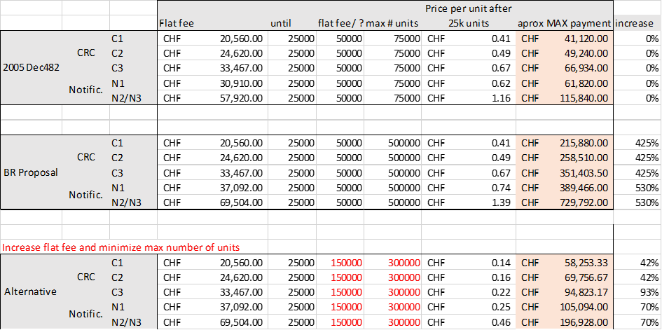

Given the data above, GSOA cannot agree to a proposal that increases the cost recovery fee of satellite filings by ~400%, and therefore suggests the below alternative for the cost recovery formula:

*[CR fee=new flat fee+(total units-25,000)*(flat fee)/(150,000) with a max of 300,000 units]*

Additionally, GSOA notes that the proposed modifications to Decision 482 included in item f) are mainly related to more complex non-GSO constellations, especially those with more than 75 000 units, that could significantly increase the time spent to finish the examination, the human resources and the complexity of the software used by the Bureau. However, due to the proposed change in the computation of the units, some other not so complex non-GSO constellations, namely those with less than 25 000 units with the application of the current Decision 482, would experience a significant increase in the number of units and therefore a significant increase in its associated Cost Recovery, apart from the new proposed fees related to EPFD examination. In order to alleviate the impact to these not so complex non-GSO constellations in terms of Cost Recovery, GSOA proposes to increase the lower ceiling in footnote e) of Decision 482 from 25 000 to 50 000 units.

______________