|  |  |
| --- | --- |
|  | **Document EG-DEC482-4/2** |
| **28 March 2025** |
| **English only** |
|  |  |
| Contribution from China (People's Republic of) | |
| Proposals for the fourth meeting of Expert Group on Decision 482 | |
| **Purpose**  This contribution provides preliminary views and comments regarding possible amendments to the Annex to Council Decision 482, as included in Revision 2 to Document [EG-DEC482-2/DT/3](https://www.itu.int/md/S25-EG3DEC482-250210-TD-0003/en).  **Action required**  The Expert Group on Decision 482 is invited to **consider** this contribution and **reflect it in the draft final report** containing recommendations for the possible revision of Decision 482 for submission to the 2025 session of the ITU Council.  _______________  **References**  *Annex to* [*Decision 632*](https://www.itu.int/md/S23-CL-C-0126/en) *(C23)* | |

# 1 Introduction

The Council 2023 agreed to adopt [Decision 632](https://www.itu.int/md/S23-CL-C-0126/en) in order to establish an expert group on Decision 482 with the terms of reference included in the Annex to this Decision.

During the third meeting of the Expert Group on Decision 482, Revision 2 to Document [EG‑DEC482-2/DT/3](https://www.itu.int/md/S25-EG3DEC482-250210-TD-0003/en) was developed to reflect the discussion results of the possible revision of Decision 482. However, due to time constraints, some study items need further analysis or discussion. This contribution provides preliminary views and comments on some specific study items regarding possible amendments to the Annex to Council Decision 482.

# 2 Discussion

Based on the further study of Revision 2 to Document [EG-DEC482-2/DT/3](https://www.itu.int/md/S25-EG3DEC482-250210-TD-0003/en) and the data on processing satellite network filings provided by BR, China would like to provide views and comments on study item f. and g. as follows:

(…)

**f. The costs of processing non-GSO filings having more than 75 000 units or, alternatively, whether the formula to compute units for such non-GSO satellite systems should take into account the impact of the number of different orbital altitudes, number of satellites, number of earth stations, or other characteristics affecting workload associated with the processing of non-GSO systems.**

Under this specific item, two co-related issues need to be studied:

– Ceiling in the fee structure (75 000 units)

– Methodology for calculating units for non-GSO satellite systems.

BR provided the following proposal to address this study item:

– Raise the threshold number of units at which the fee ceiling starts from 75 000 to 500 000.

– Insert in the computation of units the number of different sets of orbital planes and the number of forms of coordination per frequency range for categories C and N.

During the third meeting of the Expert Group on Decision 482, BR also provided some specific examples of how the new units would be calculated.

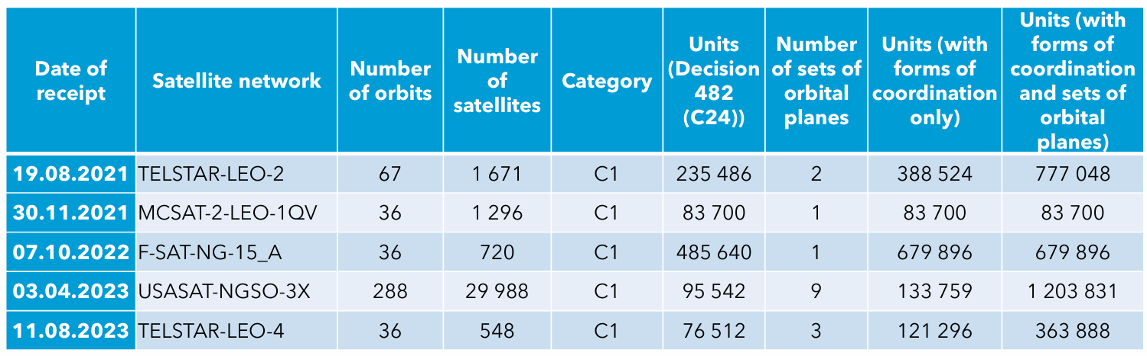

China is in favour of putting more focus on this very important item related to complex and large non-GSO satellite systems since it requires a substantial amount of resources from BR to process them.

Noting the complexity of this item and the profound impact of introducing the new methodology for calculating units for non-GSO satellite systems, further study is needed in order to obtain greater clarity before considering the update. China sincerely hopes that a decision could be reached on this item f. at the upcoming meeting in April. However, if it fails to do that, a request could be sent to the 2025 session of the ITU Council to postpone the study of this item until 2026.

**g. Consider the introduction of units in categories A1 and N4, with a different fee being charged for more complex or larger systems, depending on the number of units.**

It is noted that filings for satellite systems not subject to coordination have evolved considerably; those filings have not only grown in number but also contain a large set of frequency assignments covering a lot of possible frequency bands allocated to space services. After carefully studying the data on processing satellite network filings provided by BR, China would like to reiterate the following views:

– China supports to consider the introduction of units in categories A1 and N4, with a different fee being charged for more complex or larger systems, depending on the number of units. For submissions falling in the A1 category, units could be defined as the product of the number of frequency ranges, the number of classes of stations, and the number of emissions summed up for all frequency groups. For submissions falling in the N4 category, units could be defined as the product of the number of frequency assignments, the number of classes of stations, and the number of emissions summed up for all frequency groups.

– When considering the introduction of units in categories A1 and N4, proposals for start fee and flat fee should avoid significant changes for the current fee of the small non-GSO satellite system.

– For categories A1 and N4, the start fee and flat fee proposed by BR could be accepted.

Noting that there is no big difficulty in reaching an agreement on this study item during the third meeting of the Expert Group on Decision 482 but more time is needed, China proposes to have further discussion on this item during the fourth meeting and reflect the result in the possible amendments to the Annex to Council Decision 482.

(…)

# 3 Conclusion

Regarding revisions to Decision 482 to ensure that costs associated with the processing of satellite network filings are appropriately recovered, China proposes that the Expert Group could consider the above comments.

______________