|  |  |
| --- | --- |
|  | **Document CWG-WSIS&SDG-43/16** |
| **8 August 2025** |
| **English only** |
|  |  |
| Contribution by the secretariat | |
| ITU’s CALL FOR INPUTS ON WSIS+20 REVIEW – UPDATE | |
| **Purpose**  This document provides an update on the ITU’s call for inputs on WSIS+20 Review.  **Action required**  The Council Working Group on WSIS and the SDGs is invited to **note** this document.  _______________  **References**  [*CWG-WSIS&SDG website*](https://www.itu.int/en/council/cwg-wsis/Pages/default.aspx)*;* [*WSIS Forum website*](http://www.wsis.org/forum)*;* [*WSIS review*](http://www.wsis.org/review)*; UNGA Resolutions* [*A/RES/70/125*](https://docs.un.org/en/A/RES/70/125)*,* [*A/RES/70/1*](https://docs.un.org/en/A/RES/70/1)*,* [*A/RES/77/150*](https://docs.un.org/en/A/RES/77/150)*; UN ECOSOC Resolution* [*E/RES/2024/13*](https://docs.un.org/en/E/RES/2024/13) *and Report* [*E/2025/31–E/CN.16/2025/4*](https://unctad.org/system/files/official-document/ecn162025d4_en.pdf)*; PP Resolutions* [*172 (Guadalajara, 2010)*](https://www.itu.int/en/council/cwg-wsis/Documents/Resolution172-PP10.pdf)*,* [*140 (Rev. Bucharest, 2022)*](https://www.itu.int/en/council/Documents/basic-texts-2023/RES-140-E.pdf) *and* [*71 (Rev. Bucharest 2022)*](https://www.itu.int/en/council/Documents/basic-texts-2023/RES-071-E.pdf)*; Council Resolutions* [*1332 (Modified 2024)*](https://www.itu.int/md/S24-CL-C-0141/en) *and* [*1334 (Modified 2023)*](https://www.itu.int/md/S23-CL-C-0120/en)*; WTDC Resolution* [*30 (Rev. Kigali, 2022)*](https://www.itu.int/dms_pub/itu-d/opb/tdc/D-TDC-WTDC-2022-PDF-E.pdf)*; WTSA Resolution* [*75 (Rev. Geneva, 2022)*](https://www.itu.int/pub/T-RES-T.75-2022)*; RA Resolution* [*ITU-R 61-3 (Rev. Dubai, 2023)*](https://www.itu.int/pub/R-RES-R.61-3-2023)*;* [*Reports of the CWG-WSIS&SDG meetings*](https://www.itu.int/en/council/cwg-wsis/Pages/Previous-meetings.aspx)*;* [*Report on the outcomes of the CWG-WSIS&SDG meetings held since PP-18*](https://www.itu.int/md/S22-CWGWSIS38-C-0020/en)*;* [*Report on the outcomes of the CWG-WSIS&SDG meetings held since Council-21*](https://www.itu.int/md/S22-CWGWSIS38-C-0019/en)*;* [*Roadmap for ITU’s activities to help achieve the 2030 Agenda for Sustainable Development*](https://www.itu.int/md/S25-CWGWSIS42-INF-0006/en)*;* [*ITU Secretary-General’s roadmap: World Summit on the Information Society (WSIS)+20: WSIS beyond 2025 – WSIS+20 Roadmap*](https://www.itu.int/md/S22-CL-C-0059/en)*;* [*WSIS Stocktaking Success Stories 2025*](https://www.itu.int/net4/wsis/stocktaking/Home/Reporting)*.* | |

ITU Council Resolution 1332 invited members and stakeholders to contribute to ITU’s work in the 20th year review of the World Summit on the Information Society (WSIS+20) to gather insight into the achievements and challenges of the WSIS process. Out of 97 submissions received, some of which included input from various entities, including governments within regional groups, 62 were published upon consent: [CWG-WSIS&SDG call for inputs on the WSIS+20 Review Responses](https://www.itu.int/en/itu-wsis/Pages/CWG-WSIS%26SDG_Call_for_Inputs_2025.aspx).

The summary of the ITU’s call for inputs on the WSIS+20 Review was presented to the 2025 Session of the ITU Council. The Council noted the report contained in Document [C25/53](https://www.itu.int/md/S25-CL-C-0053/en) and agreed to submit it to the UNGA, with a compilation of all individual submissions received annexed to the report.

Since Council 2025, South Africa and the ITU have organized sessions with multistakeholder participation on the ITU’s call for inputs on the WSIS+20 Review, held at the Internet Governance Forum 2025 and the WSIS+20 High-Level Event 2025, as well as a briefing in New York during the UN High-Level Political Forum (HLPF) period.

WSIS+20 High-Level Event 2025

[**ITU's Call for Input on WSIS+20: Thursday, 10 July 2025**](https://www.itu.int/net4/wsis/forum/2025/Agenda/Session/471)

Moderated by Ms Cynthia Lesufi, Minister Council and African Coordinator for the ITU Council Working Group on WSIS&SDG (South Africa), the session featured speakers who shared insights on the ITU’s call for inputs on WSIS+20. Speakers included Mr William Lee, Assistant Director Department of Infrastructure, Transport, Regional Development and Communications, Australia, Ms Renata Figueiredo Santoyo, Regulation Expert in International Affairs at Anatel, Brazil, and Ms Gitanjali Sah, Strategy and Policy Coordinator, ITU, each of whom contributed valuable perspectives to the discussion.

The discussion centred on the ITU’s role in the implementation of WSIS Process, highlighting progress since 2003 in areas such as connectivity, infrastructure, cybersecurity, and capacity building. Participants emphasized the importance of multistakeholder engagement, transparency, and using the WSIS architecture to avoidi duplication of efforts in the implementation of the Global Digital Compact (GDC). Participants also underscored the importance of government participation in the WSIS Forum and WSIS related activities, the need for sustainable funding mechanisms, and a push for more results-oriented action on the ground. Suggestions included encouraging volunteerism, greater private sector involvement, and the submission of comprehensive, multistakeholder national reports to inform the final outcomes for the upcoming UN General Assembly review in December 2025.

Internet Governance Forum 2025

[**ITU Call for Inputs on the WSIS+20 Review: 26 June 2025**](https://www.itu.int/net4/wsis/forum/2025/Agenda/Session/504)

The session, co-organized by ITU and South Africa, and chaired by Ms Cynthia Lesufi, Minister Council and African Coordinator for the ITU Council Working Group on WSIS&SDG (South Africa), focused on the WSIS+20 review, inviting stakeholders to reflect on ITU’s contributions and share perspectives on the future of the WSIS process beyond 2025. Ms Gitanjali Sah (ITU), Ms Mina Seonmin Jun (South Korea), Ms Renata Figueiredo Santoyo (Brazil), Dr Swantje Jäger-Lindemann (Germany), Mr William Lee (Australia), and Mr Yoichi Iida (Japan) contributed to the session as speakers. The session also benefited from the presence of the WSIS+20 co-facilitators.

Key discussions addressed progress made since the Geneva Plan of Action, ongoing challenges and efforts in cybersecurity and capacity building, and the alignment of WSIS with the SDGs, as well as the integration of the Global Digital Compact with the WSIS Architecture.

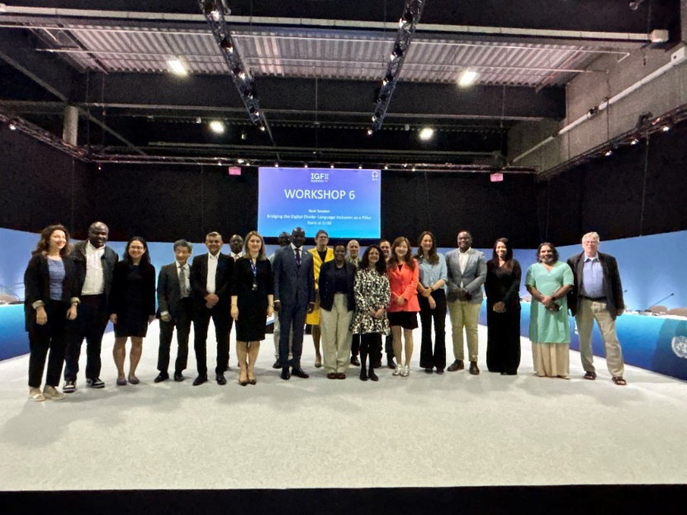Speakers highlighted the importance of multistakeholder collaboration, the value of the WSIS Stocktaking Database, and the role of national reports in capturing achievements and gaps. Contributions emphasized the need for continued inclusiveness, transparency, and funding—particularly through private sector engagement and volunteerism. The session highlighted the importance of IGF and WSIS Forum as multistakeholder platforms. The session reaffirmed ITU’s leadership in digital cooperation and encouraged ongoing participation in the review process leading up to the UN General Assembly in December 2025.

______________