|  |  |
| --- | --- |
|  | **Document CWG-WSIS&SDG-42/12** |
| **10 January 2025** |
| **English only** |
|  |  |
| Report by the Secretary-General | |
| PREPARATION OF THE OVERALL REVIEW ON THE IMPLEMENTATION OF THE WSIS OUTCOMES: WSIS+20 REVIEW – WSIS BEYOND 2025 | |
| **Purpose**  This document highlights the preparation towards the WSIS+20 review in 2025.  **Action required**  The Council Working Group on WSIS and the SDGs is invited to **note** the document.  _______________  **References**  [*CWG-WSIS&SDG website*](https://www.itu.int/en/council/cwg-wsis/Pages/default.aspx)*;* [*WSIS+20 review website*](https://www.itu.int/net/wsis/review/2024.html)*; UNGA Resolutions* [*A/RES/70/125*](https://undocs.org/Home/Mobile?FinalSymbol=A%2FRES%2F70%2F125&Language=E&DeviceType=Desktop&LangRequested=False)*,* [*A/RES/70/1*](https://undocs.org/Home/Mobile?FinalSymbol=A%2FRES%2F70%2F1&Language=E&DeviceType=Desktop&LangRequested=False)*,* [*A/RES/77/150*](https://documents-dds-ny.un.org/doc/UNDOC/GEN/N22/755/00/pdf/N2275500.pdf?OpenElement)*; UN ECOSOC* [*Resolution E/RES/2022/15*](https://unctad.org/system/files/official-document/ecosoc_res_2022d15_en.pdf)*;* [*PP Resolution 172 (Rev. Guadalajara, 2010)*](https://www.itu.int/en/council/cwg-wsis/Documents/Resolution172-PP10.pdf)*;* [*PP Resolution 140 (Bucharest, 2022)*](https://www.itu.int/en/council/Documents/basic-texts-2023/RES-140-E.pdf)*;* [*Council Resolution 1332 (Modified 2024)*](https://www.itu.int/md/S24-CL-C-0141/en)*;* [*Council Resolution 1334 (Modified 2023)*](https://www.itu.int/md/S23-CL-C-0120/en)*;* [*World Summit on the Information Society (WSIS)+20: WSIS beyond 2025 - WSIS+20 Roadmap*](https://www.itu.int/md/S22-PP-C-0047/en)*,* [*Report by the Director General on implementation of the World Summit on the Information Society (WSIS)*](https://unesdoc.unesco.org/ark:/48223/pf0000379370)*;* [*CSTD Roadmap for the WSIS+20 Review United Nations Conference on Trade and Development*](https://unctad.org/system/files/non-official-document/ecn162023_roadmap_p05_CSTDChair_en.pdf) | |

The World Summit on the Information Society (WSIS) is a UN process serving as a multistakeholder coordination mechanism on digital and emerging technologies. The WSIS process remains as crucial as ever to keep digitalization on a positive path and overcome mounting global development challenges.

[Resolution 70/125](https://undocs.org/Home/Mobile?FinalSymbol=A%2FRES%2F70%2F125&Language=E&DeviceType=Desktop&LangRequested=False) requests the General Assembly to hold a high-level meeting on the overall review of the implementation of the outcomes of the World Summit on the Information Society in 2025 (referred to as “WSIS+20”), involving the input and participation of all stakeholders, including in the preparatory process, to take stock of progress on the outcomes of the World Summit and identify both areas of continued focus and challenges. It also recommends that the outcome of the high-level meeting be considered as an input into the review process for the 2030 Agenda for Sustainable Development, including outcomes of the SDG Summit in 2023 and inputs to the next SDG Summit in 2027. The WSIS+20 will provide an opportunity to reflect and discuss the evolution of the WSIS implementation process.

**WSIS+20 roadmaps**

• [*World Summit on the Information Society (WSIS)+20: WSIS Beyond 2025: WSIS+20 Roadmap*](https://www.itu.int/net4/wsis/ungis/content/upload/doc/roadmaps/ITU-WSIS20-Roadmap.pdf); elaborates the ITU Secretary-General’s roadmap on the role of ITU in the WSIS+20 Review process and its preparations. It outlines ITU’s leadership in engaging stakeholders, assessing progress, and aligning WSIS Action Lines with the 2030 Agenda for Sustainable Development. The roadmap emphasizes comprehensive preparations, including detailing activities, events, and reporting mechanisms, all aimed at informing the UN General Assembly Overall Review in 2025. Through collaborative efforts, it identifies priorities for advancing digital development beyond 2025 while fostering global partnerships and dialogue.

• [*Report by the Director General on implementation of the World Summit on the Information Society (WSIS)*](https://unesdoc.unesco.org/ark:/48223/pf0000379370) *outcomes*, elaborates UNESCO’s roadmap towards the WSIS+20 review.

• [CSTD Roadmap for the WSIS+20 Review United Nations Conference on Trade and Development](https://unctad.org/system/files/non-official-document/ecn162023_roadmap_p05_CSTDChair_en.pdf).

At the WSIS+20 Forum High-Level Event 2024, several multistakeholder dialogues and discussions were held to discuss on the preliminary steps towards the WSIS+20 review process. The sessions were included as part of the [*Digital Governance Processes: WSIS, GDC/ Summit of the Future Special Track*](https://www.itu.int/net4/wsis/forum/2024/Agenda/SpecialTrack/29#agenda)*.* These sessions concluded with key takeaways emphasizing the need to avoid duplication of efforts while acknowledging existing mechanisms and recognizing the substantial work that lies ahead. Stakeholders reaffirmed the value of the multistakeholder framework and highlighted the key elements of the WSIS process, such as the WSIS Forum, the Internet Governance Forum (IGF), the United Nations Group on the Information Society (UNGIS), the WSIS Stocktaking platform, etc.

The WSIS Forum 2025 will be branded as the WSIS+20 High-Level Event 2025 celebrating the achievements of the WSIS Process and identifying the opportunities and challenges in implementing the WSIS Action Lines. The event is scheduled to be held from 7 to 11 July 2025 in Geneva, Switzerland.

WSIS+20 Joint preparatory process

Towards the WSIS+20 review, efforts have been made to establish a unified WSIS+20 review process involving all UN agencies, including ITU, UNESCO, UNDP, UNCTAD, UN DESA, and UN CSTD. Regular meetings are organised to facilitate collaborative discussions and planning, reflecting our joint and dedicated approach towards the WSIS+20 review. Kindly refer to the timeline of the joint preparatory process below.

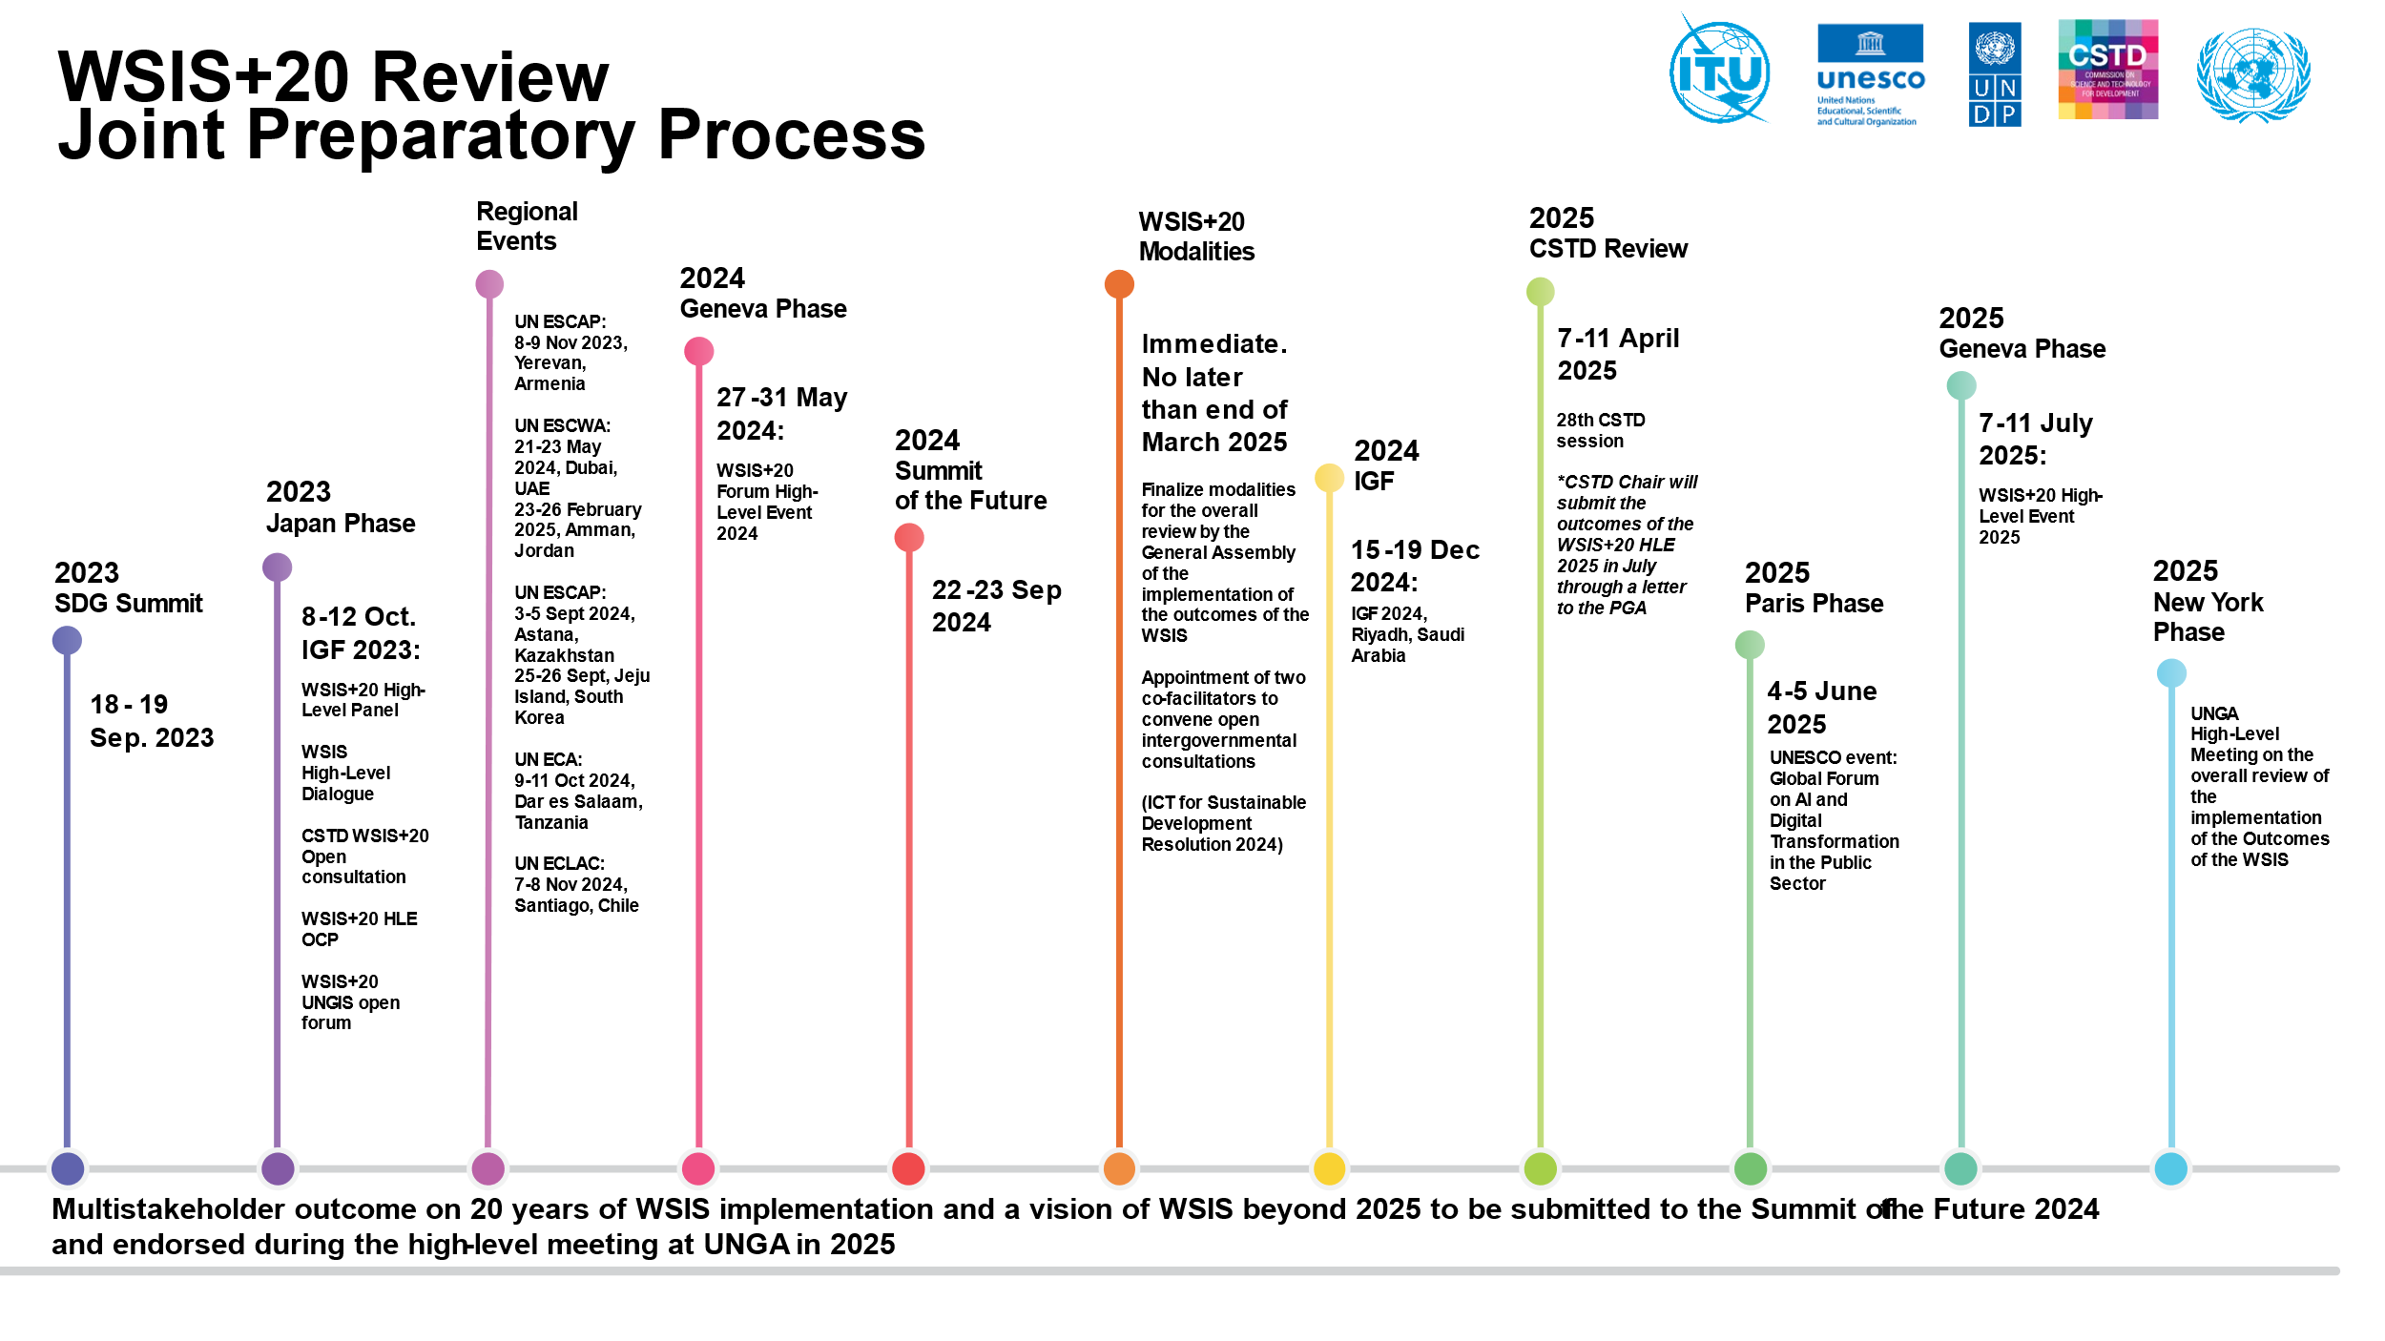

WSIS+20 Action Lines milestones, challenges and emerging trends beyond 2025

The WSIS Action Lines serve as a key framework for advancing progress towards the achievement of SDGs. The WSIS Action Lines cover eleven areas of focus with technology serving as a key enabler for sustainable development. The WSIS-SDG Matrix, developed by the UN Action Line Facilitators, clearly shows the linkage between each Action Line and the 17 SDGs and provides rationale for each.

The ITU, together with other WSIS Action Line facilitators from UN agencies, has prepared presentations highlighting key milestones, challenges, and emerging trends beyond 2025. The presentations are available [here](https://www.itu.int/net4/wsis/forum/2024/Home/About#actionLines).

ITU’s call for inputs on the WSIS+20 Review

In accordance with ITU Council Resolution 1332, ITU has launched a [call for inputs on WSIS+20 review](https://forms.office.com/pages/responsepage.aspx?id=12TkI-YEh0uRPCS9iSGf06qtDlMBPuBNoa2AwRocnE1UOUYxTDI4N0FPVzZYRzJZV1VQSDJTVjEyMS4u&route=shorturl). Members and other stakeholders are invited by the Chair of the CWG-WSIS&SDG to contribute their views on the work of the ITU in the WSIS+20 review, including ideas related to the review of the WSIS Action Lines.

To date, we have received 39 responses, and the deadline for input is 31 January 2025. South Africa, as the current Chair of the CWG-WSIS&SDG, together with ITU, organized a special session during the Internet Governance Forum 2024 in Riyadh, Saudi Arabia, on the 20 years of WSIS implementation and the vision beyond 2025, while also highlighting this ongoing call for further submissions from stakeholders.

Alignment with other UN digital governance processes

On 22 September 2024, Member States adopted the Pact for the Future, which includes the Global Digital Compact (GDC). In paragraph 71, the GDC requests the Secretary-General to provide a Compact implementation map for consideration by Governments and other stakeholders. This map would reflect the contributions of the United Nations system and other relevant stakeholders, and will be included in the Secretary-General's report on the progress made in implementing and following up on the outcomes of the World Summit on the Information Society, at both regional and international levels, ahead of the WSIS+20 review. The GDC and the WSIS+20 review are closely aligned in their shared objective of advancing global digital cooperation and addressing the evolving challenges of the digital age.

______________