Document CWG-SFP-3/6
8 August 2025
English only
Report by the Secretary-General
LINKING ITU STRATEGIC, FINANCIAL AND OPERATIONAL PLANS
Purpose
This document outlines the approach taken by the secretariat to link ITU's strategic, financial and operational plans. The approach relies on the principles of results-based management to ensure that the strategic objectives established in the ITU Strategic and Financial Plan are properly translated into the organization’s biennial and annual operational plans and budgets, thereby ensuring that resources are applied toward impactful efforts. This document provides an outline of how a robust results chain will enable more clear integration between strategic, financial, and operational plans.
Action required
The Council Working Group for strategic and financial plans 2028-2031 is invited to note and endorse this approach.
_______________
References
CWG-SFP website; Resolution 1428 (C24)

1 Linking of ITU’s Strategic, Financial and Operational Plans
In the implementation of the next ITU Strategic and Financial Plans 2028-2031, ITU will focus on strengthening its Results-Based Management (RBM) framework to ensure effective integration of Strategic, Financial and Operational plans. Specifically, this enhancement will apply a data-driven approach to more clearly distinguish between expected results (Impact and Outcome performance indicators at the level of the Strategic Plan) and the routine work plans (Outputs, Activities and their costs) at the level of the Operational Plans.
Performance indicators included in this results chain should be SMART:
– Specific – clearly defines what is being measured;
– Measurable – quantifiable or verifiable;
– Achievable – realistic given ITU resources and mandate;
– Relevant – aligned with the Outcome and Strategic Objective; and
– Time-bound – includes a time frame for achievement.
This structured results chain will help to improve the allocation of resources and workflows towards tangible and measurable results, as well as improve clarity of future financial and operational reporting.

2 RBM Principles Applied in Strategic, Operational and Financial Plans
Diagram 1 below visualizes how the Strategic and Operational Plans cover specific areas of the overall results chain, and the way in which the Financial Plan is integrated into the process.
Diagram 1
Integration of Strategic, Operational and Financial Plans in overall results chain
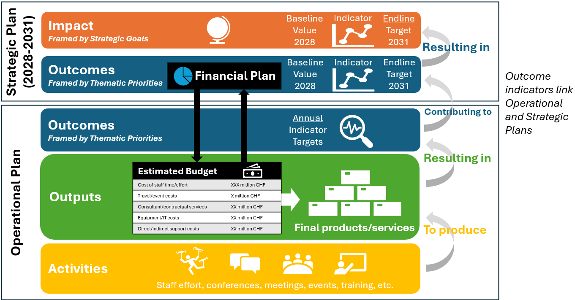

Financial Plan at the Strategic Level
The Financial Plan developed at the Strategic Plan level is an estimate of the expected revenues and allocations of resources to each of the desired Thematic Priorities/Outcomes based on their relative priorities as defined by the Strategic Plan. The Financial Plan provides guidance for the budgeting and delivery of Outputs in Operational Plans during the period covered by the Strategic Plan.
The process for generating the cost estimates included in the Financial Plan at the level of the Outcomes will be developed by the Council Working Group for strategic and financial plans (CWG-SFP), based on the proposal of the Secretariat. This proposal will take into account proposals from the General Secretariat and Bureaus regarding the activities they propose to carry out during the period to produce the Outputs that will deliver on the Outcome targets. The resources needed to conduct those activities are estimated and aggregated across the Bureaus and General Secretariat to produce the estimated resources needed to achieve each Outcome in the Strategic Plan. Those estimates comprise the Financial Plan at the Strategic level.

Results at the Level of the Strategic Plan
– Impact: Impact implies changes in people’s lives (this might include changes in knowledge, skill, behaviour, health or living conditions for children, adults, families or communities). Such changes are positive or negative long-term effects on identifiable population groups produced by an intervention, directly or indirectly, intended or unintended. These effects can be economic, socio-cultural, institutional, environmental, technological or of other types. Positive impacts should have some relationship to the Sustainable Development Goals (SDGs), internationally agreed strategic goals (i.e., ITU’s strategic goals: 1) Universal Connectivity; and 2) Sustainable Digital Transformation) as well as national development goals.
For example:
• Universal broadband coverage (measured through the performance indicator “Percentage of the world covered by broadband services”)
• Broadband services to be affordable for all (measured through the performance indicator “Cost of entry-level broadband in developing countries as percentage of monthly GNI per capita”)
– Outcomes: Changes in the institutional and behavioral capacities of ITU Membership and stakeholders, as framed by current Thematic Priorities, that occur between the completion of outputs and the achievement of Goals.
For example:
• Avoidance of causing harmful interference (measured through the performance indicator “Cases of harmful interference reported to the BR and resolved”)
• Enhanced interoperability and performance of telecommunications/ICT applications (measured through the performance indicator “Implementation of ITU standards”)
• Strengthened partnerships to adequately resource and support capacity building and cybersecurity activities (measured through performance indicator “Global Cybersecurity Index (GCI)”)
Results at the Level of the Operational Plans
– Outputs: Changes in skills or abilities and capacities of individuals or institutions, or the availability of new or enhanced products and services that result from the completion of activities within an intervention within the control of the organization. They are achieved with the resources provided and within a specified time frame (i.e., annual operational plans).
• Strategic linkage – Outputs programmed in each annual Operational Plan should set targets towards the achievement of measurable Outcome Indicators defined in the Strategic Plan. A few possible examples:
– A planned Output of National Cyber Security Strategies to X countries should target improvement of Y increase in future GCI scores for assisted countries
– A planned Output of BR software should target below X cases of harmful interference among countries implementing Radio Regulations
– A planned Output of Interoperability Standards should target X% implementation rate among targeted members.
• Financial linkage – each Output must include an estimate of the financial resources required to implement during each year of operational planning (detailed further in Section 3). Costing at Output level should apply to all financial resources, regardless of the source or category (i.e., staff costs, travel costs, contractual services, etc., whether from Regular Budget or Extrabudgetary Funds).
– Activities: Actions taken or work performed through which resources (including financial resources, ITU staff effort and other types of resources) are mobilized to produce specific outputs. To better capture the contribution of ITU staff time and effort towards planned Outputs (as well as to better integrate staff costs into the results chain), the Activity level of the results chain should closely integrate with the annual work plans of all ITU staff and be properly reflected in ITU’s electronic Performance Management and Development System (e-PMDS). Examples of activities include events, meetings, conferences, study groups, workshops, technical assistance, working groups, advisory groups, etc.

3 Operational Planning and Budgeting
ITU’s operational planning and budgeting processes will be enhanced in order to further focus operations, work effort and financial resources towards expected results in the organization’s Strategic Plan. Planning and budgeting steps that will be required each year are outlined as follows:
1 Review and refine outputs (each Bureau and Department)
Review current Outputs to assess if they are still relevant, fit for purpose, and have achieved expected Outcome targets in previous years.
2 Define key attributes for each Output:
i Targets: set end-of-year Outcome-level performance indicator targets for each Output planned for the year, considering:
i. baseline values (2027 measurements);
ii. endline targets (end of 2031); and
iii. assessment of Outcome-level targets expected to be achieved in the upcoming year (assuming that all planned Outputs are delivered).
b) Cost estimate: budgeting of Outputs should include:
i. Personnel costs based on post levels and estimated time allocation (which should include all fixed-term, continuing, permanent and temporary staff) and be reflected in individual performance management plans (ePMDS) for the same year
ii. Travel and event costs
iii. Consultant and contractual services
iv. Equipment and IT-related costs
v. Any other direct or indirect support costs
c) Risk management: In line with the ITU Risk Management Policy, identify and assess risks to the attainment objectives (i.e., expected results) whether strategic, operational, financial or fiduciary, while identifying appropriate risks.
3 Prioritize planned Outputs at Senior Management level:
a) Must – critical to ITU’s mandate and strategy
b) Should – important but not vital for 2028-2031
c) Could – valuable if resources allow
d) Won’t – not pursued in this cycle (can be revisited in the future).
4 Adaptive management - regular reviews of progress towards delivery of outputs against expected and targeted outcomes, through data-driven insights, will enable adjustment and reprioritization of planned outputs, activities, timelines and resource allocations as needed during the implementation of each operational plan.
5 Monitoring, Evaluation and Learning (MEL) of the delivery of Outputs and attribution towards the achievement of Outcomes will provide the evidence base needed to inform timely and effective adjustments for adaptive management. By systematically reviewing what works, what doesn't and why, MEL enabled by the improved results chain will foster continuous improvement and accountability, ensuring that future Operational Plans remain relevant and maximize their value towards results. Data-driven insights on the delivery of Outputs against expected and targeted Outcomes will enable adjustment and reprioritization of planned Outputs, Activities, timelines and resource allocations as needed during the implementation active Operational Plans and improvement of future Operational Plans.

______________

