Document CWG-FHR-20/28
11 February 2025
English only
Report by the Secretary-General
Update on the new website project
Purpose
This document provides a progress report on the roadmap to improve the ITU website as submitted to Council in its 2024 session (Document C24/53) and addresses the points raised in the contribution from the Russian Federation (Document CWG-FHR-20/21).
Action required
The Council Working Group on financial and human resources is invited to consider this report.
_______________
References
Documents CWG-FHR-20/21; C24/53; C24/101

ITU has made improvements to the website, following the contributions received from its Member States. These improvements include:
– Google Search was deployed for the ITU’s public-facing website during the June 2024 Council session. This enhancement has improved the search experience and will be further refined as part of the new website project.
– Significant improvements have been made to the ITU website’s feedback feature, resulting in over 600 responses to date, following the contributions from Member States (Doc. C24/101). These responses will be taken into consideration during the new web project implementation.
– As requested in Document C24/101, to analyze user experience and behaviour sessions are now being recorded (without recording or storing any personal data), and heatmaps are being generated to further enhance user behavior.
Now all new websites built on the WordPress platform include automatic translation in the six official languages of the Union, in line with the ITU’s commitment to accessibility.

New website project update
As reported verbally to the CWG-FHR in October 2024, CHF 350K out of the required CHF 600K was allocated, allowing the project to start. The Secretariat is working to identify the remaining CHF 250K.
The roadmap has been refined and now includes the following phases:
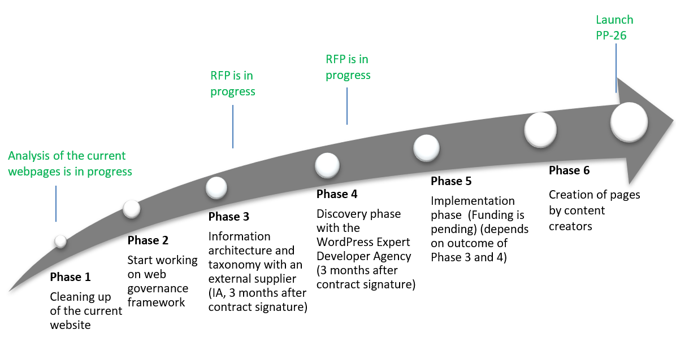
As outlined in the roadmap above, RFPs for the Information Architecture and Taxonomy (Phase 3) and the Discovery Phase with the WordPress Expert Development Agency (Phase 4) are currently in progress and are scheduled for release in February 2025.The initial analysis of the current websites has started and will continue to evolve alongside other project phases.
A web governance framework has been initiated as part of the broader project scope. The framework will address multiple aspects, including information architecture, taxonomy, web development, and ongoing maintenance. To support this, the RFPs will request external vendor expertise to establish a robust governance framework across these areas.
Regular updates on the project’s progress will be provided to the CWG-FHR and Council.

______________

