Document CWG-FHR-20/11
20 January 2025
English only
Report by the Secretary-General
UPDATE ON THE TRANSFORMATION PROCESS
Purpose
This document provides a status update on the Transformation process to achieve Organizational Excellence.
Action required
The Council Working Group on financial and human resources is invited to note the progress achieved to date.
_______________
References
CWG-FHR website; Documents C20/61, C20/74, C21/INF/15, C22/INF/13, C22/40, C22/57, C23/36, C23/50, C23/62, C23/INF/11, C23/INF/13, C24/19, C24/53, C24/31, C24/52, C24/73, INF Session Transformation

1 Introduction
ITU’s Transformation process is instrumental in driving organizational excellence as a key enabler for ITU’s Strategic Plan. The case for change has been highlighted in the ITU Strategic Plan for 2024-2027 and in Decision 5 (Rev. Bucharest, 2022) of the Plenipotentiary Conference.
Council document C24/52 outlines the approach taken by the secretariat to develop and implement a Transformation Roadmap. This roadmap serves as a comprehensive blueprint, addressing key processes across four foundational pillars: 1) Governance; 2) Systems, processes and tools; 3) People and culture; 4) and Resource optimization. We have added a fifth pillar 5) Members and Partners, to include initiatives focusing on improving member and partner experience and service delivery.
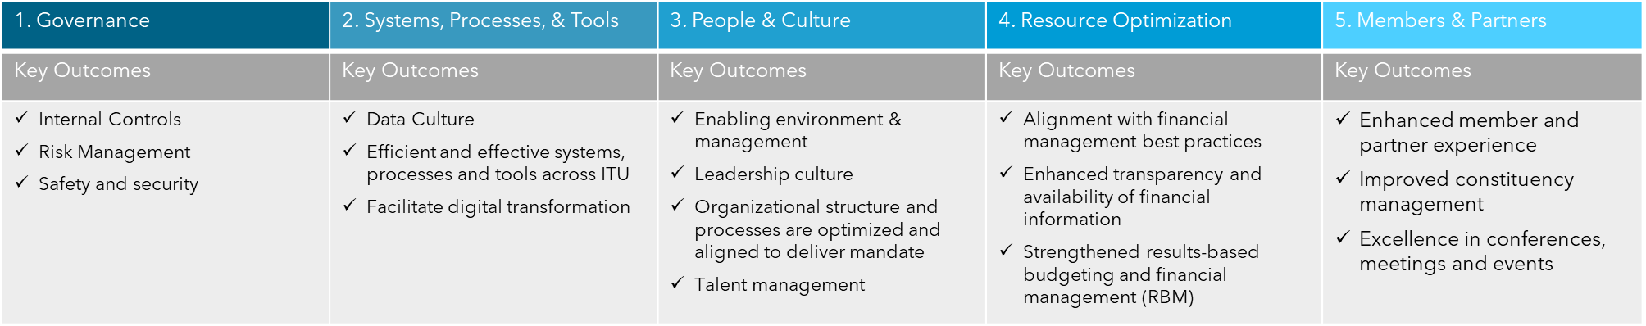
A portfolio management approach has been adopted to ensure that the Transformation process focuses on doing the right projects at the right time with selection, prioritisation and control of the identified projects, in line with the ITU’s transformation objectives and capacity to deliver. The goal is to balance the implementation of change initiatives and the business continuity requirements while optimizing benefits.
Each project is planned to follow the full transformation process and implementation plan using the appropriate delivery methodology and change management approaches. The system has been updated to allow for the integration of strategic priorities into department, units and staff workplans.

2 Key achievements
The ITU's Transformation initiative continues to make progress in enhancing the organization's digital enablement and operational efficiency. Key achievements include progress across the Accelerated Initiatives, headway on a new website, the launch of the Transformation dashboard, and the foundations for a baseline assessment of the KPIs identified to measure progress on transformation and serve as a basis for quality data-driven decision-making.

3 Transformation dashboard
One of the key objectives of the transformation process is to enhance transparency and accountability through data-driven decision-making and performance monitoring. To this end, the ITU has developed a dashboard that will provide delegates with up-to-date information on the progress of the transformation initiatives.
The dashboard is designed to be both user-friendly and interactive, allowing users to easily visualize the status of projects across various pillars. You can access the Transformation dashboard through the following link: Transformation dashboard.
In its second phase, scheduled for completion by Q2 2025, the dashboard will evolve to highlight key achievements and demonstrate how completed initiatives are directly contributing to the defined Key Performance Indicators (KPIs) and benefits.
The secretariat welcomes feedback from the delegates on the dashboard. The dashboard will be updated regularly and will serve as a valuable tool for tracking and communicating the progress and impact of the transformation.

4 Progress on the accelerated initiatives
At the outset, six Accelerated Initiatives were identified. Progress has been made across each of the Accelerated Initiatives with visible improvements in service delivery.

a) Performance management
The ITU has made improvements in enhancing its performance management system, particularly through the delivery of the enhanced ePMDS tool for the 2024 Performance Management and 2025 Workplan cycle.
Key achievements include:
– The simplification and streamlining of the ePMDS process, making it more user-friendly and intuitive. This has been realized by incorporating feedback from the ChangeMakers network, which highlighted the need for fewer redundant elements and a more efficient evaluation process.
– The introduction of the ability to link staff objectives to ITU strategic priorities has ensured better alignment between staff workplans with ITU's strategic plan.
– The Rewards & Recognition strategy that aligns closely with our performance management framework will be launched in 2025. This initiative aims to inspire and motivate our staff by providing meaningful mechanisms to recognize and celebrate their contributions, fostering a culture of excellence and engagement.
Continuous improvements are planned, with training sessions for staff and supervisors to ensure smooth adoption of the enhanced system. These efforts are part of a broader initiative to transform ITU's performance management policy and processes.

b) AI digital transformation
Artificial intelligence (AI) adoption is a key element of the ITU's Transformation agenda. The ITU has made progress in its AI digital transformation, which started with the initial piloting of Copilot as part of M365. ITU has now rolled out Copilot licenses to AI Champions with an enhanced focus on high-value use cases including:
– HR Recruitment productivity improvements
– AI-enabled search of ITU Official Documents
– End-to-end meeting management and follow-up actions as part of a broader objective to improve our relationship management with members and partners
– Data aggregation for financial dashboards
– Partnerships & Accounts management
– Event Management, Registration and Planning Optimisation
In September 2024, ITU launched the first iteration of the AI Hub, a single point of access for AI tools, e-learning materials, resources and AI Seed Fund available to all ITU staff. Building on the ‘’AI in Comms’’ ChangeMaker case, the ITU AI Hub is a collaborative initiative that promotes the adoption, capacity development, and effective utilisation of AI technologies in all internal areas of work.

c) Leadership Culture
The ITU Leadership Development training started in November 2024 and will continue in June 2025. It includes several tracks which are designed to enhance the leadership capabilities within the ITU at all levels. The plan is divided into multiple phases, each targeting specific objectives and outcomes. The first phase, started in 2024, focuses on critical topics such as psychological safety and trust, unconscious bias, gender, diversity, and inclusion.
Additionally, senior managers were involved in addressing staff wellness survey responses and building leadership capacity through adaptive leadership training with the aim to foster teamwork and collaboration among senior managers by tackling critical issues identified during the Senior Management Retreat.
Subsequent phases include development events for ChangeMakers and young professionals, engaging more people in leadership roles, and developing internal support systems to sustain the leadership development efforts long-term.

d) Recruitment
Improvement of ITU’s recruitment system has been identified as a key process for achievement of ITU’s strategic goals. A process re-engineering exercise was started in 2024. This exercise has identified the key bottlenecks and the related necessary remediation measures. Initial improvements in the recruitment process will be implemented as a first step early in 2025.

e) Travel
A review of the end-to-end travel process has now started to identify areas for improvements to streamline and introduce a more automated travel solution as well as review the current service arrangements with the external provider.

f) Mobility
The implementation of a mobility pilot is under study with input from the ChangeMakers network and Transformation Group. Further analysis of the current policy and processes, past mobility cases and lessons learned are required to refine the approach, scope and implementation.

5 Further progress on remaining transformation projects under the different pillars
Additionally, ITU’s Transformation roadmap also incorporates other initiatives under the various pillars focused on organizational modernization and digital transformation. Below are the key updates.

a) Systems, processes and tools
– Website: The website project has been launched following the last Council meeting and the partial allocation of the budget, CHF 350K out of CHF 600K overall budget. The RFPs for Phase 1 Information Architecture, Taxonomy, and website design has been launched. The feedback feature and questions on the itu.int have been improved following member states contributions. Additionally, the assessment of the current web content and infrastructure, development of the web governance framework will run in parallel, creating a data-based strategy towards cleaning-up and archiving outdated or redundant information to optimize media resources. Once we have outcomes Phase 1, the implementation phase will start.
– Enterprise Resource Planning (ERP) and Customer Relations Management (CRM) Platform Upgrade: Plans are in place to launch the ERP and CRM upgrade project, starting with the launch of the RFP.

b) People and culture
As referenced above, the Transformation effort is not only limited to the streamlining of systems, processes, tools, and policies, but includes a people-focused pillar that aims to create an agile, capable, and empowered workforce; and establish a culture of performance and accountability.

c) Resource optimisation
The financial transformation process has focused on several streams of work during 2024 as highlighted under Document C23/50. Many key streams have been successfully implemented including:
– payroll cost distribution
– extrabudgetary fund management
– treasury management
– accounting and revaluations.

d) Members and partners:
– Remote meeting participation services: Investments were made to expand and improve remote meeting capabilities, enabling greater inclusivity and addressing business continuity gaps highlighted by the Covid-19 pandemic.
– Delivery of conferences, meetings, and other events: Continuous improvement initiatives in conference service delivery and in language services are in progress, including translation, interpretation and summary records, integrating AI where possible.

6 ChangeMakers network and cases
The Transformation effort has optimised the valuable input of the ChangeMakers network, a voluntary group of 90 ITU staff purposefully formed to identify ten actionable and improvable "change cases" to achieve organisational excellence. Cases are those most relevant and meaningful to the ITU, and include Data-Driven Decision Making, AI in Communications, and Performance Management. As the Transformation agenda evolves and matures along different timelines, so too does the role of the ChangeMakers. They have fed continuously into the Transformation Team in various ways, including the Accelerated Initiatives, where they helped to accelerate the process of improving ITU's Performance Management and ensured participation across all levels of the organisation.

7 KPI and Baseline Assessment
In collaboration with the Business Units, an initial set of KPIs have been identified to start gathering data and developing a baseline assessment for future comparisons after improvements have been implemented. This will involve collecting and validating the accuracy and reliability of the data and enhancement of existing dashboards and development of new dashboards. Moreover, the development of the enhanced financial dashboards has been identified as one of the AI use cases to be delivered as part of the AI Digital Transformation.
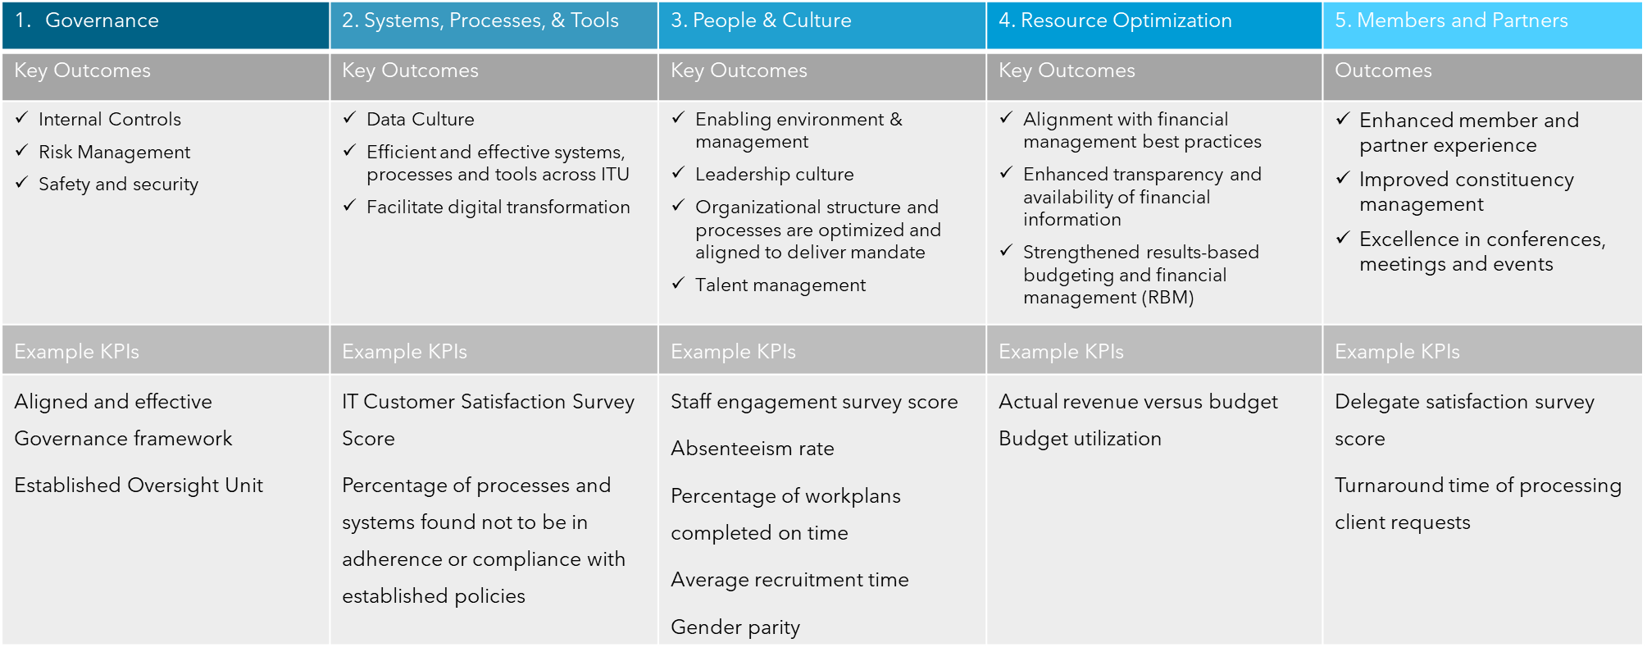

8 Resources required for Transformation’s major projects
Funding of the transformation will primarily come from regular budgetary allocations, though some additional allocations may be sought to ensure adequate capacity and expertise to implement the initiatives.
At the last Senior Management Retreat held in November 2024, the following priorities have been set for Transformation for 2025. These priorities will be included in the 2025 work plan for the responsible Departments and Units.
a. Systems, process and tools including the delivery of the new website, ERP upgrade, CRM, and AI Digital Transformation
b. Resource optimization including improvements in strategic prioritization and financial alignment, accounting, procurement, and travel
c. People and culture including leadership and culture training and process streamlining of recruitment, performance management, mobility, competency and talent development and staff administration
d. Members and partners including enhancing the conference experience, meeting and event planning and resourcing, communications & media
e. ChangeMakers network and implementation of change cases.
______________

