Revision 2 to
Document CWG-FHR-20/3
18 February 2025
English only
Report by the Chair, Council Working Group on financial and human resources
DRAFT GUIDELINES ON THE MANAGEMENT OF FULLY VIRTUAL
AND PHYSICAL MEETINGS WITH REMOTE PARTICIPATION AT ITU
IN LINE WITH THE IMPLEMENTATION OF RESOLUTION 167
(REV. BUCHAREST, 2022)
Purpose
Council 2024 instructed the Secretary-General to develop draft guidelines on the management of fully virtual meetings and physical meetings with remote participation for consideration by the Council Working Group on financial and human resources (CWG-FHR). At its 19th meeting, the CWG established a correspondence working group to review the guidelines and report back to the 20th meeting of the CWG.
This document provides proposed guidelines on each of the areas contained within Annex 1 to Resolution 167 (Rev. Bucharest, 2022) on strengthening and developing ITU capabilities for fully virtual meetings and physical meetings with remote participation, and the electronic means to advance the work of the Union.
Action required
This report is transmitted to the Council Working Group on financial and human resources for consideration.
_______________
References
CWG-FHR website; Document PP-22/64; Resolution 167 (Rev. Bucharest, 2022) of the Plenipotentiary Conference; Documents CWG-FHR-16/26, CWG-FHR-17/24, C24/61, C24/INF/7, C24/97

Background
Following the instruction of Council 2024, the secretariat presented draft guidelines on the management of fully virtual meetings and physical meetings with remote participation (Doc. CWG-FHR-19/5(Rev.1)) for consideration by CWG-FHR within a correspondence working group. The document provided proposed guidelines on each of the areas contained within Annex 1 to Resolution 167 (Rev. Bucharest, 2022) on strengthening and developing ITU capabilities for fully virtual meetings and physical meetings with remote participation, and the electronic means to advance the work of the Union. It was noted that the draft guidelines reflect the current practices of remote participation within the existing scope of Resolution 167 (Rev. Bucharest, 2022) which sets the framework for remote participation; any changes to aspects such as participatory rights in remote meetings or physical meetings with remote participants must be made through revision of Resolution 167 (Rev. Bucharest, 2022).
Following further discussions, the terms of reference and chair of the correspondence group were agreed upon and the correspondence group was requested to submit its report to the next meeting of CWG-FHR.

Activities of the Group:
Chaired by Ms Diana Gomez (Mexico), three 2-hour online meetings were organized through a dedicated Teams channel on the MS Teams platform, allowing for documents to be shared and updated. The sessions were as follows:
1) Introductory meeting (26 November 2024) – review of the terms of reference of the group and overview of the draft guidelines document
2) Second meeting of the group (9 December 2024) – detailed review of the draft guidelines document, drafting new language as relevant
3) Third meeting of the group (17 December 2024) – final review of the draft guidelines document with additional modifications.
A total of 70 participants registered to take part in the three online meetings.

Outcome
The outcome of the group’s work is the modified text attached here as Annex 1. The proposed language has been reviewed and approved by the ITU legal team and is submitted to CWG-FHR for its consideration.
Annex 1: Draft guidelines on the management of fully virtual meetings and physical meetings with remote participation

Annex 1
Draft guidelines on the management of fully virtual meetings and
physical meetings with remote participation

Purpose
The guidelines and annexes contained within this document provide high-level guidance on the management and governance of fully virtual meetings and physical meetings with remote participation at ITU.

Scope
These guidelines concern all meetings of the Sectors and General Secretariat and do not conflict with the existing regulatory frameworks and working methods of Sectors.

1 Meeting categories by modality
ITU events today have meeting sessions falling under one of the following four categories:
a) Physical – All the participants are onsite, present in the meeting room.
b) Fully virtual – All participants participate remotely through a web-conference platform, in their respective locations.
c) Physical with remote participation (intervention) – The physical meeting room is connected to a web conference platform. Participants may attend on-site, in the meeting room, and/or actively participate through a web-conference platform.
d) Physical with webcasting – Means the (real-time or almost real-time) transmission of an event online without the possibility of direct intervention.

2 Structure of these guidelines
These guidelines respond to the criteria established by Annex 1, section 2, of Resolution 167 (Rev. Bucharest, 2022) on strengthening and developing ITU capabilities for fully virtual meetings and physical meetings with remote participation, and the electronic means to advance the work of the Union, either within the body of the guidelines or within the annexes to the guidelines, as appropriate.
The review of current applicable policies and practices for fully virtual meetings and physical meetings with remote participation as detailed in Annex 1, section 1, to Resolution 167 (Rev. Bucharest, 2022) is provided as Annex 1 to these guidelines.

Guidelines

1 Clarification on the rights of different categories of members participating remotely in terms of decision-making in different types of meetings

1.1 Status of remote participants in physical meetings with remote participation
Resolution 167 (Rev. Bucharest, 2022) of the Plenipotentiary Conference emphasizes the importance of remote participation for diverse and inclusive participation and sets the legal framework for remote participation. The Constitution, the Convention, and the General Rules do not have specific provisions for remote participation.
Resolution 167 states in recognizing e) that the current status of interactive remote participation allows "remote intervention" rather than "remote participation", insofar as a remote participant cannot take part in decision-making. As a result, the following clarifications are provided with respect to rights of remote participants in physical meetings where remote participation is allowed:
a) Remote participants do not enjoy the same participation rights in physical meetings with remote participation as do on-site participants.
b) Remote participants have a right to participate in discussions and debates as part of the consensus-building process as much as possible.
c) Remote participants may not take part in the decision-making process. This means that:
i) Remote participants do not have the right to vote, and they are not taken into account for the calculation of quorum (cf. GR 93, GR 115).
ii) A decision can still be taken by consensus amongst participants physically present, even if remote participants disagree.
iii) Remote participants cannot raise points of order or motions of order.
d) As the chair of a meeting is responsible for directing deliberations, enforcing procedural rules, and putting questions to vote (cf. GR 59), as well as duties outside formal meetings, correspondingly (s)he should be present at any physical meeting, including meetings with remote participation. As a corollary to the above, it would be advisable that vice-chairs be physically present, as they may be called to stand in for the chair in case of unavailability of the latter, or to chair sub-committees or ad hoc groups.

1.2 Status of participants in fully virtual meetings
Since PP-22, fully virtual meetings have been explicitly recognized and accepted as a meeting modality in the ITU regulatory framework (cf. Decision 5 and Resolutions 25 and 167). Resolution 167 (Rev. Bucharest, 2022) provides a comprehensive mandate for the ITU to develop and strengthen its capabilities to organize and conduct fully virtual meetings. Given the decision of the Plenipotentiary Conference to maintain recognizing e) of Resolution 167 as is, any such development and strengthening of fully virtual meetings in ITU must remain within the limitations set by the aforementioned clause.
Although a strict reading of recognizing e) suggests that virtual meetings cannot reach any decision, ITU's experience during the COVID-19 pandemic and the objectives of the Resolution would support a liberal view that all participants in a fully virtual meeting can participate in consensus-based decision-making. More specifically, the ITU membership's acceptance of decisions made by consensus in fully virtual meetings during the pandemic has led to legal outcomes that are now part of ITU's operational history. This practice indicates a collective understanding and acceptance that, in the context of fully virtual meetings, consensus amongst participants is a legitimate form of decision-making within the Union. Furthermore, the lack of challenge to this practice by ITU's supreme organ, the Plenipotentiary Conference, in September 2022, could be perceived as an endorsement of the legality and acceptability of decisions by consensus taken in virtual meetings not only with respect to the past, but also regarding the future.
As a result, the role of participants in fully virtual meetings is as below:
a) Participants in a fully virtual meeting can participate in discussions and debates as part of the consensus-building process.
b) Decisions in fully virtual meetings can only be made by consensus. If consensus cannot be achieved at the meeting, the matter at hand must be reopened at a future meeting.
c) Given that a fully virtual meeting operates without a physical venue, it is logically understood that all participants involved, including those in leadership roles such as chairs and vice-chairs, participate in the meeting remotely.
d) ITU's established practice in fully virtual meetings to operate by consensus reflects an understanding of the current regulatory constraints regarding decision-making. In such an environment, the procedural tools of points of order or motions of order should not be used, as the objective remains to decide by consensus rather than by a vote.

2 Interpretation services for meetings with remote participation

2.1 Provision of interpretation services
Interpretation services for all ITU conferences, assemblies, and meetings are provided in accordance with Document C22/INF/7 on measures and principles of translation and interpretation in ITU and are available equally to all participants, whether participating physically or remotely.
Currently, the rules for provision of interpretation services are applicable to physical meetings, fully virtual meetings and physical meetings with remote participation. The maximum length of one session is three (3) hours, and there can be a maximum of two (2) sessions per day. A break of at least ninety (90) minutes is required between sessions.
Conditions for the provision of remote interpretation services in meetings are also on the agenda of the existing consultation mechanism between the United Nations Common System Chief Executives Board for Coordination (CEB) and the Association of Conference Interpreters (AIIC).

2.2 Technical considerations and risks for interpretation services in meetings with remote participation
The technology for remote participation has improved significantly in recent years, both in quality and reliability. Remote participants are also more aware of best practices when intervening remotely, such as speaking at an adequate pace and articulating clearly. While significant progress has been made in the provision of interpretation services in meetings with remote participants, certain technical risks remain, such as equipment or connectivity malfunctions on the side of remote participants or on-site, which can cause service disruptions. Interpretation quality can also suffer due to issues with remote participation platforms, causing poor sound quality or voice fading. The quality of network connections and equipment such as headsets is critical in providing interpretation services in meetings with remote participation.
To mitigate risk, real time monitoring can be established by creating communication channels through which participants can quickly report any problems with interpretation or audio that may occur. In addition, a back-up channel will be available that can be activated if remote participants experience any technical problems.

3 Technology neutrality – Web-conference platforms
The web-conference platform used for fully virtual meetings and physical meetings with remote participation must be available and accessible to all participants regardless of their physical location and when choosing it possible technical restrictions for the participants that would prevent their full and equal participation should be taken into account. The web-conferencing platform must also allow integration with interpretation services. Furthermore, to access the platform participants may not have to download or purchase any software to access it and will receive a link with the meeting invitation through which they can join.
For fully remote meetings, event organizers are required to make best efforts so that participants have equal and full access to web conference platforms. Information about meetings and relevant documents could be shared via email in addition to any online collaboration spaces to help ensure alternative ways to receive information and participate in discussions. If event organizers determine a technical barrier for interested participants, alternatives should be found.

4 Choice of meeting modality
Factors to be considered in the choice of meeting modality include the purpose of the meeting, likely audience, the proportion of the participants who will be on-site, nature of the meeting (decision-making or not), expected voting component, structure of meeting (plenary, panel, workshop etc.), duration of the event, global or regional reach, availability of meeting rooms and technology, context (e.g. final meeting before a major conference), inclusiveness (e.g. geographical or gender considerations), budgetary constraints and environmental considerations.

5 Engaging in offline discussions
Remote participants may engage in offline discussions (e.g. ad hoc sessions) as long as they are held in places/rooms integrated with the virtual platform. Many web-conference platforms also support “breakout rooms” allowing participants to create their own breakout sessions for off-line discussions. However, there may be instances where remote participation in ad hoc discussions may not be possible, such as when a Chair calls a meeting spontaneously without prior notice or in a room which is not integrated with the virtual platform. In such cases, once the meeting resumes remote participants should be informed of the discussions or agreements reached during the ad hoc discussions and given the opportunity to express their comments or points of view before a decision is formally taken.

6 Practical measures to support equitable opportunities for participation, in particular for persons with disabilities and persons with specific needs
For physical meetings with remote participation or fully virtual meetings, captioning can be followed on the web-conference platform or via the webcast service.
Sign language may be made available upon request (subject to the availability of resources) in any ITU meeting and may be extended to the web conference and webcast platforms.
Web-conference platforms selected by ITU include accessibility features (e.g. screen reader support, adjustable font size, keyboard) for persons with disabilities and persons with specific needs.
In the registration form for the meetings, participants will be asked to indicate in advance if they require any special support for their participation in order to assess the feasibility of implementing the necessary measures to guarantee accessibility during the event.
At the beginning of the sessions, the participants will be informed of the accessibility features available on the platform during the meeting in order for all participants to be informed and for these features to be enabled if necessary.

7 Flexibility in the length and timing of meetings bearing in mind the time zones of participants
For physical meetings with remote participation, the guidance is to hold the meeting during the core working hours of the location where the physical meeting is being held. Remote participants join as required. Some degree of flexibility as to timing is required: the first session typically begins at 0800 or 0900 hours local time in the location of the physical meeting, and finishes at 1700 or 1800 hours, while lunch breaks may be cut short to accommodate the different time zones of remote participants.
Currently, fully virtual meetings with global participants are organized within the central hours of the day in Geneva (1100 – 1500 hours). For the convenience of Member States in all regions, fully virtual meetings may be held during the working hours of other time zones, with resource and overtime cost implications for support staff based in ITU HQ in Geneva. If the meeting covers multiple topics or sessions, it can be divided into blocks to better suit the participants’ schedules. To accommodate different working weeks in various countries, as well as time zones, efforts should be made to avoid scheduling virtual meetings on Fridays whenever possible
In all instances, event organizers are required to make best efforts to accommodate different time zones, taking into account the implications for enabling fair participation of delegates across the ITU Member States, supporting staff in headquarters and field offices, staff overtime and interpretation costs.

8 Training, as appropriate, for ITU meeting organizers, regional office staff, chairs, rapporteurs, editors and delegates, with particular attention to chairing and effectively managing remote participation
Since 2020, on-the-job training has been provided to meeting organizers and staff. Briefing sessions to chairs include information on better streamlining of discussions involving onsite and remote participants. Guidance material and training is regularly provided to delegates, in particular when significant remote participation is expected. Depending on resource availability, ITU technical moderators may assist participants joining ITU meetings remotely, as well as help the chair and secretary in giving the floor to remote participants.

9 Best practices in managing meetings with remote participation

9.1 Registration process
For events open to ITU membership only, remote participants follow the same registration and accreditation procedure as onsite participants, and access to the physical room and virtual room is controlled through a similar authorization verification mechanism.
For public events such as workshops, the AI for Good Summit or WSIS Forum, remote participants do not need to go through the full accreditation process. A simplified CRM registration system designed to support registration for the above-mentioned public events may be used by the General Secretariat and the three Bureaux.

9.2 Managing requests from the floor
The chair is required to manage requests for the floor from the room where delegates physically raise their hands/nameplates or press the request button, and from the web conference platform, where delegates raise a virtual hand. The chair could adopt different approaches in ITU meetings:
– The chair gives priority to participants in the room and then moves to remote participants
– The chair responds to requests in chronological order as far as possible
– The chair asks remote participants to open their microphones and request to speak
– All delegates, whether present physically or remotely, are requested to connect to the web-conference platform and use the virtual raise-hand feature.

9.3 Use of the chat function
The chat function in the web conferencing platform is not automatically enabled. When it is enabled, it does not form part of the official meeting records. Remote participants must recognize that, for various reasons, the chair and secretariat may be unable to read messages in the chat of a meeting. However, the chat function may be used to provide certain inputs upon request of the chair (for example, a specific proposal made during the debates) or to share text and send private messages. It may also be used to highlight technical problems or obtain help from the moderator.
It may not be used to ask for the floor.

ANNEX 1
Current practice in the management of fully virtual meetings and physical meetings with remote participation
A full list of documents covering existing guidance of fully virtual meetings and meetings with remote participation was presented to the 17th meeting of CWG-FHR in January 2024 in Document CWG-FHR-17/INF/4.

ANNEX 2
Statistics on meetings including remote participation across all sectors

Number of meetings and sessions by event format (January 2022 – December 2024)
Meetings | Sessions
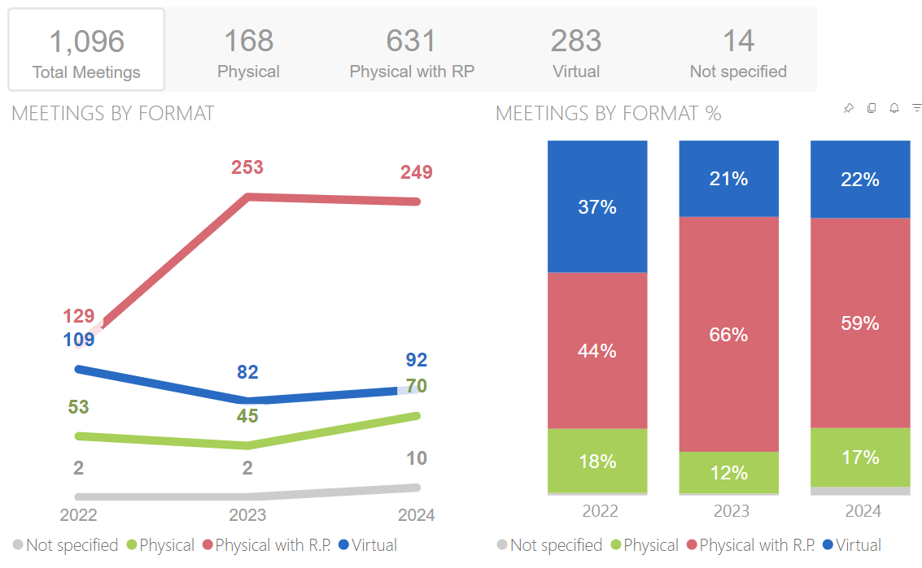 | 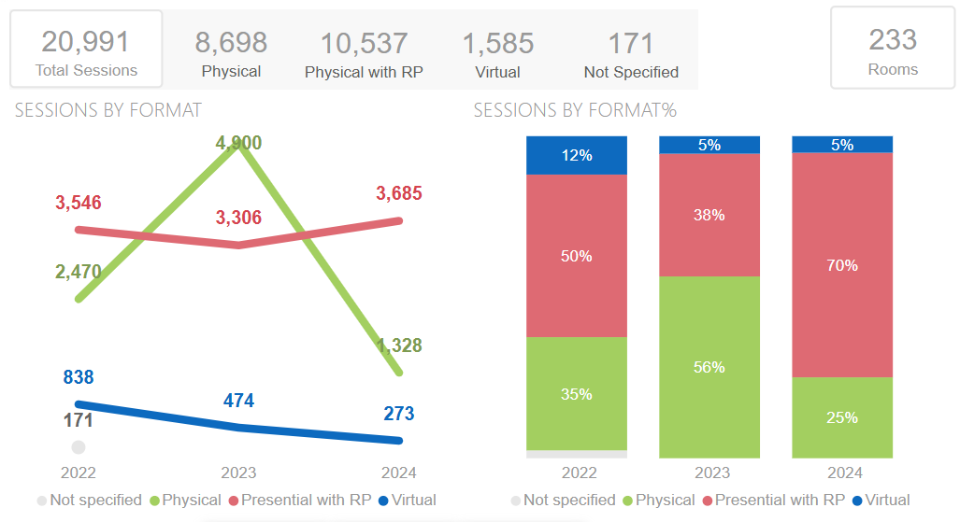

Meetings and sessions by sector and event format (January 2022 – December 2024)

ITU-R
Meetings | Sessions
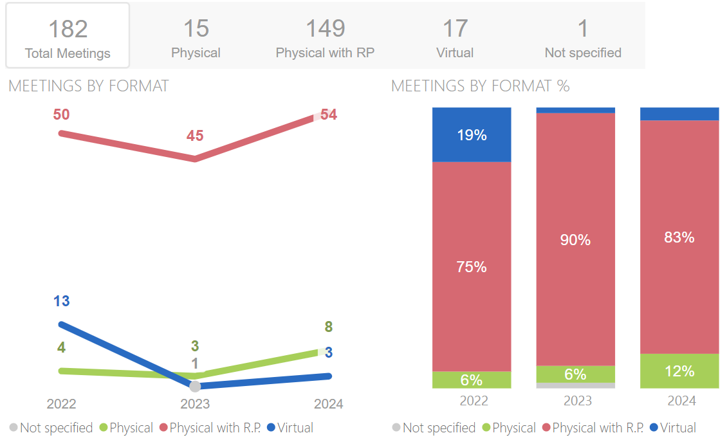 | 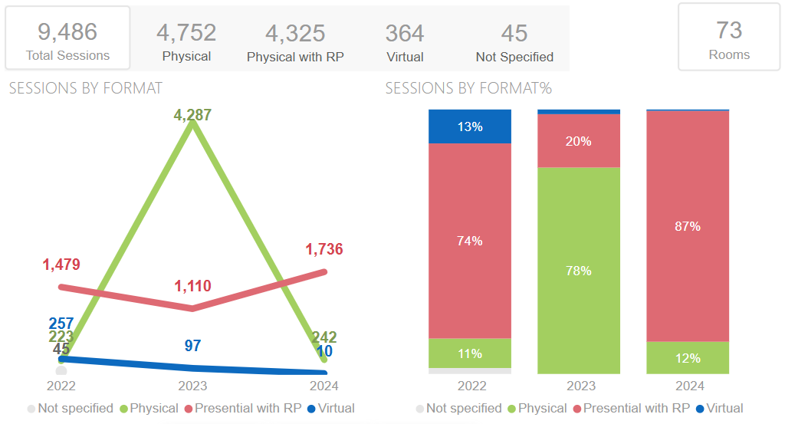

ITU-T
Meetings | Sessions
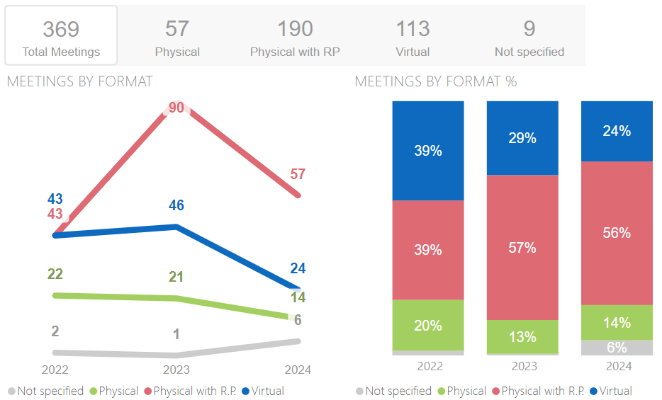 | 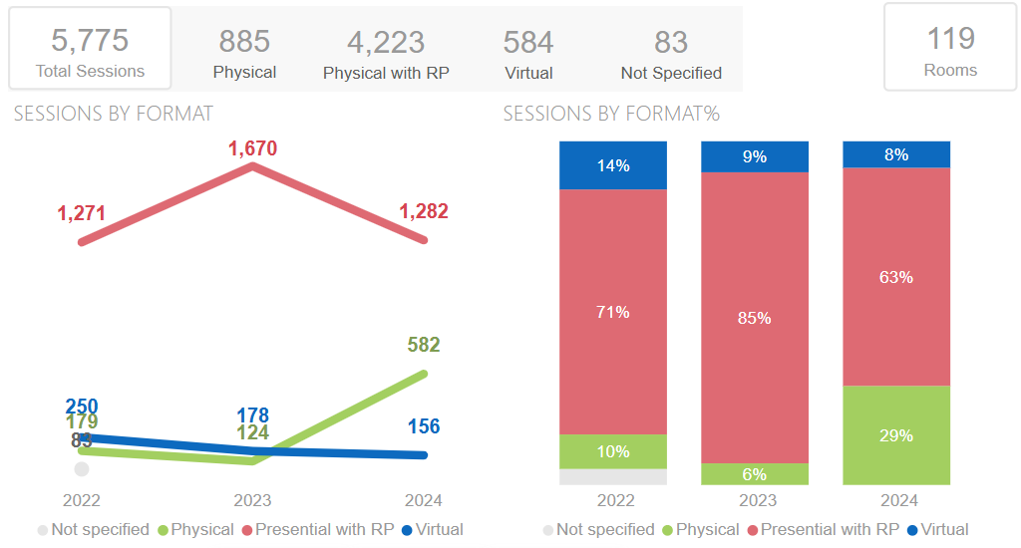

ITU-D
Meetings | Sessions
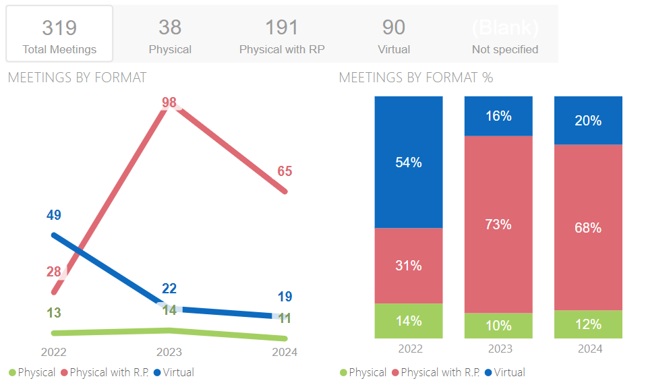 | 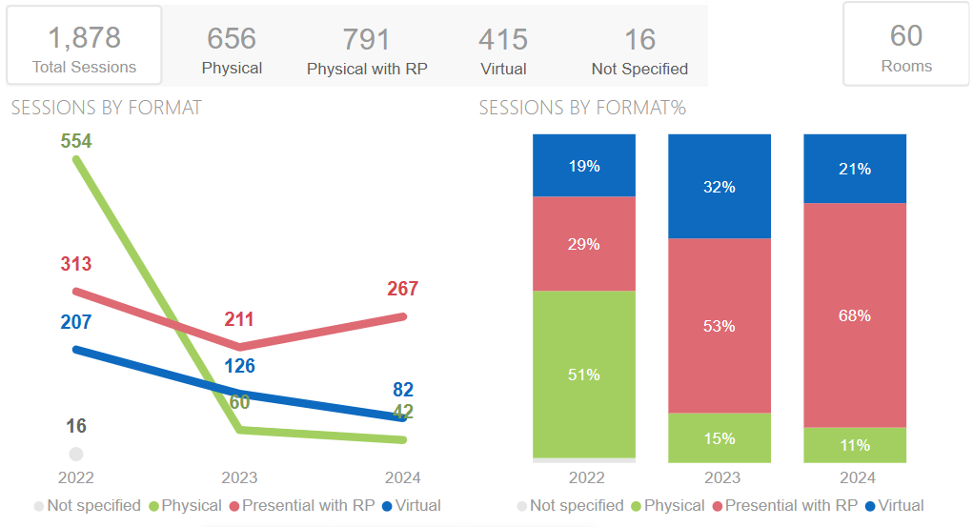

GS
Meetings | Sessions
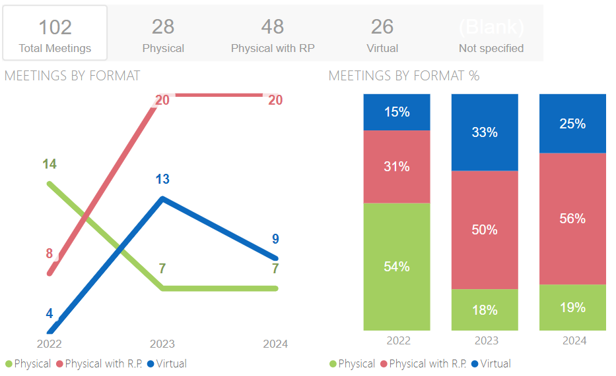 | 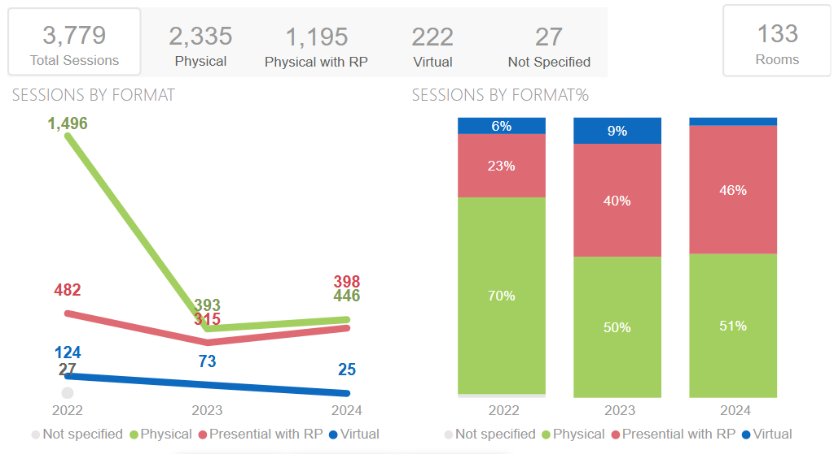

ANNEX 3
Additional considerations

1 Financial implications
For physical sessions with remote participation, in addition to the cost of hiring a technical moderator, there may be additional support costs when the sessions are held outside ITU premises. For example, meetings at the International Conference Center Geneva (CICG) have a daily surcharge of CHF 450-650 for an audio technician for each meeting room where remote participation is to be supported.
The yearly operational cost of supporting virtual events and physical events with remote participation is CHF 855 000, equivalent to CHF 3.42 million for the 2024-2027 budget period, as reported in Document PP-22/64. In addition, it is estimated that a capital investment of CHF 1 million will be needed every five years for upgrading the equipment used to support virtual events and physical events with remote participation.

2 Security considerations
For technical meetings that require registration and accreditation, only authenticated participants may enter the virtual session (web-conference platform). For public events, participants registered through the “simplified registration for public events” process receive an email with a unique URL, allowing them to enter the virtual session as identified participants, but without further authentication.
The web conferencing platform provider must implement stringent security measures, including end-to-end and in-transit data encryption, and enforce robust access controls such as two-factor authentication and role-based permissions. Comprehensive audit trails are essential for monitoring and compliance. Adherence to strict regulatory standards and contemporary best practices is essential, and the provider should hold security certifications such as ISO/IEC 27001 and SOC2. Additionally, regular penetration testing exercises are required to continuously assess and enhance the effectiveness of the security controls in place.
For physical meetings where a quorum may be required, ITU records which delegation has attended which sessions. Web-conference platforms record the date and time when participants joined the session, and the session may also be recorded, including chat messages, close up videos of the delegates taking the floor, etc.

3 Consultation with other United Nations Organizations
3.1 ITU is an active member of the UN Chief Executives Board for Coordination, in particular the Digital & Technology Network. In 2020 ITU took the lead with the publication of "Virtual events and remote participation – Guidelines and best practices".
The IS Department has worked with the World Intellectual Property Organization (WIPO) and the United Nations Office in Geneva (UNOG) to implement the infrastructure needed to support physical meetings with remote participation, including both on-site interpretation using the audio system in the booths and remote interpretation using the RSI interface of a web-conference platform.
3.2 At the request of the Council Working Group on Financial and Human Resources, the secretariat consulted with other UN organizations on their approach to managing the rights of remote participants for decision-making or legally binding meetings. The results of this consultation are presented in Document C24/INF/7.

4 Inclusivity
4.1 Resolution 30 (Rev. Bucharest, 2022) of the Plenipotentiary Conference commits ITU to implementing special measures for the least developed countries (LDCs), small island developing States (SIDS), landlocked developing countries (LLDCs) and countries with economies in transition. Statistics on the number of Member States participating in ITU events since 2020, and the number of participants from developed, developing, and least-developed countries in ITU events are presented below.
4.2 Implications for gender equality: Under Sustainable Development Goal 5, target 5.5 is to ensure women’s full and effective participation in decision-making. Virtual events and remote participation can provide flexibility and facilitate greater participation of women in ITU meetings in general. Greater understanding of women's experiences can also help make ITU meetings more gender responsive.

Delegate participation by Member State country and presence type (January 2020 – December 2024)
Developed countries | Developing countries
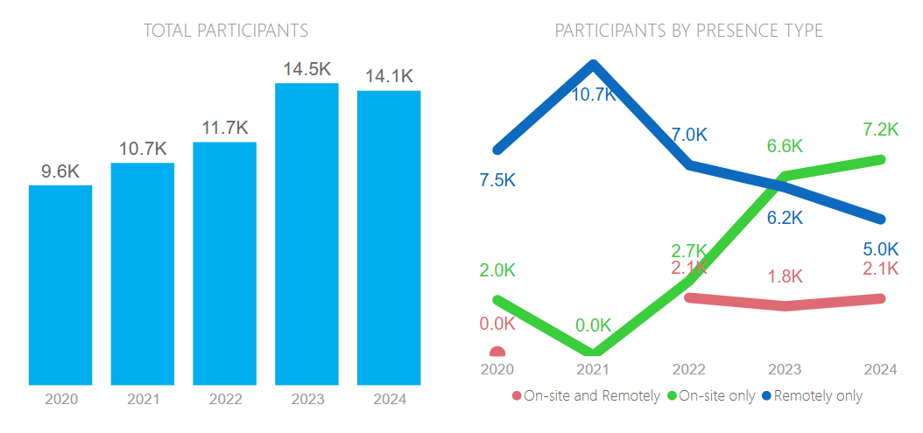 | 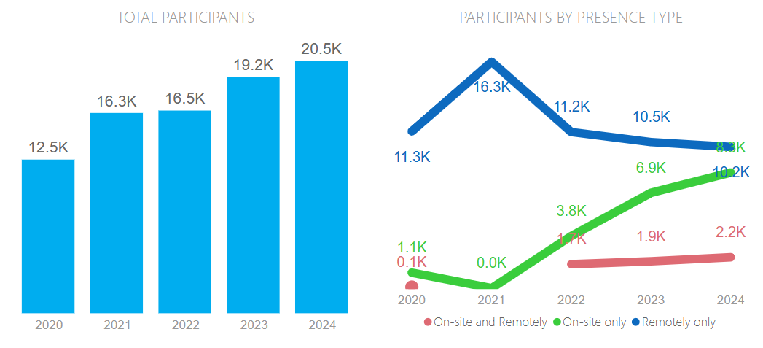
Least developed countries
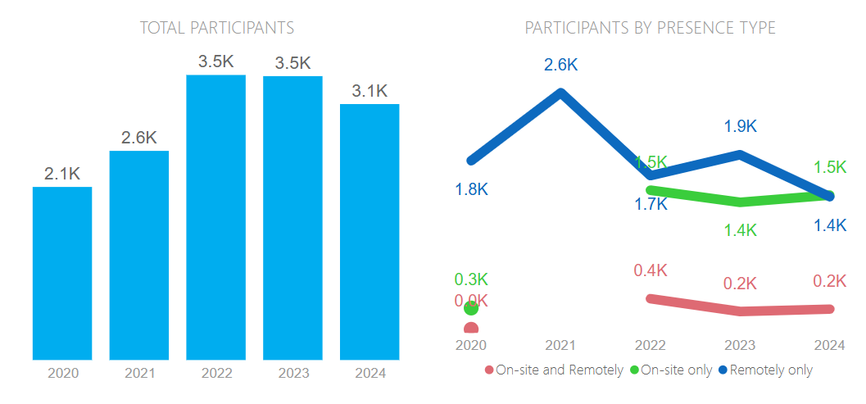

% delegate participation by Member State countries and event format (January 2020 – July 2024)
Physical with Remote Participation | Physical participation only | Remote participation only
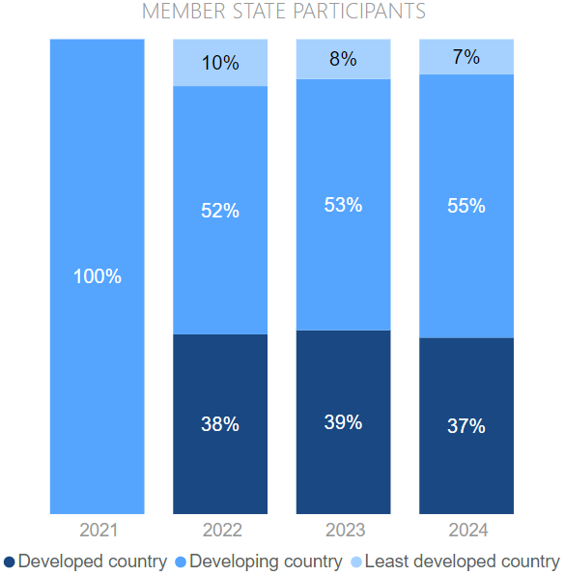 | 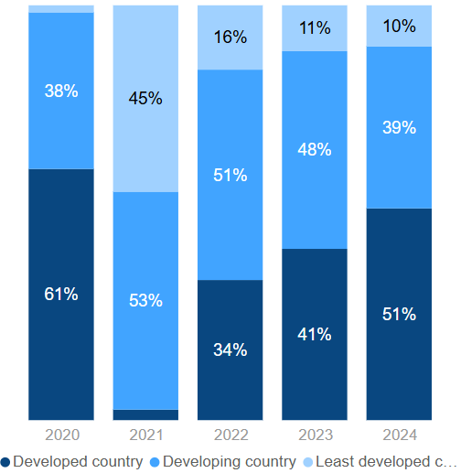 | 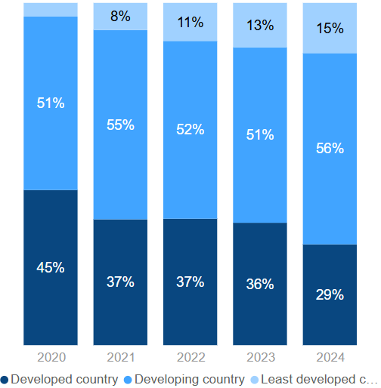

% breakdown of total participants by gender and event format
Physical with Remote Participation | Physical participation only | Remote participation only
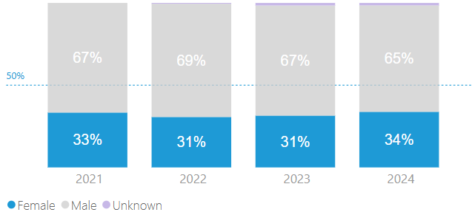 | 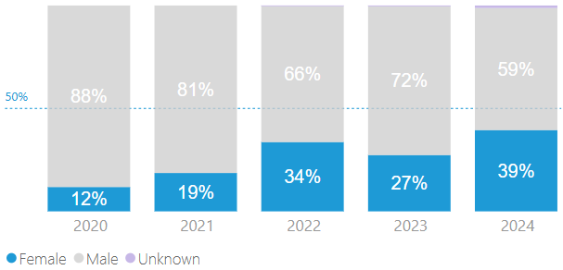 | 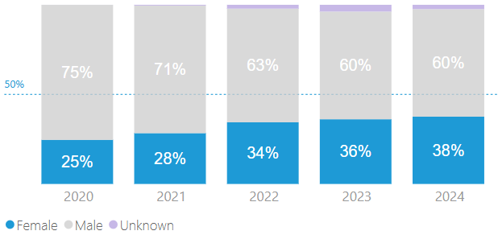
No data for 2021
Note: Unknown category refers to participant contact details created without a gender field or where the gender field was not completed.

5 Potential technical issues in the use of web-conference platforms
ITU has supported physical meetings with remote participation since 2010. The main web-conference platforms available in the market have undergone significant development since COVID-19, maturing to the extent that there are no longer any significant technical issues which may prevent participants or interpreters from using these platforms or prevent technical teams from using them to host fully virtual meetings.
ITU has ensured that all Member States have equal and full access to web conference platforms regardless of geography when connecting through the ITU portal.
While it is desirable to have the same log on mechanism to access all platforms, service providers may have implemented different ways for participants to authenticate. Therefore a different way or username/password to access each platform may be required.
As general guidance, all remote participants require adequate connectivity and devices such as headsets to ensure full and seamless participation via web-conference platforms.
One remaining challenge (as of July 2024) is the seamless integration of the Remote Simultaneous Interpretation (RSI) function of the web-conference platforms with the physical meeting rooms, where onsite participants prefer using the headsets in the room to listen to the interpretation coming from remote interpreters. None of the main web-conference platforms today provides an interface for streaming the interpretation from the RSI platform to the language channels of the physical meeting room. It is left to the local audiovisual team to find innovative ways to perform this integration. Whenever there is an update to the web-conference platform, this integration must be re-verified and, in some cases, re-implemented. This is an issue in all physical meetings or physical meetings with remote participation using RSI.

LIST OF RELEVANT DOCUMENTS
Document PP-22/64 – Report on progress in the implementation of Resolution 167 (Rev. Dubai, 2018) in the period 2018-2022 (July 2022)
Resolution 167 (Rev. Bucharest, 2022) – Including Annex 1 as above
Document C23/54 – Report to Council 23 on the implementation of Resolution 167 (Rev. Bucharest, 2022) (May 2023) – This Report outlines the activities and developments since the Plenipotentiary Conference (Bucharest, 2022) to assist the Council in developing high-level guidance for the management and governance of fully virtual meetings and physical meetings with remote participation
Document CWG-FHR-16/26 – October 2023 FHR summary record
Document CWG-FHR-17/24 – February 2024 FHR summary record
Document CWG-FHR-17/INF/4 – Current practices in holding virtual meetings across sectors
ITU-T Guidelines for remote participation (December 2022)
MyMeetings internal remote participation User Guide
WTSA Resolution 32 (Rev. Hammamet, 2016) – Strengthening electronic working methods for the work of the ITU Telecommunication Standardization Sector
Policy guide for remote participation in fully virtual ITU-T Study Group meetings (example)
ITU-R information document for participants in block of Study Groups and Working Parties meetings – including PPT on practical guidelines (example)
Guidelines for remote participation in TDAG-23 (ITU-D has a TD for each meeting)
ITU Remote Participation Task Force internal document on virtual events and remote participation – Guidelines and best practices (2022)
Document C24/61 – Contribution to Council 24 on rights of participants
Document C24/INF/7 – Overview of UN practices
Document C24/97 – Multi-country contribution led by Mexico on creation of correspondence group to discuss guidelines and rights of remote participants.
______________

By way of clarification, webcasting is not included in this category.

