|  |  |
| --- | --- |
|  | **Document CWG-COP-23/INF/4** |
| **3 September 2025** |
| **English only** |
|  |  |
| Contribution by the National Agency for Computer Security and Digital Certification (ANSICE) of Chad | |
| INITIATIVE OF THE CHADIAN GOVERNMENT FOR THE IMPLEMENTATION OF NATIONAL AWARENESS CAMPAIGNS ON CHILD ONLINE PROTECTION | |
| **Purpose**  The objective of this document is to share the initiatives of Chadian government for the implementation of national awareness campaigns on child online protection with Member States and members of the sector, in accordance with Resolution 179 (Rev. Bucharest, 2022).  **Action required**  This report is transmitted to the Council Working Group on child online protection **for information**.  _______________  **References**  [*Resolution 179*](https://www.itu.int/en/council/Documents/basic-texts-2023/RES-179-E.pdf) *(Rev. Bucharest, 2022) - ITU's role in child online protection* | |

***1. Introduction:***

The protection of children in the digital environment is a global priority. With the widespread use of information and communication technologies (ICTs), children are increasingly exposed to online risks such as cyberbullying, exposure to inappropriate or violent content, identity theft, scams, as well as screen and social media addiction. Aware of these challenges, the Government of the Republic of Chad has launched a national initiative aimed at raising awareness, informing, and protecting children and their families against the dangers of the digital world. This initiative is part of Chad’s contribution to the efforts of the International Telecommunication Union (ITU) to ensure a safe and responsible digital environment for all children

***2. Background General***

The rapid development of information and communication technologies (ICTs) has profoundly transformed the way children communicate, learn, and interact with their environment in Chad. Access to the Internet and smartphones is growing quickly, even in some rural areas, and children are increasingly using social media and educational platforms. This strong digital penetration has created new opportunities for learning, communication, and openness to the world, thereby reinforcing the role of digital tools in the daily lives of young people. However, this digital expansion also exposes children to various risks, such as access to inappropriate or violent content, cyberbullying and online harassment, scams and fraudulent solicitations, as well as digital exploitation and manipulation.

The National Agency for Computer Security and Electronic Certification (ANSICE) and play a central role in regarding child online protection. In addition, the Direction of the Personal Data Protection, is an integral part of data regulation, as well as the National Coordination in charge of cyber-crime investigation, focus on the prevention and investigation of online crimes targeting children, relying on educational programs and surveillance actions.

In addition to these authorities, Chad has implemented an initiative of national awareness campaigns including online safety education, national awareness campaigns and partnerships with the technology sector, thus promoting a multi-level approach to protecting children online.

***3. Justification de initiative***

Children in Chad are particularly vulnerable to the risks associated with the use of the Internet and digital technologies. They often have limited skills to navigate safely and to identify harmful content, which exposes them to threats such as inappropriate content, cyberbullying, and fraudulent solicitations. Moreover, most of parents and teachers they have lack of adequate training to guide and supervise children in their use of digital tools, further increasing this vulnerability. Repeated exposure to these risks can have serious consequences on children’s psychological, emotional, and social development.

In this context, the implementation of national policies and awareness campaigns are essential. Such initiatives not only strengthen child protection and align actions with international standards, but also foster cooperation and the sharing of best practices with other African. countries and international bodies such as the ITU. These efforts contribute to creating a safer, more educational, and more responsible digital environment for Chadian children.

***4. The legal framework for the protection of children online in Chad.***

* Chad has incorporated specific measures into its legislation to protect children on the Internet, in particular through several texts which are listed below:
* The Chadian Constitution guarantees the fundamental rights of children, including the right to protection against all forms of exploitation and violence, also applicable in the digital context.
* Law 006/PR/2015 and its amending texts, creating ANSICE, lays the first cornerstone for the protection of personal data in Chad.
* Law 009/PR/2015 on cybersecurity and the fight against cybercrime provides specific measures to protect children against online abuse.
* Law 007/PR/2015 on the protection of personal data stipulates that the processing of minors' data is subject to the consent of the legal guardian, thus guaranteeing the protection of children's privacy.
* The 2017 Chadian Penal Code, in relation to the fight against cybercrime, criminalizes acts of violence, exploitation and sexual abuse against children, including those committed online.

Beyond this legal arsenal, Chad has implemented several initiatives to ensure the safety of children online, including the creation of ANSICE, which is at the forefront of child protection efforts. Its mission includes regulating telecommunications services and the distribution of digital content in order to protect children from harmful content and ensure the protection of data, including that of children.

***5. Objectifs de l’initiative***

The Chadian initiative aims to:

* Raise children’s awareness of online risks and best practices.
* Promote awareness and digital literacy by educating children, parents, teachers, and communities on safe and responsible Internet use.
* Ensure a safe and secure digital environment for children by protecting them from risks such as cyberbullying, harmful content, exploitation, scams, and abuse.
* Promote awareness and digital literacy – educate children, parents, teachers, and communities about safe and responsible online practices.
* Promote a culture of cybersecurity and responsible use of ICTs.
* Strengthen international cooperation with the ITU and other partners to share expertise and best practices.

***6. Actions mises en œuvre***

To achieve these objectives, the Government of Chad, through its institutions (notably the Ministry of Education, ANSICE, and other child protection agencies), is implementing several concrete actions:

***7. Awareness Campaigns and Training Workshops***

* Organization of awareness campaigns in schools and communities.
* Dissemination of prevention messages through radio, television, and social media.
* Development and distribution of videos, posters, and educational brochures tailored for children.
* Implementation of training workshops for teachers on digital education and cybersecurity, scheduled to be launched in the coming months.
* Sessions for parents focusing on supervising children online and preventing risks, planned for the current year.

**7.1 Awareness Campaigns Initiated by the Government**

* A training session was organized at the Girls’ High School of N’Djamena under the topic: **How to Protect Your Privacy Online.** More than 40 young girls participated in this initiative, which focused on raising awareness about digital safety and the protection of privacy on the Internet.

**Workshop links:**

<https://www.facebook.com/photo?fbid=1014613290546597&set=pcb.1014598833881376>

<https://www.facebook.com/photo?fbid=1014596670548259&set=pcb.1014598833881376>

<https://www.facebook.com/photo?fbid=1014597873881472&set=pcb.1014598833881376>

<https://www.facebook.com/photo/?fbid=1014590050548921&set=pcb.1014598833881376>

<https://www.facebook.com/photo/?fbid=1014592007215392&set=pcb.1014598833881376>

<https://www.facebook.com/photo/?fbid=1014595170548409&set=pcb.1014598833881376>

<https://www.facebook.com/photo/?fbid=1014597817214811&set=pcb.1014598833881376>

Below are the photos:

|  |  |  |
| --- | --- | --- |
|  |  |  |
|  |  |  |
|  |  |  |

* We trained 300 young girls and boys at the National Library of Chad. This training focused on protecting their personal data while using the Internet, as well as on ways to avoid inappropriate or illegitimate websites.

Below are the links to the workshop:

* <https://lendjampost.com/societe-comprendre-les-enjeux-de-la-cybersecurite-et-de-la-protection-des-donnees-personnelles/>.
* <https://www.alwihdainfo.com/Tchad-partenariat-entre-l-ANSICE-et-la-Bibliotheque-Nationale-du-Tchad-pour-former-150-jeunes-a-la-cybersecurite_a134399.html?fbclid=IwY2xjawMlNAxleHRuA2FlbQIxMQABHipNxR-KVTV8JbyxlL5SgAhu6T2dkyFFTgwq1Rdgh0Xu1ONwt-tTLpMwKuEj_aem_WpDIJmJmsHi6XW1h0PWa-Q>

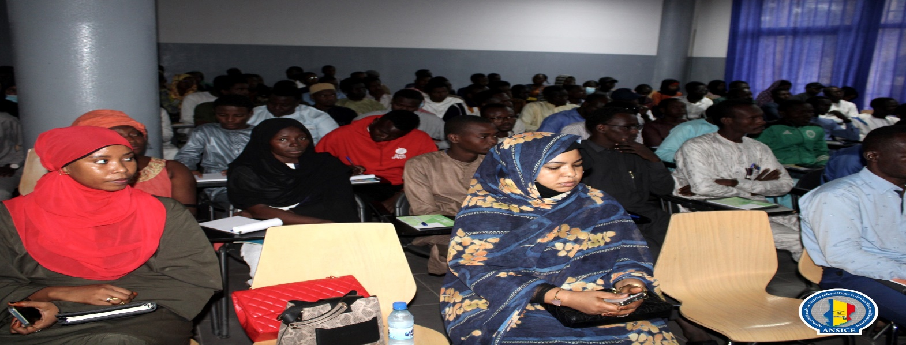Below are the photos:

* We organized another workshop for 100 high school students at Lycée de la Liberté on the topic of raising awareness about the protection of personal data on the Internet, particularly on social media platforms such as TikTok.

Below are the links to the workshop:

* <https://www.alwihdainfo.com/Tchad-L-ONG-House-of-Africa-lance-un-atelier-sur-la-conception-numerique-pour-les-jeunes-a-Abeche_a143708.html?utm_source=chatgpt.com>.
* <https://better-internet-for-kids.europa.eu/en/saferinternetday/house-africa-chad-safer-internet-day-committee?utm_source=chatgpt.com>
* <https://www.africa-press.net/tchad/politique/atelier-numerique-pour-jeunes-a-abeche-par-ong-house-of-africa?utm_source=chatgpt.com>

Below are the photos of the training workshop:

|  |  |
| --- | --- |
| alwihdainfo.com/tchad-la... |  |
|  |  |

### 7.2 Planned Partnerships and Collaborations

* Collaboration with the ITU to benefit from international expertise and pedagogical resources.
* Partnership with local and international NGOs to strengthen the impact of awareness campaigns.
* Establishment of a national network of stakeholders for monitoring and evaluating the initiative.

### 7.3 Recommended Digital Tools and Online Platforms

* Development of a dedicated website for child online protection.
* Establishment of helplines to report inappropriate content or cyberattacks.
* Use of educational platforms to deliver interactive modules to children.

### 7.4 Expected Outcomes of the Awareness Campaign

Through these initiatives, Chad aims to:

* Reduce online risks for children when navigating the Internet.
* Strengthen the vigilance of parents and teachers regarding digital dangers.
* Build a generation of children who are aware of and responsible in their use of ICT.
* Improve national and international cooperation on child online protection.
* Develop a sustainable national framework for educational cybersecurity and the protection of minors.

### 7.5 Future Perspectives and Development

* Expand campaigns to rural areas (provinces and major towns) and remote communities with limited access to information.
* Introduce cybersecurity programs starting from primary school to promote awareness from an early age.
* Create a national platform for reporting and monitoring online incidents involving children.
* Strengthen partnerships with the private sector (ISPs and telecom companies) to secure online content accessible to minors.

### *8. Conclusion*

The Government of Chad’s initiative to implement national awareness campaigns on child online protection is a proactive and strategic approach to ensuring a safe digital environment for children. It seeks to raise awareness, train both educational and family actors, and strengthen international cooperation for the protection of minors.

This initiative reflects Chad’s commitment to actively contributing to global efforts on child online protection and represents a significant contribution to the work of the ITU.

______________