|  |  |
| --- | --- |
|  | **Document C25/INF/16-E** |
| **19 June 2025** |
| **English only** |
|  |  |
| Contribution by China (People's Republic of) | |
| MORE INFORMATION ON THE PROPOSED VENUE BY CHINA FOR THE RA-27, WRC-27 AND CPM31-1 | |
| **Purpose**  Report on the proposed venues for RA-27, WRC-27 and CPM31-1 prepared by the Secretary-General was submitted to the Council. Document C25/58 shows the assessment results of the proposed venues with respect to the ITU basic requirements necessary to host WRC-27 and its associated events.  In addition to the report submitted by Secretary-General, this document provides further information of the venue proposed by China.  **Action required by the Council**  This report is transmitted to the Council for **information**.  _______________  **References**  *Council document* [*C25/58*](https://www.itu.int/md/S25-CL-C-0058/en)*.* | |

# 1 Overview of Expo Center Shanghai

In line with the principles of efficiency and green event planning, the Expo Center Shanghai, a permanent venue from the Expo 2010 Shanghai, is envisioned as the primary venue for WRC-27.

The Expo Center is located at 1500 Shibo Avenue, Pudong New Area, Shanghai, situated on the bank of the Huangpu River. Covering 149,700 squaremeters, the Expo Center features **seven floors above ground and one underground.**

The Expo Center is a high-standard complex providing well-equipped facilities that completely comply with ITU requirements for organizing WRC-27. The complex consolidates in a single venue the required large, small and medium-sized conference rooms, as well as the necessary number of meeting rooms and offices. All meeting rooms are equipped with projectors, sound systems, and other conference equipment, and dedicated internet services are provided as required. It has accumulated extensive experiences and developed a professional service team of local staffs by hosting significant gatherings and competitions. The whole building can accommodate more than 5000 participants and fully satisfy the requirements of all kinds of conference rooms and supporting facilities of WRC-27 such as exhibition space, VIP lounges, office spaces, rest areas, prayer’s room and material storage rooms. The venue can also accommodate all participants for dining simultaneously, where categorized tea break and catering areas can be set on each floor as needed.

The Expo Center Shanghai is just **a 45-minute drive** from Hongqiao International Airport, Hongqiao Railway Station, and Pudong International Airport. The venue is exceptionally well-connected, with three major metro lines traversing the city reachable within a five-minute walk, providing swift, city-wide transport options.

# 2 Overview of hotels around venue

Shanghai has a world-renowned reputation of hotel management, with a wide range of accommodation options at reasonable rates. The international and local branded hotel options are available near the Expo Center. There are **34 hotels with 8,155 rooms** of different grades near the Expo Center to meet the needs of all delegates, among which there are 14 five-star hotels with 5,329 rooms. The list of some hotel was provided to show the distance from venue.

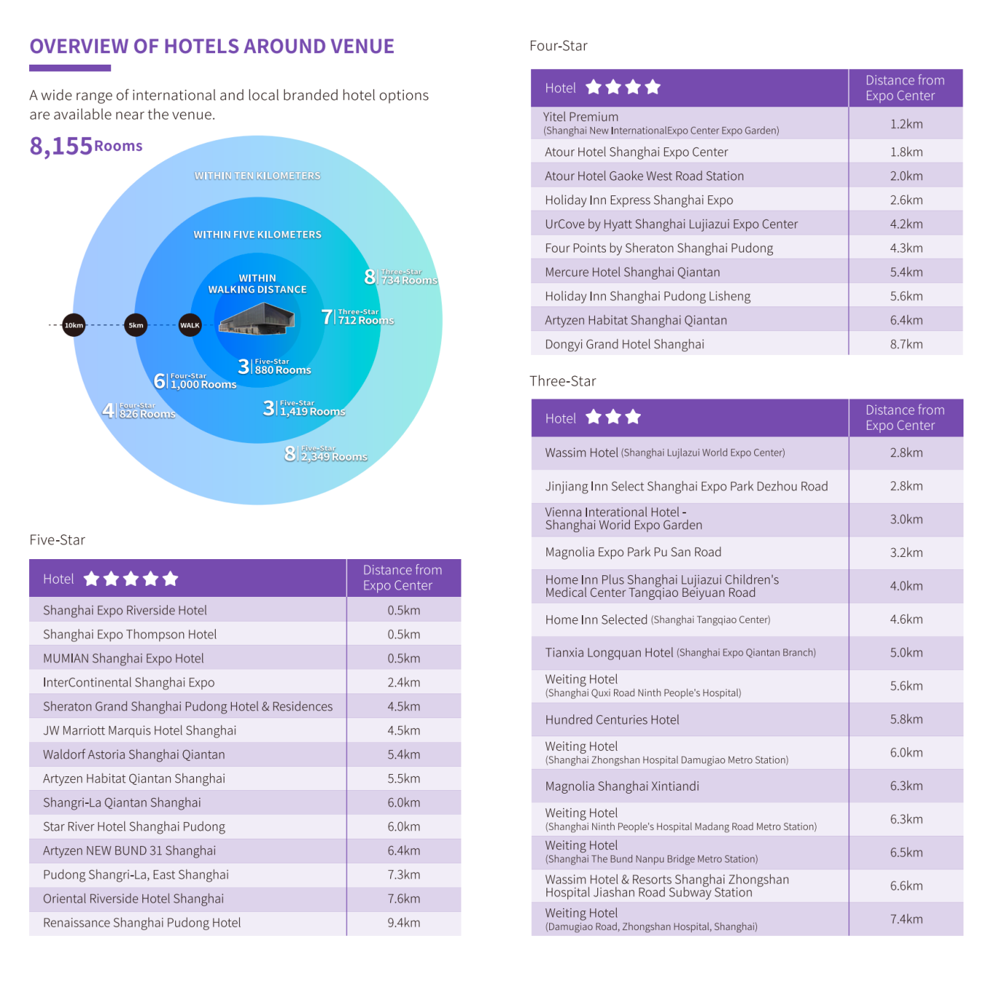

ITU-R Working Party 4A/4B/4C was successfully held in Shanghai from 23 April to 16 May 2025 for a total duration of 24 days. 476 delegates from 80 countries and regions attended the meetings in person in Shanghai, including 365 foreign delegates. The room rate for therecommended **five-star hotel Hilton is about $200 per day**, and **about $90 per day** for the recommended **four-star hotel Holiday Express.**.

# 3 Comprehensive logistics abilities

## 3.1 Convenient Visa Support Services

China currently offers **30-day visa-free** entry to passport holders from 47 countries and grants **240-hour visa-free** transit to foreign nationals from 55 nations. And the number of countries for visas granted on arrival is still increasing.

During the conference, reception and fast customs clearance services will be provided at the main ports of Pudong and Hongqiao airports to ensure an efficient entry experience for attendees. The fast entry of ITU items will also be guaranteed, with green channels provided for ITU equipment, tools, materials, and other supplies.

As one of China's main international gateways, Shanghai has firmly established itself as the "first point of entry" for foreign visitors to China.

## 3.2 International transportation hub

As a pivotal aviation hub in the Asia-Pacific region, Shanghai boasts comprehensive coverage of major international routes, **with over 1,100 international flights** operating daily to and from the city on average, connecting it to 97 international airports around the world.

# 4 Service and support

## 4.1 Discounted Air Tickets for WRC-27 Delegates

Discounted air tickets will be offered to WRC-27 delegates with collaboration with major Chinese airlines.

## 4.2 Airport transfer service

Meeting points will be set up at Shanghai Pudong International Airport and Hongqiao International Airport, and shuttle buses will be arranged to take attendees from the airports to the conference venue or the designated hotels.

## 4.3 Shuttle service between hotels and the conference venue

During the conference, a daily shuttle service will be provided from the accommodation hotels to the conference venue. The frequency of the shuttle service will be adjusted according to the conference schedule. At the same time, a special route for conference vehicles will be opened to ensure they can pass quickly.

## 4.4 Urban transportation services

During the conference, each delegate will be provided with a prepaid Shanghai Urban Transportation Card that follows international conventions. Delegates can recharge their cards independently at any transportation card recharge point or supported online channel in the city according to their personal needs, in order to continue using them.

## 4.5 Complementary Lunches & All-day Coffee and Tea services

Complementary lunches and all-day coffee and tea services will be provided for all participants throughout the conference.

If the WRC meeting runs late, there are plenty of dining options in the area, offering everything from light snacks to speciality dishes to suit different tastes and budgets. Delegates can enjoy delicious cuisine while benefiting from affordability and convenience, with prices starting at just $5 per person.

# 5 Well-facilitated local support

## 5.1 Overall Security Framework

A multi-layered security plan will be developed to cover ITU officials, VIPs, conference venues, hotels and the surrounding areas. A dedicated security coordination group will be set up to facilitate real-time communication with the ITU security team.

## 5.2 Medical support and prioritize treatment

Temporary medical stations equipped with 24-hour first aid supplies and bilingual medical professionals will be set up at the conference venue and major hotels to provide basic medical services for attendees. Waiting areas and separate examination rooms will be provided as required. First aid vehicles will be on standby to ensure a rapid response to designated hospitals in case of emergencies, and green lanes will be provided to prioritise medical treatment for attendees.

## 5.3 Emergency transportation guarantee

A transportation coordination command centre will be set up with real-time links to the transportation, security and medical departments. This will enable a quick response to traffic abnormalities and ensure timely pick-up and drop-off services during busy traffic hours or unexpected situations by using standby vehicles.

Emergency vehicles will be on standby throughout the conference to respond quickly to any unexpected medical needs.

## 5.4 Payment Information

Credit card and cash payments are widely used in China. Point-of-sale (POS) machines that accept VISA, Mastercard, American Express, Diners Club and JCB are widely available in key locations such as airports, business districts, hotels, tourist attractions, shopping areas, tax-free stores and convention centres. Coverage will continue to expand. As a leading international financial and technological innovation centre, Shanghai supports an advanced digital payment system, providing attendees with a convenient and efficient payment experience.

## 5.5 Open and Secure Internet Environment

Shanghai boasts an extensive and technologically advanced mobile communication and fiber broadband network. By the end of 2024, 10G PON (Passive Optical Network) coverage reached 98.3%, with over 180 50G PON ports deployed across the city. Shanghai has achieved comprehensive indoor 5G coverage and gigabit optical network access in all districts, including the Expo Center.

During the ITU-R Working Party 4A/4B/4C meeting, we continued to improve the network service level by optimizing the WiFi deployment in the meeting venue, increasing the conference venue nodes, setting up network dedicated lines, ensuring the international submarine cable bandwidth, and keeping technicians on duty around the clock, so as to provide participants with high-quality Internet access services and clear and smooth online conference services, and meet the requirements of the conference and delegates for the network. ITU-R Working Party 4A/4B/4C meeting had an average of 1,000 online participants per day. Delegates had full access to mainstream international websites and Apps such as Google, Twitter, WhatsApp, Facebook and Instagram, with measured signal peak download speeds of 90 Mbps and peak upload speeds of 95 Mbps. Access latency to the ITU website remained below 200 ms.

# 6 Diversified Catering Resources

Expo Center Shanghai is adjacent to two shopping malls, which offer hundreds of restaurants ranging from casual eateries to fine dining. Guests can enjoy a wide selection of cuisines, including Chinese cuisine, western cuisine, halal food and vegan cuisine.

______________