|  |  |
| --- | --- |
| **Agenda item: ADM 3** | **Revision 1 to Document C25/85-E** |
| **13 June 2025** |
| **Original: Chinese** |
|  |  |
| Contribution by China (People's Republic of) and Cuba | |
| RECOMMENDATIONS ON IMPROVING HUMAN RESOURCES MANAGEMENT IN ITU | |
| **Purpose**  This contribution proposes improvement measures based on the latest developments in ITU's human resources management.  **Action required by the Council**  The Council is invited to **consider** the proposals in the contribution and **approve** the attached draft revision of the Council resolutions concerned.  _______________  **References**  [*CV Article 4, No. 70*](https://www.itu.int/en/council/Documents/basic-texts/Convention-E.pdf)*;*  [*Resolution 48 (Rev. Bucharest, 2022)*](https://www.itu.int/en/council/Documents/basic-texts-2023/RES-048-E.pdf) *of the Plenipotentiary Conference;*  *Council Resolutions* [*1413*](https://www.itu.int/md/S22-CEXT23-C-0007/en) *(C23-EXT),* [*1107*](https://www.itu.int/dms_pub/itu-s/opb/conf/S-CONF-CL-2024-PDF-e.pdf) *(C-1997),* [*1108*](https://www.itu.int/dms_pub/itu-s/opb/conf/S-CONF-CL-2024-PDF-e.pdf) *(C-1997),* [*626*](https://www.itu.int/dms_pub/itu-s/opb/conf/S-CONF-CL-2024-PDF-e.pdf) *(C-1968, last amended C‑1984);*  *Council Decisions* [*638*](https://www.itu.int/md/S24-CL-C-0129/en) *(C24),* [*605*](https://www.itu.int/md/S18-CL-C-0113/en) *(C18),* [*593*](https://www.itu.int/md/S16-CL-C-0138/en) *(C16),* [*517*](https://www.itu.int/md/S09-CL-C-0113/en) *(C04, last amended C09);*  *Council Documents* [*C25/55*](https://www.itu.int/md/S25-CL-C-0055/en), [*C25/66*](https://www.itu.int/md/S25-CL-C-0066/en), [*C25/39*](https://www.itu.int/md/S25-CL-C-0039/en), [*C25/14*](https://www.itu.int/md/S25-CL-C-0014/en), [*C24/71*](https://www.itu.int/md/S24-CL-C-0071/en),[*C23/112*](https://www.itu.int/md/S23-CL-C-0112/en) *and* [*C11/89(Rev.1)*](https://www.itu.int/md/S11-CL-C-0089/en)  *Summary report of the 41st IMAC meeting (Doc.* [*IMAC-41/22*](https://www.itu.int/en/council/Documents/imac/Summary%20%20Report%20of%20the%2041st%20IMAC%20Meeting.pdf)*);*  *Summary record of the 5th CoCo meeting (Doc.* [*CoCo2024/05ADD/02*](https://www.itu.int/en/council/ties/Documents/coco/CoCo2024-05ADD-02.pdf)*)* | |

# 1 Background

The consideration and decision-making of human resources issues is one of the core responsibilities of the Council. Resolution 48 of the Plenipotentiary Conference instructs the Secretary-General "to prepare and implement, with the assistance of the Coordination Committee, and in collaboration with the regional offices, a four-year HRSP aligned with the ITU strategic and financial plans, that includes benchmarks, to respond to the needs of the Union, its membership and its staff". It is therefore the duty of the Secretary-General to continually improve human resources practices and to strengthen reporting to the Council. A number of Council resolutions and decisions[1] contain specific instructions to the Secretary-General to report on human resources-related activities. Important measures have been implemented by the Transformation Team ([C25/55](https://www.itu.int/md/S25-CL-C-0055/en)), the Human Resources Management Department ([C25/66](https://www.itu.int/md/S25-CL-C-0066/en)), the Oversight Unit ([C25/39](https://www.itu.int/md/S25-CL-C-0039/en)) and the Ethics Office ([C25/14](https://www.itu.int/md/S25-CL-C-0014/en)), including on-site training and system enhancements.

According to the HR dashboard on the ITU website, the number of ITU staff members is at an all-time high (see chart below), with the highest growth being recorded for D-grade staff and staff at grades P.3/P.4.

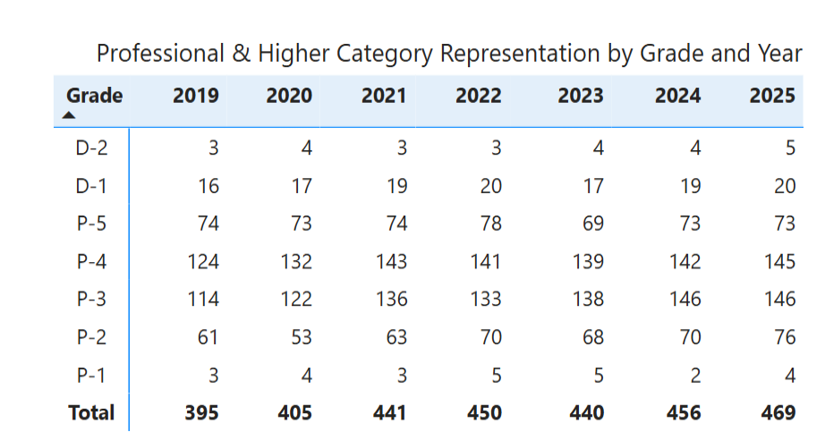

# 2 Discussions

The secretariat is to be commended for its efforts to continuously improve the human resources management of the Union. At the same time, the following should be brought to the Council's attention.

1 For posts of Grade D.1 and above, the summary record of the 5th meeting of the Coordination Committee (CoCo) (Doc. CoCo2024/05ADD/02) shows that on 23 April 2024 "The Secretary-General consulted the group on the plan to unfreeze the existing D2 post of Chief of Administration and Finance and informed the group that the final plans for the restructuring of the General Secretariat will be finalized in the coming months in close consultation with the Coordination Committee. Council will be kept informed, and approvals will be sought as required by the ITU rules and regulations". In accordance with the reorganization plan affecting the General Secretariat that was approved by the Council in 2011 (C11/89(Rev.1)), the D.2 post for the Chief of the Administration and Finance Department, created in 2007, had been frozen and not included in the biennial budget for 2012-2013, resulting in "an overall financial saving". Following the restructuring in 2011, only two posts at the D.1 level were required in the General Secretariat for the Administration and Finance Department, i.e. the Chief of the Human Resources Management Department and the Chief of the Financial Resources Management Department.

No. 70, Article 4 of the Convention authorizes the Council to "decide on proposals for major organizational changes within the General Secretariat and the Bureaux of the Sectors of the Union consistent with the Constitution and this Convention, submitted to it by the Secretary General following their consideration by the Coordination Committee". Council Resolutions 1107 and 1108 authorize the Secretary-General to regrade established posts below the P.5 grade. The adjustment of posts of D.1 and above by the Secretary-General is beyond the scope mandated by the Council. In view of the hierarchy of authority between the Convention and the Resolutions and Decisions of the Council, and the fact that the impact of D-grade posts on the organizational structure is much greater than that of P.5, any changes to posts of D.1 and above, including their creation, freezing, reinstatement and abolition, should be discussed by CoCo and approved by the Council.

2 With regard to recruitment, the report on human resources management (C25/66) indicates that the General Secretariat is working on the revision of the Staff Regulations and Staff Rules, a standard operating procedure for special service agreement (SSA) payment, and simplified SSA recruitment procedures to improve the efficiency of recruitment. Recently, however, the Secretariat has been publishing recruitment announcements mainly directly on the ITU "Careers" website and informing Member States less by correspondence. In particular, some vacancies are advertised online for irregular periods, which makes it difficult for developing countries to understand ITU's talent needs and recommend candidates.

# 3 Proposals

1 The Secretariat is requested to submit to the Council for its review the plan to unfreeze the existing D.2 post for the Chief of Administration and Finance, as well as the final plans for the restructuring of the General Secretariat.

2 The Council is requested to review and approve the two draft revised Council Resolutions attached hereto, clarifying that no adjustments to D.1 and above posts shall be implemented without the approval of the Council.

3 When the Secretariat publishes advertisements of vacancies, it will inform Member States simultaneously by posting on the website and by correspondence, and duly extend the period of posting on the website. The Secretariat will continue to disclose human resources-related information in a complete, clear and timely manner to support Member States in providing suggestions for improvement on human resources and facilitate their access to relevant Service Orders.

annex

RESOLUTION 1107 (C-1997, last amended C25)

Classification

The ITU Council,

in view of

Nos. 70 and 71 of the Convention of the International Telecommunication Union (Geneva, 1992),

authorizes the Secretary-General

after consultation with the Coordination Committee, to regrade, as justified and in accordance with the promulgated classification standards, established posts of the General Service and Professional categories in grades G.1 to P.5, without incurring expenses exceeding the limit of 0.1% of the credits allocated for established posts of the above-mentioned categories in the budget of the Union (base salary, post adjustment and contributions to the Pension Fund and Staff Health Insurance Fund),

in view of

the significant impact that any adjustments to posts at the grade of D.1 and above would have on the organizational structure,

requests the Secretary-General

not to implement any changes to posts of D.1 and above, including freezing, reinstatement or transfer from one sector[/department] to another, without having the proposed changes discussed by the Coordination Committee and approved by the Council,

instructs the Secretary-General

to submit each year to the Council a report on the action taken in pursuance of this Resolution.

This Resolution cancels Resolution 1046.

RESOLUTION 1108 (C-1997, last amended C25)

Post management

The ITU Council,

in view of

Nos. 70 and 71 of the Convention of the International Telecommunication Union (Geneva, 1992),

authorizes the Secretary-General

after consultation with the Coordination Committee, to create or abolish posts in the General Service and Professional categories in grades G.1 to P.5; and to create or abolish posts in grades D.1 and above, subject to discussion in the Coordination Committee and approval by the Council, but in no case incurring any expenditure beyond the budgetary appropriations for staff costs and other staff costs approved by the Council for the General Secretariat and Bureaux as reflected in the ITU budget,

instructs the Secretary-General

to submit each year to the Council a report on the action taken in pursuance of this Resolution.

______________

1. Including, but not limited to, Council Resolution [626](https://www.itu.int/dms_pub/itu-s/opb/conf/S-CONF-CL-2024-PDF-e.pdf) (C-1968, last amended C-1984), Decision [593](https://www.itu.int/md/S16-CL-C-0138/en) (C16), Resolution [1413](https://www.itu.int/md/S22-CEXT23-C-0007/en) (C23-EXT), Decision [517](https://www.itu.int/md/S09-CL-C-0113/en) (C04, last amended C09).