Agenda item: PL.2 | Document C25/76-E
 | 29 May 2025
 | Original: English
Contribution by Malaysia
REFLECTIONS FROM THE WORLD TELECOMMUNICATION AND INFORMATION SOCIETY DAY (WTISD) 2025, INTERNATIONAL GIRLS IN ICT DAY (GICT) 2025, AND THE INTERNATIONAL TELECOMMUNICATION UNION (ITU) 160th ANNIVERSARY CELEBRATIONS IN MALAYSIA – TRANSLATING ITU’S STRATEGIC GOALS INTO ACTIONABLE NATIONAL IMPACT
Purpose
This document provides a summary of the WTISD 2025, GICT 2025, and the ITU 160th Anniversary celebrations in Malaysia, which took place on 17 May 2025 in Cyberjaya, Malaysia. Following the discussions from the events, Malaysia’s achievements on digital connectivity and sustainable digital transformation are also highlighted in this document.
Action required by the Council
The Council is requested to take note of this contribution.
_______________
References
Malaysia’s World Telecommunication and Information Society Day (WTISD) 2025, International Girls in ICT Day (GICT) 2025, and the International Telecommunication Union (ITU) 160th Anniversary; https://www.mcmc.gov.my/en/media/press-releases/malaysia-komited-bina-masa-depan-lebih-inklusif-m

1 Background
1.1 World Telecommunication Day has been celebrated annually on 17 May since 1969, commemorating the founding of the ITU and the signing of the first International Telegraph Convention in 1865. The observance was formally established by the ITU Plenipotentiary Conference held in Málaga-Torremolinos, Spain, in 1973, through the adoption of Resolution 46.
1.2 In November 2005, the World Summit on the Information Society (WSIS) called upon the United Nations General Assembly (UNGA) to declare 17 May as the World Information Society Day. Thereafter, in its 60th session on 27 March 2006, UNGA adopted Resolution A/RES/60/252, officially designating 17 May as the day to raise awareness of the possibilities that Information and Communications Technology (ICT) can bring to societies and economies and of ways to bridge the digital divide.
1.3 Later, in November 2006, the PP-06, held in Antalya, Turkey, adopted an updated Resolution 68 (Rev. Antalya, 2006), deciding to celebrate both the founding of the ITU and World Information Society Day under the combined title of World Telecommunication and Information Society Day (WTISD). The resolution further invited Member States and Sector Members to commemorate WTISD each year by organising appropriate national programmes aimed at promoting dialogue, reflecting on the Council-adopted theme, and sharing outcomes with the wider ITU membership.
1.4 In addition to WTISD, the ITU has also championed digital inclusion through the establishment of the Girls in ICT Day (GICT) initiative, created by Resolution 70 (Rev. Guadalajara 2010) during the PP-10. The initiative aims to inspire and empower girls and young women to embrace information and communication technologies (ICTs) for their educational and socio-economic advancement, and to encourage them to pursue careers in science, technology, engineering, and mathematics (STEM) and tech-related fields. Since its inception on 8 April 2011, the ITU has celebrated GICT annually on the fourth Thursday of April.
1.5 Malaysia has been an active member of the International Telecommunication Union (ITU) since 3 February 1958, demonstrating its long-standing commitment to advancing global telecommunications and information society goals. In recognition of its contributions and active participation, Malaysia has been elected to the ITU Council multiple times, representing Region E (Asia and Australasia) during the terms 1973-1982 (Málaga-Torremolinos, 1973), 1990-1992 (Nice, 1989), 1993-1994 (APP-92), 1999-2002 (PP-98), 2003-2006 (PP-02), 2007-2010 (PP-06), 2011–2014 (PP-10), and most recently for the 2023–2026 term in PP-22. Through its role on the Council, Malaysia continues to support the ITU's strategic direction, contribute to global ICT policy development, and promote inclusive and sustainable digital transformation across Member States.
1.6 The ITU 160th Anniversary marks a historic milestone since the organisation’s founding in 1865 as the International Telegraph Union. As the oldest United Nations (UN) specialised agency, ITU has played a pivotal role in advancing global telecommunications and ICT development. The anniversary celebrates ITU’s legacy of international cooperation and its ongoing mission to foster inclusive, secure, and connected digital societies.
1.7 On 17 May 2025, Malaysia organised a 1-day event to celebrate all three (3) programmes —WTISD 2025, GICT 2025 and the ITU 160th Anniversary, where Malaysia has arranged for several panels and speaking sessions. The event was officiated by YB Datuk Fahmi Fadzil, Ministry of Communications Malaysia and was also attended by Mr Kishore Babu Yerraballa, ITU Area Representative for Southeast-Asia and other Member States in the Pacific. The event welcomed over 500 participants, with seven (7) industry partners showcasing their initiatives through exhibition booths.
1.8 During the event, Malaysia also launched the ITU 160th Anniversary Stamp (Malaysia Edition). The stamps are exclusively produced along with other collaterals compiled as a Folder Set, as shown below:
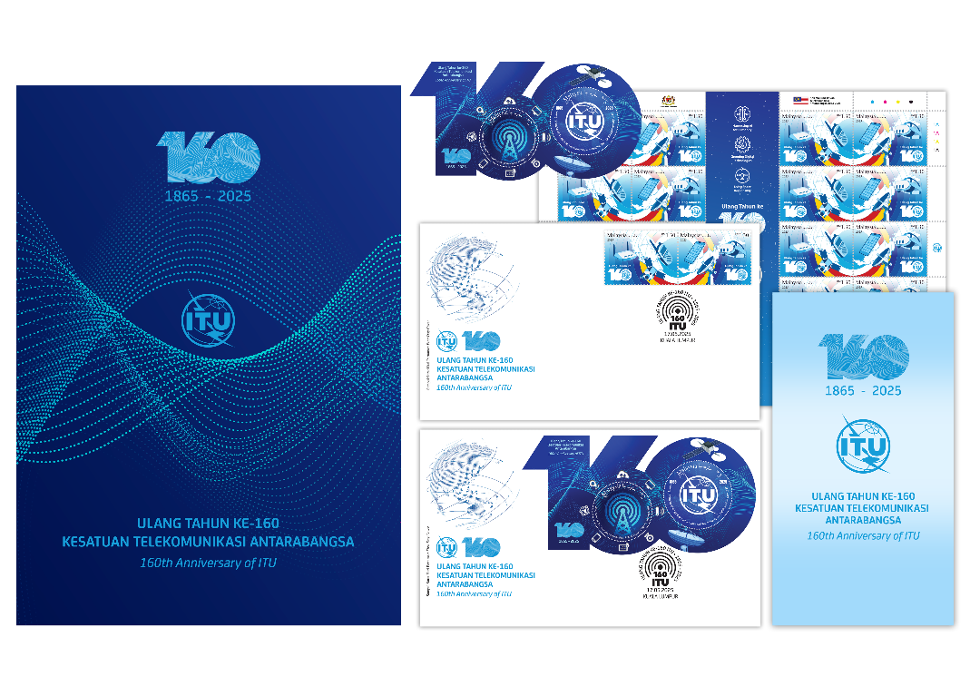

2 WTISD 2025

2.1 Introduction
In 2023, the ITU Council adopted Resolution 1416, dedicating the WTISD 2025 theme to “Gender Equality in Digital Transformation,” which highlighted the urgent need to bridge gender and digital gaps through inclusive policies, education, and partnerships. The programme underscored the importance of inclusive policies, digital literacy, and collaborative efforts to ensure that everyone can benefit from digital transformation. In her keynote via video recording, Dr. Atsuko Okuda, ITU Regional Director for Asia and the Pacific, commended Malaysia’s leadership in fostering digital inclusion and emphasised the role of education, partnerships, and youth engagement in bridging the digital gender divide. She called for continued collaboration to build a more inclusive, secure, and sustainable digital future across Malaysia and the Asia-Pacific region.

2.2 Dialogue 1: The future of connectivity: advancing digital inclusion through transformation technologies
The session focused on the role of transformative technologies such as 5G, AI, and cybersecurity in advancing digital inclusion. It emphasised Malaysia’s progress in digital infrastructure through the National Digital Infrastructure Plan (JENDELA), the socio-economic benefits of broadband access, and the growing importance of cybersecurity and digital literacy. Discussions also addressed how regulatory evolution and inclusive training programmes are critical in ensuring that digital transformation is future-ready, equitable, and sustainable.
Key outcomes:
– JENDELA’s role in expanding infrastructure: Malaysia’s JENDELA initiative has significantly accelerated broadband and 5G coverage, achieving over 82.4% 5G coverage and 98.66% population coverage, well ahead of schedule. This robust infrastructure forms the foundation for an inclusive national digital transformation.
– Cybersecurity as a pillar of digital trust: Cybersecurity capacity-building initiatives, including rural outreach and support systems (e.g. scam reporting hotlines, kill switches), have strengthened public confidence in digital services, a vital enabler of broader digital adoption and safe transformation.
– Future-ready and inclusive workforce development: Programmes such as free training for women and underserved communities, and the 5G Pioneers course reflect efforts to ensure that Malaysia’s digital future is inclusive, skills-driven, and environmentally conscious, with a strong emphasis on upskilling for emerging roles.
– Community empowerment through digital inclusion: National efforts like the National Information Dissemination Centre (NADI) centres, AI Teach programmes, and smart farming initiatives illustrate how meaningful connectivity empowers communities beyond access by enabling productive, safe, and informed participation in the digital economy.

2.3 Dialogue 2: Borderless connectivity: How ICT can drive sustainability, equality and safety
The session explored how ICT enables borderless connectivity that drives sustainability, equality, and safety. Key discussions highlighted the importance of real-world user adoption in maximising technology impact, the integration of ICT in urban and utility services, the development of green digital infrastructure, and the role of education in preparing a future-ready digital workforce. It also emphasised the need for inclusive cross-sector collaboration to ensure that digital transformation remains both impactful and sustainable.
Key Outcomes:
– User-centric technology adoption: Effective digital transformation depends not just on infrastructure but also on real-world relevance and user adoption. Technologies like QR codes and e-wallets only gained traction when linked to immediate, everyday needs, underlining the importance of designing ICT solutions that address tangible public challenges.
– Next-generation talent and infrastructure readiness: The Multimedia University’s upcoming AI and 6G research lab, along with sustainability-integrated curricula and industry-linked programmes, demonstrates how education can prepare a future workforce equipped to lead and sustain Malaysia’s digital economy.
– Smart cities for sustainable urban development: TM’s smart city initiative in Ipoh, featuring AI-driven traffic management and public mobility solutions, illustrates how ICT can reduce carbon emissions and improve urban quality of life through more efficient infrastructure.
– Strengthening national and global connectivity: TM’s investments in submarine cable systems like CMEW6 and ALC position Malaysia as a key player in regional and global digital infrastructure, enhancing the nation’s digital resilience and economic competitiveness.

3 GICT 2025

3.1 Introduction
GICT 2025, themed “Girls in ICT for inclusive digital transformation”, emphasised the importance of empowering girls and young women with the skills and opportunities to lead in the digital age. In his keynote, Mr Kishore Babu Yerraballa, ITU Area Representative for Southeast Asia and the Pacific, encouraged lifelong learning through free ITU Academy courses and highlighted initiatives such as AI for Good and child online protection tools. He also recognised Malaysia’s digital leadership and called for stronger cross-sector collaboration to ensure no one is left behind in the digital transformation journey.

3.2 Pocket-Talk 1: From learners to leaders: empowering the next generation of women in tech
The session focused on empowering women to transition from learners to leaders in the tech space by addressing internal barriers, encouraging mentorship, and promoting inclusive support systems. It highlighted the importance of confidence-building, everyday role models, and structured mentorship in preparing women to take on leadership roles and drive inclusive digital transformation.
Key Outcomes:
– Mentorship as a catalyst for digital talent development: Structured mentorship programmes create pathways for young women to gain hands-on experience in the digital and tech sectors, fostering a more diverse and skilled digital workforce essential for sustainable digital transformation.
– Confidence building to unlock leadership in digital spaces: Overcoming internal barriers enables more women to step into digital leadership roles, promoting gender-inclusive innovation and decision-making in digital connectivity initiatives.
– Active partnership strengthens inclusive digital ecosystems: Male champions' involvement in supporting and uplifting women leaders fosters a collaborative culture that enhances organisational capacity to drive sustainable digital transformations.
– Everyday empowerment drives grassroots digital change: Small, consistent acts of encouragement and role modelling within communities contribute to sustainable growth in digital literacy and leadership, ensuring broader participation in the digital economy.

2.3 Pocket-Talk 2: Tech for all: how diversity fuels innovation – and why children’s voices must lead
The session emphasised the vital inclusion of children’s voices in digital innovation to create technologies that are safe, accessible, and uphold children’s rights. It highlighted the importance of genuine child participation and promoted co-design approaches that actively involve children, including those with special needs. The discussion underscored adherence to UNICEF’s child-centred AI principles, the adaptation of global best practices to local contexts, and the development of gender-sensitive policies. Meaningful engagement with youth in policymaking and advocacy was identified as essential to protecting and empowering children in the digital era.
Key outcomes:
– Inclusive innovation through child participation: Integrating children as co-designers ensures digital technologies are tailored to diverse needs, improving accessibility and safety—key factors for sustainable digital transformation.
– Child rights-based approach to digital design: Embedding safeguards aligned with children’s rights (e.g. privacy, safety, agency) promotes trustworthy digital environments that support long-term digital inclusion.
– Meaningful engagement with authentic participation: Genuine involvement of children in decision-making nurtures digital literacy and empowerment from an early age, promoting the sustainable growth of digital ecosystems.
– Adoption of global child-centred ai principles locally: Applying UNICEF’s principles and adapting proven international child protection policies enhances Malaysia’s capacity to safeguard children in emerging digital technologies, ensuring sustainable and equitable digital connectivity.

4 Malaysia’s achievements on digital connectivity and sustainable digital transformation
4.1 At the national level, Malaysia’s efforts under JENDELA continue to drive progress in online connectivity. As of Q1 2025, over 9.24 million premises have been provided access to high-speed Internet and fibre connectivity, surpassing the initial target of 9 million by 2025. The country’s mobile broadband speed has reached a median of 169.04 Mbps, while Internet coverage in populated areas has risen to 98.66%, steadily progressing towards full national coverage.
4.2 Malaysia’s broader digital vision extends beyond infrastructure. The successful deployment of 5G has enabled 82.4% coverage in populated areas, with a mobile penetration rate of 51.56%. This advancement is expanding access to digital services and opportunities across sectors including education, healthcare, manufacturing, and rural development.
4.3 These efforts are supported by strong public-private collaboration, ensuring that digital transformation is inclusive, equitable, and sustainable. Malaysia is committed to ensuring that every citizen, regardless of background or location, can access and benefit from digital tools and opportunities.
4.4 Malaysia’s achievements have also received international recognition. At MWC Barcelona 2025, ZTE Malaysia received the GSMA Foundry Innovation Award for its Minimalist Private 5G for Entertainment. Additionally, the Malaysian Communications and Multimedia Commission (MCMC) was named a WSIS Prizes Winner (2023) for JENDELA, and a WSIS Prizes Champion (2024) for its digital outreach to Orang Asli communities. In 2025, 25 Malaysia-led initiatives were shortlisted for the WSIS Prizes—Malaysia’s highest number to date. From these, four (4) initiatives have been announced as WSIS Prizes Champions.
4.5 One of these projects is NADI, which provides Malaysians of all backgrounds with access to digital literacy and upskilling programmes. NADI bridges the gap between infrastructure availability and capability, ensuring that connectivity translates into meaningful and lasting empowerment.
4.6 National efforts to integrate women into the ICT sector continue to gain momentum. In 2025, the Ministry of Education announced that beginning in 2026, 70% of students in fully residential schools will pursue Science, Technology, Engineering and Mathematics (STEM) streams, aiming to produce 60,000 skilled talents to meet growing industry demands in high-tech sectors such as semiconductors and electronics. Women now represent 35% of the technology workforce, with female labour force participation reaching 51.6% in 2023. These statistics reflect growing interest and investment in advancing gender equality in digital and technology fields.
4.7 To further empower women in ICT, NADI has trained over 4 000 entrepreneurs as of March 2025, including more than 3 390 women. This initiative supports inclusive digital entrepreneurship, particularly in underserved communities. For 2025, the target is to reach 7 000 participants, equipping them with skills to expand businesses through e-commerce platforms, as part of Malaysia’s commitment to local economic development and community empowerment.
4.8 Malaysia also remains vigilant in ensuring a safe and secure digital environment. Malaysia continues to lead efforts to protect users from cyber threats, safeguard personal data, and promote responsible Internet use. The “Kempen Internet Selamat” campaign is one such initiative, focused on raising awareness of online safety across all segments of society, particularly among vulnerable groups.
4.9 Malaysia recognises that inclusive digital transformation is not only about access, but also about safety, literacy, and empowerment. In this regard, Malaysia intends to continue its efforts to encourage young women and underserved communities to see themselves as leaders in ICT, whose ideas and innovations can shape the future of the digital world.

5 Conclusion
Malaysia’s celebration of WTISD 2025, GICT 2025, and the ITU 160th Anniversary exemplifies how a Member State can successfully align national initiatives with the ITU’s strategic objectives. Key accomplishments —such as 82.4% 5G coverage, 35% female participation in the tech sector, and 25 WSIS Prize nominations— highlight models that can be replicated by other nations. Malaysia’s integrated, multi-stakeholder approach illustrates the effective utilisation of resources and significant impact across ITU initiatives. This experience provides valuable insights into public-private partnerships, inclusive digital transformation, and international cooperation. Reflecting its long-standing commitment to the ITU since 1958, Malaysia has combined robust infrastructure development with inclusive programmes like NADI to ensure that connectivity translates into empowerment. The ITU is encouraged to build upon this by supporting knowledge-sharing platforms and establishing regional centres to advance global digital development.

______________

