Agenda item: PL.1 | Document C25/55-E
 | 19 May 2025
 | Original: English
Report by the Secretary-General
UPDATE ON ITU TRANSFORMATION PROCESS AND ROADMAP
Purpose
This document reports on the status of the Transformation process to achieve Organizational Excellence.
Action required by the Council
The Council is invited to note the progress achieved to date.
Relevant link(s) with the Strategic Plan
Excellence in human resources and organizational innovation.
Financial implications
Any additional financial or human resources to fulfil the objectives of this programme are proposed in Document C25/43.
_______________
References
Council Documents C20/61, C20/74; C21/INF/15; C22/INF/13, C22/40, C22/57; C23/36, C23/50, C23/62, C23/INF/11, C23/INF/13; C24/19, C24/53, C24/31; C25/50, C25/66

1 Introduction
In January 2023, ITU’s leadership team launched the ITU Transformation Process based on a comprehensive visioning process that involved extensive input from staff and experts at all levels of the organization.
ITU Transformation is a shared opportunity and collaborative in nature requiring agility, continuous learning, and change management. This period of Transformation has been defined by project implementation and tangible deliverables across the five pillars.
Following the previous status updates at the Council Working Group on finance and human resources (CWG-FHR) in November 2024 and February 2025 and summarized in the Report of the Chair of the CWG-FHR (Doc. C25/50), this document provides further information on ITU’s ongoing Transformation Process. Moreover, following discussions in CWG-FHR and CWG-LANG in February 2025, a progress report on the New Website Project has been provided as an Annex to this document.

2 Transformation roadmap
This year, the Transformation effort continues to build momentum. As the Transformation Portfolio matures, teams across ITU are increasingly involved in each initiative and are empowered to deliver these end-to-end changes. ITU Transformation is not solely a technical effort, but aims to create an agile, capable and empowered workforce that puts people at its centre. Fig. 1 provides an overview of ITU’s current Transformation portfolio and indicates where initiatives have either started or have now been completed, as well as initiatives in the pipeline. Completed initiatives will be monitored for continuous improvement.
The online Transformation Dashboard can be accessed through this link.

Transformation initiatives overview
Governance | Systems, processes,  & tools | People & culture | Resource optimization | Members & partners
ONGOING AND COMPLETED INITIATIVES
Accountability framework and delegation of authority  Audit and oversight | AI implementation  Information governance and knowledge management | Leadership culture  Recruitment  Performance management  Mobility  Staff engagement | Travel  Extrabudgetary fund management  Budget Allocation  Management ^{Completed}  Financial Regulation and Rules ^{Completed}  Treasury Management ^{Completed} | Engagement with UN / digital ecosystem  Website, branding and external communication  Resource mobilization  Conference and event management  Communication and media  CRM system
UPCOMING INTIATIVES
Risk management and compliance  Strategic prioritization and financial alignment  Corporate governance and decision-making framework  Results-based framework  Internal control framework | Document management  Target operating model  Lean and continuous process improvement  Enterprise architecture  Data strategy and management  Technology platform review  IT service delivery model | Skills, competency and talent development  HR service delivery model  Staff administration  Payroll  Succession Planning  Gender parity  ERP System (HR) | Planning and budgeting  Procurement and contracts management  Financial accounting and reporting  ERP system (Finance) | Service delivery model  Member engagement  Modern products and services

3 Progress on the Transformation Initiatives
Since the last update to the Council, various transformation initiatives have progressed, including the Six Accelerated Initiatives.
These initiatives have been selected based on an assessment of their business readiness and impact, costs, benefits, and risk. Below is a summary of the key achievements and work completed to date.

3.1 Six Accelerated Initiatives: priority transformation projects

3.1.1 Performance management
Goal: To implement a simpler, fairer, and results-driven performance management process that motivates employees and drives organisational success.
✓ Simplified the 2024 end-of-year evaluation and 2025 work plan tool to reduce completion time by 50%, to strengthen alignment of goals to ITU organisational priorities, and to create an overall more efficient process that focuses on regular and systematic feedback.
✓ Reviewed ITU’s process of managing underperformance to develop a clearer and more streamlined process to support staff and their managers.
✓ Developed a concept note to implement a new and transparent Rewards and Recognition framework to recognize excellent performance and award team excellence.
KPIs: Number of workplans completed on time; number of year-end reviews completed on time; % of performance issues addressed at the informal stage.

3.1.2 AI implementation
Goal: To leverage the potential of AI to boost innovation, efficiency, and decision-making, ensuring ITU maintains a competitive edge and delivers greater value to stakeholders.
✓ Equipped 100 Copilot Champions with licenses and launched an upskilling program to train on the use of Microsoft Copilot for effective adoption. Expansion will follow during the second half of 2025 based on pilot results.
✓ Drafted first guidelines for the use of Generative AI at ITU to ensure ethical and responsible use of the technology.
✓ Initiated prototyping of AI “Agents” to facilitate better management of multistep and long-running tasks across different business streams (HR, Finance, Conferences).
KPIs: Percentage in time savings following adoption of AI tools per use case; number of automated processes deployed; percentage of adoption of Copilot Champions; percentage of Copilot Champions having completed the upskilling programme.

3.1.3 Leadership culture
Goal: To instil leadership values at all levels; fostering a culture of respect, integrity, and a willingness to work together.
✓ Launched the first All-Staff Engagement Survey in January 2025 with 72% response rate. The data helps to identify immediate priority areas for improvement. ITU-wide and Bureau-level teams are mobilized to drive the action planning at a grassroot level, with ongoing tracking of progress.
✓ Conducted an adaptive leadership programme across the organisation tailored to the needs and challenges of different ITU management levels, addressing outcomes of the Employee Engagement Survey and following up on the Senior Management Retreat.
KPIs: Number of trainings offered; number and percentage of staff trained; staff engagement survey participation rate; staff engagement score.

3.1.4 Recruitment
Goal: To improve the efficiency of the end-to-end recruitment process and to attract the right talent.
✓ Streamlined SSA (individual consultants/experts) and fixed-term policy and workflows have been drafted.
✓ Automation and AI solutions have been identified.
KPIs: Average turnaround time to recruit from advertisement to approved selection; percentage of rejected offers.

3.1.5 Travel
Goal: To streamline operations and automate workflows to improve compliance, reduce cost, and provide real-time visibility.
✓ Identified the main challenges in our internal travel process.
✓ Established an implementation plan for an end-to-end digitised solution to enable full self-service of the Travel process for all staff.
KPIs: Number of travel requests processed through full self-service; processing time of travel requests; processing time of travel claims; customer satisfaction score.

3.1.6 Mobility
Goal: To introduce a mobility process that builds a strong global workforce by providing varied and hands-on opportunities for professional development.
✓ Developed new Concept Note for a Mobility “pilot”, with implementation to start in Q4 2025.
✓ Reviewed the current Mobility policy in collaboration with ChangeMakers.
KPIs: Number of staff participating in the mobility pilot program.

3.2 Other ongoing transformation projects by pillar

Governance

3.2.1 Accountability framework and delegation of authority
Goal: To further strengthen the accountability mechanisms within the organization while streamlining work processes and increasing efficiencies.
✓ Project has been initiated to create a new delegation of authority framework for ITU.
✓ The new framework seeks to decentralize decision-making, align authorities with responsibilities, and strengthen accountability.
KPIs: Number of approvals reduced.

3.2.2 Audit and oversight
Goal: To strengthen the organization with an effective system of risk-based, independent, and objective internal oversight and evaluation.
✓ Recruitment of an Evaluation Officer underway.
✓ ITU-wide formal training in Evaluation Management to be provided to a voluntary group of staff, to support the Oversight Unit in piloting an initial standardized ITU evaluation policy.
✓ Adoption of shared service model for the Ombudsman function through UNOMS to reinforce institutional integrity, dispute resolution mechanisms, and workplace accountability.
KPIs: Number of open compliance recommendations; number of implemented compliance recommendations; number of personnel utilizing the Ombudsman function and number of disputes resolved informally through mediation.

Systems, processes & tools

3.2.3 Information governance and knowledge management
Goal: To manage ITU information effectively, efficiently, and securely throughout its lifecycle, ensuring that it is reliable, accurate, complete, and relevant to support decision-making, accountability, transparency, business continuity, and knowledge transfer.
✓ Developed the ITU Information Governance Strategy.
✓ Plan to establish an ICT Governance Committee Working Group to address Information Governance and Management issues.
✓ First phase – Implementation of the Information Governance in M365 in progress.
KPIs: Number of recommendations implemented.

Resource optimisation

3.2.4 Extrabudgetary fund management
Goal: Through the implementation of more streamlined processes on Extrabudgetary funds (EXB) the Secretariat ensures improved reporting on extrabudgetary resources allowing for improved financial compliance and decision-making.
✓ Extrabudgetary funds processes and reporting are better aligned to business requirements.
✓ Next step is to develop executive dashboards.
KPIs: EXB funds management processes clearly defined; reports issued on grant implementation on time.

Members and partners

3.2.5 Website, branding and external communications
Goal: To improve the ITU website with modern and mobile-responsive features, enhanced search functionality, security, user experience and harmonization.
✓ A new website is under steady development, with plans to have a modern, mobile-responsive, secure, multilingual, and harmonised website by PP-26.
KPIs: Website user satisfaction survey score.

3.2.6 Conference and event management – Document processing
Goal: To streamline and harmonize conference and event documentation at ITU.
✓ Project being developed to streamline and standardise the document management process to improve members’ experience for ITU Conferences and Assemblies.
KPIs: Turnaround time from submission to publishing; member satisfaction survey.

3.2.7 Communications and media
Goal: To enhance staff experience and engagement through a modern internal communication platform for staff.
✓ Develop and implement a pilot of an integrated solution, designed to enhance communication, collaboration, and knowledge-sharing while facilitating new ways of working among ITU personnel.
KPIs: Adoption rate: active participation of the users; platform engagement (visits, posts, comments); staff satisfaction survey for the usage of the platform; reduced email volume for internal updates; participation in cross-departmental campaigns or groups.

3.2.8 Resource mobilization & CRM system
Goal: To strengthen ITU-wide coordination of member and partner engagement, fundraising and event management.
✓ Developed a roadmap for CRM implementation.
✓ First step use cases have been prepared for ITU-wide coordination of resource mobilization and partner engagement as well as executive bilateral meeting preparation and follow-up to improve efficiencies and impact.
✓ Roadmap also includes:
o Service management module empowered by AI to modernize and improve efficiency of service delivery processes across ITU, including IT service desk and other internal and delegate services.
o Marketing module to enhance the user journey and experience and personalized engagement.
o Event management to follow to improve delegate experience, reduce internal administrative processes through automation and using AI tools and enable potential new revenue-generating business models.
KPIs: For resource mobilization: report on prospective partners/donors/sponsors and members, conversation rates and total revenues and growth year over year. For service management: measure improvements in efficiency, including reduce average time to resolve requests and reduce average cost to handle and resolve support tickets due to automation/AI agents, and improved client satisfaction. For event management: improve participant satisfaction, simplified processes for staff and participants, reduced cost/staff time for event organization.

3.3 Completed transformation initiatives

3.3.1 Budget allocation management
Goal: To ensure that budget allocation across ITU is managed effectively and in line with resources to ensure continuity towards priority initiatives, maximizing impact through the rationalization of fund management.
✓ Ensured budget allocation and revenue are in alignment in 2025.
KPIs: Approved budget aligned with forecasted revenue at beginning of year; quarterly reviews on revenue forecasts and adjustments made to allocated budget.

3.3.2 Financial regulation and rules
Goal: To ensure improved financial management, greater transparency and accountability.
✓ Ensured ITU is fully IPSAS compliant.
KPIs: 100% compliance with IPSAS on issuance of financial report; financial report issued by 31 March of the following year.

3.3.3 Treasury management
Goal: To improve investment decisions for ITU.
✓ Ensured ITU has complete information prior to investment decisions including awareness of currency and market risks.
✓ Treasury Committee has been formally established.
✓ Related Investment policy has been adopted.
✓ Currency risk management needs to be integrated into treasury operations.
KPIs: Treasury Committee is formally established; Committee makes investment decision in accordance with the investment policy.

4 Benefits and efficiency gains
The Transformation Initiatives implemented thus far have begun delivering measurable benefits across ITU, both in terms of operational efficiency and organizational transformation.
Strengthened engagement, leadership and culture: The launch of the first all-staff engagement survey, with a participation rate of 72%, has enabled a data-driven approach to staff experience and provided clear areas for leadership improvement, which is supported by a tailored training programme for leadership skills building.
Enhanced operational efficiency and cost effectiveness: Performance evaluations now take 50% less time. The realignment of budget and revenue under the resource allocation and extrabudgetary fund management projects has optimized resource use, ensuring funds are directed toward the highest-priority initiatives. Improvements in treasury management and financial regulation have strengthened financial transparency and compliance.
Enhanced institutional agility and productivity through digital tools and innovation: The adoption of AI tools has laid the foundation for smarter, faster decision-making, helping staff to reduce 8-10% time on manual and repetitive tasks and to focus on high-value work. Going forward, the benefit and efficiency gains across all initiatives will be continuously monitored and reported upon throughout the implementation.

5 Timeline
Transformation efforts on the Six Accelerated Initiatives began in 2024. Since January 2025, Transformation has consolidated its portfolio of initiatives and enabled many more to move into their implementation phase. The table below provides a timeline overview of ongoing initiatives.
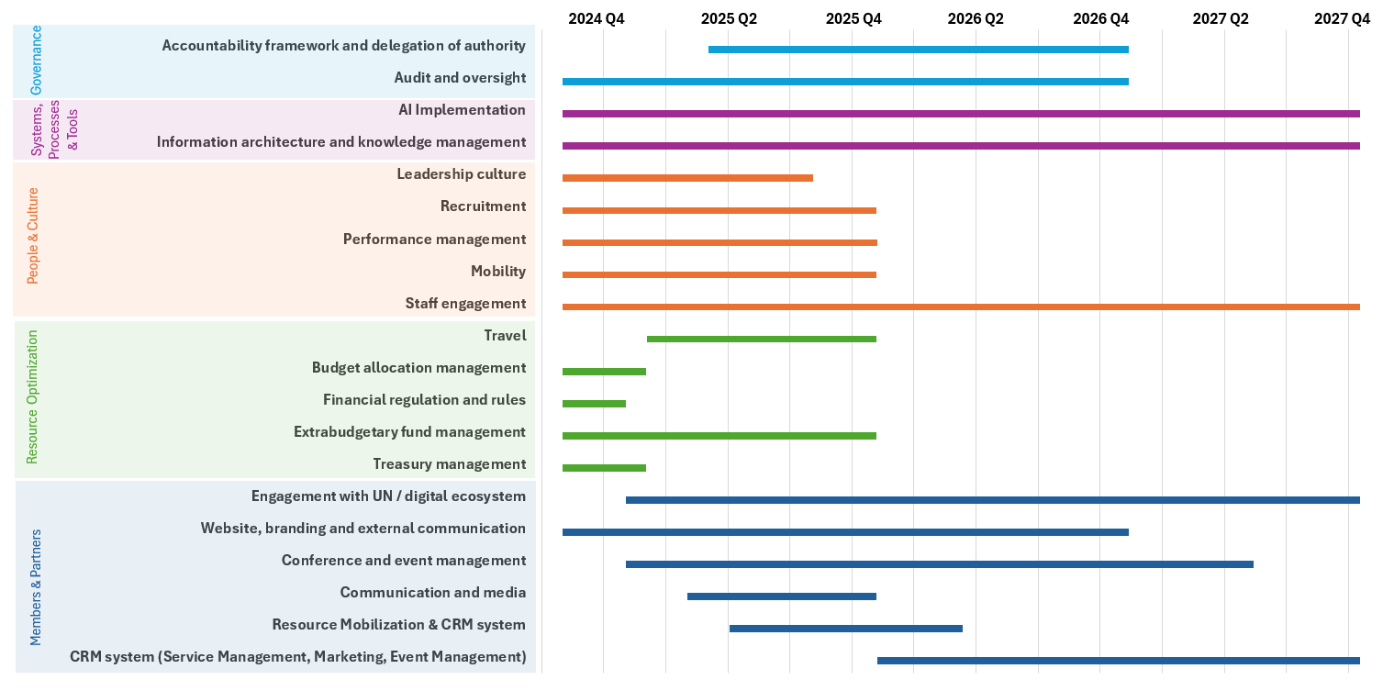

6 Communicating change
Many are involved in ITU’s Transformation. There is regular dialogue between the Transformation Team and Staff Council to ensure staff voices are consistently heard; a dedicated space for Transformation updates in the staff internal newsletter, and a Transformation Team member focused on facilitating the Changemakers’ network –a group of over 90 voluntary staff engaged in the Transformation process– to maintain a healthy sense of momentum. A dedicated Transformation intranet site will be launched to consolidate the Changemakers’ portal, the AI Hub and serve as a communication vehicle to staff for all transformation project updates.
The Adaptive Leadership training will be instrumental in building a common leadership language across ITU. It will train a large percentage of staff to approach change and its associated challenges with an adaptive mindset - whether as an individual, as a team, or at the organizational level. This training is part of the overall change management strategy to equip staff with the skills to navigate complexity, drive change, and lead with agility in today’s dynamic environment.

7 Financial implications
Funding of ITU Transformation will come from regular budgetary allocations. Additional allocations may be sought to ensure adequate capacity and expertise to implement the initiatives.
During 2025, certain Transformation initiatives requiring support through additional funding have been factored into the budget. However, the Transformation Team has worked to ensure that ITU makes the most of its existing resources and keeps costs to a minimum.
Annex
Website project progress update

1 Introduction
Following approval of the Roadmap (Doc. C24/53) at Council 2024, the New Website Project was launched. As improvement of the website is a cross-cutting issue with financial implications, it was discussed in parallel at the 16th meeting of CWG-LANG and the 20th meeting of CWG-FHR in February 2025 in line with a Member State Contribution (Doc. CWG-FHR-20/21). Subsequently, the secretariat was requested to present an update to Council in June 2025.

2 Timeline to improve ITU website search and harmonization
The project focuses on developing a modern, mobile-responsive, secure, and multilingual website, characterized by a unified information architecture and well-defined taxonomy. The aim is to provide strong search capabilities, user-friendly navigation, and consistent branding and messaging. The goal is to ensure a design that prioritizes and enhances the user experience.
Two Requests for Proposals (RFPs), one on Information Architecture and Taxonomy and another on Website Development Agency, are in progress. Proposals for both RFPs have been received and are being evaluated.
Business requirements regarding the website have been gathered across the three Bureaux and the General Secretariat.
Analysis of the TSB webpages is ongoing. This will be followed by GS, BR, and BDT webpages. Due to the large amount of data, the cleaning-up phase is taking longer than originally estimated and ideally should be finished before going live. The outcome of the clean-up phase will serve as input to the governance framework to keep the website content up to date.
The roadmap has been refined since the start of the project execution. The project timeline with main milestones is shown below.
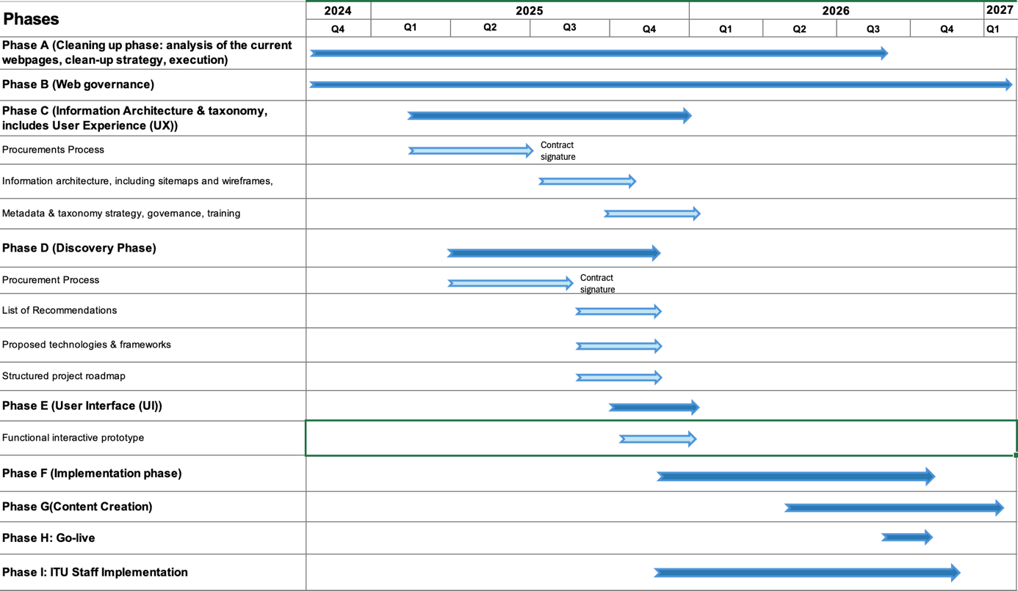

2.2 Financial implications
The project requires an estimated budget of CHF 600K (as part of the transformation roadmap and budget). As reported verbally to CWG-FHR in October 2024 and to CWG-FHR in February 2025, CHF 350K of the required CHF 600K has been allocated, allowing the project to start. The remaining CHF 250K budget requirements are included in Document C25/43, distribution of savings achieved in 2024, for consideration by the Council.

Estimated details

2.3 Estimated expenses by project phases
Phases | Estimates CHF 2025
Phase C (Information Architecture and Taxonomy, includes User Experience (UX)) | 200K
Phase D (Discovery Phase) | 150K
Phase E (User Interface (UI)) | 50K
Phase F (Implementation Phase) | 200K
Total | CHF 600K

______________

Information on the Engagement Survey can be found in Document C25/66.
Document C25/44 contains more information on Audit and Oversight.

