Agenda item: ADM 1 | Document C25/43-E
 | 22 April 2025
 | Original: English
Report by the Secretary-General
ALLOCATIONS OF SAVINGS ACHIEVED IN 2024 BUDGET IMPLEMENTATION
Purpose
The purpose of this document is to request the Council to authorize the use of savings from the 2024 budget implementation to finance certain activities that are not covered by the Union’s regular budget.
Action required by the Council
The Council is requested to approve the draft resolution annexed to this document.
Relevant link(s) with the Strategic Plan
This document is consistent with the 2024-2027 strategic plan.
Financial implications
Allocation of KCHF 5 060 of the savings achieved in the 2024 budget implementation to finance activities that are not covered by regular budget.
__________________
References
Decision 5 (Rev. Bucharest, 2022); Resolution 11 (Abrogated. Bucharest, 2022) of the Plenipotentiary Conference; Council Resolutions 1111 and 1338; Council Document C24/19

1 Introduction
The implementation of the 2024 budget ended with a surplus of KCHF 5 652. It is proposed to use the sum of KCHF 5 060 from this surplus to finance some activities that are not covered by the regular budget.
This surplus resulted from rigorous management of costs to make available funding for priorities which had not been funded or fully funded in the Financial Plan 2024-2027, and which have become necessary since it was developed in 2021/2022. The following factors and the full result will be further specified in the audited Financial Statements for 2024, which will be separately presented to the Council. More details are in the following sub-paragraphs:
1.1 Spending Controls: During 2024 the secretariat exercised rigorous management of spending based on anticipated shortfalls in projected revenue compared to the ITU Financial Plan 2024-2027. In this way, the secretariat was able to reduce its expenses by KCHF 8 900, to KCHF 155 830 compared to planned expenses of KCHF 164 730 included in the approved budget for 2024.
1.2 Interest and Currency Exchange Results: ITU experienced a smaller than anticipated revenue shortfall of KCHF −3 249. A shortfall of KCHF −6 088 in cost recovery revenues was offset by higher than anticipated revenues from interest and currency exchange gains. ITU manages several currencies as part of its project implementation and regular budget, using interest-bearing term investments. These investments are maintained in different currencies based on the specifics of the projects and donors. During 2024 ITU earned interest of KCHF 4 635 (similar to 2023) and recorded exchange losses on those investments of KCHF 1 200 (in 2023 exchange losses were more significant, at KCHF 3 600). Therefore in 2024 ITU earned net interest and currency exchange rate revenues of KCHF 3 635. This, combined with gains in project support cost revenue and assessed contribution revenue, resulted in a smaller than expected revenue shortfall result of KCHF −3 249.
The secretariat has previously reported to membership on the challenging financial position experienced by ITU in relation to funding its activities and ensuring prudent resource management. The surplus for 2024 is not an indication of excess resources, but reflective of efficiencies and positive treasury management, with the intention to make additional funding available for key underfunded activities.

2 Proposals for allocation of the 2024 surplus
The Council is requested to approve the use by the secretariat of the surplus from 2024 to fund key organizational priorities for the coming years. Based on the existing constraints on the ITU Budget for 2025, the secretariat requests that the Council authorize the Secretary-General to make the following allocations from the 2024 surplus.

3 Deferred activities
The World Telecommunication Development Conference 2025 (WTDC-25) has been scheduled to be held in Baku, Azerbaijan, in November 2025. Due to the timeline for the preparatory process for this conference, Regional Preparatory Meetings for WTDC-25 could not be scheduled during 2024 in order to align with the preparatory process determined by membership. As such, the sum of KCHF 203, which was provided in the budget 2024 for RPMs, could not be spent during 2024, and these meetings will now take place during 2025. The secretariat therefore proposes that this expenditure be deferred from 2024 to 2025.

4 Resolution 198
Resolution 198 (Rev. Bucharest, 2022) of the Plenipotentiary Conference, on empowerment of youth through telecommunication/information and communication technology, instructs the Secretary-General to continue to ensure that the youth perspective is incorporated in the work programmes, management approaches, and human resources development activities of ITU. The proposal for the allocation of KCHF 250 (for one additional position for the Young Professionals Programme (YPP)) to be funded from the 2024 budget implementation savings was presented in Document C24/31 and was noted by Council 2024.

5 Funding of initiatives agreed by the Council but not funded
Several initiatives have been discussed and agreed at the Council, subject to funding from surpluses which arise. These are further detailed below.

5.1 Information and communication technologies development fund (ICT-DF)
Concerning the regional initiatives, launched in 1997, the Information and Communication Technologies Development Fund (ICT-DF) supports the implementation of projects based on multi-stakeholder partnerships with ITU Member States, Sector Members, public and private sector, multilateral organizations, foundations, financial institutions, and development agencies. Council 2024 discussed the need to provide mechanisms for the replenishment of the ICT Development Fund, and in that respect, the Council noted the proposal by the secretariat contained in Document C24/34(Rev.1) that “As a further step to replenish the ICT-DF, any surplus AOS generated beyond the budgeted amount annually from 2024 onwards shall be channelled back to the ICT-DF Capital Account, with the primary purpose of such funds to support project implementation”. During 2024, due to a better return on support costs linked in particular to the implementation of projects in the 2024 financial year, the AOS recovery exceeded the budgeted amount by KCHF 524. It is proposed and the Council is asked to approve the allocation of this amount to the ICT Development Fund (Document C25/34).

5.2 ITU Transformation Initiative
The new ITU Website Project was presented to Council 2024 in Document C24/53 and approved. Total funding for the website project was estimated at KCHF 600, of which a total of KCHF 350 was allocated from savings generated in 2023, as part of the ITU Transformation Initiative. A report on the use of these funds is provided to the Council as Document C25/55, and progress has been made with the issuance of a Request for Proposals for the first phase of the project. The secretariat now requests that the Council approve that additional funding, in the amount of the remaining KCHF 250 required to fund the estimated budget, be allocated from the 2024 surplus to the website project.

5.3 ITU artificial intelligence-related Initiatives
Since 2017 ITU has been executing an ambitious programme on artificial intelligence (AI), guided by Resolution 214 (Bucharest, 2022) of the Plenipotentiary Conference, and amplified by the new landmark Resolution A/78/L.49 of the UN General Assembly.
These efforts directly support Resolution 101 adopted at WTSA-24, which encourages continued support for the AI for Good platform, enhanced international cooperation on AI capacity-building and standards development and coordination. These activities also reflect the swift implementation of the Global Digital Compact recommendations on AI.
As demand continues to grow, ITU is seeing more requests for national and regional AI for Good events, and AI related capacity-building projects. These requests come from Member States, regional offices, and external partners, placing an increased strain on ITU’s existing resources.
Considering this, ITU proposes an allocation of KCHF 500 from the 2024 savings for the creation of a fund to support ITU’s AI-related initiatives carried out within the General Secretariat and the TSB.
The requested funds will be used to cover production, consultants, fellowships, research, web and software tools for challenges, travel, rentals, and logistics.

5.4 WTPF
The Plenipotentiary Conference (Bucharest, 2022) instructed the Council to schedule a World Telecommunication/ICT Policy Forum (WTPF) in 2026. The secretariat proposes an allocation of KCHF 180 to fund the engagement of a supplementary staff member to support preparations for and support the hosting of the WTPF (Doc. C25/19).
The staff member will provide critical support to the secretariat in the lead-up to the World Telecommunication/ICT Policy Forum (WTPF), specifically in supporting the Informal Expert Group (IEG), and the WTPF itself. This includes assisting in the preparation of multiple drafts of the Secretary-General’s report to the IEG; preparing reports, briefing notes, and other background material; and supporting strategic communication efforts. The staff member will also be responsible for the overall design, management, and content development of the WTPF website. Additional responsibilities will include organizing intersessional meetings to support informal discussions among IEG members and facilitating the use of electronic working methods to enhance collaboration.
Given the cross-cutting nature of the WTPF themes, this role also involves facilitating intersectoral coordination to ensure active engagement across all ITU Bureaux throughout the preparatory process and at the Forum itself.

5.5 The Building Maintenance Fund
The secretariat has identified that the current level of allocation to building maintenance falls short of the amount needed to carry out necessary remedial and preventative works. This is discussed in further detail in Document CWG-FHR-20/8, and it is becoming increasingly important that ITU address the continuity and sustainability of its presence in Geneva. To meet this need, the secretariat proposes the allocation of KCHF 1 000 to the Building Maintenance Fund.

5.6 ICT Capital Fund
The secretariat proposes the allocation of KCHF 1 500 to the ICT Capital Fund to support ongoing maintenance, upgrades, and improvements. ITU has identified several IT system and service upgrades in core IT functionality and as part of transformation initiatives, which need to be addressed but cannot be funded from current allocations. ITU has also been faced with increasing costs by several of its key ICT service providers, which have placed increasing strain on its regular budget and therefore impacting ITU’s ability to make ongoing investments in ICT infrastructure. This allocation will help the secretariat to build the necessary resources to carry out these improvements. It should be noted that this allocation does not meet the full need for improvements, and therefore the secretariat will continue in alignment with the transformation process, to seek additional resources for allocation to this area.

6 Funding to meet new financial implications of world conferences and assemblies
6.1 WTSA-24: WTSA-24 produced three new resolutions with financial implications that were not included in the approved Budget 2024-2025. The secretariat proposes that the Secretary-General be authorized to allocate funds from the 2024 surplus to cover the estimated costs for the year 2025, in the amount of KCHF 556 to the budget of the TSB, to enable it to begin implementation of these resolutions. Further allocations will be proposed annually where budgetary savings permit and in alignment with the estimated needs for delivery of the relevant objectives.
6.2 WRC-23: Document C24/19 provided a report on the cost of implementation of WRC-23 resolutions, pursuant to which the Council allocated CHF 3.3 million towards the total cost. That allocation has not been fully spent. It is proposed to allocate a further sum of up to KCHF 300 from the 2024 surplus to supplement the amount remaining from the allocation made at Council 2024.
The secretariat reiterates its request for Member States to consider making voluntary contributions to ITU to support the implementation of the decisions of world conferences that have not been provided for in the Union’s Financial Plan.

Summary of the proposal
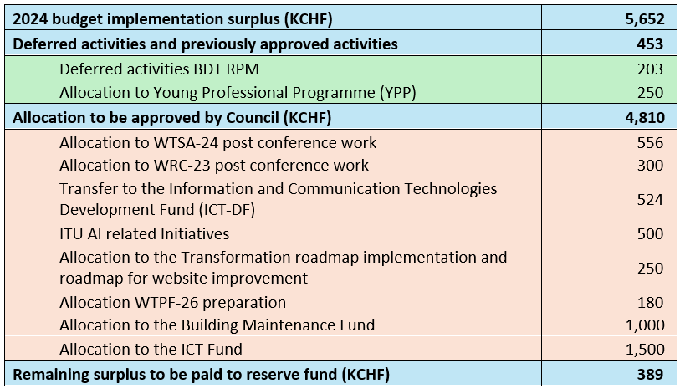

ANNEX
DRAFT NEW RESOLUTION [...]
Allocations of savings achieved in 2024 budget implementation
The ITU Council,
having considered
the savings achieved in the implementation of the 2024 budget (result) that amount to KCHF 5 652,
having further considered
the status of the Information and Communication Technologies Development Fund (ICT-DF),
resolves
1 to allocate the funds required for implementation of the first year of the resolutions of the WTSA-24 (KCHF 556); WRC-23 decisions (KCHF 300); the Transformation roadmap including the roadmap for website improvement (KCHF 250), the preparation of WTPF-26 (KCHF 180), the Building maintenance Fund (KCHF 1 000); ICT Capital Fund (KCHF 1 500); KCHF 500 for AI activities and a transfer of KCHF 524 to the ICT Development Fund;
2 to allocate the remaining surplus (KCHF 389) to the reserve account.

______________

