Agenda item: ADM 1 | Document C25/38-E
 | 17 April 2025
 | Original: English
Report by the Secretary-General
Status Report on implementation of Council Decisions 600 and 601 (UIFN, IIN)
Purpose
Following the approval of Decisions 600 and 601 at the Council 2017 session, ITU has been in the process of implementing these Decisions. This report provides updates to what was reported in Document C24/38.
Action required by the Council
The Council is invited to note this report.
Relevant link(s) with the Strategic Plan
International telecommunication numbering resources.
Financial implications
Revenue from the implementation of Council Decisions 600 and 601 are included in the 2024-2025 budget.
_______________
References
Documents C17/133 and C17/134; C18/100; CWG-FHR-9/14 and CWG-FHR-9/15; C19/47 and C19/120; C20/47; C21/47; CWG-FHR-14/6, CWG-FHR-14/7 and CWG-FHR-14/12; C22/50;
CWG-FHR-17/8; C24/38; CWG-FHR-20/13

Background
1 Following the approval of Decisions 600 (Doc. C17/133) and 601 (Doc. C17/134) at the 2017 session of the Council, the ITU secretariat has been in the process of implementing these Decisions.
2 The Telecommunication Standardization Bureau (TSB) presented Document C24/38 to the 2024 session of the Council, which contained the status of implementation of the Council Decisions and the revenue from Universal International Freephone Number (UIFN) and Issuer Identifier Number (IIN).
3 This document provides an update on this implementation since Council 2024.

Financial updates on UIFN (Council Decision 600)
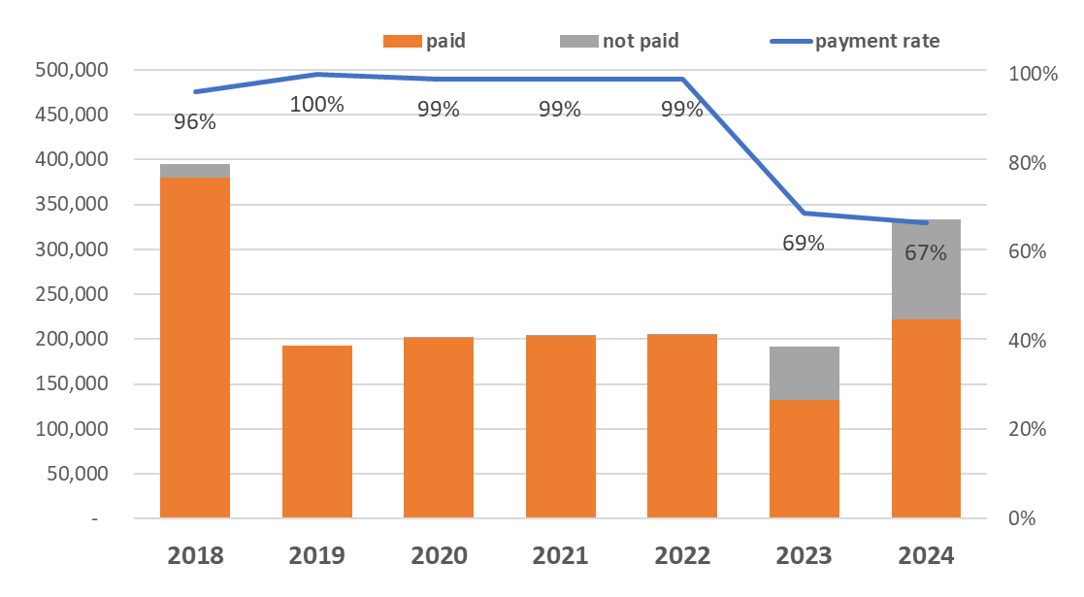
After 1 March 2024 (the last day of the reporting period for the Council 2024), the following additional payments have been made up to of 19 March 2025:
– For the annual maintenance fee for 2018, an additional CHF 300 was paid. To date 96 per cent of the valid invoices have been paid and CHF 15 300 still needs to be recovered.
– For the annual maintenance fee for 2023, an additional CHF 5 900 was paid. To date 69 per cent of the valid invoices have been paid and CHF 59 800 still needs to be recovered.
– For the annual maintenance fee for 2024, CHF 222 400 was paid. To date 67 per cent of the valid invoices have been paid and CHF 111 500 still needs to be recovered.
The unpaid fee for the period of 2018-2022 decreased to CHF 16 600. The unpaid fee for the period of 2023-2024 is CHF 171 300 in total, and the unpaid fee of one service provider amounts to 65 per cent of the total amount in the same period.
Annex 1 lists the entities for which TSB has a valid contact, that have been billed for 2018-2024 and have not paid their bills as of 19 March 2025.
For 2024, the expected revenue from UIFN is CHF 403 800 (Includes one-off fee and annual maintenance fee).

Discussion at CWG-FHR-20 on IIN (Council Decision 601)
At the 20th meeting of the Council Working Group on financial and human resources (CWG-FHR) in February 2025, TSB presented Document CWG-FHR-20/13 “Challenges faced in implementing Council Decision 601 on IIN registration”. One Councillor (SG2 Chair) reported that Recommendation ITU-T E.118 had been under revision and was determined by the ITU-T Study Group 2 (SG2) meeting (Geneva, 5-14 February 2025). The registrar function for IIN has been removed from the revised Recommendation. Consequently, there is a potential loss of approximately CHF 35,000. It is expected that ITU-T SG2 will communicate with the Council via the TSB director once the revised Recommendation ITU-T E.118 on IIN is officially approved. Consequently, Decision 601 will likely be abrogated/suppressed.

Conclusion
The secretariat continues the implementation of Council Decisions 600 and 601.
Annex: 1

Annex
Updates to the list of UIFN service providers pending payment
(for 2018, 2019, 2020, 2021, 2022, 2023 and 2024, as of 19 March 2025)
Year | Amount | Currency | UIFN quantity | Company's name | Country/  Geographic Area | Note
2018 | 14 000.00  [partial payment: CHF 2 800] | CHF | 140 | Bezeq International | Israel
2018 | 5 600.00  [partial payment from credit: CHF 4 000] | CHF | 56 | International Telcom Ltd. | United States
2023 | 2 300.00 | CHF | 23 | TeliaSonera Finland Oyj | Finland
2023 | 1 300.00 | CHF | 13 | Slovak Telekom, a.s. | Slovakia
2018 | 1 000.00 | CHF | 10 | Eutelia S.p.A. | Italy | partially purchased by CloudItalia with no UIFN responsibility, however,  3 UIFNs are reachable
2022 | 600.00 | CHF | 6 | PLANinterNET VoIP-GmbH | Germany
2018 | 500.00  [partial payment from credit:  CHF 200] | CHF | 5 | Telefónica S.A.  (formerly Colombia Telecomunicaciones S.A. ESP - Telecom Colombia) | Colombia
2018 | 500.00  [partial payment from credit:  CHF 400] | CHF | 5 | Kingston communications/Affiniti | United Kingdom
2021 | 500.00 | CHF | 5 | Qupra Wholesale | Netherlands
2018 | 400.00 | CHF | 4 | HKBN Enterprise Solutions HK Limited (ex-WTT HK Limited) | Hong Kong, China
2018 | 300.00  [partial payment: CHF 200] | CHF | 3 | Telefonica del Peru | Peru
2018 | 300.00 | CHF | 3 | PTGI INTERNATIONAL CARRIER  (formerly PRIMUS Telecommunications Ltd.) | United Kingdom
2023 | 200.00 | CHF | 2 | EMTEX GmbH | Germany
2020 | 200.00 | CHF | 2 | Telefónica de Argentina S.A. | Argentina
2023 | 100.00 | CHF | 1 | HGC Global Communications Limited | Hong Kong, China
2018 | 100.00 | CHF | 1 | Vodafone New Zealand | New Zealand
2018 | 100.00 | CHF | 1 | Empresa Hondureña de Telecommunicaciones (HONDUTEL) | Honduras
2018 | 100.00 | CHF | 1 | Telecom Itália Móbile S.p.A. (TIM)  (ex-INTELIG Telecomunicações Ltda.) | Brazil
2023 | 55 900.00 | CHF | 559 | eircom Limited | Ireland
2024 | 1 300.00 | CHF | 13 | Slovak Telekom, a.s. | Slovakia
2024 | 100.00 | CHF | 1 | JSC Kazakhtelecom | Kazakhstan
2024 | 700.00 | CHF | 7 | Cable & Wireless Panamá S.A. | Panama
2024 | 1 200.00 | CHF | 12 | Cyprus Telecoms. Authority | Cyprus
2024 | 28 100.00 | CHF | 281 | TDC A/S | Denmark
2024 | 55 900.00 | CHF | 559 | eircom Limited | Ireland
2024 | 13 200.00 | CHF | 132 | Singapore Telecommunications Ltd | Singapore
2024 | 900.00 | CHF | 9 | Beltelecom | Belarus
2024 | 600.00 | CHF | 6 | Hellenic Telecommunications Org. S.A. | Greece
2024 | 300.00 | CHF | 3 | Mass Response Service GmbH | Austria
2024 | 4 500.00 | CHF | 45 | MessageBird B.V. | Netherlands
2024 | 200.00 | CHF | 2 | EMTEX GmbH | Germany
2024 | 2 100.00 | CHF | 21 | Telia Norge AS | Norway
2024 | 2 300.00 | CHF | 23 | TeliaSonera Finland Oyj | Finland
2024 | 100.00 | CHF | 1 | Elisa Eesti AS | Estonia

______________

