|  |  |
| --- | --- |
| **Agenda item: PL 1** | **Document C25/35-E** |
| **19 May 2025** |
| **Original: English** |
|  |  |
| Report by the Secretary-General | |
| ANNUAL REPORT ON THE IMPLEMENTATION OF THE STRATEGIC PLAN AND THE ACTIVITIES OF THE UNION, 2024 | |
| **Purpose**  Reporting on implementation of the strategic plan of the International Telecommunication Union (ITU) for 2024-2027, highlighting activities undertaken and results achieved during 2024.  **Action required by the Council**  Council is invited **to approve** the report.  **Relevant link(s) with the ITU Strategic Plan**  As instructed by Resolution 71 (Rev. Bucharest, 2022) of the Plenipotentiary Conference, this is the annual report to ITU Council on the implementation of ITU’s strategic plan and activities (combining the requirement by No. 102 of the Convention, i.e. an annual activities report; and by No. 61 of the Convention, i.e. a report on the implementation of the strategic plan).  **References**  [*Resolutions 71*](https://www.itu.int/en/council/Documents/basic-texts-2023/RES-071-E.pdf) *(Rev. Bucharest, 2022) of the Plenipotentiary Conference,* [*Resolution 151*](https://www.itu.int/en/council/Documents/basic-texts-2023/RES-151-E.pdf) *(Rev. Bucharest, 2022) of the Plenipotentiary Conference,* [*Resolution 200*](https://www.itu.int/en/council/Documents/basic-texts-2023/RES-200-E.pdf) *(Rev. Bucharest, 2022) of the Plenipotentiary Conference; and* [*CV102 and 61*](https://www.itu.int/en/council/Documents/basic-texts-2023/Convention-E.pdf) | |

**Foreword**

Dear members of the ITU family,

As the International Telecommunication Union marks its 160th anniversary this year, digital technologies continue to shape every facet of our lives.

Throughout 2024, the first year of our current strategic plan, we made important progress towards our shared goals of universal connectivity and sustainable digital transformation. 2024 also saw more people using the Internet than ever before.

Gaps in skills and affordability narrowed in some regions, and new standards laid important foundations for emerging technologies to serve humanity. Yet with 2.6 billion people worldwide still offline, much work lies ahead.

Lags in development, economic uncertainty, and humanitarian crises as well as climate-related disasters continue to remind us that digital solutions must be accessible, affordable, resilient, and meaningful for all.

At the same time, advances in artificial intelligence (AI) and quantum technologies raised urgent questions about trust, security, and inclusivity in the digital age.

Against this backdrop, ITU deepened its work across all sectors.

Our Radiocommunication Sector published a new edition of the Radio Regulations and strengthened work on spectrum management to support crucial services across land, sea, air, and space.

This includes the processing of over 123 000 requests related to space and terrestrial services, as well as updating tools to navigate the Radio Regulations and explore satellite filings more easily.

The World Telecommunication Standardization Assembly (WTSA-24) in New Delhi reinforced efforts to bridge the standardization gap, and the AI for Good Global Summit brought together experts, innovators, and policymakers to drive practical applications of AI for sustainable development.

The Partner2Connect Digital Coalition surpassed USD 73 billion in pledges, underscoring the power and potential of collaboration to bridge digital divides and unlock opportunity for all.

ITU issued 412 new telecommunication standards (ITU-T Recommendations) in 2024.

Throughout the warmest year on record, ITU championed Green Digital Action, e-waste solutions, and early warning systems to strengthen climate resilience.

And we galvanized efforts to strengthen global digital infrastructure by establishing both the International Advisory Body for Submarine Cable Resilience and the Digital Infrastructure Investment Initiative in 2024.

The Pact for the Future and its Global Digital Compact, adopted at the United Nations General Assembly in September 2024, have brought renewed momentum to our shared mission of harnessing digital technologies for the benefit of people and planet.

The WSIS+20 Review in December 2025 offers a timely opportunity to reflect on progress and recalibrate collective action in this regard.

As we look ahead to 2026, sustaining this momentum will be vital.

We must continue scaling solutions, strengthening partnerships, and translating global commitments into real impact on the ground.

I am deeply grateful to our members, partners, and staff for their steadfast dedication to building a fit-for-purpose, fit-for-future ITU.

Since embarking on this transformation journey together in 2023, identifying efficiencies and adapting to new challenges have been key to our shared success.

I invite you to explore the collective achievements captured in this report — and to join us as we continue shaping our shared digital future together.

Doreen Bogdan-Martin

Secretary-General, International Telecommunication Union

Contents

i. Executive summary 6

ii. Insights and takeaways from 2024 8

1. Introduction 10

2. Global statutory conferences in 2024 10

2.1 World Telecommunication Standardization Assembly 10

3. Impact of ITU’s work 12

3.1 Universal Connectivity 12

3.2 Sustainable Digital Transformation 17

4. Products and services 21

4.1 Development and application of ITU Administrative Regulations 21

4.1.1 Radio Regulations 21

4.2 Allocation and management of resources 21

4.2.1 Spectrum use for space and terrestrial services 21

4.2.2 Numbering, naming, addressing and identification resources 23

4.3 Development of international standards 24

4.3.1 ITU-T Recommendations 24

4.3.2 ITU-R Recommendations 25

4.3.3 Bridging the standardization gap 25

4.4 Development of policy frameworks and knowledge products 25

4.4.1 Cybersecurity: building confidence and security in ICTs 26

4.4.2 Emerging techs: Shaping frameworks for transformation 26

4.5 Provision of data and statistics 29

4.6 Capacity development 30

4.7 Provision of technical assistance 31

4.8 Convening platforms 32

4.8.1 World Summit on the Information Society (WSIS) process 32

4.8.2 AI for Good 34

4.8.3 Global Standards Symposium (GSS-24) 35

4.8.4 Global Symposium for Regulators 35

4.8.5 Engaging academia in ITU’s work 35

4.8.6 ITU Journal 35

4.8.7 Kaleidoscope academic conference 35

4.8.8 Seminars and workshops: Diving deeper 35

5. Enablers 38

5.1 Membership-driven approach 38

5.2 Regional presence 39

5.3 Bringing everyone to the table 40

5.3.1 Gender equality 40

5.3.2 Youth empowerment 41

5.3.3 ICT accessibility 42

5.3.4 Support for ageing populations 43

5.4 Commitment to environmental sustainability 43

5.5 Partnerships and international cooperation 45

5.6 Resource mobilization 50

5.7 Excellence in human resources and organizational innovation 51

5.7.1 Human resources 51

5.7.2 Transformation Process 52

6 Implementation of the Resolutions from the Plenipotentiary Conference 53

# ****Executive summary****

This is the first annual report since ITU’s current strategic plan (2024-2027) entered into force. It is based on a results framework linking product and service delivery to thematic priorities and corresponding outcomes, ITU strategic goals, the ITU mission and shared global development goals.

Progress continued globally in 2024 towards universal connectivity, as well as in advancing sustainable digital transformation, the two strategic goals in the Strategic Plan 2024-2027.

ITU’s latest *Facts and Figures* report shows 5.5 billion people (68 per cent of the world's population) using the Internet in 2024, up from 65 per cent in 2023. However, 2.6 billion people remain offline. In fact, nearly 98 per cent of households worldwide now have Internet access, but usage gaps persist due to unaffordability and inadequate skills, particularly in the least developed countries.

**Standards for everyone**

ITU’s latest statutory conference, the World Telecommunication Standardization Assembly (WTSA-24) in New Delhi, India, strengthened the organization’s mandate to develop and promote technical standards for the good of everyone worldwide.

New conference resolutions have reinforced ITU’s standards work to meet fast-evolving global needs (see [WTSA-24 snapshot report](https://www.itu.int/reports/itu-standardization-2024/)). Other result included appointing chairs and vice-chairs for 10 telecommunication standardization (ITU-T) study groups and consolidating two former study groups into a single group for technologies for multimedia, content delivery and cable television.

Another WTSA-24 resolution reaffirmed ITU’s commitment to bridging the standardization gap, aiming to ensure developing countries can participate in ITU-T standards development and implementation.

**Guidance and technical support**

ITU processed over 5 000 requests related to space services in 2019-2024, and 118 000 notices on terrestrial services in 2024. Following the latest updates to the key Radio Regulations treaty, the organization introduced new tools to navigate the regulations, find radio-frequency information, and explore filings for geostationary and non-geostationary satellites, earth stations and radio-astronomy services.

ITU issued 412 new telecommunication standards (ITU-T Recommendations) and 24 new radiocommunication standards (ITU-R Recommendations) in 2024.

In the crucial field of advancing development through technologies, ITU was engaged on 105 projects worth CHF 91.8 million (~USD 107 million) and signed agreements on 37 new projects valued at CHF 28.6 million over the course of the year.

The annual Global Symposium for Regulators (GSR-24) in Kampala, Uganda, highlighted the need for digital capacity development, technical assistance, and regulation for impact.

**Meaningful connectivity and resilience**

ITU’s multifaceted work is consistently dedicated to bridging digital divides and fostering a more connected world. The ITU-led Partner2Connect Digital Coalition has continued mobilizing public and private pledges, which exceeded USD 54 billion by end-2024 and USD 73 billion by March 2025. New initiatives launched in 2024 also aimed to expand digital infrastructure and enhance service delivery for the good of all.

The new Digital Infrastructure Investment initiative (DIII), led by ITU with leading development finance institutions (DFIs), aims to close the estimated USD 1.6 trillion investment gap to connect everyone meaningfully by 2030. The newly formed International Advisory Body on Submarine Cable Resilience promotes dialogue and cooperation to strengthen vital undersea communications infrastructure.

ITU also engaged with UN partners, the World Bank, and others to explore how safe, inclusive, and interoperable digital public infrastructure (DPI) can enable more effective service delivery, foster innovation, and strengthen digital cooperation across borders. Meanwhile, ITU’s first Space Sustainability Forum brought together space and telecom agencies, industry experts, governments, civil society and key UN agencies with the common aim of keeping outer space viable for future generations.

**Artificial intelligence for humanity**

The ITU-led AI for Good initiative continued growing as a global showcase for responsible AI aligned with development priorities such as the 2030 Agenda. Annual summit discussions tackled key AI governance questions, exploring the crucial shift from theory to practice. In parallel, stakeholders explored the future of digital cooperation based on the World Summit on the Information Society (WSIS), pending the WSIS+20 review at the UN General Assembly later in 2025.

**Addressing environmental impact**

ITU continued bringing together partners in the global push to reduce tech-related emissions, promote green computing, develop and adopt green standards, and build a circular digital economy, as well as helping leverage radiocommunications for climate monitoring and advanced digital solutions for emergency telecommunications. An ITU-led sub-group is promoting AI-enhanced disaster alerts as part of the Early Warnings for All initiative.

The widely endorsed COP29 Declaration on Green Digital Action helped put digital technologies at the forefront of UN climate change talks.

**Ensuring voices are heard**

ITU remains dedicated to empowering women in its work and across the wider global tech industry, with initiatives to address persistent gender divides in digital employment, engagement and skills.

The formation of ITU Secretary-General’s inaugural Youth Advisory Board and opening the call for Young Professionals in early 2024 signalled the organization’s commitment to meaningful engagement with young people on defining questions for the global digital future.

**Milestones for the future**

The organization also advanced its transformation roadmap, focusing on people and culture, resource optimization, and governance improvements.

Throughout the year, digital technologies stood out as a unifying force in a fragmented world. The Global Digital Compact – adopted along with the Pact for the Future at the UN General Assembly in September 2024 – provides a framework for digital cooperation going forward, complementing other frameworks and processes.

Looking ahead, ITU’s operational plan for 2025-2028 outlines 43 specific outputs aligned with UN goals and global development priorities.

ITU, which marks its 160th anniversary in 2025, remains dedicated to coordinating radiocommunications, setting global standards, and driving digital development for humanity and the planet.

# Insights and takeaways from 2024

* An estimated 79% of individuals aged 15 to 24 were online in 2024, compared to 66% of the overall population. Significant disparities also persist between urban (83% online) and rural areas (48% online) worldwide.
* Globally, some 70% of men and 65% of women used the Internet in 2024, with gender parity improving but still uneven.
* The median price of mobile broadband decreased from 1.3% to 1.1% of gross national income (GNI) per capita, and fixed broadband from 2.8% to 2.5%.
* Global international bandwidth usage reached 322.8 kbit/s (per Internet user) in 2024, more than doubling since 2020. The total bandwidth usage in 2024 was 1.78 Tbits/sec, almost a 150% increase from 2020.
* Progress is evident in cybersecurity readiness, with 132 countries establishing computer incident response teams (CIRTs) by 2024, up from 109 in 2020; and 127 countries implementing national cybersecurity strategies and action plans, up from 107 in 2020.
* **ITU’s key standards conference, WTSA-24,** attracted **3 700 delegates from 164 countries**, achieving 27% female representation.
* **37 Member States** sent ministers to WTSA-24.
* ITU maintains the **Radio Regulations**, governing the use of radio-frequency spectrum and satellite orbits.
* In 2024, the ITU Radiocommunication Bureau published a new edition of the Radio Regulations, based on outcomes from the last World Radiocommunication Conference, WRC-23.
* The **Radio Regulations Navigation Tool** and **RR5 Table of Frequency Allocations tool** were updated based on WRC-23 outcomes.
* The latest **Maritime Manual**, published in December 2024, provides an overview of vital information for maritime communications and safety at sea.
* **The ITU Radiocommunication Sector (ITU-R)** addressedover **1 100 reports of harmful interference** in 2024.
* Mobile to mobile (M2M) and Internet of Things (IoT) services result in a growing demand for **Numbering, Naming, Addressing, and Identification** standards and coordination by ITU.
* ITU hosted the first **AI Governance Day** during the AI for Good Global Summit in May 2024.
* The **AI for Good Global Summit 2024** (combined with the WSIS+20 Forum High-Level Event) attracted over **5 000 on-site participants** and **900 000 views** online.
* The ITU Focus Group on metaverse produced a roadmap for definitions and standardization.
* The **Metaverse Think-a-Thon 2024** challenged participants to design solutions for smart, sustainable cities.
* **ITU’s Global Standards Symposium (GSS-24)** attracted over **1 800 participants** to explore emerging technologies and international standards ahead of WTSA-24.
* ITU Academia membership, the ITU Journal, and ITU Kaleidoscope conferences continue to foster collaboration between academia and industry.
* ITU surpassed **1 000 Sector Members, Associates, and Academia in 2024**, its highest level of membership ever.
* In 2024 the **Republic of Palau** became ITU’s 194th Member State
* ITU’s **Network of Women (NoW)** initiatives increased women's leadership appointments, with 26% representation at WTSA-24.
* The **Youth Task Force** and **Generation Connect Young Leadership Programme** promote youth engagement and digital skills development.
* The number of countries with regulatory frameworks for tech accessibility for persons with disabilities increased by **8.5%**, reaching **127 countries** in 2024.
* ITU's online training courses registered **1 055 participants** from 144 countries.
* ITU continued building partnerships to reduce tech-related emissions, promote green standards, and manage e-waste, with the **COP29 Declaration on Green Digital Action** receiving endorsements from over 80 countries and about 1 800 companies, organizations and other stakeholders.
* The **Global Initiative on Resilience to Natural Hazards through AI Solutions** explores leveraging AI for disaster management.
* ITU's **Greening Digital Dashboard** tracks the climate impact of the tech sector.
* The **WSIS+20 Forum** High-Level Event 2024 welcomed 42 Ministers and convened 227 sessions over 5 days.
* The ITU/UNESCO **Broadband Commission for Sustainable Development** launched a new working group on data governance in 2024.
* The **EQUALS Global Partnership** reached over **100 partners** to promote gender balance in the tech sector.
* The ITU/UNICEF **Giga initiative** – aiming to connect every school to the Internet – expanded to 34 countries by the end of 2024 and has continued expanding in 2025.
* As of 31 December 2024, the **P2C** Pledging Platform had received **956 pledges** valued at **USD 54.27 billion** from **452 entities** across **146 countries** worldwide
* The secretariat continues to advance a resource mobilization strategy focusing on strengthening member engagement, leveraging events, and increasing voluntary contributions.
* The **Digital Infrastructure Investment Initiative** led by ITU and leading development finance institutions identified key enablers to close an estimated **USD 1.6 trillion investment gap** and connect everyone meaningfully by 2030.
* The new **International Advisory Body on Submarine Cable Resilience** brings together 42 leaders and high-level experts with the aim of strengthening the vital undersea infrastructure that carries over 99% of international communications.
* ITU has continued enhancing the scope of its quantum-related standardization work and, with 2025 designated as **International Year of Quantum Science and Technology**, is building partnerships to promote Quantum for Good.

**The digital future starts here!**

At ITU, we are dedicated to connecting everyone, everywhere. We aim to connect some 2.6 billion people who are still offline, spur innovation for good, and make the dawning digital age healthy, safe and prosperous for all.

Our online *Year in Review* outlines many of the ways we are [boosting connectivity](https://www.itu.int/osg/year-in-review-2024/boosting-connectivity/), shaping digital transformation, and delivering digital impact. Readers can also revisit key moments in 2024 through annual highlights from ITU’s diary.

[Explore our ITU Year in Review 2024](https://www.itu.int/osg/year-in-review-2024/)

# Introduction

This annual report – formally the *Annual report on the Implementation of the Strategic Plan and activities of the Union 2024* – is the first since ITU’s current four-year strategic plan ([SP 2024-2027](https://www.itu.int/en/council/Documents/basic-texts-2023/RES-071-E.pdf)) entered into force. Covering the fiscal year from January to December 2024, this report is based on the results framework underpinning our strategic plan.

That results framework links our product and service delivery to key thematic priorities, strategic goals, the ITU mission and vision, and global goals and priorities such as the 2030 Agenda for Sustainable Development and the 17 Sustainable Development Goals:

Section 2 details the ITU Statutory Conference held during the reporting period, the World Telecommunication Standardization Assembly (WTSA-24), in New Delhi, India, from 15 to 24 October 2024.

Section 3 highlights progress towards ITU’s two overarching strategic goals: universal connectivity and sustainable digital transformation. Section 4 emphasizes results and activities related to products and services, while section 5 focuses on enablers of ITU work and impact.

# 2. Global statutory conferences in 2024

## 2.1 World Telecommunication Standardization Assembly

[WTSA-24](https://www.itu.int/wtsa/2024/) took place from 15 to 24 October 2024 in New Delhi, India. It was preceded by [GSS-24](https://gss.itu.int/) (14 October 2024) and followed by leadership training, which was offered to newly appointed chairs and vice-chairs. The assembly welcomed H. E. Narendra Modi, Prime Minister of India, to its opening ceremony. The assembly was chaired by Mr Ritu Ranjan Mittar (India). Attended by 3 700 delegates from 164 countries, it achieved the 27 percent female representation, the highest to date for ITU-T conferences held outside Geneva. It also showed the highest-level participation for ITU-T, with 37 Member States sending ministers. More than 20 side events were held during WTSA-24.

Key WTSA-24 outcomes include:

* Consolidation of ITU-T [Study Group 9](https://www.itu.int/en/ITU-T/studygroups/2022-2024/09/Pages/default.aspx) and [Study Group 16](https://www.itu.int/en/ITU-T/studygroups/2022-2024/16/Pages/default.aspx) as the new ITU-Study Group 21: *Technologies for multimedia, content delivery and cable television*
* Appointments of chairs and vice-chairs for ten ITU-T study groups, the Telecommunication Standardization Advisory Group, and the Standardization Committee for Vocabulary
* Updated mandate (Resolution 2) and new questions for 10 study groups in ITU-T
* 8 new resolutions
* 44 revised resolutions
* 1 revised ITU-T Recommendation (A.25)

Related information:

* [WTSA-24 website](https://www.itu.int/wtsa/2024/)
* [WTSA-24 Proceedings](https://www.itu.int/pub/T-REG-LIV.1-2024)
* [WTSA-24 snapshot report](https://www.itu.int/reports/itu-standardization-2024/)
* [WTSA-24 brochure](https://www.itu.int/en/ITU-T/wtsa24/Documents/WTSA-24_GSS-24_Brochure.pdf)
* [Related events](https://www.itu.int/wtsa/2024/related-events/)

# Impact of ITU’s work

The latest edition of ITU’s flagship report [Measuring digital development: Facts and Figures 2024](https://www.itu.int/en/ITU-D/Statistics/Pages/facts/default.aspx) shows Internet use continuing to grow incrementally, but universality remains elusive, especially in low-income regions. Furthermore, there is a lack of progress in bridging the urban-rural divide, except in the lowest income group. It tracks global connectivity with estimates of key indicators, including those related to Internet use, infrastructure, affordability, Internet traffic, gender, and location.

ITU's performance in achieving its strategic goals can be based on associated targets and corresponding indicators:

|  |  |  |
| --- | --- | --- |
| Goal | Targets | Target Indicators |
| **Universal connectivity** | 1.1: Universal broadband coverage | Percentage of the world population covered by broadband services (SDG indicator 9.c.1— ITU is custodian agency) |
| 1.2: Broadband services to be affordable for all | Cost of entry-level broadband services in developing countries as percentage of monthly gross national income (GNI) per capita |
| 1.3: Broadband access to every household | Percentage of households with access to the Internet (by level of development; urban/rural) |
| 1.4: Ownership of and access to Internet-enabled devices | Percentage of individuals using a smart telephone  Percentage of individuals who own a smart telephone |
| 1.5: Access on the Internet for all schools | Percentage of schools with entry-level Internet service (at least 500 MB per month) |
| 1.6: Improved cybersecurity preparedness of countries (with key capabilities: presence of strategy, national computer incident/emergency response teams and legislation) | Increased commitment measured through the pillars of the Global Cybersecurity index (GCI) |
| 1.7: Universal access to the Internet by all individuals | Percentage of individuals using the Internet (by urban/rural; aggregated by region, level of development) (SDG indicator 17.8.1 – ITU is custodian agency) |

|  |  |  |
| --- | --- | --- |
| Goal | Targets | Target Indicators |
| **Sustainable Digital Transformation** | 2.1: Targets All digital gaps to be bridged (particularly gender, age and urban/ rural) | Percentage of individuals using the Internet (by gender, age and urban/rural) |
| 2.2: Majority of individuals to have digital skills | Percentage of youth and adults with ICT skills (by type of skill) (SDG indicator 4.4.1 – ITU is custodian agency) |
| 2.3 Universal usage of Internet services by businesses | Percentage of businesses using the Internet (total and by size) |
| 2.4 Majority of individuals accessing government services online | Percentage of population interacting with government services online |
| 2.5 Significant improvement of ICT contribution to climate and environment action | Contribution of telecommunications/ICTs to global GHG emissions |

## 3.1 Universal Connectivity

ITU’s push for universal connectivity includes specific targets for broadband, Internet access, and cybersecurity.

**Target 1.1: Universal broadband coverage**

As of 2024, 5.5 billion people, representing 68 per cent of the world's population, are online, up from 65 per cent in 2023. Despite this growth, 2.6 billion people, or one-third of the global population, remain offline, indicating that achieving universal connectivity is still a significant challenge.

Percentage of Individuals using the Internet - – by Development status

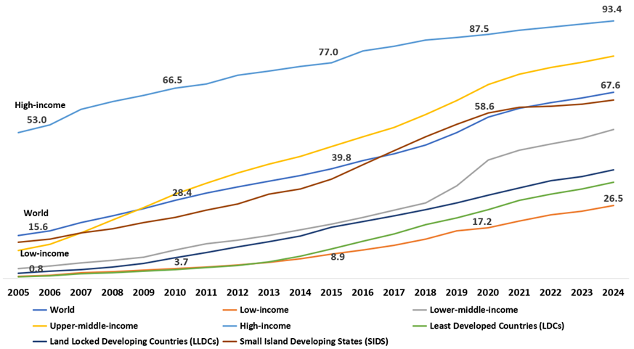

Adapted from **Facts & Figures**. [See interactive chart: Internet use](https://www.itu.int/itu-d/reports/statistics/2024/11/10/ff24-internet-use/#chart-1)

**Target 1.2: Broadband services to be affordable for all**

In 2024, both the data-only mobile broadband and fixed broadband baskets have become more affordable across all regions and income groups. Globally, the median price of the mobile broadband basket, measured as a percentage of gross national income (GNI) per capita, decreased from 1.3 per cent to 1.1 per cent. Similarly, the median price of the fixed broadband basket fell from 2.8 per cent to 2.5 per cent.

However, affordability remains a significant barrier to Internet access, particularly in low-income economies. Despite some progress, a substantial gap persists between high-income economies and others. Subscribers in lower-middle-income economies pay approximately six times more of their income for mobile broadband compared to those in high-income economies, while low-income subscribers pay 19 times more. Additionally, in low-income countries where fixed broadband is available, the subscription cost can consume nearly a third of the average person's income.

Price of data-only mobile broadband (2GB) basket as per cent of gross national income per capita 2023-2024

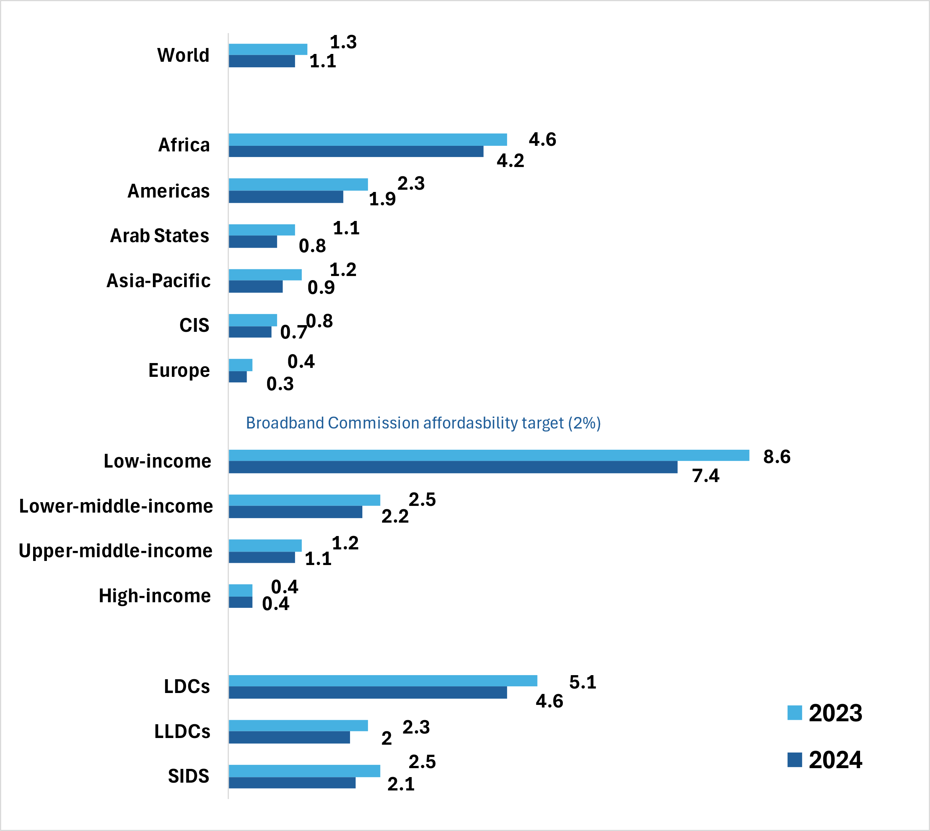

Adapted from **Facts & Figures**. See [interactive chart: Internet use](https://www.itu.int/itu-d/reports/statistics/2024/11/10/ff24-affordability-of-ict-services/)

Price of fixed broadband (5GB) basket as per cent of gross national income per capita 2023-2024

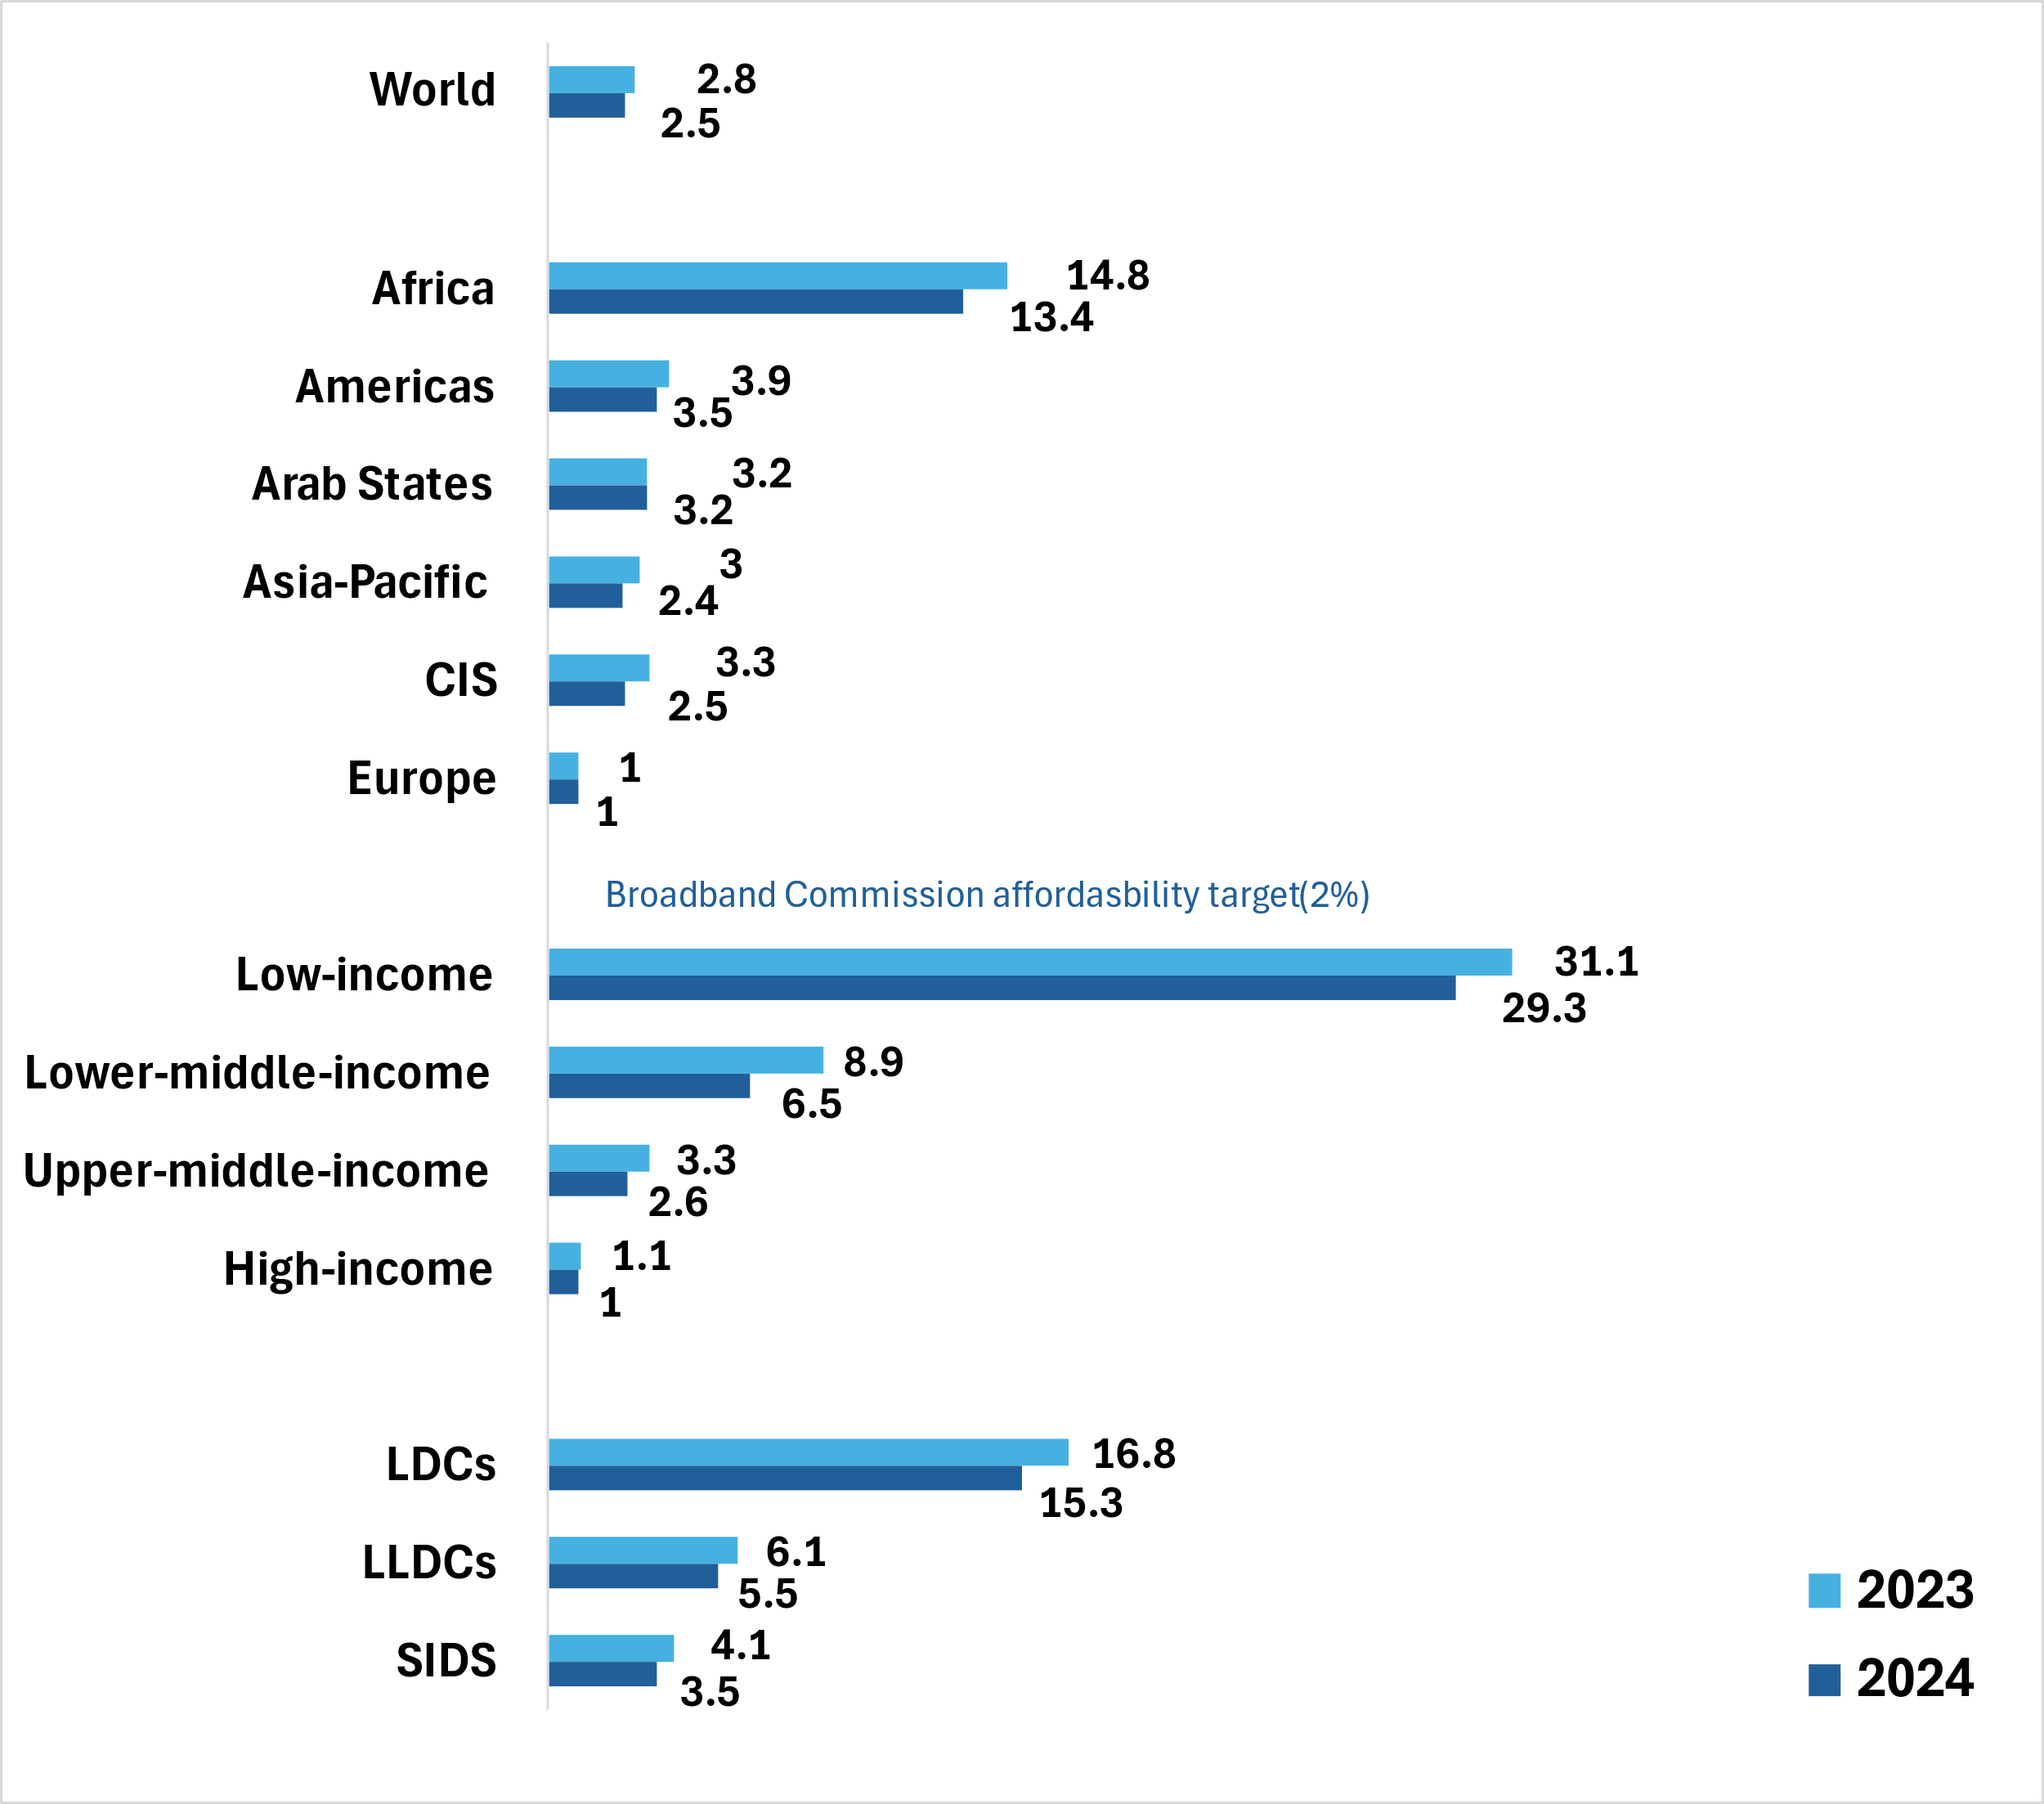

Adapted from **Facts & Figures**. See [interactive chart: Internet use](https://www.itu.int/itu-d/reports/statistics/2024/11/10/ff24-affordability-of-ict-services/)

**Target 1.3: Broadband access to every household**

Global international bandwidth usage has significantly increased in recent years, reaching 322.8 kbits per second (per internet user) in 2024, more than doubling the level from 2020. This usage is heavily concentrated in high-income economies, where demand has surged from 399.3 to 858.3 kbits per second (per internet user) over the past four years, reflecting their advanced digital infrastructure and data-intensive applications. On the other hand, low-income economies, despite experiencing notable growth, still represent a disproportionately small share of global bandwidth, rising from 28.3 to 60.9 kbits per second (per Internet user). The total bandwidth usage in 2024 was 1.78 Tbits/sec, almost a 150 per cent increase from 2020.

In 2024, 167 countries had established broadband plans or digital strategies, a figure that has stagnated since 2019 and declined from 170 in 2022. To advance global connectivity, further efforts are needed to encourage the remaining 20 to 30 countries to develop and adopt their national broadband plans.

Percentage of individuals using the internet by region and level of development 2019-2024

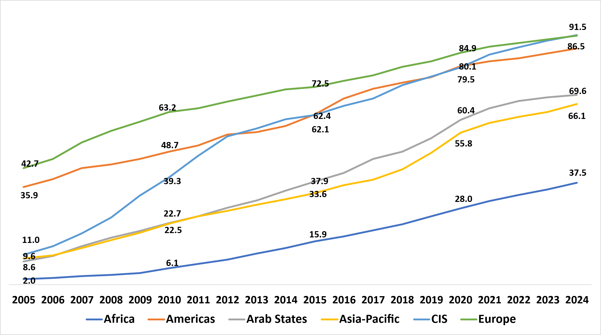

Adapted from **Facts & Figures**. See [interactive chart: Internet use](https://www.itu.int/itu-d/reports/statistics/2024/11/10/ff24-internet-use/#chart-2)

On the other hand, the population covered by a mobile-cellular network (not limited to broadband) continues to grow, reaching 97.9 per cent in 2024. High-income economies have sustained near-universal coverage, consistently exceeding 99.6 per cent since 2020. In contrast, low-income economies, despite steady improvements, lag significantly, with coverage increasing from 88.0 per cent in 2020 to 91.1 per cent in 2024.

Internet usage is closely tied to development levels. In high-income countries, the online penetration rate reached 93 per cent in 2024, while in low-income countries, only 27 per cent of the population is online. Although these economies are experiencing an annual growth rate of 8.5 per cent in 2024—higher than any other group or region—this growth is inadequate to close the gap in connectivity soon.

**Target 1.4: Ownership of and access to Internet-enabled devices**

Globally, four out of five individuals aged 10 and older own a mobile phone, with high-income economies achieving universal ownership, defined as a penetration rate exceeding 95 per cent. In stark contrast, low-income economies show only 56 per cent of the population aged 10 and above owning a mobile phone.

Percentage of Individuals owning a mobile phone and using the Internet 2024

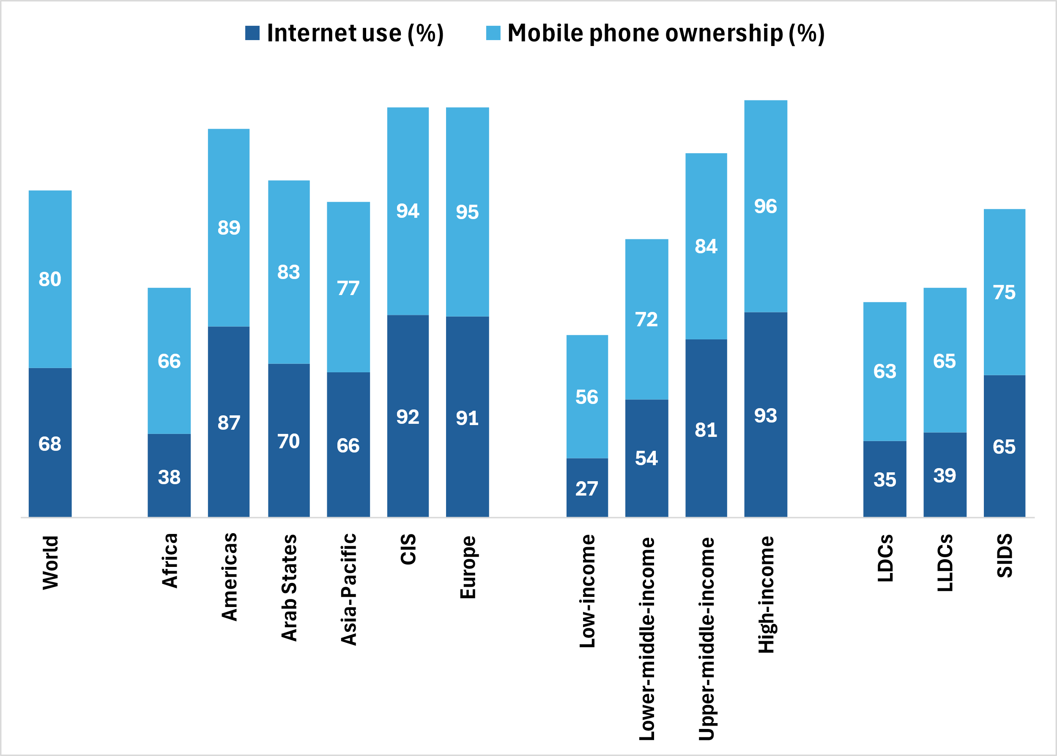

Adapted from **Facts & Figures**. See [interactive chart: Internet use](https://www.itu.int/itu-d/reports/statistics/2024/11/10/ff24-mobile-phone-ownership/#chart-1)

**Target 1.5: Access on the Internet for all schools**

This data is gathered by the United Nations Educational, Scientific and Cultural Organization (UNESCO). In their Dashboard (see [here](https://www.unesco.org/en/sdg4scorecard-dashboard)), it is possible to find (under Indicator 4a, Target 4a.1):

* The percentage of schools with access to the Internet for pedagogical purposes and
* The percentage of schools with access to computers for pedagogical purposes

Both by country and disaggregated by level (i.e. primary; lower secondary, upper secondary and secondary).

The existing data does not allow yet for extracting conclusions on the evolution of World averages.

**Target 1.6: Improved cybersecurity preparedness of countries**

In terms of enhancing cybersecurity preparedness among countries, notable progress has been observed. By 2024, 132 countries had established Computer Incident Response Teams (CIRTs), an increase from 109 in 2020. Additionally, 127 countries had implemented National Cybersecurity Strategies and Action Plans, up from 107 in 2020.

**Target 1.7: Universal access to the Internet by all individuals**

In 2024, active mobile broadband subscriptions worldwide reached 94.6 per 100 inhabitants, demonstrating consistent growth. High-income countries achieved nearly universal coverage with a rate of 152.7 per cent, whereas low-income countries, although experiencing rapid growth, reached only 40.1 per cent. This persistent digital divide highlights the continuing challenge of achieving universal connectivity.

Percentage of individuals using the Internet by rural/urban; aggregated by level of development 2021-2024

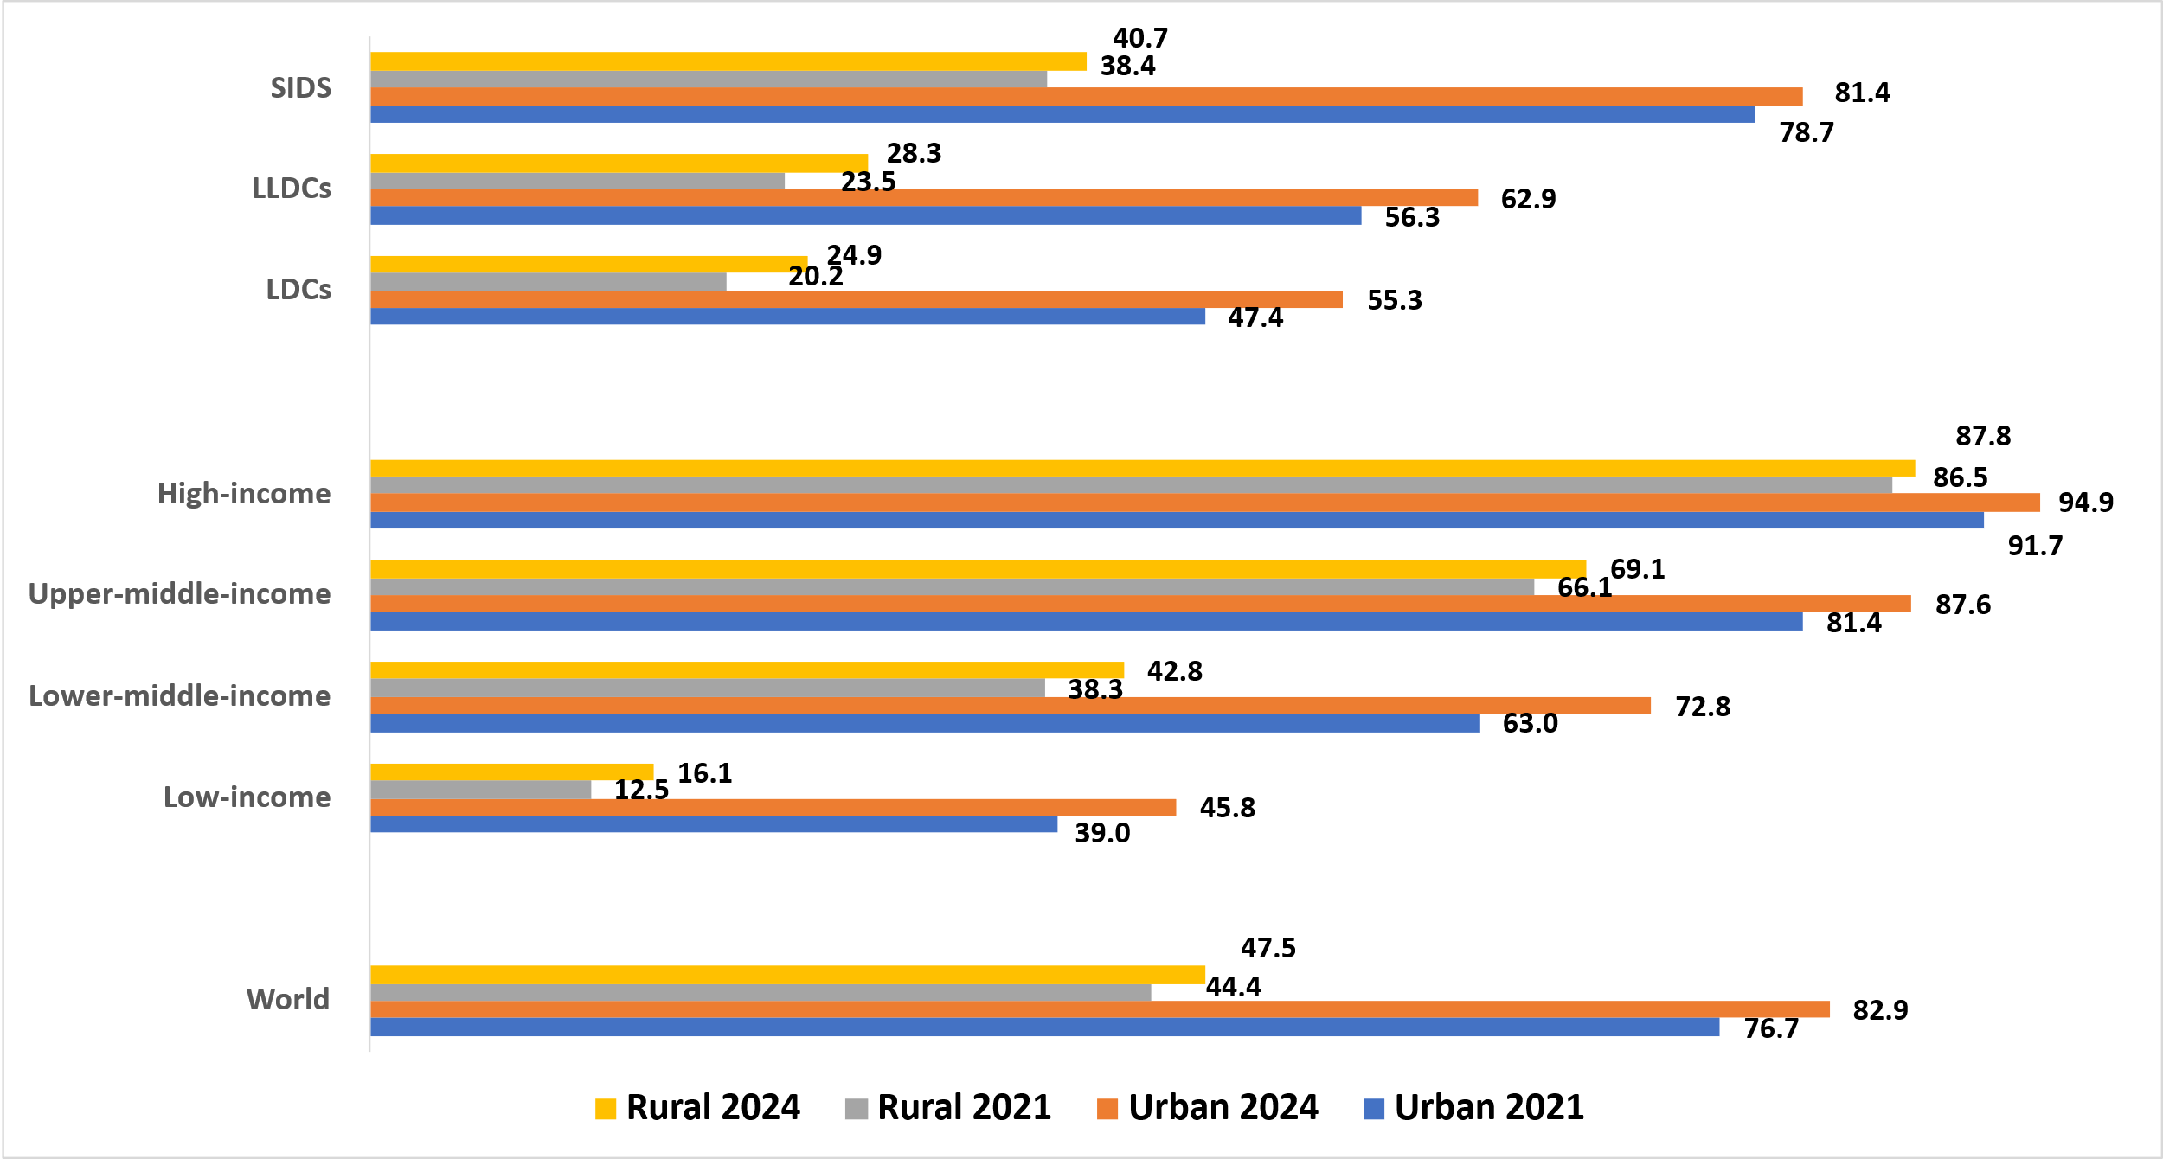

Adapted from **Facts & Figures**. See [interactive chart: Internet use](https://www.itu.int/itu-d/reports/statistics/2024/11/10/ff24-internet-use-in-urban-and-rural-areas/#chart-1)

## 3.2 Sustainable Digital Transformation

ITU’s digital transformation push includes specific targets to bridge all digital gaps, boost digital skills, enhance online services (both business and governmental), and strengthen climate and environmental action through digital technologies.

**Target 2.1: All digital gaps to be bridged (particularly gender, age and urban/rural)**

This target, aimed at bridging all digital gaps, shows uneven progress depending on the chosen criteria for aggregation, such as gender, age, and rural versus urban distinctions. This indicates that advancements in digital access are not uniform, highlighting the need for targeted strategies to address specific gaps. For example, in 2024, 70 per cent of men and 65 per cent of women globally used the Internet, resulting in nearly 189 million more men online than women. Gender parity is considered achieved when the gender parity score—calculated as the female percentage divided by the male percentage—falls between 0.98 and 1.02. Similar to overall Internet usage, gender parity closely correlates with the level of development (see [Facts&Figures 2024](https://www.itu.int/dms_pub/itu-d/opb/ind/d-ind-ict_mdd-2024-4-pdf-e.pdf)).

|  |
| --- |
| Percentage of individuals using the Internet by gender; aggregated by level of development  2019-2024    Adapted from **Facts & Figures**. See [interactive chart: Internet use](https://www.itu.int/itu-d/reports/statistics/2024/11/10/ff24-the-gender-digital-divide/#chart-3) |

Percentage of individuals using the Internet by age; aggregated by region 2021-2024

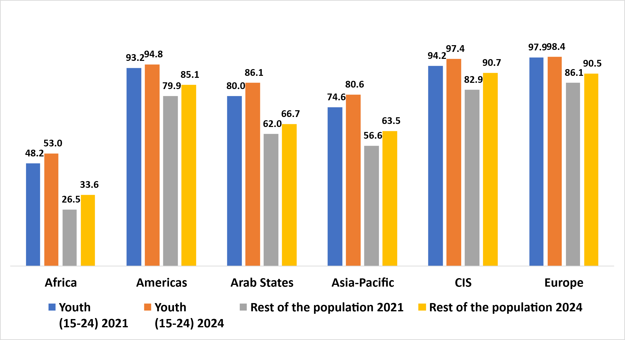

Adapted from rom **Facts & Figures**. See [interactive chart: Internet use](https://www.itu.int/itu-d/reports/statistics/2024/11/10/ff24-youth-internet-use/#chart-1")

Recently, the global trend has moved gradually toward gender parity, with the gender parity score rising from 0.91 in 2019 to 0.94 in 2024. This improvement is evident across various regions and country groups, except for Least Developed Countries (LDCs), where gender parity has declined from 0.74 in 2019 to 0.70 in 2024.

In the Small Island Developing States (SIDS) group, the gender parity score has decreased slightly, falling from just above one —indicating that more women than men were using the Internet— to exactly one in 2024, reflecting perfect gender parity. Notably, the SIDS represent a positive exception to the typical correlation between gender parity and overall Internet use, as they have achieved gender parity despite less than two-thirds of their population having Internet access.

Among the six ITU world regions, gender parity has been achieved in the Americas, Europe, and the Commonwealth of Independent States (CIS) region. The Asia-Pacific region is making rapid progress, with its gender parity score increasing from 0.89 in 2019 to 0.95 in 2024. Conversely, the Arab States have seen no improvement, maintaining a score of 0.86 during this period. While Africa is making progress, it still lags significantly behind the other regions.

In terms of Internet usage by age, 79 per cent of individuals aged 15 to 24 are online, which is 13 percentage points higher than the overall population's usage rate of 66 per cent. This disparity exists across all regions but has been gradually decreasing over the past four years.

In low-income countries, people between 15 to 24-year-old are 1.9 times more likely to use the Internet than other individuals. While this is the largest gap of any income group, it marks a slight improvement from 2021, when the figure was 2.2.

Significant disparities in Internet usage persist between urban and rural areas. In 2024, 83 per cent of urban dwellers are online, while less than half of the rural population (48 per cent) has Internet access. Among the 2.6 billion people not using the Internet, 1.8 billion reside in rural areas, compared to 800 million in urban areas.

Over the past four years, the urban-rural gap in Internet usage, quantified as the ratio of urban to rural Internet users, has remained steady at 1.7. This gap is smallest in regions with high Internet penetration, such as Europe, where the ratio stands at just 1.1, while in Africa, it is significantly wider at 2.5. Overall, progress in narrowing this gap has been modest across all regions, with the Asia-Pacific region experiencing a slight increase in the gap from 1.6 to 1.7.

On the other hand, in high-income countries the gap is almost non-existent, with an average ratio of 1.1. In low-income countries, by contrast, it remains a potent force, with just one rural dweller in six (16 percent) using the Internet, barely one-third the figure for urban dwellers.

**Target 2.2: Majority of individuals to have digital skills**

Digital skills: While the importance of digital skills in leveraging information and communication technologies (ICTs) for economic prosperity and social well-being is well-documented, data remain very scant. Only 90 countries have submitted data since 2020, and rarely for all skill areas. Even fewer – just 40 countries – provide comparable data on ICT skill levels.

Regarding progress towards Target 2.2, which aims for the majority of individuals to have digital skills, emerging trends in ICT skills have been observed despite existing gaps. Among countries that report data on communication and collaboration skills, over 80 per cent of Internet users demonstrate at least basic communication skills, irrespective of the overall Internet usage levels in their respective countries.

**Target 2.3: Universal usage of Internet services by businesses**

The United Nations Conference on Trade and Development (UNCTAD) is the custodian of this indicator. However, world averages are currently unavailable due to insufficient data.

**Target 2.4: Majority of individuals accessing government services online**

ITU is in charge of this indicator, but world averages are not yet available as there is insufficient data.

**Target 2.5: climate and environment action**

This target focuses on enhancing the role of technologies in climate and environmental action, emphasizing the urgent need for responsible management electronic equipment waste (e-waste), particularly as digital innovation accelerates. According to the 2024 Global E-waste Monitor, the world is projected to produce 82 billion kilograms of e-waste annually by 2030. ITU has been actively supporting several countries across the Americas, Africa, and Asia-Pacific in developing and implementing producer responsibility regulations for e-waste. In 2010, around 24 per cent of the total e-waste was re-cycled. A record 62 billion kilograms of e-waste was generated globally in 2022, equivalent to an average of 7.8 kilograms per capita for the year; 22.3 per cent of this e-waste mass was documented as formally collected and recycled in an environmentally sound manner. Of the 81 countries covered by a national e-waste policy, legislation, or regulation, 67 applied the Extended Producer Responsibility (EPR) principle, 46 had enshrined national e-waste collection targets in their regulations, and 36 had done so for e-waste recycling targets at the national level.

Figure adapted from ITU & UNITAR: [Global e-Waste Monitor 2024](https://globalewaste.org/)

Additionally, ITU has made strides in studying energy consumption and greenhouse gas (GHG) emissions across the global tech sector. Through the "[Greening Digital Companies report](https://www.itu.int/hub/publication/d-str-digital-04-2024/)" series, the new Greening Digital Dashboard enables ITU and partners to monitor the climate impact of the ICT sector more effectively. It assesses GHG emissions and energy use of 200 digital companies. The report shows that emissions for the 166 digital companies that disclose climate data (accounting for 98 per cent of the revenue of the 200 companies) were 293 million tCO2 in 2022, or 0.8 per cent of the world total energy-related emissions (global figure was 36.8 Gt in 2022).

The challenge of quantifying the positive impact of ICTs on reducing the environmental footprint of other sectors persists.

# Products and services

## 4.1 Development and application of ITU Administrative Regulations

### 4.1.1 Radio Regulations

ITU maintains the [Radio Regulations](https://www.itu.int/pub/R-REG-RR) – the international treaty governing the use of the radio-frequency spectrum and satellite orbits for all kinds of wireless communications. In upholding the regulations and facilitating related international cooperation, the organization supports equitable access to and rational use of spectrum and orbits as finite natural resources. Through ITU, administrations agree on the allocation of radio frequencies and management, along with the procedures for coordination to avoid harmful radio interference. ITU and its Radiocommunication Bureau enable these activities, supporting Member States worldwide with expertise on communications on land, at sea, in the air, and in space.

In 2024, the Radiocommunication Bureau implemented the results of [WRC-23](https://www.itu.int/wrc-23/), including the completion of the following activities:

* The new edition of the Radio Regulations, containing the final acts adopted by WRC-23 was [published in 2024](https://www.itu.int/hub/publication/r-reg-rr-2024/). The Radio Regulations are available for free download from the ITU website.
* The Radiocommunication Bureau continues to update and maintain software tools for the use and analysis of the Radio Regulations (RR). The Radio Regulation Navigation Tool is being updated with the 2024 edition. The RR5 Table of Frequency Allocations tool has been updated based on WRC-23 outcomes and the 2024 RR edition, incorporating changes in frequency allocations, country footnotes, and related references to associated Resolutions and Recommendations, as well as the latest version of the relevant Rules of Procedure, while also supporting the extraction of National Tables of Frequency Allocations.
* The Manual for Use by the Maritime Mobile and Maritime Mobile-Satellite Services (Maritime Manual), published in December 2024, provides a comprehensive overview of maritime communications.
* The Radiocommunication Bureau also began preparations across the ITU Radiocommunication Sector (ITU-R) for the next World Radiocommunication Conference, coming up in 2027. In this regard, the WRC-27 agenda was adopted by Council 2024 and subsequently agreed by the majority of ITU Member States. The responsible and contributing groups for each WRC-27 agenda item, which were identified by CPM27-1, initiated the preparatory studies for WRC-27.

## 4.2 Allocation and management of resources

### 4.2.1 Spectrum use for space and terrestrial services

**ITU's role in spectrum and orbit regulation and management**

**Key results of the processing of space and terrestrial notices and related activities**

ITU’s [Radiocommunication Bureau (BR)](https://www.itu.int/en/ITU-R/Pages/default.aspx) continues to produce software applications and databases to best facilitate the use of outputs by the membership of the [ITU Radiocommunication Sector (ITU-R)](https://www.itu.int/en/ITU-R/Pages/default.aspx). In 2024, the bureau focused on software updates following WRC-23 decisions.

**Progress in space services**

ITU-R processed and managed advanced publication information, coordination requests, and notification notices for non-planned space services, as well as broadcasting-satellite and fixed-satellite service plans and their associated feeder links. From 2019 to 2024, this involved handling over 5 000 coordination and notification requests and managing more than 500 broadcasting-satellite and fixed-satellite service plans. These efforts ensure compliance with relevant regulations and resolutions, supporting the efficient use of spectrum and orbital resources.

**Progress in terrestrial services**

Regarding terrestrial notices, in 2024, more than 118 000 Notices were recorded in the MIFR and Plans, more than 1 800 Notifications of coast and ship stations were processed for recording in the ITU maritime database, and more than 1 100 reports of harmful interference were treated. Our work ensures reliable spectrum management, promotes the efficient and interference-free use of radio frequency resources, and supports the growth and development of telecommunication infrastructure.

**Advancement in software and tools for space services**

The [BR IFIC (Space services)](https://www.itu.int/en/ITU-R/space/brific/Pages/default.aspx) online application (an updated format for the ITU Radiocommunication Bureau’s long-running Frequency Information Circular) was officially released on 23 January 2024 on a secure server that provides 24/7 access. This interface allows users to browse online the BR IFIC (Space services) content and to download the relevant publications and databases). From 1 January 2025, the main means of distribution for the BR IFIC are a web-based image version (ISO file) and the BR IFIC online application. The distribution of the BR IFIC on DVD-ROM has been discontinued for all administrations and subscribers, except for those who explicitly request to continue receiving it in this format. Member State administrations have been granted unlimited access to the BR IFIC Online. For paid subscribers, each subscription includes access for one designated user to the BR IFIC Online application and the web-based distribution of the ISO file.

Implementation of instructs 2 of Resolution **186 (Rev. Dubai, 2018)**: The ITU Space Explorer web application was released in production on 18 December 2024.

**Modernization of the database platform for frequency assignments to space radiocommunication services**

The ITU Radiocommunication Bureau reviewed and updated most of the space software applications used for capturing, processing, and publishing satellite network submissions, including changes in the database schema and reference tables, data capture, validation, and examination software modules. The external administrative software was released on 10 December 2024 as BR Soft v10, while the new v10 database format and the external technical examination v10 software were released on 7 January 2025.

Implementation of Resolution **55 (Rev.WRC-23)**: The Radiocommunication Bureau has been delivering reliable round-the-clock operation of the e-Submission system and e-Communications system, attracting a growing number of administrations to register to use these systems throughout 2024.

The e-Submission system was further improved to allow administrations and operating agencies to upload satellite network filings in SNS v10 format, including the new types of filings introduced at WRC-23, on 20 December 2024.

Furthermore, the new functions to integrate the e-Submission and e-Communications systems were introduced on 6 March 2024. This enhancement further facilitates administrations and intergovernmental satellite organizations to efficiently review satellite network filings submitted via e-Submission and manage correspondences between the notifying administration and the ITU Radiocommunication Bureau or other administrations on e-Communications.

**Advancement in software and tools for terrestrial services**

The development of software modules and associated tools continued during the reporting period, with activities in the ITU Radiocommunication Bureau including:

* processing of coordination requests under RR No. 9.21 and of HAPS notifications,
* HFBC software re-engineering,
* modernization of the database platform for frequency assignment to terrestrial services,
* BR IFIC (Terrestrial services) online application,
* Geographic Information Systems (GIS) and GIS Task Force,
* further development of terrestrial web tools and their integration into a single portal,
* Maritime Service Publications Project: online sales platform and the desktop application containing three digital publications (List IV, List V and Maritime Manual), and
* harmful Interference to Terrestrial Services (HITS): new online platform for the treatment of the reports of harmful interference and infringements.

See ITU-R web pages for [progress in terrestrial services](https://www.itu.int/en/ITU-R/terrestrial/Pages/default.aspx).

The Radiocommunication Bureau completed the update of the software used for processing and publication of terrestrial notices, both for internal (TerRaSys) and external (BR IFIC (Terrestrial)) utilization. These includes changes in the terrestrial databases, validation, and examination software, and reference tables for the frequency bands shared with space services, subject to RR No. 9.21, identified for IMT, etc. All necessary changes were implemented, and the complete integration is expected during 2025.

The bureau also developed the software modules for processing HIBS notifications (validation, examination and publication tools). This task included the development of calculation modules for checking technical conditions specified Resolutions **213 (WRC-23)**, **221 (Rev.WRC-23)** and **218 (WRC-23)**, the changes in the database and filing structure.

### 4.2.2 Numbering, naming, addressing and identification resources

**Enhancing global connectivity: Evolution of NNAI resource management**

In recent years, there has been a growing demand for international telecommunication numbering, naming, addressing, and identification (NNAI) resources, driven largely by the growth of machine-to-machine (M2M) and Internet of Things (IoT) services. Additionally, the scope of numbering assignments has broadened to include services provided via Low Earth Orbit (LEO) satellites, expanding beyond traditional Geostationary Orbit (GEO) satellites. These NNAI resources are increasingly serving as global identifiers for a diverse range of users and services, extending well beyond conventional telecommunication applications.

The dynamic nature of international mobile subscriber identity numbers, particularly with the introduction of embedded SIM cards (eSIMs), highlights the need for enhanced flexibility and adaptability in resource management. Promoting innovation and fostering an enabling environment for the adoption and effective use of new and emerging digital technologies is crucial. This involves the establishment of robust international telecommunication management infrastructure to support these advancements.

At WTSA-24 in October 2024, most resolutions relevant to international telecommunication numbering resources were revised to address the above challenges. ITU-T Study Group 2 plays a pivotal role as the lead group in addressing the complexities of numbering, naming, addressing, and identification. To meet evolving demands, ITU-T Study Group 2 has actively revised relevant recommendations, as well as introducing new recommendations defining procedures for applicants, as well as for ITU’s Telecommunication Standardization Director, and pertinent ITU-T study groups, which has improved transparency in the application process. These new recommendations also outline roles, responsibilities, and mechanisms for auditing assigned international resources. Such audits are designed as a supplementary and complementary mechanism to the existing principles related to identifiers and the reporting of misuse, as delineated in the E series of ITU-T recommendations.

This ongoing revision and enhancement of recommendations and resolutions ensure that the management of NNAI resources remains robust, transparent, and responsive to the technological shifts shaping the global telecommunication landscape.

**Addressing numbering misuse: Revisions and initiatives from WTSA-24**

To promote report of numbering misuse and misappropriation, WTSA Resolution 61 “Countering and combating misappropriation and misuse of international telecommunication numbering, naming addressing and identification resources” was revised. It also resolves to invite Member States to periodically review and update national regulations, share best experiences and develop public awareness campaigns. There is an ever-increasing use of spoofed CPN and CLI, short-message service (SMS) interception, voice cloning technologies, etc. that previous generation signalling protocols and telecommunication networks need to consider emerging requirements. Accordingly, WTSA Resolution 65 “Calling party number delivery, calling line identification and origin identification information” was revised.

**Enhancements in information distribution**

Established in 1966, the ITU Operational Bulletin facilitates the mandates in the ITU Constitution and Convention, International Telecommunications Regulations and ITU-T Recommendations, disseminating information approved by national Administrations, including notifications about updates, assignments, and reclamations of both national and international numbering/identification resources. Issued bi-monthly in ITU’s six official languages, the Bulletin is now available in both PDF and Word formats. In alignment with digital transformation initiatives, the Telecommunication Standardization Bureau (TSB) is enhancing the readability and efficiency of publishing of the ITU Operational Bulletin.

In response to WTSA Resolution 91, titled “Enhancing Access to an Electronic Repository of Information on Numbering Plans,” TSB has established a repository for ITU national numbering plans (NNPs) based on methodologies introduced in Recommendation ITU-T E.129. The newly launched ITU National Numbering Plan website is set to evolve further based on contributions and feedback from users. The revised WTSA Resolution 91 encourages Member States, Sector Members, Associates, and Academia to actively participate in ITU-T Study Group 2 and the Telecommunication Standardization Advisory Group, contributing to the discussions on requirements for electronic access to the repository of national numbering resources maintained by ITU-T.

## 4.3 Development of international standards

**Standardization: Foundations to shape technologies of today and tomorrow**

Accessible technologies built to universal specifications can work smoothly for everyone. An unwavering commitment to interoperability, accessibility, security, affordability, and resilience ensures that standards from ITU benefit the whole world. Through ITU technical standards, local devices link seamlessly with global networks. Safe connections, within reach for all, give communities access to vital information and help reduce climate impact.

ITU standards are developed in the Telecommunication Standardization Sector (ITU-T) and Radiocommunication Sector (ITU-R), being issued, respectively, as [ITU-T Recommendations](https://www.itu.int/en/ITU-T/publications/Pages/recs.aspx) and [ITU-R Recommendations](https://www.itu.int/pub/R-REC).

### 4.3.1 ITU-T Recommendations

ITU approved 412 new and revised Recommendations and related texts in the Telecommunication Standardization Sector (ITU-T) during the reporting period (374 in [2022-2024 study period](https://www.itu.int/itu-t/workprog/wp_search.aspx?isn_sp=8265&isn_status=-1,2&adf=2024-01-01&adt=2024-12-31&details=0&field=acdefghijo) (from 1 January to 24 October 2024) and 38 in [2025-2028 study period](https://www.itu.int/itu-t/workprog/wp_search.aspx?isn_sp=9677&isn_status=-1,2&adf=2024-01-01&adt=2024-12-31&details=0&field=acdefghijo) (from 25 October to 31 December 2024). For all such decisions currently in force, see the [catalogue of ITU-T Recommendations](https://www.itu.int/en/ITU-T/publications/Pages/recs.aspx). Executive summaries of study group meetings can be found on ITU-T study group [homepages](https://www.itu.int/en/ITU-T/studygroups/Pages/default.aspx).

Seven ITU-T focus groups were active in the reporting period. Focus groups lay the groundwork for related standardization work in ITU-T study groups. Information on focus group activities and deliverables of can be found on ITU-T focus group [homepages](https://www.itu.int/en/ITU-T/focusgroups/Pages/default.aspx).

### 4.3.2 ITU-R Recommendations

During the period of January to December 2024, the ITU Radiocommunication Sector (ITU-R) approved more than 24 new or revised standards, known as ITU-R Recommendations. See full set of [ITU-R Recommendations](https://www.itu.int/pub/R-REC). As of February 2025, there are 1 203 ITU-R Recommendations in force. ITU-R approved more than 24 new or revised radiocommunication standards in 2024. See the full set of [ITU-R Recommendations](https://www.itu.int/pub/R-REC). There were 1 203 ITU-R Recommendations in force as of February 2025.

### 4.3.3 Bridging the standardization gap

[WTSA Resolution 44](https://www.itu.int/pub/T-RES-T.44-2024), “Bridging the standardization gap between developing and developed countries”, was updated at WTSA-24 to reaffirm and clarify the action plan for the next four years. ITU’s programme [Bridging the Standardization Gap](https://www.itu.int/en/ITU-T/gap/Pages/default.aspx) aims to enhance the ability of all countries, in particular developing countries, to participate in thedevelopment and implementation of ITU-T standards.

Since WTSA-24, ITU’s Telecommunication Standardization Bureau (TSB) has continued building on previous work, concentrating on:

1. Enhancing the content and delivery of training to more fully meet the needs of newcomers and experienced delegates, including those who serve or wish to serve in leadership positions. Training is provided online and in person at stand-alone events, study group meetings and regional group meetings, with an increased emphasis on practical skills and interactive learning; training materials are also provided for on-demand access via [ITU-T resources](https://www.itu.int/en/ITU-T/info/Pages/resources.aspx), in all six languages wherever possible.

Such training and capacity building activities are being carried out in close collaboration with work on WTSA Resolutions [55](https://www.itu.int/pub/T-RES-T.55-2024) (gender equality) and [107](https://www.itu.int/pub/T-RES-T.107-2024) (next-generation experts).

1. Enhancing Electronic Working Methods to facilitate the participation of delegates from developing countries, primarily through the [MyWorkspace portal](https://www.itu.int/myworkspace/#/Home), and the enhancement of language services, such as on-demand machine translation of official (DMS) meeting documents. Such enhancements reinforce ITU’s implementation of WTSA Resolutions [32](https://www.itu.int/pub/T-RES-T.32-2024) (strengthening electronic working methods) and [67](https://www.itu.int/pub/T-RES-T.67-2024) (use of all official languages on an equal footing).
2. ITU’s bureaux for standardization (TSB) and development (BDT) are working closely with ITU regional offices and partners to raise awareness and build regional capacity. Japan's Ministry of Internal Affairs and Communications, for example, supports a project for the build AI tech and standards capacity in the Asia-Pacific region.

WTSA Resolution 44 invites voluntary contributions from all stakeholders to facilitate ITU-T’s efforts to bridge the standardization gap.

1. Streamlining and harmonizing internal data analysis, working methods and delegate on-boarding to help delegates, particularly those from developing countries, to contribute effectively at ITU-T events, and to report progress on implementation of WTSA Resolution 44 to Council, WTSA and the Telecommunication Standardization Advisory Group.

## 4.4 Development of policy frameworks and knowledge products

ITU develops handbooks, technical reports and papers through its study groups to assist its membership on telecommunication/ ICT matters (see, for example, section 4.3 above). Best practices from Member States, the private sector, research and academia are collected and shared back with Member States. ITU provides knowledge-exchange products and tools to enable dialogue and enhance cooperation, helping countries maximize digital benefits for everyone, and providing key insights to understand and navigate the challenges and opportunities that come with promoting connectivity and digital transformation.

### 4.4.1 Cybersecurity: building confidence and security in ICTs

ITU works to build confidence and security in the use of new and emerging technologies, particularly through support for countries to develop national strategies and set up cyber incident response teams (CIRTs). ITU’s child online protection programme helps raise awareness of online dangers and ensure a safe environment for young digital technology users.

Document [C25/18](https://www.itu.int/md/S25-CL-C-0018/en) on the implementation of Resolution 130 (Rev. Bucharest, 2022) of the Plenipotentiary Conference summarizes ITU’s activities in 2024-2025 in relation to Resolution 130, ITU’s role as sole facilitator for WSIS Action Line C5, and other decisions by the membership on strengthening the role of ITU in building confidence and security in the use of tech. See also [[ITU Cybersecurity activities](https://www.itu.int/en/action/cybersecurity/Pages/default.aspx)](https://www.itu.int/en/action/cybersecurity/Pages/default.aspx).

Progress has been identified on preparedness of administrations to face Cyberthreats (132 countries had CIRTS by 2024, up from 109 in 2020; and 127 have National Cybersecurity Strategies and Action Plans, as compared to 107 in 2020).

### 4.4.2 Emerging techs: Shaping frameworks for transformation

ITU’s work has continued to focus heavily on managing the world’s radio spectrum; shaping emerging technologies and standards for the good of humanity; and addressing the climate and environmental impact of rapidly accelerating tech uptake. Ongoing ITU-led projects and initiatives serve to strengthen cooperation on cybersecurity, ensure digital access for all, and build impactful partnerships addressing global socio-economic development needs. Much of this work is carried out through in-depth workshops, as well as through high-profile international meetings.

In working to shape accelerating tech development, ITU has focused closely on artificial intelligence (AI), quantum information technology, and the potential of the metaverse, or virtual worlds, to support digital transformation for the good of everyone worldwide.

**Artificial intelligence**

ITU has been at the leading edge of AI since 2017 with the aim of ensuring that AI accelerates beneficial social and economic development globally, as well as driving progress on universal connectivity and sustainable digital transformation.

[ITU’s work](https://www.itu.int/en/action/ai/Pages/default.aspx) related to AI includes:

* [AI for Good](https://aiforgood.itu.int/) – the leading action-oriented United Nations platform promoting AI to advance health, education, infrastructure, and other global development priorities. AI for Good is organized in partnership with over 40 UN sister agencies and co-convened with the government of Switzerland.
* The [AI Skills Coalition](https://aiforgood.itu.int/ai-skills-coalition/) – spearheaded by AI for Good under the AI for Good Impact Initiative, aims to serve as an open and trusted platform for AI education and capacity building globally.
* The adoption of [Resolution 101 (New Delhi, 2024)](https://www.itu.int/dms_pub/itu-t/opb/res/T-RES-T.101-2024-PDF-E.pdf) at WTSA-24 – further emphasizing ITU's recognized role in establishing trusted AI standards.
* Newly established pre-standardization groups:
  + ITU-T [Focus Group on AI-Native Networks (FG AI-Native)](https://www.itu.int/en/ITU-T/focusgroups/ainn/Pages/default.aspx)
  + [Global Initiative on Resilience to Natural Hazards through AI Solutions](https://www.itu.int/en/ITU-T/extcoop/ai4resilience/Pages/default.aspx)
* The new International AI Standards Summit – co-organized with ISO and IEC and launched at WTSA-24, bringing together global experts to advance standards for responsible AI. The next edition is set to take place in Seoul, Republic of Korea, in late 2025. In the meantime, the AI for Good Global Summit 2025 will feature a dedicated AI standards day.
* The first [AI Governance Day](https://s41721.pcdn.co/wp-content/uploads/2021/06/2401225_AI_Governance_Day_2024_Report-E.pdf) – held during the AI for Good Global Summit 2024. Bringing together global leaders, policymakers, and experts, the event focused on AI governance strategies. The next edition will take place at the 2025 summit.
* The annual [UN Activities on AI](https://aiforgood.itu.int/about-ai-for-good/un-ai-actions/) report – with the 2024 edition highlighting 408 AI projects from 47 agencies, involving collaborations across the UN system, governments, academia, and industry in line with the 2030 Agenda.
* The Inter-Agency Working Group on AI, co-chaired by ITU and UNESCO – leading comprehensive coordination across almost 50 UN entities. It has produced the [UN System White Paper on AI Governance](https://unsceb.org/sites/default/files/2024-04/United%20Nations%20System%20White%20Paper%20on%20AI%20Governance.pdf), endorsed by the UN’s High-Level Committee of Programmes and UN Chief Executives Board for Coordination.

**AI for Health**

The [Global Initiative on AI for Health](https://www.itu.int/hub/2023/07/new-un-initiative-aims-to-step-up-ais-contribution-to-health/), driven by ITU with the World Health Organization (WHO) and World Intellectual Property Organization (WIPO), has set out to help step up AI’s contribution to healthcare and ensure universal access to the resulting benefits.

The initiative aims to develop technical standards and policy guidance, facilitate knowledge and data sharing, and support evidence-based decisions on the introduction of AI solutions for health. It also promotes collaborative mechanisms for AI solutions to reach underserved communities, and its scaling programme will assist low- and middle-income countries in adopting AI solutions for health.

The initiative, announced at the [AI for Good Global Summit 2023](https://aiforgood.itu.int/summit23/) and formalized in late 2024, builds on the momentum of the [ITU-WHO Focus Group on AI for Health](https://www.itu.int/en/ITU-T/focusgroups/ai4h/Pages/default.aspx).

**Quantum information technology**

Following the World Telecommunication Standardization Assembly (WTSA-24), ITU-T study groups reviewed and updated their mandates, enhancing the scope of quantum-related standardization work across multiple groups:

**WTSA-24 Hackathon in New Delhi**

A special collaborative hackathon in New Delhi, India, on 7-8 October 2024 focused on integrating artificial intelligence and machine learning (AI/ML) into 5G and 6G telecom networks. The competition – organized by ITU and India’s Department of Telecommunications during the World Telecommunication Standardization Assembly (WTSA-24) – reflected the country’s growing influence in setting global telecom standards.

[**Learn more**](https://www.linkedin.com/pulse/shaping-future-telecommunications-itu-wtsa-24-hy9be/)

* [ITU-T Study Group 11](https://www.itu.int/en/ITU-T/studygroups/2025-2028/11/Pages/default.aspx): To continue studies on network signalling and control architectures for Quantum Key Distribution Networks (QKDN).
* [ITU-T Study Group 13](https://www.itu.int/en/ITU-T/studygroups/2025-2028/13/Pages/default.aspx): To continue studies on quantum networks, covering both networking aspects of QKDN and broader quantum network technologies.
* [ITU-T Study Group 15](https://www.itu.int/en/ITU-T/studygroups/2025-2028/15/Pages/default.aspx): Introduced studies addressing the management and use of Quantum Information Technology (QIT) in transport networks as well as network synchronization, timing and deployment requirements for QKDN.
* [ITU-T Study Group 17](https://www.itu.int/en/ITU-T/studygroups/2025-2028/17/Pages/default.aspx): To continue leading security-related standardization for quantum technologies, including QKD and Post-Quantum Cryptography (PQC). WTSA-24 adopted an action recognizing the need to promote migration to and utilization of PQC in telecommunication and ICT networks, reinforcing Study Group 17’s role in developing necessary ITU-T recommendations, technical reports, and best practices.

ITU-T currently hosts a suite of 40 quantum technology standards, primarily focused on QKD covering its network, security and signalling aspects. An additional 30+ standards are under development.

The [Joint Coordination Activity on Quantum Key Distribution Networks](https://www.itu.int/en/ITU-T/jca/qkdn/Pages/default.aspx) (JCA-QKDN) which oversees ITU-T’s quantum standardization efforts and facilitates collaboration with external standards bodies held a [collaborative meeting in Singapore in May 2024](https://www.itu.int/en/ITU-T/Workshops-and-Seminars/2024/0517/Pages/default.aspx), aligning with discussions held by mobile industry association GSMA and the European Telecommunications Standards Institute (ETSI). It also advanced the development of a [quantum standards database](https://www.itu.int/itu-t/landscape/?topic=tx467&group=g&search_text=), providing a structured overview of global quantum information technology standards.

In recognition of the 100th anniversary of quantum mechanics, the United Nations General Assembly declared 2025 as the International Year of Quantum Science and Technology (IYQ) through [Resolution 78/287](https://docs.un.org/en/A/RES/78/287), adopted on 7 June 2024. ITU plays a key role in the IYQ Steering Committee, guiding its implementation, planning global events, and overseeing related expenditures.

**Quantum preparations**

ITU helped set the stage for 2025 as the International Year of Quantum Science and Technology, enhancing cooperation on standards to address quantum security challenges, as well as stepping up partnerships to build skills, ensure access for everyone, and advance quantum for the good of humanity. [**Learn more**](https://www.itu.int/hub/2024/11/quantum-no-longer-20-years-away/)

One new initiative supporting ITU’s contributions to the International Year is *Quantum for Good*, which explores how quantum technologies can drive global impact in line with UN Sustainable Development Goals. It began with a high-level side event, “[Quantum for Good: Frontier Technology for the SDGs](https://www.unicc.org/event-quantum-for-good-sep2024/),” on 20 September 2024 in New York during the Summit of the Future Action Days, co-organized with the United Nations International Computing Centre (UNICC), the World Economic Forum (WEF), and Quantum Delta NL.

A follow-up event, “[Quantum for Good: Setting the Stage for the International Year of Quantum](https://www.unicc.org/quantum-for-good-nov-2024/)” in The Hague on 20-21 November 2024, deepened discussions on the role of quantum technologies in addressing global challenges, forming thematic sub-working groups (ITU leads the cybersecurity track).

**Metaverse**

The [ITU Focus Group on metaverse (FG-MV)](https://www.itu.int/en/ITU-T/focusgroups/mv/Pages/default.aspx) concluded in June 2024 and produced 52 [deliverables](https://www.itu.int/en/ITU-T/focusgroups/mv/Pages/deliverables.aspx) during its lifetime, including a definition of the metaverse and standardization roadmap. Deliverables also addressed generative AI in the metaverse and citiverse, cross-platform interoperability, security and trust, accessibility, and energy efficiency, as well as metaverse applications for cities and industrial settings, IoT, digital twins, ethical issues in metaverse standardization, and policy and regulatory considerations.

The [Metaverse Think-a-Thon 2024](https://www.itu.int/metaverse/un-virtual-worlds-day/thinkathon/), organized by ITU in collaboration with UNICC, the UN Food and Agriculture Organization (FAO), and the International Atomic Energy Agency (IAEA), challenged students and recent graduates to design innovative, technology-driven solutions for smart, sustainable cities and communities. Participants developed virtual simulations addressing global challenges in education, disaster preparedness, conflict resolution, and urban sustainability, in line with agreed global development priorities. The winning teams—RtVall, focusing on tech education for youth; Hust Delia, presenting innovative virtual solutions; and HolNetVerse, promoting sustainable l development through virtual worlds—were honoured during the UN Virtual Worlds Day for their impactful contributions.

The [1st UN Citiverse Challenge](https://www.itu.int/metaverse/virtual-worlds/1st-un-citiverse-challenge/), prepared in 2024 and launched on 13 February 2025 and co-organized by ITU alongside 15 global partners, invites students and startups to reimagine the future through the citiverse and digital public infrastructure. Focusing on access to public services, sustainability and resilience, and tourism and digital culture, participants will design bold, innovative solutions to shape the cities of tomorrow and drive technology-driven urban transformation for the benefit of all.

The [1st UN Executive Briefing on Unlocking the Potential of Virtual Worlds and the Metaverse for the Sustainable Development Goals](https://www.itu.int/net/epub/TSB/2024-UN-Executive-Briefing-on-unlocking-potential/index.html#p=1) was published by ITU and other 16 UN entities in June 2024. The briefing underscored the transformative potential of virtual worlds and the metaverse in reshaping sectors such as education, healthcare, and urban planning. The briefing also highlighted the importance of developing international standards and guidelines to ensure these technologies are harnessed responsibly, aligning with agreed development priorities such as the 2030 Agenda.

## Provision of data and statistics

ITU [collects and disseminates vital data](https://www.itu.int/itu-d/sites/statistics/) and carries out world-class research to track and interpret the status of [universal meaningful connectivity](https://www.itu.int/itu-d/meetings/statistics/umc2030/) and sustainable digital transformation globally. ITU’s Flagship report [Measuring digital development: Facts and Figures 2024](https://www.itu.int/en/ITU-D/Statistics/Pages/facts/default.aspx) offers a snapshot of the most important ICT indicators, including estimates for the current year.

The [ICT Data and Analytics Division](https://www.itu.int/itu-d/sites/statistics/) within the Telecommunication Development Bureau's Digital Knowledge Society Department is responsible for ITU’s statistical work. The division leads the global ICT statistics agenda by collecting and disseminating vital information and conducting world-class research, supporting evidence-based decision making towards universal and meaningful connectivity and sustained digital transformation.

**Key ICT Data and Analytics activities**

BDT is active across the data lifecycle in the following areas:

* **Statistical standards:** Through the Expert Group on Telecommunication/ICT Indicators (EGTI) and the Expert Group on ICT Household indicators (EGH), ITU sets and updates the international [statistical standards](https://www.itu.int/en/ITU-D/Statistics/Pages/definitions/default.aspx) and methodologies for ICT indicators.
* **Collection, compilation and dissemination of ICT statistics:** ITU compiles statistics for hundreds of ICT indicators, based on data collected from over 200 economies, and computes global and regional and country group estimates. All data is available free on the [ITU DataHub](https://datahub.itu.int/).
* **Data science and next-gen ICT statistics:** BDT’s [data science practice](https://www.itu.int/en/ITU-D/Statistics/Pages/bigdata/default.aspx) leverages big data to enhance the accuracy, timeliness, and granularity of ICT statistics. ITU chairs the UN Committee of Experts on Big Data and Data Science [Task Team on Mobile Phone Data](https://unstats.un.org/bigdata/task-teams/mobile-phone/index.cshtml) and supports countries through pilot projects, particularly in using mobile phone data.
* **Analysis:** Through various [publications](https://www.itu.int/en/ITU-D/Statistics/Pages/publications/default.aspx), including the Measuring Digital Development series, the reports on the state of global connectivity, analyses drivers and impacts, and identifies good practices and solutions.
* **Capacity building and technical assistance:** BDT [supports](https://www.itu.int/en/ITU-D/Statistics/Pages/capacitydev/default.aspx) the statistical community and other stakeholders, including policymakers, by developing technical documentation, training materials, online courses, workshops, and providing technical assistance.
* **Partnerships, events and international cooperation:** Through the ICT Data and Analytics division, ITU [cooperates](https://www.itu.int/en/ITU-D/Statistics/Pages/intlcoop/default.aspx) with various organizations, to advance the statistics agenda, leverage synergies and complementarities, scale up activities, and maximize impact. This includes the multi-pronged project “[Promoting and measuring universal and meaningful connectivity](https://www.itu.int/itu-d/sites/projectumc/).” Additionally, ITU is responsible for ITU’s [World Telecommunication/ICT Indicators Symposium](https://www.itu.int/itu-d/meetings/wtis24/), the global forum on ICT statistics. The [Partnership on Measuring ICT for Development](https://www.itu.int/en/ITU-D/Statistics/Pages/intlcoop/partnership/default.aspx) is an international, multi-stakeholder initiative that was launched in 2004 to improve the availability and quality of ICT data and indicators, particularly in developing countries. The initiative is a direct response to the request made by the World Summit on the Information Society (WSIS) to produce official statistics to monitor the information society.

## 4.6 Capacity development

Capacity development is the flagship programme in the ITU Telecommunication Development Sector (ITU-D), aimed at achieving a digitally competent society where all people can improve their livelihoods through digital skills and tech knowledge. This is realized by developing capacities of tech professionals, boosting digital literacy and skills of citizens, and developing knowledge resources. One of ITU’s key training delivery mechanisms, known until 2023 as the Centres of Excellence programme, continues in [ITU Academy Training Centres](https://academy.itu.int/itu-d/projects-activities/itu-academy-training-centres).

The courses provided are conducted online through ITU's e-learning platform (the ITU Academy). Hybrid and face-to-face courses are also offered. Registration is available online through the ITU Academy platform. 14 centres were selected initially to begin working in 2023 and have been working in 2024.

ITU capacity development activities address the knowledge and skills gap in various tech-related fields. Key topics include cybersecurity, digital access, innovation ecosystems, and digital services and applications, as well as emergency telecommunications, network and digital infrastructure, policy and regulation, statistics, and Internet development issues.

Section 2.2 details the capacity building component of Bridging the Standardization Gap, with the initiative’s training materials provided for on-demand access via [ITU-T resources](https://www.itu.int/en/ITU-T/info/Pages/resources.aspx), in all six languages wherever possible. Collaboration is ongoing between ITU’s standardization and development bureaux (TSB and BDT) and ITU regional offices to raise awareness and build regional-level capacity.

Another example of ongoing capacity building programmes and initiatives can be found in section 4.8.2. ([AI Skills Coalition](https://aiforgood.itu.int/ai-skills-coalition/)). A final example can be found in section 5.5, which shows how the Giga school connectivity initiative is underpinned by capacity development programmes with governments and stakeholders, leveraging the ITU Academy platform.

## 4.7 Provision of technical assistance

Along with providing extensive technical expertise and coordination as a UN specialized agency, ITU serves as an executing agency for digital development projects aimed at ensuring connectivity benefits everyone, everywhere.

The ITU Development Sector (ITU-D) has the key function of implementing projects under arrangements established with funding partners. Such projects aim to facilitate and enhance telecommunication development by offering, organizing, and coordinating technical cooperation and assistance activities.

During 2024, ITU’s Telecommunication Development Bureau (BDT) was engaged on 105 projects, valued at CHF 91.8 million, including those funded in 2024, in previous years, and yet to be implemented. Figure 1 presents the overall distribution of this portfolio by region and the overview of (1) the funds mobilized to support the implementation of these projects, (2) the seed funding allocated by ITU from the ICT Development Fund (ICT-DF).

**Figure 1 – Overview of on-going ITU projects by region (figures in k CHF)**

|  |  |  |  |  |
| --- | --- | --- | --- | --- |
| **Region** | **Number of Projects** | **Funding from partners** | **ITU funds** | **Total project funding** |
| AFR | 17 | 26,548.5 | 1,516.8 | 28,197.8 |
| AMS | 19 | 12,600.3 | 335.5 | 13,211.4 |
| ARB | 5 | 2,989.6 | 664.5 | 3,654.1 |
| ASP | 15 | 6,667.2 | 655.6 | 7,804.7 |
| CIS | 4 | 342.0 | 532.2 | 874.1 |
| EUR | 4 | 4,034.6 | 44.2 | 4,078.8 |
| MUL (*) | 41 | 26,852.4 | 6,676.5 | 33,979.1 |
| **Total** | **105** | **80,034.7** | **10,425.3** | **91,800.0** |

(*) Multi-regional projects benefiting all regions

In 2024, the Telecommunication Development Bureau signed agreements on 37 new projects valued at CHF 28.6 million. These figures represent the highest level of funds raised in projects in the last 10 years, confirming the positive trend in mobilizing extra-budgetary funds in support of telecommunication development projects (see figure 2).

These new projects are multi-regional, regional, and national in nature, and cover the full range of ITU-D priorities defined in the WTDC Kigali Action Plan (KAP). With regards to funding sources, 92 per cent of the funds for new projects come from extra-budgetary funds mobilized from third parties, while the remaining 8 per cent result from the allocation of seed-funds from ITU.

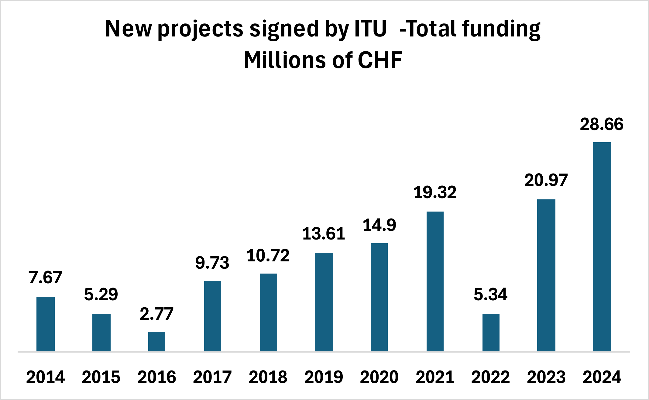

During 2024 ITU has also continued to strengthen project management practices across all ITU projects. This included strengthening reporting to partners, continuing with the operation of the Projects Board and strengthening the project monitoring function.

Further details and data can be found in the [ITU-D projects portal](https://www.itu.int/itu-d/sites/projects/home/projects/) and the new [dashboard for ITU membership on status of projects](https://www.itu.int/en/ITU-D/Projects/Pages/reports/default.aspx) (TIES protected).

## 4.8 Convening platforms

### 4.8.1 World Summit on the Information Society (WSIS) process

In 2024, ITU remained key in strengthening the outcomes of the World Summit on the Information Society (WSIS) and subsequent, ongoing digital cooperation, aligning those with various United Nations processes and activities, such as the ECOSOC Partnership Forum, Beijing+30, the Commission on the Status of Women (CSW), the High-Level Political Forum, the Summit of the Future and the resulting Pact for the Future and Global Digital Compact. ITU also worked at the regional level, collaborating with UN regional commissions, regional ITU offices, and other stakeholders to ensure the integration of the regional perspectives.

A key aspect of ITU’s work in 2024 was the continued implementation of WSIS action lines, which are fundamental in driving on global socio-economic development. These Action Lines address a broad range of issues, from building people-centred digital economies to cybersecurity, creating an enabling environment, and promoting the tech use for health, education, and environmental sustainability. By aligning WSIS action lines with overall development priorities, ITU ensured that the WSIS process helps advance sustainable development globally.

**WSIS achievements and milestones**

The WSIS process reached several milestones in 2024, the last full year ahead of the WSIS+20 overall review.

**WSIS+20 review preparation**: The year saw a strengthened multistakeholder approach, contributing to the WSIS objectives in advancing information and communication technologies (ICTs) for development. The WSIS process remains central to the global dialogue on ICT and development, with continued emphasis on broad multistakeholder collaboration. ITU, together with other UN agencies serving as WSIS Action Line facilitators, highlighted key milestones, challenges, and emerging trends that could shape digital cooperation beyond 2025 in each of the [WSIS action lines](https://www.itu.int/net4/wsis/forum/2024/Home/About#actionLines).

**Joint preparatory process**

ITU initiated the [WSIS+20 Joint Preparatory Process](http://www.wsis.org/review) in collaboration with key UN partners such as the UN Department for Economic and Social Affairs (UNDESA), UNESCO, UNCTAD (CSTD), and the United Nations Development Programme (UNDP). This initiative has been crucial in preparing for the WSIS+20 review, ensuring that all relevant stakeholders are involved in the ongoing review of WSIS outcomes. A calendar of key milestone events has been scheduled and made available. The ITU Secretary-General has taken key step to enhance communication and information flow between the New York and Geneva diplomatic communities.

**Call for input**

The ITU Council Working Group on WSIS and Sustainable Development Goals (CWG-WSIS&SDG) launched the [ITU Call for Input on WSIS+20](https://www.itu.int/en/council/cwg-wsis/Pages/default.aspx), inviting stakeholders to provide feedback on ITU’s role in implementing the outcomes of WSIS since 2003. This open call is a vital part of the preparatory process for WSIS+20, promoting multistakeholder input on the impact of WSIS over the past two decades and its vision beyond 2025.

**Strategic positioning** **of UNGIS**

As the permanent secretariat of the [United Nations Group on the Information S](http://www.ungis.org/)ociety (UNGIS) and the group’s vice-chair in 2024, ITU continued to strengthen UNGIS as a well-functioning mechanism for digital cooperation. UNGIS actively contributed to various global processes through side events and joint inputs, including at the High-Level Political Forum, Internet Governance Forum, Summit of the Future, and discussions on the Global Digital Compact. ITU maintains the UNGIS website, including the Digital Transformation Repository, which serves as a reference guide and repository for UN agencies on the implementation of various initiatives, showcasing the direct impact of WSIS action lines.

**Linking WSIS with other UN processes**

ITU continued its efforts to connect WSIS with other major UN processes, highlighting the importance of tech to drive socio-economic development and address emerging global challenges. These efforts were especially visible in ITU’s coordination of inputs to the Global Digital Compact and organization of key side events.

**Ongoing engagement and activities**

The [WSIS Stocktaking](http://www.wsis.org/stocktaking)platform, through its extensive database, continued to grow, reaching over 15 000 entries and 2.2 million stakeholders engaged in 2024. This platform, which provides annual and special reports (such as the WSIS+20 special report with Korea (Rep. of)), has become an analytical tool, offering insights into emerging trends and challenges in the implementation of WSIS action lines worldwide.

The [WSIS Prizes](https://www.itu.int/net4/wsis/stocktaking/Prizes/2024) are a key global contest highlighting and driving digital innovation and development. In 2024, the competition engaged stakeholders worldwide with online voting and celebrations of 18 winners and 72 champions, showcasing outstanding contributions to global development with digital technologies.

Through collaborative initiatives, strategic positioning, and active participation in global discussions, ITU worked with UN sister agencies and other stakeholders to continually renew and update the WSIS framework. A prime example of this is the organization of the WSIS Forum alongside the AI for Good event. As we approach the WSIS+20 review, ITU remains committed to advancing ICTs as tools for global development.

### 4.8.2 AI for Good

The AI for Good initiative identifies innovative AI applications, helps build skills and standards, and advances partnerships to solve global challenges. It is organized by ITU in partnership with over 40 UN sister agencies and co-convened with the Government of Switzerland.

The AI for Good Global Summit in 2024 involved 27 UN partners and attracted more than 5 000 on-site participants, along with 35 000 Neural Network members and an online community of 137 000, attracting 900 000 views. Participants came from 183 countries.

**AI for Good Global Summit 2024**

ITU’s annual AI for Good summit brought 47 United Nations partners together with global tech innovators to showcase the power of artificial intelligence (AI) for people, planet and prosperity. Live demonstrations of state-of-the-art brain-machine interfaces (BMIs) for advanced neurology and healthcare, as well as robotics improving accessibility for persons with disabilities, took centre stage over the three-day event.

[Learn more about BMI innovation](https://aiforgood.itu.int/brain-machine-interface-press-conference-at-ai-for-good-global-summit-2024/)

[Summit closing press release](https://www.itu.int/en/mediacentre/Pages/PR-2024-05-31-AI-for-Good-Global-Summit.aspx)

**Innovation Factory**

This global competition has grown to become the leading UN pitching and acceleration platform for AI startups from all corners of the world. At the Innovation Factory Grand Finale in 2024, the top AI solution award went to Stemuli, a US-based AI developer with a generative metaverse gaming platform for education and continuous learning.

[Learn more about the startups](https://s41721.pcdn.co/wp-content/uploads/2024/12/t-ai4g-ai4good-2024-9-pdf-e.pdf)

**Young AI Leaders Community**

A new community of young AI leaders launched at the AI for Good summit in 2024 highlights diverse perspectives, promotes gender equality in tech, and aims to equip youth around the world with crucial skills and tools to shape the future of AI.

[**Learn more**](https://aiforgood.itu.int/young-ai-leaders-community/)

[AI for Good](https://aiforgood.itu.int/) has become the leading action-oriented UN platform promoting AI to advance global development priorities for the benefit of everyone, everywhere. AI for Good is organized in partnership with over 40 UN sister agencies and co-convened with the government of Switzerland. The new [AI Skills Coalition](https://aiforgood.itu.int/ai-skills-coalition/) (formed under the AI for Good Impact Initiative) aims to provide an open, trusted platform for AI education and capacity building.

**AI Skills Coalition**

Rapid changes in the job market mean individuals and organizations need to focus and upskilling and continuous learning for the age of artificial intelligence (AI). ITU, with the United Nations Development Programme (UNDP) as a key partner, put together the new AI Skills Coalition launched in January 2025 to deliver high-quality AI training worldwide.

[**Learn more**](https://www.itu.int/hub/2025/03/ai-skills-for-the-future-a-new-un-training-platform/)

ITU’s [AI for Good Impact India](https://aiforgood.itu.int/event/ai-for-good-impact-india/) in 2024 signalled growing regional-level engagement, with AI for Good Impact Africa set to follow in South Africa in 2025, in partnership with the G20 secretariat.

### 4.8.3 Global Standards Symposium (GSS-24)

The [Fifth Global Standards Symposium (GSS-24)](https://gss.itu.int/) took place on 14 October 2024 in New Delhi, under the theme “Charting the Next Digital Wave: Emerging Technologies, Innovation, and International Standards.” GSS-24 explored how cutting-edge technologies and international standards are reshaping the digital future. The event featured a High-Level Segment with over 20 ministers and industry leaders, shaping the future of innovation and driving global change. It was attended by 1 800+ on-site participants and 800+ remote participants. See [GSS-24 conclusions](https://gss.itu.int/gss24-conclusions/).

### 4.8.4 Global Symposium for Regulators

The 23rd edition of the Global Symposium for Regulators (GSR-24) was held in Kampala, Uganda, from 1 to 4 July 2024 under the theme “Regulation for impact”. The event attracted over 600 participants including Ministers and Deputy Ministers (10), Heads of Regulatory Authorities and C-level industry executives (50+) from over 77 countries.

Regulators from around the world identified and endorsed the GSR-24 Best Practice Guidelines on "Helping chart the course of transformative technologies for impact." The guidelines can help ICT regulators shape a regulatory environment that enables the rollout of cutting-edge infrastructure to support digital societies and digital economies of the future. The guidelines also identify measures to minimize risk and maximize the social and economic benefits of transformative technologies. The guidelines are included in annex to this report and on the [GSR-24 website](http://www.itu.int/gsr24).

### 4.8.5 Engaging academia in ITU’s work

[ITU Academia membership](https://www.itu.int/hub/membership/), the [ITU Journal](https://www.itu.int/en/journal/j-fet/Pages/default.aspx), and [ITU Kaleidoscope conferences](https://www.itu.int/en/ITU-T/academia/kaleidoscope/Pages/default.aspx) serve as key platforms for academic engagement in ITU’s work. These initiatives foster collaboration between academia and industry, driving research and development while accelerating the transition of cutting-edge innovations from the lab to the market.

### 4.8.6 ITU Journal

The [ITU Journal on Future and Evolving Technologies (ITU J-FET)](https://www.itu.int/en/journal/j-fet/Pages/default.aspx) – free of charge to both readers and authors – offers comprehensive coverage of communications and networking. The quarterly, online journal welcomes research submissions all year long, on all topics relevant to the work of ITU. Volume 5 (2024) focused on [Next generation computer communications and networks](https://www.itu.int/en/journal/j-fet/2024/002/Pages/default.aspx), [Satellite constellations and connectivity from space](https://www.itu.int/en/journal/j-fet/2024/001/Pages/default.aspx) , [Intelligent technologies for future networking and distributed systems](https://www.itu.int/en/journal/j-fet/2023/003/Pages/default.aspx), and [AI and machine learning solutions in 5G and future networks](https://www.itu.int/en/journal/j-fet/2024/003/Pages/default.aspx).

Along with research articles, the journal includes [recorded webinar discussions](https://www.itu.int/en/journal/j-fet/webinars/Pages/default.aspx) with top-level researchers and industry leaders.

### 4.8.7 Kaleidoscope academic conference

The 15th edition of the [Kaleidoscope academic conference](https://www.itu.int/en/ITU-T/academia/kaleidoscope/2024/Pages/default.aspx), held in New Delhi, India, alongside WTSA-24, focused on advancing digital technologies to address unprecedented global challenges. Kaleidoscope 2024 also highlighted the role of youth in global standards development and the urgency of connecting the last one-third of the world’s population who are not yet online.

### 4.8.8 Seminars and workshops: Diving deeper

In-depth seminars and workshops are vital to ITU’s engagement across the radiocommunication, standardization and development sectors.

**Seminars**

The World Radiocommunication Seminar (WRS-24) was held from 2 to 6 December 2024 in Geneva, Switzerland.

**Keeping radio regulators up to date**

ITU published a new edition of the Radio Regulations treaty in 2024, following updates determined at WRC-23 for harmonized global and regional radio-frequency spectrum usage. ITU’s subsequent global seminar, WRS-24, provided hands-on training based on the latest frequency allocations, emphasizing the importance of effective spectrum management for digital connectivity.

[**Learn more about the seminar**](https://www.itu.int/hub/2024/12/wrs-24-global-itu-seminar-outlines-latest-radio-spectrum-regulations/)

[**Radio Regulations** (2024 edition)](https://www.itu.int/hub/publication/r-reg-rr-2024/)

In complement to the WRS held every other year, ITU-R achieved regional outreach through Regional Radiocommunication Seminars.

In 2024, ITU-R held three regional seminars:

* [RRS-24-CIS](https://www.itu.int/en/ITU-R/seminars/rrs/rrs-24-cis/Pages/default.aspx) in Astana, Kazakhstan
* [RRS-24-Americas](https://www.itu.int/en/ITU-R/seminars/rrs/RRS-24-Americas/Pages/default.aspx) in St Georges, Grenada
* [RRS-24-Asia&Pacific](https://www.itu.int/en/ITU-R/seminars/rrs/rrs-24-asia%26pacific/Pages/default.aspx) in Apia, Samoa

**Workshops**

ITU-R held three [Workshops on National Tables of Frequency Allocation (NTFA)](https://www.itu.int/en/ITU-R/seminars/ntfa/Pages/default.aspx) in 2024, that is, one per Radio Regulation region: Addis Abba (Region 1), Mexico City (Region 2) and Shanghai (Region 3).

Upon the request of 16 Southern African Development Community (SADC) administrations in August 2024, the ITU Radiocommunication Bureau provided technical assistance in identifying a suitable orbital slot for the SADC Shared Satellite Network. This request aimed to take advantage of the special procedure outlined in Resolution 170 (Rev. WRC-23). To further evaluate the results of the review of technical characteristics and compatibility analysis, the bureau and the SADC administrations also held a series of virtual meetings and a workshop between October 2024 and February 2025.

In addition, the following events were held in Almaty, Kazakhstan in September 2024:

* WMO-ITU Seminar: “Earth observation for Sustainable Development Goals: technologies, spectrum, applications, impacts” and
* ITU Workshop on Radioastronomy.

In 2024, 98 ITU-T workshops, symposia and webinars were organized in addition to the weekly programming of the year-round [AI for Good](https://aiforgood.itu.int/) digital platform. A listing of all past and planned events can be found on the [ITU-T workshops homepage](https://www.itu.int/en/ITU-T/Workshops-and-Seminars/2024/Pages/default.aspx). See [Related Events - WTSA-24](https://www.itu.int/wtsa/2024/related-events/).

ITU-T workshops, symposia and webinars discuss emerging trends in standardization, increase the visibility of ITU-T work, enhance ITU-T collaboration with other bodies, attract and recruit new ITU-T members, and encourage peer-learning relevant to the development and implementation of international standards.

In 2024, the Telecommunication Development Bureau (BDT) organized 173 events, comprising seminars, workshops, webinars, and forums in the Telecommunication Development Sector (ITU-D), focused on advancing sustainable digital transformation globally. Over 70 per cent of these were structured as seminars and workshops, reflecting a strong emphasis on capacity building, knowledge sharing, and collaborative problem-solving. These gatherings addressed critical challenges in cybersecurity, digital access, and policy development, addressing technology impact and aligning with ITU’s strategic goals to bridge digital divides and foster innovation.

The thematic focus areas reveal a targeted approach to sectoral priorities. There were 18 dedicated workshops on the theme of Cybersecurity, including hands-on cyber drills such as the ITU Regional CyberDrill for CIS and the CyberDrill for Europe & Mediterranean. Digital access initiatives featured prominently, with 22 seminars and workshops like the Mainstreaming Gender in ICTs series in Senegal, Nigeria, and Rwanda, alongside regional Girls in ICT Day events targeting youth empowerment.

Policy and regulation formed another cornerstone, with more than 15 workshops such as the Digital Regulation Training for Africa and Stakeholder Engagement Workshops on 5G and broadband in Uganda and Gambia. Additionally, environmental impact was addressed through seminars like Greening Digital Companies 2024 and e-waste management workshops in Thailand and Paraguay. Notably, capacity-building workshops such as the GovStack Architects Training and ITU Academy Training Centres (ATCs) Annual Meeting underscored efforts to strengthen technical and institutional capabilities globally.

Seminars and workshops also highlighted cross-cutting collaboration, with virtual platforms ensuring broad participation. By prioritizing interactive formats, ITU ensured that seminars and workshops served as hubs for innovation, policy dialogue, and actionable outcomes, driving progress toward resilient digital ecosystems for the good of everyone.

# 5. Enablers

## 5.1 Membership-driven approach

**ITU’s Growing and diverse membership: Reflecting the changing digital ecosystem.**

In 2024, ITU welcomed a new Member State, Palau, bringing the total to 194, as well as surpassed 1 000 Sector Members, Associates and Academia, the highest level of membership ever.

ITU’s membership has evolved and grown over time to reflect the global, changing digital ecosystem. With this evolution, ITU is continuously adapting its topics and working methods to remain a relevant global, neutral platform for its members.

ITU has reached 1 004 distinct member entities (+80 new/+35 net new entities in a year) including Sector Members, Associates and Academia. Almost all new memberships were from new entities: 80 new entities joined in 2024 while 10 members expanded or upgraded their membership.

* 1 343 memberships across all Sectors: +91 new and -62 either denounced or excluded.
* Sector Members accounted for 46 per cent of all new memberships (48 per cent in 2023), Associates for 37 per cent (36 per cent in 2023) and Academia for 16 per cent (16 per cent in 2023).
* Positive/stable trend across all Sectors, with net new memberships of +1 in ITU-R, +6 in ITU-T), +20 in ITU-D, and +2 for Academia.
* As opposed to 2023, where membership growth was spread across almost all regions, but driven primarily by Americas (+12 net new memberships), International (+12), and Asia & the Pacific (+10), 2024 saw growth mainly coming from Asia & the Pacific (+19 net new memberships).

Forecasted contributions grew slightly but remain just under CHF 17 million, despite net growth in membership. This is due to the continued growth in low fee categories and exempted entities.

* The community of SMEs is growing, though the pace of growth has slowed down since 2023 and 2022. Associates with SME reduced fees option (available from January 2020): 94 memberships (74 from ITU-T and 20 from ITU-R) have benefited from the reduced fees. +8 net new entities in 2024 (+15 net new entities in 2023).

## 5.2 Regional presence

As an extension of ITU as a whole, the [regional presence](https://www.itu.int/itu-d/sites/priorities/enablers-of-itu-d-priorities/regional-presence/) plays a vital role in the achievement of ITU’s mission, enhancing ITU’s understanding of local contexts and its ability to respond to countries’ needs effectively. The regional presence consolidates strategic planning at the level of each regional/area office, implementing programmes and initiatives that are consistent with and based on ITU’s strategic goals and thematic priorities. By applying the global targets and clarifying programme priorities at the regional level, ITU also seeks to enhance its overall global effectiveness and impact.

The regional presence strengthens ITU’s position as a shaper/doer and enhance United Nations cooperation, to build enhanced regional opportunities and thereby reach more countries and define clearer, more impactful priorities for country-level engagements. Efforts are also be made to strengthen capacity at the regional level to ensure the ability of the regional and area offices to implement the programmes and engagements determined based on ITU’s strategic goals and thematic priorities.

See section 4.7 for more details on the distribution and funding of ITU Projects by Region.

**Regional Initiatives 2023-2025**

ITU’s latest World Telecommunication Development Conference (WTDC), held in Kigali in June 2022, approved a new set of regional initiatives for the period 2023-2025. Those initiatives, outlined in the Kigali Action Plan, address specific needs for each major region of the world to advance and accelerate digital transformation. See the ITU-D webpage for further details on ITU’s [regional initiatives](https://www.itu.int/en/ITU-D/Pages/regional-initiatives-2023-2025.aspx).

***Driving transformation on the ground***

**Impact in Africa: Malawi tackles e-waste**

Malawi launched a new policy in October 2024 to address the growing challenge of electronic waste. The National E-waste Management Policy, prepared with ITU support, aims to promote safe collection, recycling, and disposal of e-waste, protecting the environment and public health**.** [**Learn more**](https://www.itu.int/itu-d/sites/digital-impact-unlocked/a-new-national-e-waste-policy-in-malawi/)

**Impact in the Americas: Life-saving response to Hurricane Beryl**

When the Category 4 hurricane hit Grenada, Jamaica, and Saint Vincent and the Grenadines in July 2024, ITU provided vital support with emergency telecommunications, helping restore connectivity to affected communities and coordinate life-saving disaster management and relief operations. [**Learn more**](https://www.itu.int/itu-d/sites/digital-impact-unlocked/crisis-response-itus-response-to-hurricane-beryl/)

**Impact in the Arab States: Robust cybersecurity cooperation**

The Arab region achieved record participation in cyber response training in 2024, with over 400 experts from 20 countries taking part in ITU-led exercises to enhance national capabilities. The sessions, organized jointly with the UAE Cyber Security Council, fostered regional cooperation and helped boost resilience against escalating cyber threats.[**Learn more**](https://www.itu.int/itu-d/sites/digital-impact-unlocked/bdt4impact-case-study-record-breaking-cyber-response-trainings/)

**Impact in Asia-Pacific: Digital hub for PNG vanilla farmers**

The European Union’s Support to Rural Entrepreneurship, Investment and Trade (STREIT) programme, with ITU as a key partner,opened a new digital hub to provide weather advisories, facilitate spice crop management, and promote climate-smart agriculture and prosperous livelihoods in rural Papua New Guinea. [**Learn more**](https://www.itu.int/itu-d/sites/digital-impact-unlocked/digital-training-empowers-vanilla-farmers-in-papua-new-guinea-to-find-new-markets/)

**Impact in the CIS region: Enhancing Azerbaijan’s digital data systems**

Azerbaijan’s latest digital skills data, compiled in partnership with ITU, show the country’s rapid progress in digital literacy and infrastructure development. Reliable tech statistics support evidence-based policy making and ensure digital transformation benefits everyone.[**Learn more**](https://www.itu.int/itu-d/sites/digital-impact-unlocked/enhancing-azerbaijans-ict-data-systems/)

**Europe: Co-creation advancing innovation in Albania**

Albania’s Ministry of Infrastructure and Energy, working closely with ITU, consulted experts and service users in government, industry and academia to produce the country’s ground-breaking new *Digital Innovation Profile*, identifying priorities to drive growth.[**Learn more**](https://www.itu.int/itu-d/sites/digital-impact-unlocked/digital-innovation-profile-co-creation-advances-innovation-in-albania/)

## 5.3 Bringing everyone to the table

**Ensuring equal access and use of technologies for all**

ITU actively promotes gender equality and strives to close gender divides in digital access worldwide. Dedicated initiatives incorporate youth perspectives into all areas of ITU’s work, as well as addressing the needs and perspectives on indigenous peoples, ageing populations, and other vulnerable groups. In accordance with UN principles, ITU also supports digital access for persons with disabilities through standards, policy guidance, awareness-raising, and education.

## 5.3.1 Gender equality

Report [C25/6](https://www.itu.int/md/S25-CL-C-0006/en) provides greater detail on ITU activities to support women and encourage girls across global tech and in all aspects of ITU’s work.

The digital gender divide refers to the gap in access, skills, and use of digital technologies among men and women. As of [2024](https://www.itu.int/itu-d/reports/statistics/facts-figures-2024/), 70 per cent of men and 65 per cent of women are using the Internet, narrowing the gap from 277 million more male users in 2021 to 189 million in 2024. While regions like the Americas, Europe, and the CIS have achieved gender parity, progress varies globally. Despite lower overall Internet usage, Small Island Developing States also achieved parity. The Asia-Pacific region has improved significantly, but this is less so in the Arab States region. There is progress in Africa, but the region is still far behind the other regions. Globally, women are still about 7 per cent less likely to own a mobile phone than men, outnumbering men among non-owners by 31 per cent.

The digital gender divide perpetuates inequalities and hinders women’s and girls’ opportunities for education, employment, and participation in the digital economy. Bridging this gap is essential to create opportunities for women, foster economic empowerment, and ensure digital development across the board.

ITU aims to ensure digital and tech-related benefits reach everyone. Popular [International Girls in ICT Day](https://www.itu.int/women-and-girls/girls-in-ict/international-girls-in-ict-day-2025/) events encourage girls and young women to pursue tech careers. On 25 April 2024, global celebrations in the Philippines were followed by a high-level dialogue in Geneva.

ITU-D and Ernst & Young (EY), together with [EQUALS](https://www.equalsintech.org/), launched a two-year [AI skills accelerator for girls](https://www.itu.int/women-and-girls/women-in-ict/ai-skills-accelerator-for-girls) to train 1 000 participants from marginalized communities in 12 countries. Under the [Her Digital Skills](https://www.equalsintech.org/her-digital-skills/) initiative, ITU, along with GSMA, EY, W4, Qualcomm, and Verizon, delivered 21 workshops in 2024, benefiting around 1 758 participants. The [Her CyberTracks](https://www.itu.int/en/ITU-D/Cybersecurity/Pages/Skills-Development/Her-CyberTracks.aspx) initiative, addressing the underrepresentation of women in cybersecurity, engaged around 300 participants and brought new perspectives on the global cybersecurity landscape.

Network of Women (NoW) initiatives are active in each of ITU’s three sectors: [ITU-R](https://www.itu.int/now4wrc/), [ITU-T](https://www.itu.int/en/ITU-T/NoW/Pages/default.aspx) and [ITU-D](https://www.itu.int/en/ITU-D/Digital-Inclusion/Women-and-Girls/NoW/Pages/default.aspx). The “NOW4WTSA24” campaign ahead of ITU’s key standardization conference increased women's leadership appointments, and women’s representation at WTSA24 reached 26 per cent. The NoW in ITU-D, meanwhile, launched the new Empowering Women Leaders Mentorship Programme ahead of the World Telecommunication Development Conference, WTDC-25. Additionally, a Network of Women Ministers and Leaders in ICT event took place alongside the WSIS+20 High-Level Event in July 2024.

For further information, visit [www.itu.int/gender](http://www.itu.int/gender) and [www.itu.int/genderdashboard](http://www.itu.int/genderdashboard).

## 5.3.2 Youth empowerment

The ITU secretariat continued implementing Resolution 198 (Rev. Bucharest, 2022) of the Plenipotentiary Conference, advancing youth empowerment through digital technologies and integrating youth perspectives into work programmes, management, and human resources development. In 2024, the Youth Task Force strengthened its advisory role, contributing to reviews such as Service Orders, and established an Internal Youth Network to engage young professionals across the organization. It also advocated for engaging youth in ITU activities, enhancing its visibility and advocated for intergenerational dialogue. Key outcomes included work on mobility and succession planning, collaboration with the ITU Transformation Office/Change makers programme, and two deliverables: contributions to ITU’s succession plan and the role of young staff in shaping ITU’s future, and the integration of young professionals into staffing tables at major ITU conferences to enhance career development opportunities.

Following the launch of the first ITU Young Professionals Programme, more than 3 500 applications were received and reviewed. Six entry-level professional (P1) positions were offered in ITU’s General Secretariat and Radiocommunication, Standardization and Development bureaux.

To promote and mainstream youth engagement, ITU launched several key initiatives. [The ITU Secretary-General’s Youth Advisory Board](https://www.itu.int/en/action/youth/Pages/itu-secretary-generals-youth-advisory-board.aspx) was established to empower young people to contribute to shaping global digital policies. The board provided recommendations from the youth perspectives to the ITU Secretary-General on how to narrow the digital divide and harness technology for societal benefits on topics such as AI, space, submarine cables, and environmental issues. The [Generation Connect Young Leadership Programme (GCYLP)](https://www.itu.int/generationconnect/empower/generation-connect-young-leadership-programme-in-partnership-with-huawei/) was designed to empower and inspire young digital changemakers. Through the GCYLP, 30 young fellows annually receive guidance, training, and financial support to implement digital development projects in their communities worldwide. In 2024, the first cohort was selected by a global jury from over 5 000 applicants across 200+ countries. Following a successful first year, selection is now underway for the second cohort. ITU advanced youth involvement in digital development by empowering 184 Generation Connect Youth Envoys (GCYE) from 64 countries, amplifying their voices through global platforms.

In 2024, ITU increased youth participation in ITU events and initiatives such as the AI for Good Global Summit, Regional Development Forums, ITU-D Study Group sessions, the EQUALS in Tech Awards, Girls in ICT Day, and more.

ITU’s Telecommunication Standardization Bureau (TSB) champions meaningful youth engagement on AI. In 2024, ITU’s [AI/ML in 5G Challenge](https://aiforgood.itu.int/the-5th-edition-of-the-itu-ai-ml-in-5g-challenge-a-year-of-competitions-in-review/) hosted 13 youth-focused challenges, providing a global platform for young innovators to develop AI/ML-driven solutions for real-world applications. The competition attracted over 4 000 young participants, who contributed more than 30 000 submissions. The [Robotics for Good Youth Challenge](https://aiforgood.itu.int/robotics-for-good-youth-challenge/) – the 2024-2025 edition centred on disaster response —is in its Curation and Preparation Phases and the Qualifying should start in April 2025. A youth zone at the AI for Good Global Summit 2024 provided a dynamic and engaging platform for young participants to learn, collaborate, and explore the exciting world of AI and robotics.

More information about youth related activities is provided in ITU Council Document [C25/31](https://www.itu.int/md/S25-CL-C-0031/en).

Moreover, youth engagement was a focus at [WTSA-24](https://www.itu.int/wtsa/2024/) in New Delhi, India, with targeted initiatives introduced to the side-event programme to attract young participants. Member States also approved the adoption of a new youth-focused [WTSA-24 Resolution 107](https://www.itu.int/dms_pub/itu-t/opb/res/T-RES-T.107-2024-PDF-E.pdf): “Enhancing the engagement of the next-generation experts in the standardization activities of the ITU Telecommunication Standardization Sector”. Key activities included a special session on youth participation in standards development during [ITU Kaleidoscope 2024: Innovation and digital transformation for a sustainable world](https://www.itu.int/en/ITU-T/academia/kaleidoscope/2024/Pages/default.aspx), held from 21 to 23 October 2024, as well as the [Robotics for Youth Challenge India](https://aiforgood.itu.int/event/robotics-for-good-youth-challenge-india/#:~:text=The%20Robotics%20for%20Good%20Youth%20Challenge%20is%20an%20UN%2Dbased,Sustainable%20Development%20Goals%20(SDGs).), the [two-day AI Bharat 5G/6G Sandbox Hackathon](https://challenge.aiforgood.itu.int/match/matchitem/95) that brought together students and young experts worldwide, and the launch of the [Young AI Leaders Community](https://aiforgood.itu.int/young-ai-leaders-community/) platform to foster youth participation, collaboration, creativity, and leadership in driving the AI revolution.

## 5.3.3 ICT accessibility

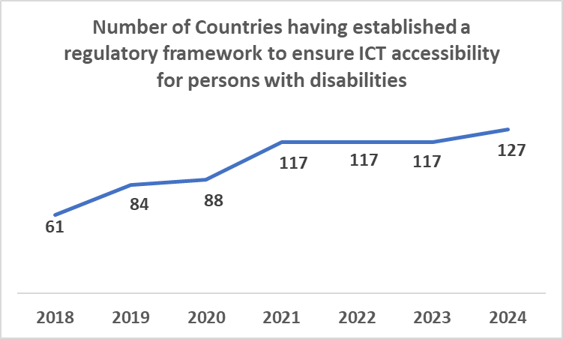

Source ITU

In 2024, the number of countries with a regulatory framework to ensure tech accessibility for persons with disabilities increased by 8.5 per cent, reaching a total of 127 countries. This marks a significant development after three years of stagnation at 117 countries.

Digital technologies should be not only be available and affordable, but also accessible, designed to meet the needs and abilities of all people – including those with disabilities. Adopting an intersectional approach, the Telecommunication Development Bureau's ICT/digital accessibility work encompasses key activities, events, tools, and resources to strengthen capacities, enhance communication, and help build a prosperous digital future for all.

The valuable accessibility resources, such as guidelines, toolkits and reports, training and knowledge development programmes; video tutorials, and more.

In 2024, the ITU Academy programme attracted 1 055 participants from 144 countries, with 74 per cent from developing countries and 42 per cent women, registered in online self-paced and tutor-led training courses on topics related to digital access. These included accessibility in websites, crisis and emergency communications, and other digital interactions, building smart cities for all people, issues related to ageing in the digital age, and strategies to ensure connectivity in rural, remote, and Indigenous communities. Online self-paced training sessions delivered through the ITU Academy are free of charge and available in multiple UN languages and digitally accessible formats, making them also accessible to deaf and blind persons.

## 5.3.4 Support for ageing populations

Examples of activities in progress are: developing digital skills in Gran Chaco (Argentina, Bolivia and Paraguay) and ICT Network Management training in Latin America, training people from indigenous and rural communities in network management, with an emphasis on connectivity, community media, maintaining local projects and indigenous networks.

## 5.4 Commitment to environmental sustainability

**Climate and environment: Monitoring and cutting emissions and e-waste**

ITU continued to bring together partners in the global push to reduce tech-related emissions, promote green computing, develop and adopt green standards, build a circular economy for the ICT sector, leverage radiocommunications in addressing climate change and use digital technologies for climate change emergency telecommunications. For instance, the [[AI sub-group of the Early Warnings for all Initiative](https://www.itu.int/en/ITU-D/Emergency-Telecommunications/Pages/AI-Sub-Group-EW4All-.aspx)](https://www.itu.int/en/ITU-D/Emergency-Telecommunications/Pages/AI-Sub-Group-EW4All-.aspx) is piloting AI to enhance early warning capabilities.

Furthermore, ITU also continues collaboration with the World Meteorological Organization (WMO), the UN Environment Programme (UNEP), the UN Framework Convention on Climate Change (UNFCCC) and the Universal Postal Union (UPU) on the [Global Initiative on Resilience to Natural Hazards through AI Solutions](https://www.itu.int/en/ITU-T/extcoop/ai4resilience/Pages/default.aspx) which explores leveraging AI across the disaster management cycle. This Initiative builds on the work of the [ITU/WMO/UNEP Focus Group on AI for Natural Disaster Management (FG-AI4NDM)](https://www.itu.int/en/ITU-T/focusgroups/ai4ndm/Pages/default.aspx).

***Reducing disaster risks with AI***

A new initiative promotes artificial intelligence (AI) to help protect against escalating climate and disaster risks. The Global Initiative on Resilience to Natural Hazards through AI Solutions, launched by ITU and other UN partners in October 2024, promotes research, innovation, and standards to strengthen early warning systems and boost national disaster readiness.

[**Learn more about the global initiative**](https://www.itu.int/hub/2024/08/new-un-initiative-to-reduce-disaster-risk-with-ai/)

[**Initiative chair’s perspective**](https://www.itu.int/hub/2025/04/ai-standards-and-future-disaster-resilience/)

Continued cooperation through ITU, WMO, and other international bodies is essential to ensuring that radio spectrum remains available for meteorological services and that these services can operate without interference. The ITU Radiocommunication Bureau launched a joint WMO-ITU training activity for the period leading up to WRC-27. Events were organized for RCC countries (Almaty, Kazakhstan, 16-17 September 2024) and APT (Singapore, 3-4 March 2025). The new edition of the ITU brochure “[Radiocommunication and climate change](https://www.itu.int/pub/R-GEN-CLC-2025)” (January 2025) raises awareness about the importance of meteorological radio services, particularly among policymakers and industry stakeholder, and helping ensure that spectrum allocation decisions prioritize public safety and environmental protection, particularly in the context of climate change.

On 16 November 2024, the first-ever Digitalization Day at a climate conference, was announced by Azerbaijan, holding the Presidency of COP29 – the 29th meeting of the Conference of the Parties to the UN Framework Convention on Climate Change. The day culminated in the COP29 Declaration on Green Digital Action, which received endorsements from over 80 countries and nearly 1 800 companies, organizations and other non-state stakeholders. Built around eight common objectives, the declaration recognizes the importance of digital technologies to mitigate and adapt to climate change while acknowledging the adverse impacts of digital technologies on the climate.

ITU has made further progress in studying energy use and GHG emissions across the global tech sector and continues to develop, promote and implement international standards to enhance the contribution of ICTs to climate and environmental action (see C25/45).

ITU also continues working on the environmental impact of AI, and the [AI and the Environment](https://www.itu.int/pub/T-ENV-ENV-2024-1) report highlights existing and emerging standards that support AI’s environmental efficiency. ITU, France and UNEP co-initiated the Coalition of Sustainable AI, and ITU was a key contributor to the report, [*Standardization for AI Environmental Sustainability – Towards a coordinated global approach*](https://www.sustainableaicoalition.org/wp-content/uploads/Standardization_AI_Sustainability.pdf), launched during France's AI Action Summit in Paris in February 2025. Additionally, the Green Digital Action working group on Sustainable AI (part of the initiative’s Green Computing pillar) is identifying measurement gaps to better assess the environmental footprint of AI workloads.

**Challenges to find AI-driven climate solutions**

The AI for Climate Action Innovation Factory and AI/ML in 5G Smart Energy Supply Scheduling for Green Telecom Challenge organized by ITU and partners during the UN climate conference, COP29, showcased the potential of AI-driven solutions to reduce emissions, optimize renewable energy uptake, enhance agriculture, and help address the climate crisis.

[**Learn more**](https://www.linkedin.com/pulse/harnessing-ai-sustainable-future-cop29-climate-bahme/)

As digital innovation continues to accelerate, responsible e-waste management has become increasingly urgent. At current rates, the world will produce 82 billion kilograms of e-waste annually by 2030, according to the 2024 [Global E-waste Monitor](https://www.itu.int/en/ITU-D/Environment/Pages/Publications/The-Global-E-waste-Monitor-2024.aspx). ITU has been supporting several countries across the America, Africa and Asia and the Pacific to advance and implement producer responsibility-based regulations for e-waste.

ITU has developed key standards to support countries and the ICT sector in responsible e-waste management and the transition to a circular economy. Key examples include environmental performance scoring for smartphones and a model for a digital product passport promoting circularity.

Internally, ITU has [strengthened governance and operations](https://www.itu.int/en/action/environment-and-climate-change/Pages/greening-ITU.aspx) of its Environmental Management System (EMS) in line with requirements set by the UN Chief Executives Board for Coordination. In 2024, this work included revising the ITU [Environmental Sustainability Policy](https://www.itu.int/en/action/environment-and-climate-change/Documents/ITU%20Environmental%20Sustainability%20Policy%20%282025%29.pdf) and strengthening ITU’s internal targets to reduce GHG emissions and improve operational efficiency. However, at the current trend , ITU will face challenges to meet the UN system target of reducing its emissions by 45 per cent from its 2010 baseline, in line with Intergovernmental Panel on Climate Change (IPCC) recommendations. Corrective actions are being considered in this regard.

## For further information, please see [C25/45](https://www.itu.int/md/S25-CL-C-0045/en).

## 5.5 Partnerships and international cooperation

**Partner2Connect**

Launched in 2021, the Partner2Connect Digital Coalition ([P2C](https://www.itu.int/partner2connect/)) mobilizes resources, partnerships, and commitments to accelerate universal meaningful connectivity and digital transformation. As of 31 December 2024, the P2C Pledging Platform had received 956 pledges valued at USD 54.27 billion from 452 entities across 146 countries worldwide. To date, over 1 000 pledges from 470 entities across 148 countries have been made, with a total value exceeding USD 73 billion as of March 2025. 38 per cent of pledges have so far provided updates on the status of their pledge implementation, compared to 33 per cent in 2023.

P2C fosters a global community of committed stakeholders by providing a platform to announce and provide updates on P2C, and by facilitating new partnerships and collaboration opportunities. During 2024, P2C sessions took place at the RDF-CIS, WSIS, AI for Good, SDG Digital, WTSA, and National Roundtables in Cambodia and China. Numerous webinars and the P2C Annual Meeting in January 2025 further provided opportunities for announcements and collaboration. P2C also launched the Explore Pledges and Explore Reports dashboards, introduced new matchmaking features including a virtual matchmaking session in collaboration with the Caribbean Telecommunication Union (CTU), expanded its marketing and communications activities with the launch of P2C Flash, and enhanced the P2C platform and website to optimize user experience and pledge tracking. A continued comprehensive program of activities is planned for 2025 with an aim to mobilize USD 100 billion in pledges by end 2026.

**Promoting solutions to accelerate progress**

Building on the impact of activities the previous year, ITU and the United Nations Development Programme (UNDP) held a second SDG Digital on 20-21 September 2024 in New York. The event highlighted cooperation and partnerships aimed at leveraging digital innovation for global development ahead of the UN General Assembly, the Summit of the Future and associated Action Days.

Presentations and demonstrations exemplified how digital technologies can lay the groundwork for a better global future. By convening leaders from government, civil society, the private sector, youth, and academia, the event focused on the future, encouraging exploration of the trends, risks, and opportunities presented by digital and emerging technologies on our journey forward.

**Broadband Commission – putting broadband firmly on the international policy agenda**

In 2024, the Broadband Commission for Sustainable Development, led by ITU and UNESCO engaged diverse partners, including over 50 commissioners, external experts on working groups, and other strategic partners and contributors.

The Commission hosted and its members attended international advocacy events, issued 2 thought leadership publications, and launched the Commissioner-led [Working Group on Data Governance](https://www.broadbandcommission.org/working-groups/data-governance/). [The Annual virtual Spring Meeting under the theme of “Harnessing Emerging Technologies for Universal Access and Connectivity](https://broadbandcommission.org/event/2024-annual-spring-meeting-of-the-broadband-commission/)” addressed how emerging technologies can help achieve universal connectivity and change the outlook. [The Fall Meeting 2024 addressing the theme: “Towards a Resilient, Safe, and Inclusive Digital Future”](https://broadbandcommission.org/event/2024-annual-fall-meeting-of-the-broadband-commission/) was hosted in New York on 20 September against the backdrop of the 79th session of the UN General Assembly and the Summit of the Future. The Commission called for enhanced global digital cooperation and emphasized the importance of reinforcing digital infrastructure to withstand disruptions and mitigate growing risks. The Commission called also for greater cross-sector collaboration to strengthen preparedness and crisis response capabilities.

The Broadband Commission participated in UN agency-led events (including CSW68, WSIS Forum 2024, World Telecommunication and Information Society Day (WTISD) 2024, etc.) and Commissioners also attended private sector conferences (including the 2024 SAMENA Leaders’ Summit, GSMA MWC 2024 etc.).

Publications, working group reports, open statements/contributions, and research across the reporting period include:

[The State of Broadband Report 2024, “Leveraging AI for Universal Connectivity,”](https://broadbandcommission.org/publication/state-of-broadband-2024/) which was launched and discussed at the annual Spring Meeting of the Commission in June 2024. The report offers an initial overview of how AI applications are shaping development across e-government, education, digital health, digital finance, and the environment, while also addressing associated risks and implications for the digital divide.

[Open statements to UN processes and events](https://www.broadbandcommission.org/contributions-to-un-processes/): (e.g. [Broadband Commission impact stories on Championing Digital Equality](https://www.broadbandcommission.org/wp-content/uploads/2024/04/Broadband-Commission-Championing-Digital-Equality-1.pdf), input to the 2024 High-Level Political Forum).

New Working Group on Data Governance launched by UNESCO, ITU, UNDP and the African Union Commission (AUC) which held its [physical meeting in New York](https://www.broadbandcommission.org/global-digital-compact-data-governance/), is building on previous work of the Commission, such as the [Data for Learning 2023](https://www.broadbandcommission.org/working-groups/data-for-learning/) and [AI Capacity Building 2022](https://www.broadbandcommission.org/working-groups/ai-capacity-building/).

Strategic outreach: The Commission has gained over 1 000 newsletter subscribers and has more than 16 800 combined followers on X (Twitter), LinkedIn, and Facebook. Over 55 800 readers downloaded Commission reports in 2024.

**EQUALS – promoting access, skills, and ICT leadership for women and girls.**

The [EQUALS](https://www.equalsintech.org/) Global Partnership for Gender Equality in the Digital Age is a committed group of corporate leaders, governments, businesses, not-for-profit organizations, academic institutions, NGOs and community groups around the world dedicated to promoting gender balance in the technology sector by championing equality of access, skills development and career opportunities for women and men alike. In 2024, EQUALS reached more than 100 partners – including governments, companies and NGOs.

**Giga – working to connect every school to the Internet.**

The joint ITU/UNICEF [Giga initiative](https://giga.global/), established in 2019, supports governments and other stakeholders with the aim to connect every school to the Internet, and every child and young person to information, opportunity and choice, by 2030. By the end of 2024, globally, 34 countries and territories were engaged with Giga, which focuses on connecting schools and surrounding communities. Giga’s work – recognized in the Global Digital Compact as a critical part of mapping Internet connectivity and connecting schools and hospitals – is carried out under four key pillars: mapping schools, modelling the requisite infrastructure, mobilizing finance, and contracting for connectivity. This work is underpinned by capacity development programs with governments and stakeholders, leveraging the ITU Academy platform.

**Digital Infrastructure Investment Initiative**

The lack of physical digital infrastructure remains one of the main challenges to achieving universal and meaningful connectivity. Recognizing this, ITU launched the Digital Infrastructure Investment initiative (DIII) in April 2024. Co-led with seven development finance institutions (DFIs), the initiative identifies key actions needed to close the estimated investment gap of USD 1.6 trillion to connect everyone meaningfully by 2030, starting with the development of innovative financing mechanisms and platforms.

The Fourth International Conference on Financing for Development (FfD4) in mid-2025 presents a key opportunity to mobilize digital infrastructure investment funds. An ITU policy brief, drawing on the work of the DIII, outlined three key steps to unlock investments in digital infrastructure: first, establishing a technical forum with DFIs; second, launching a dedicated transaction platform; and third, building a knowledge hub on innovative financing for connectivity within the new Giga Connectivity Centre in Geneva. The conference (Seville, June 30 – July 3) will feature a side event, Strategies for Financing a Sustainable and Inclusive Connected World, to be organized by ITU in collaboration with UNCTAD, UNICEF, and the governments of Brazil, Spain, and South Africa. Through these ongoing efforts, ITU is strengthening collaboration among DFIs, the private sector, UN agencies and other key stakeholders, aiming to catalyse digital infrastructure investment on the required scale globally.

**International Advisory Body on Submarine Cable Resilience**

In November 2024, ITU and the International Cable Protection Committee (ICPC) jointly launched the International Advisory Body on Submarine Cable Resilience, comprising 42 leaders and experts from the public and private sectors. The Advisory Body – chaired jointly by Nigeria’s Minister of Communications, Innovation and Digital Economy and the head of Portugal’s national telecom regulator, Anacom – aims to find ways to improve the resilience of submarine telecommunication cables. This vital undersea infrastructure carries over 99 per cent of the world’s international communications.

**Digital Public Infrastructure**

The inaugural Global DPI Summit, hosted with UNDP, the UN Office for Digital and Emerging Technologies (ODET), the World Bank, and Co-Develop, together with the Government of Egypt, took place in Cairo on 1-3 October 2024 under the auspices of H.E. President Abdel Fattah El-Sisi. The summit brought together around 700 delegates from 101 countries – including governments, the private sector, civil society, and international organizations – to explore how safe, inclusive, and interoperable digital public infrastructure (DPI) could enable more effective service delivery, foster innovation, strengthen digital cooperation across borders, and accelerate sustainable development progress.

**Space Sustainability Forum**

ITU’s first [Space Sustainability Forum 2024](https://www.itu.int/ssf/), taking place in September 2024, brought together leaders and experts from the satellite and space industries, along with space and telecom agencies, governments and other stakeholders committed to responsible space use. The forum provided the opportunity to explore policies, best practices, guidelines and strategies to ensure space remains accessible and sustainable for further space ambitions and future generations.

**Virtual Worlds and AI initiative**

In June 2024, ITU, together with UNICC and Digital Dubai, has launched the [Global Initiative on Virtual Worlds and AI – *Discovering the Citiverse*](https://www.itu.int/metaverse/virtual-worlds/). The Initiative serves as a global platform that aims at fostering open, interoperable and innovative AI-powered virtual worlds that can be used safely and with confidence by people, businesses and public services.

The [UN Virtual Worlds Day](https://www.itu.int/un-virtual-worlds-day/2025/) is an annual event organized by ITU and other 17 UN entities exploring AI-powered virtual worlds, including the metaverse, to advance global development priorities, including the recently adopted UN Pact for the Future and Global Digital Compact. The inaugural event on 14 June 2024, in Geneva, showcased how immersive digital platforms can drive global progress. The second edition will be held on 11-12 June 2025, in Turin, Italy, featuring high-level dialogues, interactive showcases, and collaborative sessions to discuss how virtual technologies can help build digital public infrastructure that is resilient and beneficial to everyone.

**Digital transformation for smart cities and communities**

The [United for Smart Sustainable Cities (U4SSC)](http://www.itu.int/en/ITU-T/ssc/united/Pages/default.aspx) initiative is supported by 19 UN bodies with the aim of achieving SDG 11 (“Make cities and human settlements inclusive, safe, resilient and sustainable”) and advancing the Pact for the Future. Over 200 cities have adopted [U4SSC Key Performance Indicators](https://www.itu.int/en/ITU-T/ssc/united/Pages/publication-U4SSC-KPIs.aspx) based on ITU standards. The results of these evaluations are shared by [city snapshots, factsheets, verification reports and case studies](https://www.itu.int/en/ITU-T/ssc/united/Pages/publication-U4SSC-KPIs.aspx).

U4SSC is providing expert guidance (see [U4SSC reports](https://u4ssc.itu.int/publications/))in nine thematic areas:

* City platforms
* Enhancing Urban Economic Resilience and Smart Sustainable Cities
* AI in cities
* Enabling people-centred cities through digital transformation
* Digital public infrastructure for cities
* Digital wellbeing
* Sustainable digital transformation in buildings and urban energy
* Social-cultural sustainability in people-centred city governance
* Future foresight for cities

The [eighth U4SSC meeting](https://u4ssc.itu.int/latest-meetings/8th-meeting/) was held on 19 September 2024, in Madrid, Spain. Highlights of the meeting included the establishment of new Thematic Groups and the newly published U4SSC deliverables.

See [U4SSC reports](https://u4ssc.itu.int/publications/) and [ITU reports](https://www.itu.int/cities/publications/) on smart cities.

See also [ITU Digital Transformation Dialogues](https://www.itu.int/cities/digitaltransformationdialogues/) (DTD), which serves as a dynamic platform for sharing knowledge and deepening our understanding of emerging technologies and technical standardization across various fields. Through a series of engaging sessions, DTD fosters discussions on the rapidly evolving digital landscape and its impact on industries and society.

The [ITU Digital Transformation and Cities Digest](https://www.itu.int/cities/dt-digest/) provides the latest updates on digital transformation, smart cities, virtual worlds and the metaverse. It also features information on upcoming events and new publications.

In addition, ITU continues to curate a wealth of knowledge through the [Digital Transformation Resource Hub](https://www.itu.int/cities/dt-resource-hub/), offering high-quality publications on key digital transformation topics. These include, digital public infrastructure, AI, the Internet of Things, blockchain, digital twins, the metaverse and virtual worlds, and emerging digital transformation trends.

**Intelligent transport systems**

During WTSA-24, a new [Resolution 104](https://www.itu.int/en/ITU-T/ITS/Pages/WTSA-Resolution-104.aspx) was adopted on Promoting and Strengthening Standardization Activities for Vehicular Communications.

The Collaboration on ITS Communication Standards ([CITS](https://www.itu.int/en/ITU-T/extcoop/cits/Pages/default.aspx)), which is a global platform for coordination of Intelligent Transportation Systems (ITS) communication standards, continues to serve as a vital link between ITU and the [UNECE World Forum for Harmonization of Vehicle Regulations (WP.29)](http://www.unece.org/trans/main/welcwp29.html), addressing key topics such as ITS and automated driving, which are the focus of ongoing studies by various ITU-T study groups.

CITS established, on 22 September 2023, the [Expert Group on Communications Technology for Automated Driving](https://www.itu.int/en/ITU-T/extcoop/cits/Pages/egcomad.aspx) (EG-ComAD). The activities of EG-ComAD are conducted through two Working Groups:

* WG1 – [*“Vehicular communications for merging automatically into congested lanes”*](https://www.itu.int/en/ITU-T/extcoop/cits/egcomad/wg01/Pages/default.aspx)
* WG2 – [*“Vehicular communications for advanced emergency braking, including to protect vulnerable road users (VRUs)”*](https://www.itu.int/en/ITU-T/extcoop/cits/egcomad/wg02/Pages/default.aspx)

ITU and the UN Economic Commission for Europe (UNECE) are co-organizing the 20th edition of the **Future Networked Car Symposium** ([FNC-2025](https://fnc.itu.int/)) during the week 24-27 March 2025.

**CTO and CxO meetings**

CTO and CxO meetings convene industry executives to discuss industry priorities and related standardization activities with senior management of ITU's Telecommunication Standardization Bureau (TSB). Resulting communiqués highlight innovation areas benefiting from new ITU standards.

The most recent [CxO Roundtable](https://www.itu.int/en/ITU-T/tsbdir/CxO/Pages/CxO-Roundtable-9-December-2024.aspx) was held on 9 December 2024 at the Telecom Review Leader's Summit in Dubai, UAE.

CxOs discussed support for fibre optics, AI for future networks, data processing and management. They also addressed non-terrestrial networks, mitigating voice traffic fraud, broadband networks for public safety, and quantum information technologies. (Meeting [communiqué](https://www.itu.int/en/ITU-T/tsbdir/cto/Documents/Communique_ITU_CxO_2024.pdf).)

**World Standards Cooperation**

The [World Standards Cooperation (WSC)](https://www.itu.int/en/ITU-T/extcoop/Pages/wsc.aspx) is a partnership of ITU, the International Organization for Standardization (ISO) and the International Electrotechnical Commission (IEC) to advance the voluntary consensus-based international standardization system.

Among the partnership’s key activities in 2024 were:

* [World Standards Day](https://www.worldstandardsday.org/home.html) (14 October 2024), when ITU, ISO and IEC led celebrations of “A Shared Vision for a Better World." (See [past editions of World Standards Day](https://www.worldstandardscooperation.org/what-we-do/world-standards-day/)).
* [AI and Multimedia Authenticity Standards Collaboration: ‘’AI Watermarking’’](https://aiforgood.itu.int/multimedia-authenticity/) convened by ITU under the World Standards Cooperation (see [terms of reference](https://www.itu.int/en/ITU-T/extcoop/amas/Documents/Terms%20of%20reference%20for%20AI%20and%20multimedia%20authenticity%20standards%20collaboration.pdf)).
* [The International AI Standards Summit](https://aiforgood.itu.int/ai-standards/) launch, in New Delhi, India, in October 2024, answering the call from the global community on an AI standards exchange. This is part of the Global Digital Compact (global framework for digital cooperation and governance of artificial intelligence)
* Joint presence at the Standards Pavillion at COP29 and continuing Green Digital Action (GDA) collaboration under the Green Standards Pillar on embedding sustainability into technical standards by design, aimed at achieving net-zero emissions and a resource-efficient, circular, and low-carbon economy.

**Leveraging AI as part of Early Warnings for All**

ITU, together with WMO, the UN Office for Disaster Risk Reduction (UNDRR), and the International Federation of Red Cross and Red Crescent Societies (IFRC) formed the [AI Sub-group of the Early Warnings for all Initiative](https://www.itu.int/en/ITU-D/Emergency-Telecommunications/Pages/AI-Sub-Group-EW4All-.aspx) to leverage AI to enhance early warning systems by uniting experts in AI, data science, and disaster risk management. The group bridges the gap between AI research and the practical needs of early warning practitioners and communities worldwide, where work is ongoing to facilitate pilot initiatives in countries.

For instance, using the [Disaster Connectivity Map](https://dcm.itu.int/), ITU has partnered with Microsoft AI for Good Lab, Planet and Institute of Health Metrics Evaluation to use AI to analyse satellite imagery and create high-resolution population density maps. [The Global Map of the Unconnected too](https://www.youtube.com/watch?v=xjKjamBKHAw&feature=youtu.be)l identifies areas lacking connectivity, aiding early warning dissemination. Initially piloted in Fiji, Tonga, and Vanuatu, work is being scaled to 30+ countries under the Early Warnings for All initiative.

**Advancing AI-driven disaster resilience**

ITU collaborates with WMO, UNEP and other UN organizations to advance AI-driven disaster resilience and lay the foundations for the development of standards to apply AI in disaster management.

The [ITU/WMO/UNEP Focus Group on AI for Natural Disaster Management (FG-AI4NDM)](https://www.itu.int/en/ITU-T/focusgroups/ai4ndm/Pages/default.aspx), established in 2020, explored AI's potential in improving data collection and handling, improving modelling across spatial and temporal scales, and facilitating effective communication during disaster events. FG-AI4NDM developed the following outputs in 2024:

* [AI for communications: Towards natural disaster management](https://www.itu.int/pub/publications.aspx?lang=en&parent=T-FG-AI4NDM-2023-2)
* [Standardization Roadmap on Natural Disaster Management: Trends and Gaps in Standardization](https://www.itu.int/pub/publications.aspx?lang=en&parent=T-FG-AI4NDM-2022)
* [Glossary - Artificial Intelligence for Natural Disaster Management](https://www.itu.int/pub/publications.aspx?lang=en&parent=T-FG-AI4NDM-2022-1)
* [Innovative Approaches to Natural Disaster Management: Leveraging AI for Data-related processes](https://www.itu.int/pub/T-FG-AI4NDM-2023-3)
* [Transformative AI Models for Natural Disaster Management](https://www.itu.int/en/ITU-T/focusgroups/ai4ndm/Documents/Deliverables/FG-AI4NDM%20WG-MODELING%20-%20AI%20for%20Modeling.pdf)

FG-AI4NDM organized 12 meetings and [10 Workshop/Webinars](https://www.itu.int/en/ITU-T/focusgroups/ai4ndm/Pages/events.aspx) between March 2021 to March 2024 (as outlined in the [FG-AI4NDM snapshot report](https://www.itu.int/pub/publications.aspx?lang=en&parent=T-FG-AI4NDM-2024-4)). The best practices developed by the FG-AI4NDM are being implemented by the EU-funded project – [MedEWSa](https://www.medewsa.eu/) which brings together a consortium of partners, including Justus-Liebig-Universität, WMO, and the European Centre for Medium-Range Weather Forecasts (ECMWF), among others.

Building on the work of FG-AI4NDM, the [Global Initiative on Resilience to Natural Hazards through AI Solutions](https://www.itu.int/en/ITU-T/extcoop/ai4resilience/Pages/default.aspx) was announced in May 2024 during the AI for Good Global Summit. This Global Initiative is a collaborative effort of ITU, WMO, UNEP, UNFCCC, and UPU. It continues to examine how AI can be harnessed to enhance resilience against natural hazards by providing expert guidance, supporting research and innovation, and laying the foundation for standards development related to the use of AI across the disaster management cycle.

The Global Initiative held its first meeting in Barcelona, Spain, on 6 November 2024, hosted by the Barcelona Supercomputing Centre.

**AI and IoT for digital agriculture**

The [ITU/FAO Focus Group on Artificial Intelligence for Agriculture (FG-AI4A)](https://www.itu.int/en/ITU-T/focusgroups/ai4a/Pages/default.aspx), established in October 2021, was dedicated to exploring how AI, Internet of Things (IoT) and other emerging technologies can enhance agricultural productivity, and global food security. The FG-AI4A held 10 meetings and [10 Workshops/Webinars](https://www.itu.int/en/ITU-T/focusgroups/ai4a/Pages/events.aspx) between March 2022 to June 2024 and brought together experts from diverse sectors, including government agencies, academia, industry, and international organizations, to underscore AI-driven solutions for the agricultural sector.

During its tenure, FG-AI4A worked to identify standardization gaps, facilitate knowledge exchange, and develop best practices in leveraging AI for precision farming, climate resilience and resource optimization across agricultural production processes (outlined in the [FG-AI4A snapshot report](https://www.itu.int/net/epub/TSB/2025-Digital-Agriculture-A-Standards-Snapshot/index.html#p=1)).

## 5.6 Resource mobilization

The ITU Council – following instructions from the 2022 Plenipotentiary Conference (PP-22) – adopted a resource mobilization strategy proposed by the Secretary-General at the 2024 session of the Council. The strategy has three main pillars, including strengthening member engagement and revenues, leveraging events, products, and services, and increasing voluntary contributions.

Member State unit contributions account for about 70 per cent of regular budget revenues. In the preparation of the strategy through the Council Working Group on financial and human resources (CWG-FHR), delegates asked the ITU secretariat for assistance in making the case for ITU within their own administrations for maintaining or increasing their unit contributions. The secretariat is developing an investment case for ITU, along with executive briefing materials and updated related web resources that can be used by delegations for internal consultations.

The secretariat is also undertaking a significant effort to modernize its operations, generating new efficiencies, and preparing more detailed, transparent reporting for Member States. Lastly, under the guidance of the Council Working Group for strategic and financial plans (CWG-SFP), an ITU-wide effort is underway to improve the presentation of the ITU budget and make clearer links between the budget and operational and strategic plans, identifying funding gaps. To strengthen *Sector Member* engagement and revenues, which account for about 10 per cent of regular budget revenues, the strategy calls for a review of Sector membership in consultation with the Sector Advisory Groups. This includes considering benefits that would encourage existing Sector Members to have memberships across multiple Sectors, and Associates to upgrade to full Sector membership. It also includes reviewing and modernizing key member services like study groups. To this end, the CWG-FHR sent a liaison statement to the advisory groups calling for inputs. This topic will be on the advisory group agendas of each sector in 2025, with reporting back to the CWG-FHR’s fall session.

The resource mobilization strategy also calls for reviews of various events, products and services. Products and services account for about 20 per cent of the regular budget through cost recovery. Investments in new systems have been made to modernize delivery of maritime products, which account for the other half of cost recovery revenues, and further investments are planned to support the sale of digital products and modernization of ITU’s event experience, which would open the door to potential new revenue streams. In addition, major events like AI for Good are testing various revenue models.

Regarding voluntary contributions, which are used to supplement the regular budget, the World Telecommunication Development Conference in 2025 (WTDC-25) presents an opportunity to explore new approaches to raise funds for projects and initiatives. Initiatives like Giga confirm the potential to boost funding and maximize impact by partnering with other UN agencies. The secretariat is also working to address key enablers of project implementation, including streamlined hiring and procurement processes, new information technology (IT) systems to support efficient ITU-wide coordination of outreach to members and partners, and a new partnership strategy to leverage partnerships for impact and provide greater transparency, while protecting the reputation of ITU.

## 5.7 Excellence in human resources and organizational innovation

## 5.7.1 Human resources

In 2024, ITU advanced its vision of building an agile, capable, and empowered workforce, while fostering a welcoming work culture and delivering people-centred HR services. These efforts formed a core component of ITU’s organizational transformation, reinforcing its ability to respond to evolving priorities and deliver on its mandate.

1. **People** – A cost-effective Learning Plan was implemented leveraging a hybrid model and external platforms to enhance accessibility and control costs. The performance management system was streamlined through the introduction of a simplified ePMDS tool and targeted trainings to promote accountability, ongoing feedback, and professional growth.

Talent development was strengthened through the implementation of Young Professionals Programme, the expansion of the Junior Professional Officer (JPO, 8 in March 2025 with more expected over the year) scheme, and a new partnership with UN Volunteers (UNV), enhancing workforce agility. A second tranche of the Voluntary Separation Programme was launched, enabling enhanced organizational agility and supporting structural realignment. The [Workforce Analytics Dashboard](https://app.powerbi.com/view?r=eyJrIjoiNTNlMzVkYmItZWE5ZC00NTMwLTk2ZTgtZjJiM2IxZmJjY2UyIiwidCI6IjIzZTQ2NGQ3LTA0ZTYtNGI4Ny05MTNjLTI0YmQ4OTIxOWZkMyIsImMiOjl9) is available to Member States through the Council website: Microsoft Power BI.

1. **Culture** – The outsourcing of the Ombudsman function to UNOMS marked a significant step in strengthening ITU’s internal support mechanisms. The first ‘Inclusive Leadership’ programme was successfully rolled out for staff at P5 level and above, as part of a wider, more comprehensive Leadership program. A new Mandatory Learning Policy was introduced to build a common foundation of knowledge and reinforce organizational standards and behaviours. Our first Gender Parity Implementation Plan and first Mental Health and Wellbeing Action Plan were developed, and extensive counselling and wellbeing initiatives further promoted staff engagement and workplace inclusion. The first employee engagement survey was developed and conducted to assess staff members’ level of commitment, motivation, and connection to their work and the Organization, with the aim of informing strategies to strengthen organizational efficiency and effectiveness. It achieved a response rate of 72 per cent.
2. **Services** – The Human resource management department (HRMD) advanced efforts to strengthen the regulatory framework, aligning HR policies with evolving workforce needs and UN system best practices. Key achievements included the development of a new teleworking and flexible working policy, the launch of the first phase of the HR Delegation of Authority Framework, and the introduction of SOPs for SSA payments and emergency procedures for staff in Field Offices and on missions. ITU contributed actively to the first inter-agency generative AI project, developing an AI chatbot to automate policy queries and improve access to HR information. The UNJSPF Financial Interface Phase I went live, automating annual reporting and improving pension reconciliation. Engagement with regional offices and delivery of induction and pre-retirement seminars further supported staff across duty stations. ITU’s workforce analytics dashboard continues to serve Member States and promote transparency.

For further details, please refer to the Council document on Progress Report on the Implementation of the HR Transformation Plan ([C25/66](https://www.itu.int/md/S25-CL-C-0066/en)).

### 5.7.2 Transformation Process

Following the previous status update at the Council Working Group on finance and human resources in February 2025 and November 2024, the Council-25 document ([C25/55](https://www.itu.int/md/S25-CL-C-0055/en)) provides further information on ITU's ongoing Transformation Process, which is crucial for achieving organizational excellence and supporting the ITU's Strategic Plan for 2024-2027. ITU Transformation is guided by a comprehensive roadmap outlined in Council document [C24/52](https://www.itu.int/md/S24-CL-C-0052/en), focusing on five pillars: Governance, Systems, Processes and Tools, People and Culture, Resource Optimization, and Members and Partners.

This period of Transformation has been defined by project implementation and tangible deliverables across the five pillars. To date, the Transformation Team has strengthened its resources with an additional AI Data Programme Manager to facilitate ITU's AI implementation plans and strengthen AI learning across a broad cross-section of staff at all levels. As before, feedback, engagement and participation from across the ITU and its membership remain vital as the Transformation journey matures and develops.

**Key achievements**

The Transformation's key achievements continue to include, but are not limited to, enhancements to our internal performance management process including a more modern tool for staff to set their goals, a more robust strategy to manage underperformance, and a just and fair rewards and recognition system; financial resources transformation; advancing ITU’s internal AI learning and skills path; training for improvements in our leadership culture, and efficiency gains in our official Recruitment, Travel, and Mobility processes. The roadmap includes digital transformation initiatives to modernize our systems and tools including the new website project, assessment of our document management processes and systems, CRM for account and partner management, developing fit-for-future data foundations and AI enablement.

For more details, please refer to document [C25/55](https://www.itu.int/md/S25-CL-C-0055/en).

# 6 Implementation of the Resolutions from the Plenipotentiary Conference

The status of implementation of PP Resolutions can be found in the dedicated Web platform [[here](https://www.itu.int/net4/Search/CL25)](https://www.itu.int/net4/Search/CL25).

_____________