|  |  |
| --- | --- |
| **Agenda item: PL 2** | **Document C25/28-E** |
| **16 May 2025** |
| **Original: English** |
|  |  |
| Report by the Secretary-General | |
| DRAFT FOUR-YEAR ROLLING OPERATIONAL PLAN FOR THE UNION FOR 2026-2029 | |
| **Purpose**  This document presents the draft ITU operational plan for the Union for 2026-2029.  This Plan is published pursuant to the ITU Convention as follows: No. 181A of Article 12 (ITU-R); No. 205A of Article 15 (ITU-T); No. 223A of Article 18 (ITU-D); and No. 87A of Article 5 (General Secretariat).  The Sector's plans were presented to the advisory groups of ITU-R and ITU-D. The plan will also be presented to the forthcoming TSAG.  **Action required by the Council**  The Council is invited to **review** and **approve** the draft ITU operational plan for the Union for 2026-2029 and to **adopt** the draft resolution presented in Annex A to this document.  **Relevant link(s) with the Strategic Plan**  The operational plan sets forth details for the five thematic priorities and the 43 outputs of the Union as laid down in the strategic plan.  **Financial implications**  The operational plan is consistent with the financial limits set by the Plenipotentiary Conference in Decision 5 (Rev. Bucharest, 2022).  __________________  **References**  [*Resolution 71 (Rev. Bucharest, 2022)*](https://www.itu.int/en/council/Documents/basic-texts-2023/RES-071-E.pdf)*,* [*CV 87A, 181A, 205A, 223A*](https://www.itu.int/en/council/Documents/basic-texts/Convention-E.pdf) | |

1. **Outline of the operational plan by Thematic Priorities, Outputs, and Sector**
   1. The draft operational plan for 2026-2029 addresses the implementation of the five thematic priorities and forty-three outputs. It follows the structure of the 2024-2027 strategic and financial plans approved by the 2022 Plenipotentiary Conference.
   2. This draft operational plan provides a detailed analysis for 2026 and a condensed one for the three subsequent years.

1.3 The structure of the draft operational plan for 2026-2029 stands as follows:



**2 Thematic priorities and outputs**

2.1 Table 1 provides the 2026 costs breakdown by thematic priority and sector.

**Table 1**

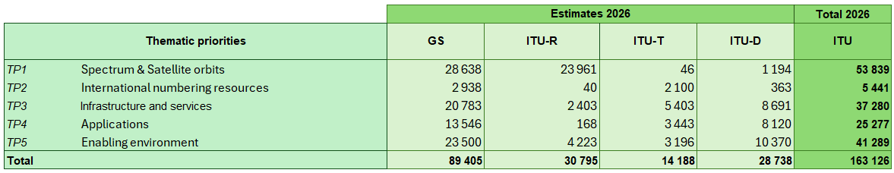

2.2 Table 2 provides the breakdown of 2026 full costs by output.

**Table 2**

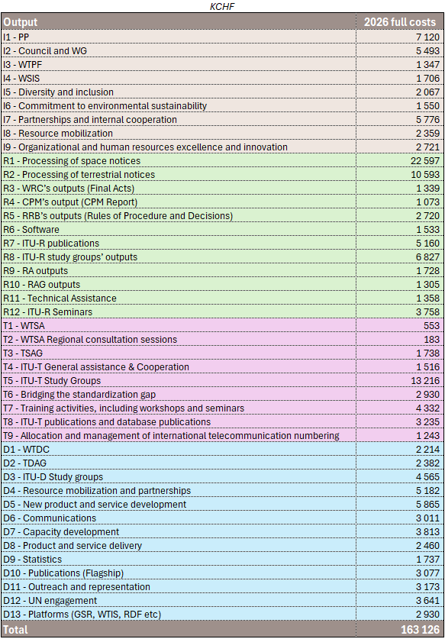

**3 Cost structure and cost allocation methodology**

3.1 The full cost allocation to each Results-Based Budget component, i.e. the thematic priorities and outputs, is based on the cost allocation methodology described in Council Decision 535.

3.2 The full cost structure stands as follows:



3.3 The Planned Expenses (Financial Budget) are represented by the Categories of Expenses as follows:

Staff costs

* Category 1 Staff costs (salaries and allowances, etc.)
* Category 2 Other staff costs (pensions, health insurance, human resources development, etc.)

Non-staff costs

* Category 3 Travel on duty
* Category 4 Contractual services
* Category 5 Rental and maintenance of premises and equipment
* Category 6 Materials and supplies
* Category 7 Acquisition of premises, furniture, and equipment
* Category 8 Public and internal service utilities
* Category 9 Audit and inter-agency fees and miscellaneous

3.4 The Documentation Costs represent services provided by the Conferences and Publications Department, which can be directly charged to an Output on a number-of-page basis. Those services are:

* Translation (in the six official languages of the Union)
* Text processing (in the six official languages of the Union)

3.5 The Bureau/General Secretariat Support Costs represent the costs of staff and related expenses of the Bureaux (including the Office of the Director) and General Secretariat (Strategic Planning and Membership Department) that are reallocated to thematic priorities and outputs based upon work effort measurement (Time survey).

3.6 The Centralized Administrative Services Costs represent the costs of staff and related expenses of:

* The Office of the Secretary-General and Deputy Secretary-General
* The Human Resources Management Department
* The Financial Resources Management Department

that provide general administrative support to all thematic priorities and outputs of the Union. These costs are reallocated to outputs based on reallocation drivers.

3.7 The Centralized Support Services Costs represent the costs of staff and related expenses of:

* The Conferences and Publications Department (outside Documentation Costs)
* The Information Services Department
* ITU Common expenses

that provide general support to the thematic priorities and outputs of the Union. These costs are reallocated to Outputs based on reallocation drivers.

**4 Thematic priorities**

4.1 The draft operational plan for 2026-2029 provides information for the implementation of five thematic priorities and 43 outputs:

* 9 Inter-Sectoral outputs
* 12 Radiocommunication Sector outputs
* 9 Telecommunication Standardization Sector outputs
* 13 Telecommunication Development Sector outputs

4.2 For each thematic priority, the following information is provided:

* Description of the thematic priority
* Summary of cost allocation for 2026
* Key outline of outcomes, outcomes indicators
* Key risks
* Outputs contribution to the thematic priority for the 2026 costs

**Intersectoral**

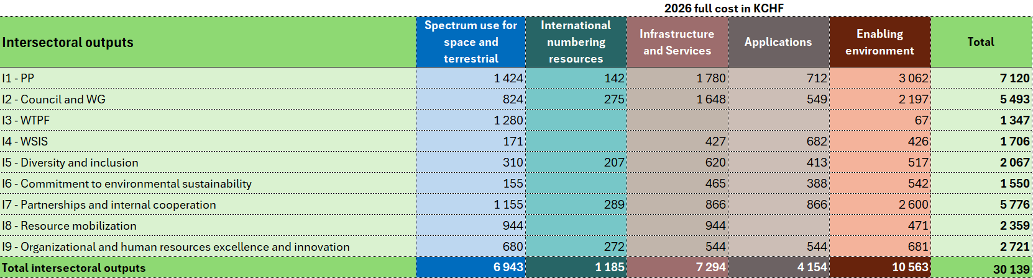

**Radiocommunication Sector**

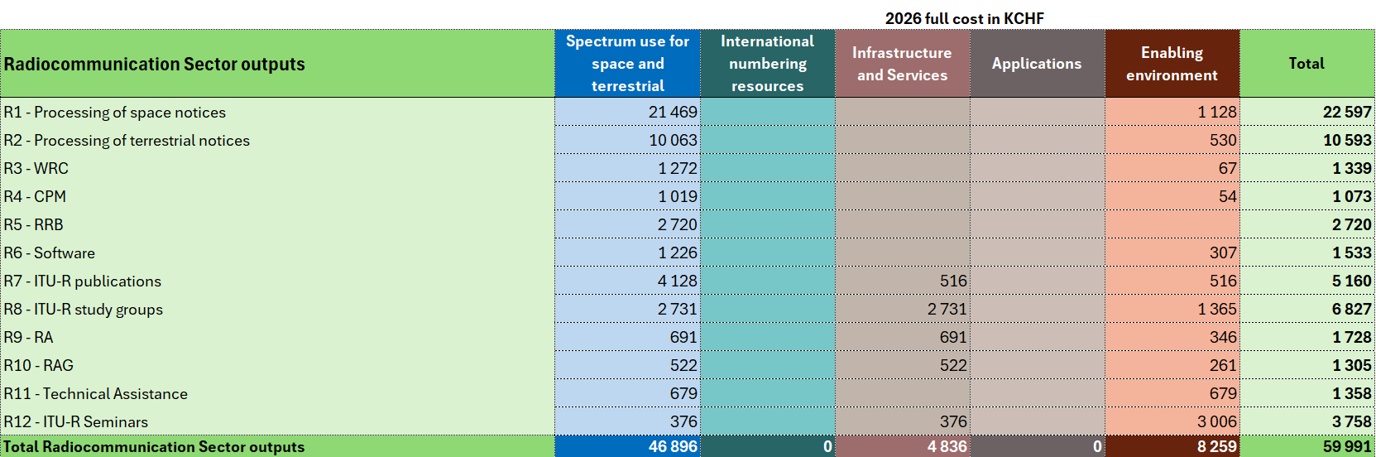

**Telecommunication Standardization Sector**

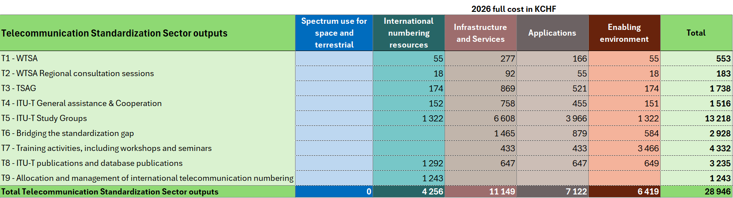

**Telecommunication Development Sector**

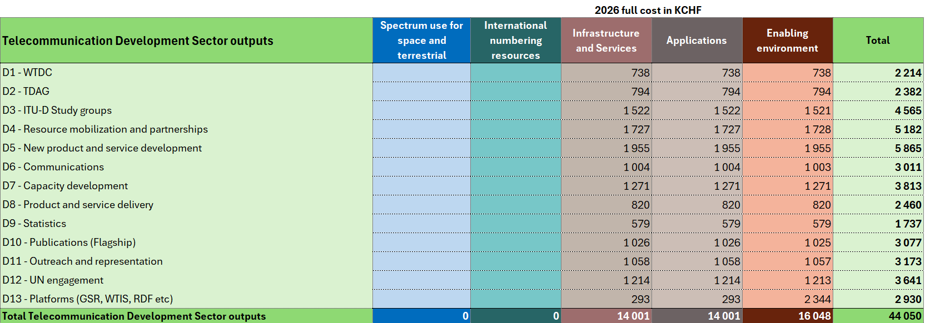

ANNEX A

DRAFT RESOLUTION [...]

Operational plan for the Union for 2026-2029

The ITU Council,

recognizing

the provisions of Articles 5, 11A, 12, 14A, 15 and 18 of the ITU Convention,

recalling

Resolution 71 (Rev. Bucharest, 2022) on the strategic plan for the Union  
for 2024-2027 and Resolution 151 (Rev. Bucharest, 2022) on the implementation of results-based management,

having considered

the operational plan for the Union for 2026-2029 (Document C25/28),

having also considered

the need for the Secretary-General and the Directors of the Bureaux to have some flexibility in the implementation of the corresponding elements of the operational plan to take into consideration any changes that may occur during the interval between two council sessions,

resolves

1 to approve the operational plan for the Union for 2026-2029; and

2 to allow the Secretary-General and the Directors the necessary flexibility in the implementation of the corresponding elements of the operational plan for the Union for 2026-2029.

__________________