Document CWG-WSIS&SDG-41/16
20 September 2024
English only
Contribution from Lithuania (Republic of)
MESSAGES OF THE EuroDIG 2024 ON GLOBAL PROCESSES (GDC, WSIS+20 REVIEW)
Purpose
To inform the Council Working Group on WSIS and the SDGs about the EuroDIG annual meeting in June 2024 (Vilnius, Lithuania) and the thematic messages on Global Processes, including Global Digital Compact and WSIS+20 review.
Action required
The Council Working Group on WSIS and the SDGs is invited to note this document.
_______________
References
Resolution 140 (Rev. Bucharest, 2022) of the Plenipotentiary Conference;
EuroDIG 2024 web page https://www.eurodig.org/get-involved/
EuroDIG 2024 – Messages from Vilnius https://www.eurodig.org/eurodig-2024/messages-from-vilnius/

Launched in 2008, EuroDIG, the European Dialogue on Internet Governance or regional IGF, is a platform for discussion and the exchange of ideas on emerging issues and challenges concerning the Internet. The inclusive and continuous dialogue culminates in an annual event that brings together Internet stakeholders, representing government, industry, civil society, academia and the technical community, from throughout Europe and beyond. Stakeholders and participants work over the course of each year to develop, in a bottom-up fashion, a dynamic agenda that explores the pressing issues surrounding how we develop, use, regulate and govern the Internet.

Background
EuroDIG 2024 under the theme “Balancing Innovation and Regulation” took place from 17 to 19 June in Vilnius, Lithuania. It was hosted by the Communications Regulatory Authority of Lithuania (RRT) in cooperation with the three Ministries and other local and international partners. The event attracted 822 registered participants from 100 countries. During the call for topics for the agenda, 83 submissions were received. More statistics are presented in the Annex to this document.
The main results of the EuroDIG are conveyed in the form of thematic “Messages” which are forwarded to policy makers and fed into the annual global UN Internet Governance Forum (IGF). This year, reflecting on the ongoing discussions about the global digital agenda, EuroDIG agreed on the set of Messages on Global Processes, such as:

On the Global Digital Compact
– EuroDIG looks forward to the opportunities to amplify the purpose and objectives of the Global Digital Compact (GDC) following the Summit of the Future. EuroDIG offers to play its part in contributing to and monitoring progress in the implementation of GDC commitments.
– EuroDIG strongly supports the commitment in the Rev.1 draft text of the GDC to strengthen the multistakeholder model of governance and advises against any watering down of this commitment in the finalisation of the text.
– EuroDIG believes that the GDC process should build on the strong foundations and accomplishments of the WSIS instead of creating new mechanisms.
– EuroDIG supports enhancing the role of the UN IGF.
– EuroDIG recommends simplifying the process of GDC follow up and review of the implementation of the GDC commitments, with a substantive role for the Internet Governance Forum and the WSIS Forum so that non-governmental stakeholders can fully contribute to the process.

On the WSIS+20 review
– EuroDIG recognises the positive linkages between the WSIS+20 Review, the Global Digital Compact and the 2030 Agenda for Sustainable Development.
– EuroDIG believes there needs to be a comprehensive understanding of the process of the WSIS+20 review.
– The review should not undermine the achievements of both the 2003 and the 2005 phases of the WSIS. It should instead be primarily an opportunity to enhance the processes of Internet governance, global digital policy and cooperation, by using the Sao Paulo Guidelines as an inspiration for making processes more inclusive, transparent and accountable.

Proposal
We invite the Council Working Group on WSIS and the SDGs to note these Messages from the EuroDIG 2024 considering further discussions on the outcomes of the Summit of the Future, implementation of the Global Digital Compact and forthcoming review of WSIS+20.
We would also like to commend ITU’s participation in the relevant multistakeholder dialogue fora for digital issues, such as the UN Internet Governance Forum (IGF) and the national and regional IGF initiatives. We would like to commend the active participation of ITU’s delegation, led by the Deputy Secretary General, in the related discussions at this year’s conference of EuroDIG (the European IGF) in Vilnius in June 2024 and look forward to seeing an active participation of the ITU at this year’s UN IGF in Riyadh in December.

ANNEX
EuroDIG 2024 in figures
Figure 1
Registrations to the EuroDIG 2024
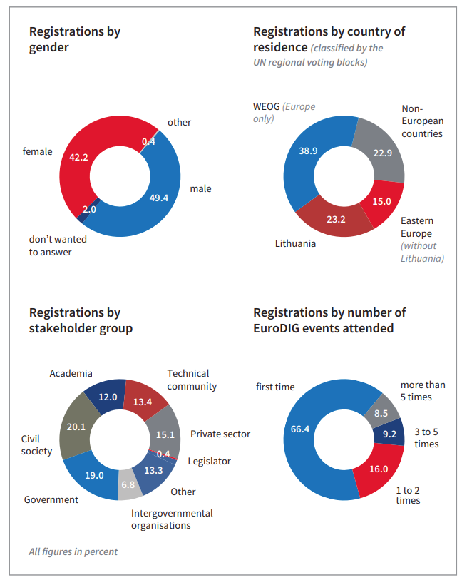
Source: EuroDIG Association
Figure 2
Submissions to the EuroDIG agenda
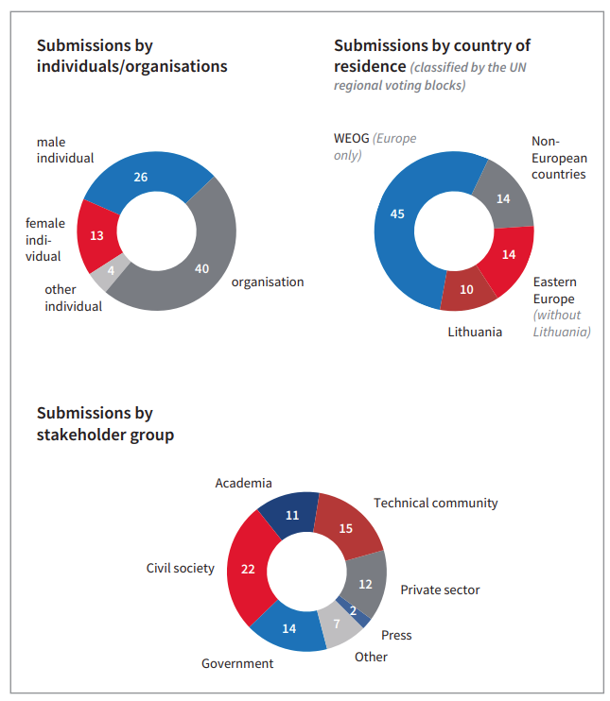
Source: EuroDIG Association

______________

These Messages were developed and agreed on 19 June 2024 based on the version of GDC available at the time.

