|  |  |
| --- | --- |
|  | **Document CWG-SFP-1/5-E** |
| **11 September 2024** |
| **English only** |
|  |  |
| Report by the Secretary-General | |
| ASSESSMENT OF THE PRELIMINARY AMOUNT OF THE CONTRIBUTORY UNIT | |
| Purpose  According to Article 28, No. 161B of the Constitution, at its session preceding the plenipotentiary conference, the Council shall fix the provisional amount of the contributory unit. Based on the input from Council, the Plenipotentiary Conference then sets the bases for the preparation of the budget and financial limits for the ITU for the following four-year period. The purpose of this document is to present some elements that could be taken into consideration when considering setting the provisional amount of the contributory unit.  Action required  This report is transmitted to the CWG-SFP for **further consideration and guidance**.  _______________  References  [*CS/Art. 8, CS/Art. 28, CS/Art. 33*](https://www.itu.int/en/council/Documents/basic-texts/Constitution-E.pdf)*;* [*Decision 5 (Rev. Bucharest, 2022)*](https://www.itu.int/en/council/Documents/basic-texts-2023/DEC-005-E.pdf) | |

Background

1 The Plenipotentiary Conference establishes the basis for the budget of the Union and determines related financial limits, after considering all relevant aspects of the work of the Union during the period concerned (Article 8, No. 51 of the Constitution) and upon the recommendation from the Council.

2 According to Article 28, No. 161B of the Constitution, at its session preceding the plenipotentiary conference, the Council shall fix the provisional amount of the contributory unit, based on the draft financial plan for the corresponding period and the total number of contributory units.

3 In this framework, Decision 5 (Rev. Bucharest, 2022) *invites the Council* to fix, to the extent practicable, the preliminary amount of the contributory unit for the period 2028-2031 at its 2025 ordinary session and *invites Member States* to announce their provisional class of contribution for the period 2028-2031 before the end of the calendar year 2025.

4 Membership is already aware of the challenges experienced by ITU in respect of its financial situation. Over the past years, due to a significantly expanded requests from the Member States enshrined in Resolutions and Decisions of ITU governing bodies coupled with inflationary economic environment, ITU’s operations have become increasingly difficult to finance with the current funding levels.

The Context for an Increase of ITU’s Funding

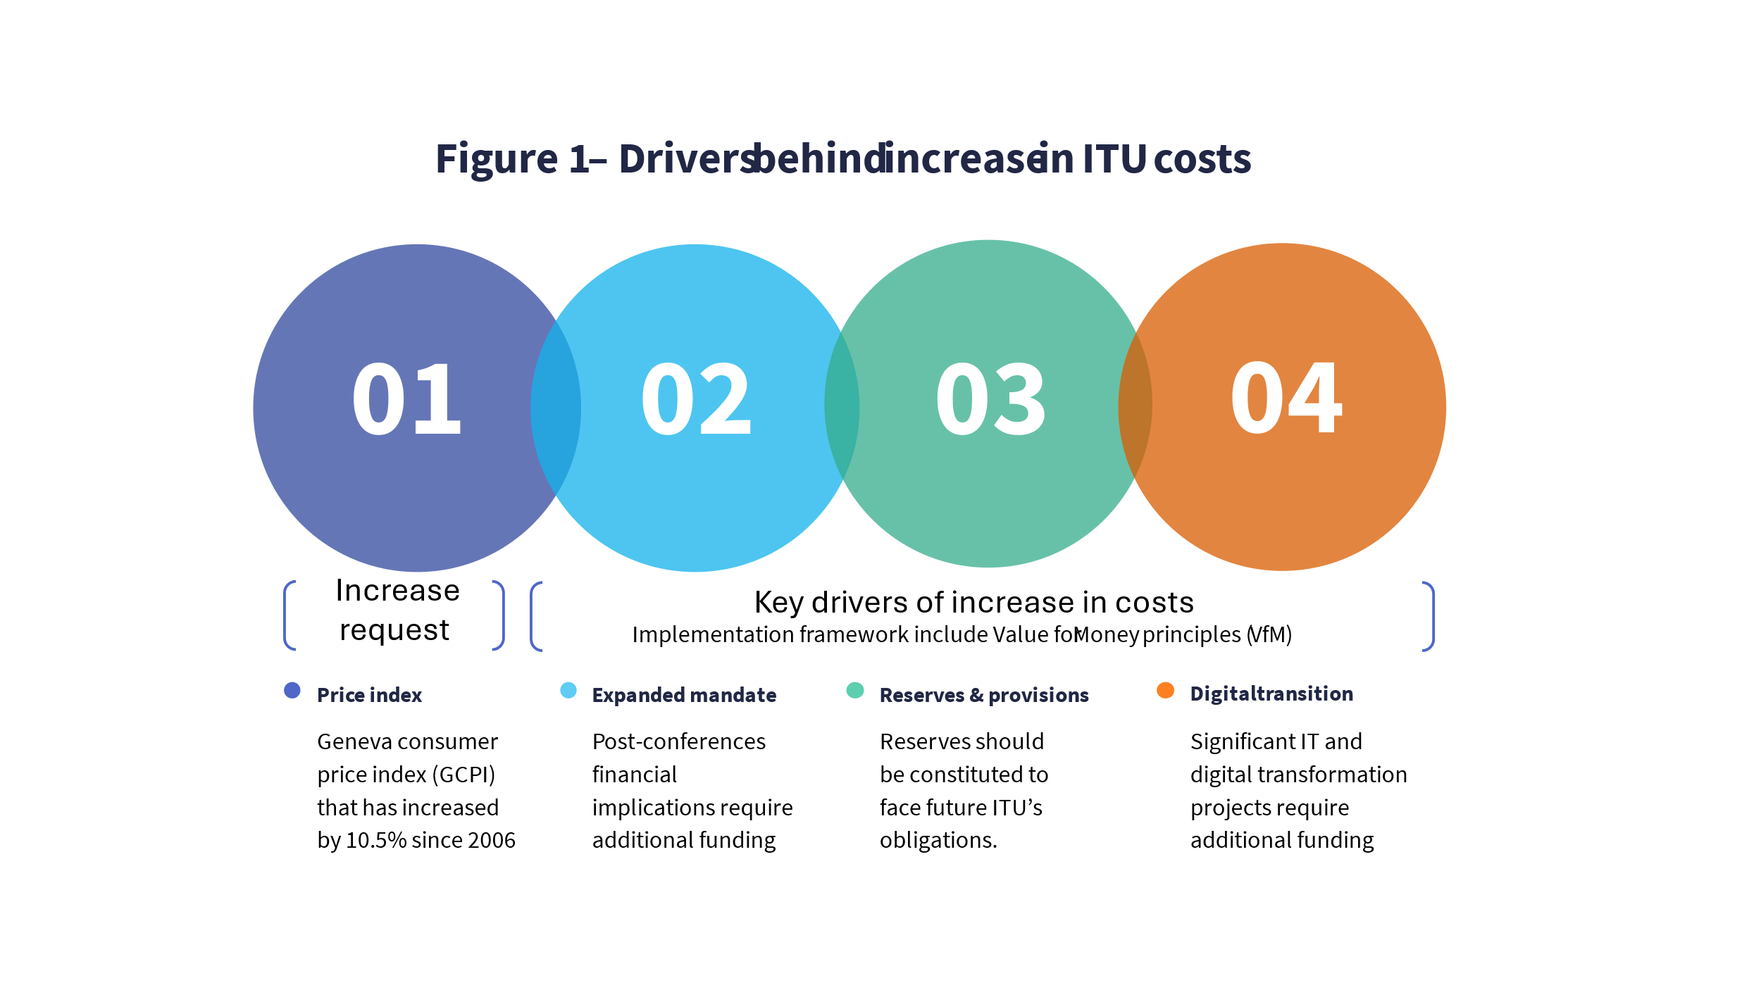

5 Figure 1 above identifies the direct extrapolation of the Consumer Price Increase as applied to the contributory unit, as well as key increases in expenses which necessitate an increase in funding for ITU.

Each of these elements are further elaborated on in the next sections of this document.

**6 Geneva Consumer Price Index**

The amount of the contributory unit has remained unchanged since 2006, a zero-nominal growth, despite a Geneva consumer price index (GCPI) that has increased by 10.5% during this timeframe. The majority of ITU’s costs are incurred in Switzerland, this lack of revenue growth has significantly imperiled ITU’s ability to implement its strategic plan and the priorities laid down therein. This is particularly impactful since ITU’s staff salaries, which comprise more than 80% of budgeted expenses, are index linked through the review processes carried out by the ICSC.

Several other UN and international organizations have addressed similar challenges by adjusting their financial contributions to account for inflation. Without a similar approach, ITU risks falling behind in its ability to attract and retain talent, invest in new technologies, and sustain its operational capacity at the levels required by its stakeholders.

**Impact:**

ITU is currently under financial strain to maintain its operational activities at the same level of quality and efficiency. Without an increase in funding, ITU risks compromising the quality of its services or being forced to cut costs in areas that could affect its core functions. The discussion below more specifically identifies each area of additional costs that should be considered by membership in determining an appropriate increased funding target for ITU.

**7** **Post Conference Work and Global Digital Advancement**

In recent years, the decisions and resolutions made by World Conferences and Assemblies have resulted in significant financial implications for the Union. By way of example, during the period of the Financial Plan 2020 to 2023, such conference outcomes required approximately CHF 4 million for full implementation, and ITU was required to undertake a prioritization exercise to balance its budget for 2022 and 2023 (classifying some of these activities as unfunded mandatory activities). To date, an additional CHF 12 million of expenses have already been added to ITU’s Financial Plan for 2024 – 2027, without any related increase in funding. Without additional funding, such activities put significant pressure on the finances of the Union and limit its ability to respond effectively to membership’s expectations.

The rapid increase in the use of digital technologies has also significantly heightened the demand for ITU’s expertise across its membership. As countries increasingly adopt digital solutions to drive economic growth, social inclusion, and innovation, the need for specialized knowledge and support from ITU has grown exponentially. This surge in demand encompasses a wide array of areas, including cybersecurity, digital infrastructure development, and capacity-building initiatives. Consequently, ITU is faced with the dual challenge of scaling its operations to meet these heightened expectations while navigating the financial constraints imposed by its current funding framework.

**Impact:**

In summary, the expanded mandates and post-conference work have created a significant financial and operational burden on the Union, limiting its ability to meet the growing expectations of its members and potentially compromising the quality of its services. The Union needs to address these challenges by seeking additional funding or re-evaluating its approach to managing these expanded activities.

8 **Need to Fund Long Term obligations**

ITU is currently facing several significant obligations that are critical to the organization’s long-term sustainability and operational resilience. These obligations include the building project, maintenance of current buildings, the necessity to maintain reserves for After Service Health Insurance (ASHI), and other contingency reserves. Addressing these obligations effectively is essential not only for ITU's ongoing operations but also for its ability to manage and mitigate financial uncertainties.

**The Building Project:**

The building project represents a major capital investment for ITU, aimed at modernizing and expanding its physical infrastructure. This project is not just about improving facilities; it is a strategic investment in the future of ITU, ensuring that the organization has the physical capacity to support its growing functions and the evolving needs of its Member States.

* **Financial Commitment for the building project:** The building project will require substantial financial resources. While this is mostly funded from the interest free Swiss loan, repayments (at CHF 3 million a year) will have to be included in the financial plan. Furthermore, to ensure the project remains on track and does not face delays, or compromises in quality ITU need sufficient reserves to fund a risk register fund and ensure contingencies are met as quality and ultimate delays in delivery of the building could negatively impact ITU’s ability to serve its stakeholders effectively.
* **Business continuity:** During the building project ITU will incur an increase in costs to cover business continuity needs, particularly in relation to Conferences and Meetings. An initial assessment was done in the amount of CHF 30 million over the 4-year period.
* **Facilities Maintenance, Renovation and Capital Replenishment:** Having regard to the significant investment in the new building and the ITU Campus in general, it would be prudent to enhance ITU’s Building Fund to properly account for the ongoing costs of major repairs, renovation, upgrading of the building and replacement of the buildings’ equipment, in line with Article 21 of ITU Financial Rules and Regulations. The objective is to have sufficient and dedicated funding to handle substantive capital expenditure, which are not covered by yearly routine maintenance funded through the annual operational budget. It is recommended that a suitable provision would be CHF 2 million per year.

**After Service Health Insurance (ASHI):**

* **Long-Term Obligation:** ASHI represents a significant long-term financial obligation for United Nations agencies, including ITU. It involves providing health insurance benefits to retired employees of all UN System entities. These benefits are a critical component of ITU’s commitment to its workforce, ensuring that former employees continue to receive necessary health coverage after their service has ended. At present the ASHI liability is approximately CHF 375 million for which ITU has a reserve of CHF 14 million.
* **Reserve Requirements:** Building a reserve is essential to cover future liabilities and ensure that ITU can meet its commitments to retirees without placing undue strain on its current operational budget. Many UN agencies have commenced financing this liability and have a clear long-term plan in place which avoids jeopardizing their obligations to former employees. Figure 2 proposes an initial financing level of CHF 3.75 million to finance at least 50% of ASHI over a 50-year period.

**Other Contingency Reserves:**

* **Operational Resilience:** In addition to the building project and ASHI, ITU must also maintain contingency reserves to ensure operational resilience. The current reserve account only would sustain ITU operations for 9 to 10 weeks. Typically, other specialized UN Agencies maintain higher levels of reserves to offset potential downturn in operations, which could leave the organization vulnerable. These reserves are vital for managing unexpected financial challenges, such as sudden reductions in revenue, unanticipated expenses, or economic downturns. Having a healthy level of reserves allows ITU to respond quickly and effectively to unforeseen events, maintaining continuity of operations without resorting to drastic cost-cutting measures.
* **Sustaining Operational Efficiency:** Maintaining a healthy level in the reserve account is crucial for sustaining ITU’s operational efficiency. In an increasingly volatile global environment, where financial shocks can occur unexpectedly, these reserves provide a buffer that allows ITU to continue its work without interruption. This is particularly important for maintaining the trust and confidence of Member States, who rely on ITU to deliver consistent and reliable services.

**Impact:**

Insufficient reserves jeopardize ITU's ability to meet these obligations, leading to potential disruptions in key projects or an inability to fulfil long-term commitments to employees and stakeholders. The estimated cost is CHF 6 million per year.

9 **ITU Digital Transformation and Future IT Developments**

The digital aspect of ITU's ongoing transformation project is not just a strategic initiative but a critical necessity for the organization's continued relevance and operational efficiency. This transformation aims to overhaul the ITU's processes, enabling the organization to remain agile and responsive to the rapidly evolving technological landscape. As digital technologies become increasingly integral to the ITU's operations, the organization must ensure that its infrastructure and systems are modernized and capable of supporting its expanding mandates and services. Some of the needed investment areas currently being faced by ITU are described below.

* **Cloud Migration:** The shift to cloud-based services is a foundational element of ITU’s digital transformation strategy. This migration is expected to incur ongoing subscription fees of approximately CHF 2 million per year. Cloud infrastructure will provide the scalability and flexibility required to manage the growing volume of data and services, ensuring that the ITU can continue to operate efficiently and securely in a digital-first environment.
* **Transformation of Services and Parallel Operations:** The digital transformation will involve a comprehensive reengineering of ITU’s services, which must be executed without disrupting ongoing operations. This dual-track approach necessitates significant investment in parallel operations to maintain service continuity during the transition. This aspect of the project is estimated to require CHF 8 million between 2028 and 2031.
* **Customer Relationship Management (CRM) and Events Management Solutions:** To better serve its members and stakeholders, the ITU plans to invest CHF 3 million in new CRM and events management systems. These systems will enhance the ITU's ability to manage interactions with member states, partners, and other stakeholders, providing a more personalized and efficient experience.
* **Remote Participation Services:** In response to the increasing demand for remote and hybrid participation in ITU’s activities, the organization plans to invest CHF 5 million from 2028 to 2031 in developing and maintaining remote participation services. These services will ensure that ITU’s meetings, conferences, and events are accessible to a global audience, regardless of location, thereby enhancing inclusivity and engagement.

**Impact:**

Securing the necessary funding for ITU's digital transition and future IT developments is essential to avoid these severe operational impacts. The organization's ability to remain a relevant, efficient, and trusted global entity depends on its capacity to successfully navigate this digital transformation. It is noted that many of the transformative activities will generate savings in ITU’s activities moving forward through efficiencies in operations, such efficiencies should be applied toward improving ITU’s efficiency and effectiveness in achieving its mandate.

10 Impact on the value of the contributory amount

The table below summarizes each increased expense that ITU faces, with the estimated financial cost, extrapolated into specific increases in contributory unit. The contributory unit is the most predictable and stable funding mechanism for ITU. Certain key organizational needs should be met through a stable source of income which allows for long term planning, rather than through voluntary or limited means which has historically failed to provide the required funding. Further, while ITU encourages individual countries to increase their number of contributory units, an increase to the base unit ensures that a fair overall basis for contribution is maintained and the future of ITU secured, while allowing individual members to demonstrate additional commitment at their discretion.



**11 Summary**

CWG-SFP is invited to consider the foregoing issues and other relevant matters, and to advise the Council on the decisions that should be taken in respect of the establishment of the preliminary amount of the contributory unit, in alignment with its recommendations on the Strategic and Financial Plans for the Union for the period from 2028 to 2031.

______________