Document CWG-FHR-17/21
15 January 2024
English only
Contribution from Ghana
TOWARDS A RESOURCE MOBILIZATION STRATEGY-TRENDS AND ANALYSIS
Purpose
This contribution responds to Document CWG-FHR-17/3, which invites CWG-FHR to note the document and consider launching a process to review Sector Membership fees and benefits as recommended in the document.
Action required
The Council Working Group on Financial and Human resources is invited to consider this document.
____________________________________
References
CWG-FHR-17/3

ANALYSIS OF THE PROPOSAL TO REVIEW SECTOR MEMBERSHIP FEES AND BENEFITS
The trend of growing membership and the consequent revenues do not support the way forward that financial contributions from Sector Members, especially from SMEs, are a sustainable way towards revenue mobilization of the ITU.
From the information provided, despite the net sector membership growth in Figure 1, the revenue contributions in absolute terms have declined since 2019, as in Table 1.
Figure 1 Growth of net membership and decline of revenue contributions.
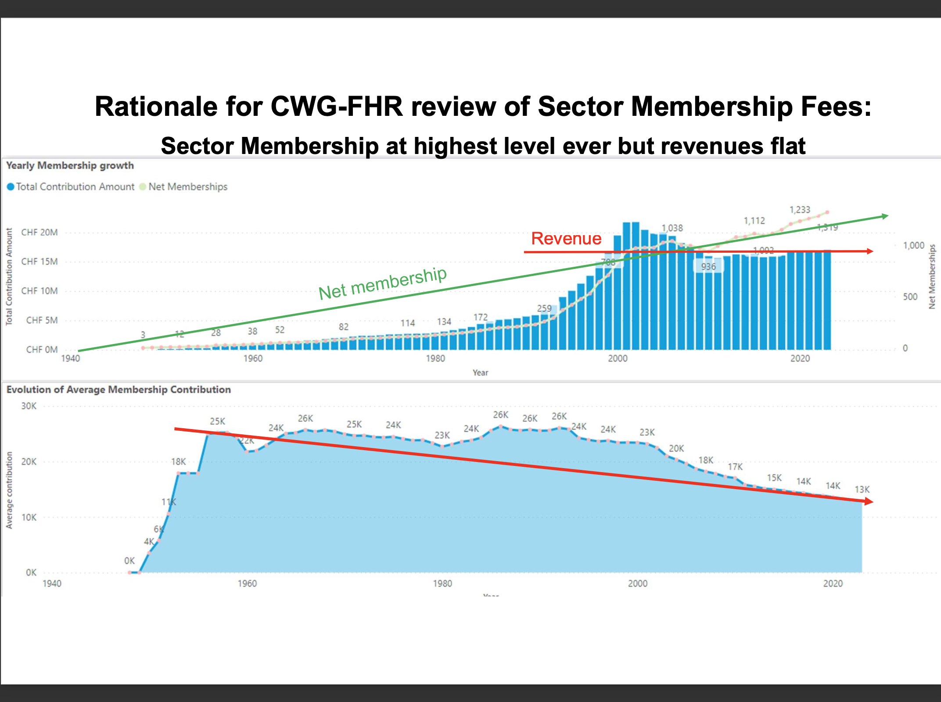
Source: Document CWG-FHR-17/3

Table 1 Revenue Trend (CHF) as reported in C23/62 from 2018 to 2022
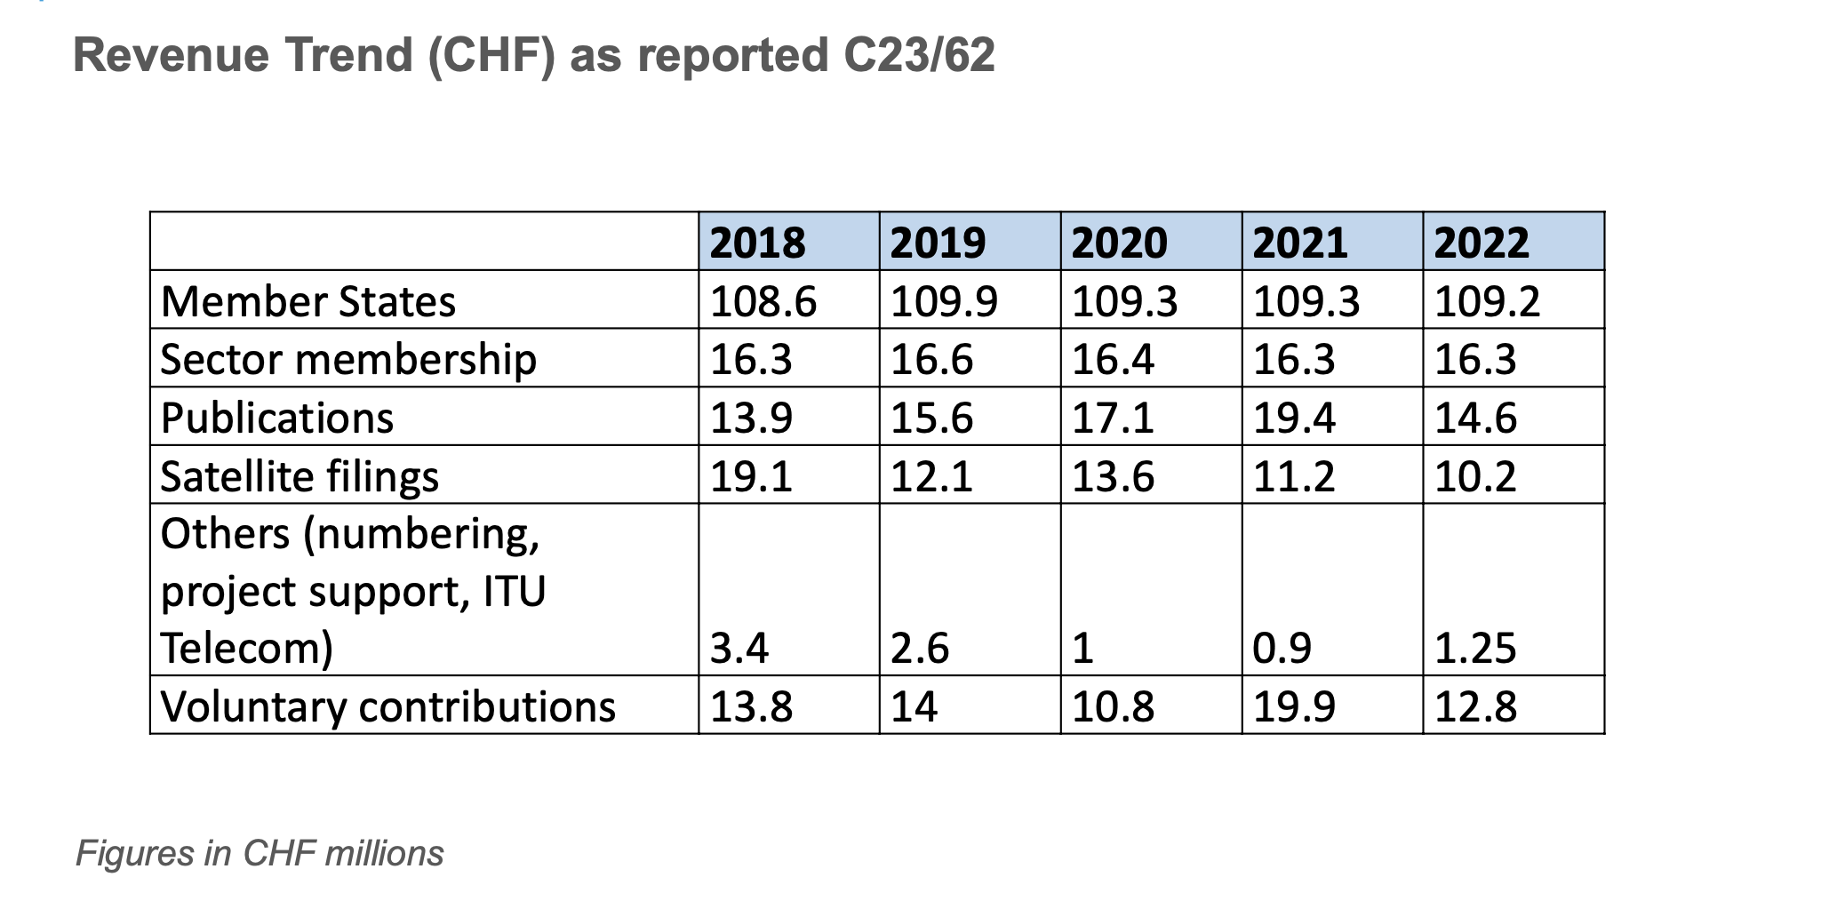
Source: Document CWG-FHR-17/3
Likely Effect of Increased Sector Membership Fees on Membership
The trend of some Sector Members not fulfilling their financial obligations is likely to be higher if fees are increased. Also, with the short-tenure interest in ITU by Sector Members, there is a potential decline in sector membership, especially by SMEs enabling sector membership growth. The objective of ITU membership to Industry, Academia, Research Institutions, and others is for their contributions towards decision-making and not as a means of increasing ITU revenues.

SUGGESTIONS ON REVENUE MOBILIZATION AND COST RECOVERY
Revenue mobilization should be considered with cost recovery. Rather than considering increased sector membership fees, the ITU secretariat should analyse the costs to ITU by each member to determine the cost recovery contributions to match their privileges. Similar to Member States using radio and numbering resources as their main streams of revenue mobilization, the ITU should consider improved revenue mobilization from satellite, other radio, and numbering resources.

Cost Recovery of Sector Members’ Involvement in ITU
The financial contribution from sector membership is only 10%, less than the revenues from publications in 2020 and 2021. The ITU secretariat should analyze whether the current sector membership fees cover the cost shared by each Sector Member in their involvement in ITU activities. The approach is to ensure that contributions from Sector Members cover the shared cost. For example, sector members may be limited by the number of registrations and seats at a physical meeting according to their contributions.

Separation of Administrative Accounts from Project Accounts
Voluntary contributions in recent years have been higher than satellite filings. The trend of voluntary contributions could be indicative that ITU members are willing to contribute financially to particular projects when voluntary contributions are invited. It is therefore suggested projects may have a call for invitations for voluntary donations and partnerships to lessen budgetary allocation from ITU membership financial contributions.

Revenue Mobilization from Radio and Numbering Resources
The CWG-FHR should consider how the ITU can be financed from overall radio and numbering resources determined through meetings, assemblies, and conferences.
_____________

