Document CWG-FHR-17/8
21 December 2023
English only
Contribution by the secretariat
STATUS REPORT ON IMPLEMENTATION OF COUNCIL DECISIONS 600 AND 601 (UIFN, IIN)
Purpose
Following the approval of Decisions 600 and 601 at the Council 2017 session, ITU has been in the process of implementing these Decisions. This report summarizes the status of the implementation and next steps in the process.
This document presents updated information to the document C21/47, which was presented to and reviewed at the 2021 session of the Virtual consultation of councillors.
Action required
The Council Working Group on Financial and Human resources is invited to note this document.
____________________________________
References
CWG-FHR website; Document C17/133; C17/134; C18/100; CWG-FHR 9/14; CWG-FHR 9/15; C19/47, C19/120; C20/47; C21/47; CWG-FHR-14/6; CWG-FHR-14/7;CWG-FHR-14/12; C22/50

1 Background
1.1 Following the approval of Decisions 600 (C17/133) and 601 (C17/134) at the Council 2017 session, the ITU secretariat has been in the process of implementing these Decisions.
1.2 TSB presented document C19/47 to Council 2019 which provided updates of the status of implementation of Council Decisions 600 and 601, including the status of the contacts for UIFN service providers and IIN assignees.
TSB presented document C21/47 to Council 2021 in April 2021 and document CWG-FHR-14/6 to the fourteenth CWG-FHR meeting in July 2021, which provided updates of the status of implementation of Council Decisions 600 and 601, including the status of the contacts for UIFN service providers and IIN assignees.
TSB presented document CWG-FHR-14/7 to the fourteenth CWG-FHR meeting which summarized the proposed advice to the Director of TSB from an ITU-T SG2 meeting regarding International Numbering Resource revenue collection and the possibility of reclaiming International Numbering Resource where payment to the ITU is outstanding.
As a result of the COVID-19 pandemic, Council meetings were conducted in a virtual format. These virtual meetings were time constrained and focusing on addressing specific tasks. Consequently, no formal reports were presented during these meetings.
1.3 Council 19 approved the recommendations captured in Section 2.2.25 of the summary record of the ninth and last council plenary meeting in document C19/120. The approved recommendations are as follows:
Recommendation
The list of UIFN service providers in Annex A to Document C19/47 will be marked as “not reachable” in the ITU database. The records for these UIFN service providers are subject to removal from the ITU database and the UIFNs assigned to them are subject for reclamation based on confirmations/notifications from national Administrations/regulators as recommended by Council 2018. Among these UIFN service providers, for the ones to whom invoices for the maintenance fee for 2018 have been sent, the invoices will be cancelled.
If the invoices sent to the UIFN service providers in Annex B to Document C19/47 remain unpaid for an extended period, the secretariat will seek assistance from Member States to recover the debt.
National Administrations/regulators or authorized agencies are encouraged to provide assistance in identifying the up-to-date contact or status of the UIFN service providers (e.g., if they are no longer in business) listed in Annex C to Document C19/47.
The list of IINs for which contact information is pending will be published on ITU website as IINs with the status “assignee not reachable” and will be announced in the ITU Operational Bulletin. National Administrations/regulators or authorized agencies are encouraged to provide assistance in identifying their up-to-date status and/or contact information.
For the UIFNs and IINs which are still under consultation with national Administrations/regulators or authorized agencies, their status should be confirmed before 31 October 2019. If no objection is received from national Administrations/regulators or authorized agencies, the corresponding UIFNs and IINs will be considered as no longer active and removed from ITU databases.
UIFN service providers or IIN assignees with the status of ADMIN RELATED are not subject to the annual maintenance fee.
The fourteenth CWG-FHR meeting conclusions are captured in Section 9 of the summary report of the fourteenth meeting of CWG-FHR in document CWG-FHR-14/12, in particular the conclusions below:
Conclusion
9.7 The secretariat seeks the continued assistance of Members States in recovering the debt identified in Annex B.
9.8 National Administrations/regulators or authorized agencies are encouraged to aid the secretariat in identifying up-to-date status and/or contact information for UIFN identified in Annex C and IIN contacts in section 3.1.4.
… …
9.15 SG2 also advises the Director of TSB to invite Council to instruct him to proceed as follows in case of non-payment of fees for numbering resources:
a) Send a request for payment within 90 days (if the contact information in the ITU-T database is incorrect, request the relevant Member State to assist in obtaining up-to-date contact information; if no up-to-date contact information can be obtained, send a notice of planned reclamation to the address in the database in accordance with step (c) below and proceed in accordance with step (d) below).
b) If no payment is received within 90 days, send a second request for payment within 60 days.
c) If no payment is received within 60 days, send a notice of planned reclamation if no payment is received within 30 days.
d) If no payment is received within 30 days, reclaim the resource (a notification of reclamation is sent to the assignee and the reclamation is published in the Operational Bulletin).
Conclusion
9.16 The TSB Director consulted with internal ITU departments, including the Financial Resources Management Department. The proposed advice and elements in section 2 of this document were considered useful as they give a clear basis to deal with non-payment issues related to numbering resources.
9.17 The Financial Resources Management Department would apply the timeframes mentioned above in its billing system when collecting revenue for INRs. This approach helps to ensure consistent and efficient implementation.

2 Financial updates
2.1 UIFN (Council Decision 600)
As shown in the figure below:
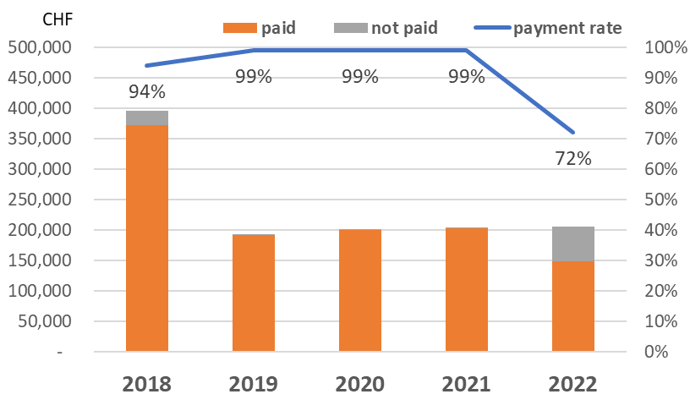
In 2018, the invoices for the UIFN annual maintenance fee represented CHF 744 400. An amount of CHF 349 033 has been cancelled per Council 2019 recommendations for entities that are no longer in business. To date 94% of the valid invoices amounting to CHF 395 367 have been paid and CHF 20 300 still needs to be recovered.
For 2019, the invoices sent represented CHF 193 100 and 99% of the payments have been received. The remainder still needs to be recovered.
For 2020, the invoices sent represented CHF 201 600 and 99% of the payments have been received. The remainder still needs to be recovered.
For 2021, the invoices sent represented CHF 204 400 and 99% of the payments have been received. The remainder still needs to be recovered.
For 2022, the invoices sent represented CHF 205 700 and 72% of the payments have been received. The remainder still needs to be recovered.
As of 31.10.2023, the total amount to be recovered for UIFN maintenance fee for 2018-2022 is CHF 77 600. And the unpaid fee of one service provider occupies 72% of the total amount.
Annex B lists the entities for which TSB has a valid contact, that have been billed for 2018-2022 and have not paid their bills to date. The SG2 advice approved at the fourteenth meeting of CWG-FHR (document CWG-FHR-14/12, C22/50) has mostly implemented for the cases in the table except for few in 2022. The secretariat will start to remove the service providers in the table and write off the corresponding debts.
2.2 IIN (Council Decision 601)
Preparation of IIN invoices is in process. ITU FRMD will issue IIN invoices in the first semester of 2024.
2.3 Revenue from UIFN and IIN
For 2022, the revenue from UIFN is CHF 236 200 (Includes one-off fee and annual maintenance fee). For 2023, a forecast revenue from UIFN is around CHF 190 000 (Includes one-off fee and annual maintenance fee).
Newly registered IINs were around 20 per year. This represents a revenue of CHF 5 000.
In general, CHF 200 000 would be a reasonable anticipated revenue per year.

3 Status of the contacts for UIFN service providers and IIN assignees
3.1 In accordance with Council 19, approved recommendations captured in Section 2.2.25 document C19/120, the list of UIFN service providers in Annex A have been removed from the list of UIFN service providers (https://www.itu.int/en/ITU-T/inr/unum/Pages/uifn-service-provider.aspx) considering that no notifications have been received from Member States since Council 2019.
3.2 As per an announcement in ITU Operational Bulletin No. 1222 (15.VI.2021), the list of ITU-T E.118 IINs for which the assignee contact is still in progress and with the status “assignee not reachable” can be found on the following ITU web page:
https://www.itu.int/en/ITU-T/inr/forms/Pages/iin.aspx#assignee-contact-not-reachable
National Administrations/regulators or authorized agencies have been encouraged to provide assistance in identifying their up-to-date status and/or contact information. While little notification has been received since years. The records of these IINs in ITU database have been marked as “contact_not_reachable”.
3.3 As of 31.10.2023, the contact information status of 898 IINs kept in ITU database is shown in the figure below.

Note: the number of IIN records for the countries listed in the above figure include geographic areas under their Administrations.

4 Conclusion
The secretariat continues the implementation of Council Decision 600 and 601.

Annex A - list of UIFN service providers that have been removed

year | Amount | currency | UIFN quantity | Company's name | country/  Geographic Area | note
2018 | - | - | 3 | IT-Austria GmbH | Austria
2018 | - | - | 1 | AES Comunicaciónes Bolivia S.A. | Bolivia
2018 | - | - | 2 | BellSouth Chile | Chile

Annex B - list of UIFN service providers pending payment for 2018, 2019, 2020, 2021 and 2022 (as of 31.10.2023)

year | Amount | currency | UIFN quantity | Company's name | Country/  Geographic Area | note
2022 | 55,900.00 | CHF | 559 | Eircom | Ireland
2018 | 14,000.00  [partial payment:  CHF 2800] | CHF | 140 | Bezeq International | Israel
2018 | 5,600.00 | CHF | 56 | International Telcom Ltd. | United States
2018 | 1,000.00 | CHF | 10 | Eutelia S.p.A. | Italy | partially purchased by CloudItalia with no UIFN responsibility, however,  3 UIFNs are reachable
2022 | 600.00 | CHF | 6 | PLANinterNET VoIP-GmbH | Germany
2018 | 500.00 | CHF | 5 | Telefónica S.A.  (formerly Colombia Telecomunicaciones S.A. ESP - Telecom Colombia) | Colombia
2021 | 500.00 | CHF | 5 | Qupra Wholesale | Netherlands
2018 | 500.00 | CHF | 5 | Kingston communications/Affiniti | United Kingdom
2018 | 400.00 | CHF | 4 | HKBN Enterprise Solutions HK Limited (ex-WTT HK Limited) | Hong Kong, China
2018 | 300.00  [partial payment: CHF 200] | CHF | 3 | Telefonica del Peru | Peru
2018 | 300.00 | CHF | 3 | PTGI INTERNATIONAL CARRIER  (formerly PRIMUS Telecommunications Ltd.) | United Kingdom
2020 | 200.00 | CHF | 2 | Telefónica de Argentina S.A | Argentina
2018 | 200.00 | CHF | 2 | Altice France  (formerly Télécom Développement) | France
2018 | 100.00 | CHF | 1 | Telecom Itália Móbile S.p.A. (TIM)  (ex-INTELIG Telecomunicações Ltda.) | Brazil
2018 | 100.00 | CHF | 1 | Empresa Hondureña de Telecommunicaciones (HONDUTEL) | Honduras
2018 | 100.00 | CHF | 1 | SIA LATTELEKOM | Latvia
2018 | 100.00 | CHF | 1 | Vodafone New Zealand | New Zealand
2018 | 100.00 | CHF | 1 | Telecable de Asturias SA | Spain
2019 | 100.00 | CHF | 1 | ComoreTel Holdings Ltd. | United States

Annex C - list of UIFN service providers requiring further information
None
_____________________

