|  |  |
| --- | --- |
|  | **Document C24/INF/10** |
| **5 May 2024** |
| **English only** |
|  |  |
| Report by the Secretary-General | |
| ITU HR PARTNERSHIPS - ARRANGEMENTS FOR FUNDS-IN-TRUST (FIT)/SECONDMENTS, LOANS, JUNIOR PROFESSIONAL OFFICERS (JPO), SPONSORED INTERNS | |
| **Purpose**  The purpose of this document is to inform the ITU Council on collaboration with Member States and institutions under the ITU HR partnerships programme, which manages Funds-in-Trust (FIT)/secondments, loans, Junior Professional Officers (JPO) and sponsored interns.  **Action required by the Council**  This document is transmitted to the Council **for information**.  __________________  **References**  _ | |

**Funds-in-Trust (FIT)/secondments and loans programme**

The program promotes the temporary exchange of expertise through FIT/secondments or loans from Member States and organizations to ITU. It aims to enhance mutual knowledge transfer, enabling professionals to acquire new perspectives and skills, and boosting ITU’s programme execution and rapid expertise mobilization.

Key points of the programme:

* ITU and the releasing institution establish a formal agreement specifying the obligations of both parties and the seconded or loaned personnel.
* Secondments and loans are sponsored, with all associated costs fully covered by the donor.
* The duration of the secondment or loan may vary from one to three years.
* The selection process is based on candidates’ qualifications, experience, and skills, as well as the needs of ITU.
* Seconded and loaned personnel are expected to adhere to ITU’s standards of conduct and security regulations, and their performance will be evaluated upon completion of the assignment.
* ITU does not accept Member States to ‘sponsor’ a candidate for any ITU vacancy.

The difference between a secondment under the FIT programme and a loan is explained in the table below.

|  |  |
| --- | --- |
| **FIT/secondment** | **Loans** |
| * The releasing institution transfers funds to cover the full costs of employing the person under an ITU staff contract for the period concerned. * The seconded individual has the status of a staff member at the P3, P4, or P5 level and is subject to ITU’s Staff Regulations and Staff Rules during their assignment.[1] | * Loaned personnel remain under contract with the releasing Member State or institution. * There is no transfer of funds between the releasing institution and ITU. * ITU facilitates the work permit for the duration of the assignment. * Loaned personnel are placed under the functional and technical supervision of ITU. |

The main partners of the FIT and loans programme from 2018 to 2024 have been:

* Ministry of Industry and Information Technology (China)
* Export-Import Bank of China (China)
* Expertise France (France)
* Ministry of Communication (India)
* Trento University (Italy)
* Ministry of Internal Affairs and Communications (Japan)
* Nippon Telegraph and Telephone Corporation (Japan)
* Ministry of Science and ICT (Republic of Korea)
* Korea Radio Promotion Association (RAPA)[2]
* Communications Regulatory Authority (Lithuania)
* International Affairs, Communications, Space, and Technology Commission (Kingdom of Saudi Arabia)
* Telecommunications and Digital Government Regulatory Authority (United Arab Emirates)
* Department of State (United States)

**Junior Professional Officer (JPO) programme**

The objective of the JPO programme is to provide young professionals with the opportunity to gain hands-on experience in an international organization by working on projects and tasks that align with their academic and professional backgrounds. JPOs contribute to ITU’s mission and work by sharing their skills, knowledge and enthusiasm for technology and telecommunications, while simultaneously acquiring valuable professional experience in a diverse and multicultural environment. JPOs are sponsored by ITU Member States, with all associated costs, including salaries, allowances, and insurance, fully covered by the donor.

Key points of the programme:

* Applicants must be under 32 years of age and hold at least a university degree.
* The duration of the programme is typically one year, with the possibility of extension for a further year. Additional extensions may be subject to cost sharing, depending on the releasing institutions and the availability of funds at ITU.
* JPOs have the status of staff members at the P2 level and are subject to ITU’s Staff Regulations and Staff Rules.
* The selection process involves an assessment of qualifications and experience and an interview.
* ITU and the releasing institution establish a formal agreement specifying the obligations of both parties and the JPO.
* JPOs are expected to adhere to ITU’s values, code of conduct and performance standards.
* ITU does not accept Member States to ‘sponsor’ a candidate for any ITU vacancy.

The main partners for this programme in recent years have been:

* Government of Australia (Australia)
* Ministry of Industry and Information Technology (China)
* Bureau of International Organization Personnel (Germany)
* Ministry of Internal Affairs and Communications (Japan)
* Ministry of Foreign Affairs, European Union and Cooperation (Spain)
* Government of the United Kingdom of Great Britain and Northern Ireland (UK)
* Government of the United States of America (USA)

This year, ITU participated in the 14th Meeting of National Recruitment Services and UN Organizations on the JPO Programmes where other international organizations (IO) and Donor Countries can meet. ITU is also having ongoing discussions with other ITU Member States to expand this programme.

**Sponsored interns programme**

ITU has established agreements with academic institutions for the sponsoring of interns. Under this framework, the academic institution provides the respective interns with a stipend that allows them to defray living costs.

The academic institution provides the payment directly to the individual. The following institutions are currently part of the programme, and ITU is working to expand it to include others:

* China Scholarship Programme (China)
* Carlo Schmid Programme (Germany)

Both institutions select their sponsored interns following a competitive process.

**Participant statistics**

The table below shows the number of personnel employed with ITU per year under each of the programmes and indicates their sponsoring institutions.

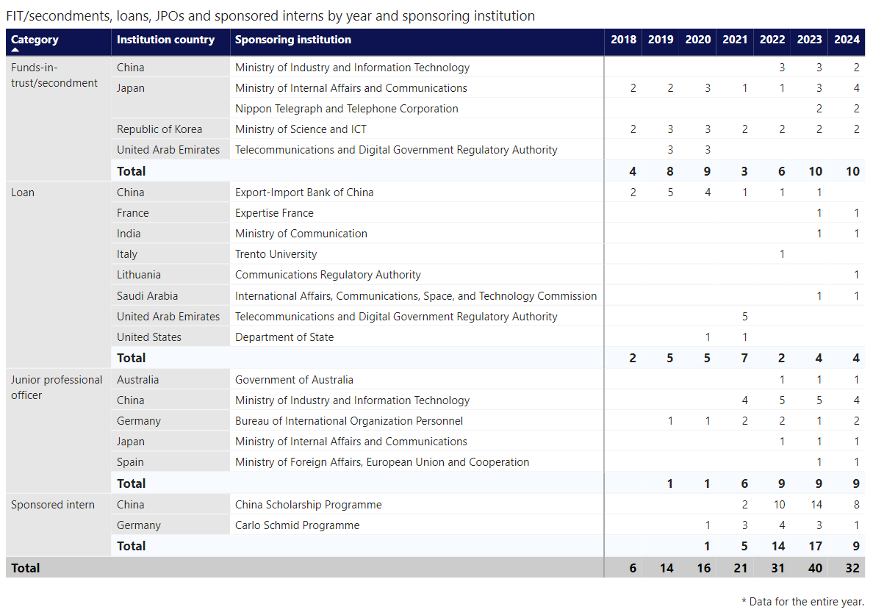

_____________

1. ITU has previously accepted secondments at the D1 level, although this practice has been discontinued.
2. Covered by the agreement with the Ministry of Science and ICT (Republic of Korea)