Agenda item: ADM 3 | Revision 1 to  Document C24/71-E
 | 7 June 2024
 | Original: English
Note by the Secretary-General
TELECOMMUNICATION STANDARDIZATION BUREAU (TSB) REORGANIZATION 2024
Purpose
In response to the World Telecommunication Standardization Assembly (WTSA-20) (held in 2022) and the Plenipotentiary Conference (PP-22) outcomes, it has been necessary to reorganize and reinforce the Telecommunication Standardization Bureau (TSB) to implement the WTSA-20 and PP-22 Action Plans. The main change is the creation of a new Strategic Engagement Department and the move of the Study Groups to the existing Telecommunication Standardization Policy Department (and renaming it to the Study Groups and Policy Department).
The Deputy to the Director will be the Chief of the Study Groups and Policy Department.
Following advice of the Coordination Committee, the Secretary-General has approved the reorganization of TSB.
Action required by the Council
The Council is invited to note the reorganization of TSB and to approve the attached draft decision regarding the job description of the D.1 post of Chief, Strategic Engagement Department.
Relevant link(s) with the Strategic Plan
Organizational excellence.
Financial implications
The cost of the post has been included in the budget 2024-2025.
__________________
References
Nos. 70 and 71 of the Convention of the International Telecommunication Union (Geneva, 1992); Council Resolution 1108 on post management.

TSB Reorganization
1 In response to WTSA-20 and PP-22 outcomes, it has been necessary to reorganize and reinforce the TSB to implement the WTSA-20 and PP-22 Action Plans.
2 The former structure of the TSB is shown in Annex A and the new structure is shown in Annex B.
3 The main change is the creation of a new Strategic Engagement Department, the move of the Study Groups under the Telecommunication Standardization Policy Department and renaming it to Study Groups and Policy Department. The Job Description of the Chief, Strategic Engagement Department is contained in Annex C.
4 The mandate and key role of the Deputy to the Director and Chief of Department does not change. There are also no changes to the Operations and Planning Department.
5 Following advice of the Coordination Committee, the Secretary-General approved the TSB reorganization.
6 The Council is invited to note the reorganization and approve the draft Decision in Annex D regarding the job description of the post of Chief, Strategic Engagement Department.
Annexes: 4

ANNEX A
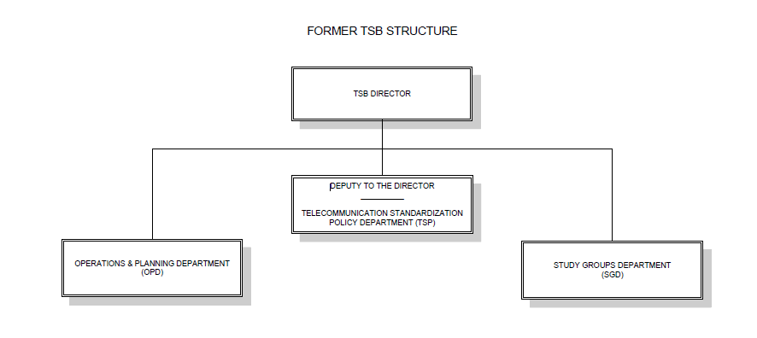
FORMER TSB STRUCTURE

ANNEX B
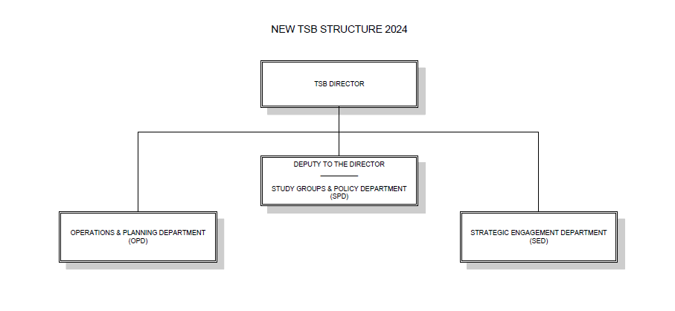

ANNEX C
DRAFT NEW JOB DESCRIPTION FOR POST NO. ST02/D1/579
CHIEF, STRATEGIC ENGAGEMENT DEPARTMENT (SED)
D.1

Duties/Responsibilities
Under the direction of the Director of the TSB, the incumbent is responsible for the management of the Strategic Engagement Department. To this end, he/she:
- Lead and direct the Strategic Engagement Department (SED) activities, human and financial resources of the Department, ensuring alignment with the overall strategic direction of the TSB and compliance with organizational regulations and rules and assigned mandate; empower and build the capacity of the team to increase their commitment; and drive change to achieve objectives of the Department:
- supervise the Communications, Media Relations, Social Media, Digital Marketing and Web Development programmes related to the work of the Bureau in close coordination with ITU’s Corporate Communication Service;
- lead the Division responsible for crafting and executing comprehensive communication strategies to enhance the Bureau’s visibility and brand recognition (e.g. WTSA, GSS, FNC, WSC, AI for Good, and other priority public-facing events and platforms), including promoting ITU-T study group outputs;
- generate media opportunities and partnerships; and
- manage social media channels and digital marketing campaigns to engage with ITU-T’s target audience effectively.
- Direct, plan and oversee the membership, sponsorship and outreach and business development activities and lay the groundwork for positioning TSB to engage on future-oriented emerging technology standards:
- lead the development and implementation of strategies to attract new members and retain existing ITU-T members;
- lead the strategy to attract and engage with new industry verticals and emerging technology standards such as metaverse, esports, robotics, autonomous driving, brain-computer interfaces, cloud and edge computing, and quantum technologies, positioning TSB as a future-oriented Bureau;
- cultivate relationships with potential sponsors and partners, negotiating agreements and sponsorship packages to support organizational goals;
- oversees business development efforts, identifying opportunities for growth and partnership expansion; and
- lead outreach initiatives to engage with stakeholders, including industry professionals, academia, governmental bodies, and youth to enhance collaboration. Supervise the ITU Journal and ITU-T Academia Programme.
- As a core component of the overall strategic engagement strategy, direct, plan and lead major initiatives such as AI for Good and other emerging technology standards. Work collaboratively with the other Bureaux and General Secretariat to enhance ITU's standing within the ICT industry, UN system, and standards community. Utilize these platforms to foster internal innovation, develop pathways for emerging standards, and strengthen ITU's thought leadership activities:
- coordinate AI and emerging technology efforts with the General Secretariat to ensure that TSB and these initiatives are strategically aligned and leveraged across all Bureaux;
- lead initiatives such as AI for Good with its three pillars, the always online, all year round platform, the annual in-person Global Summit and collaboration efforts under the impact initiative;
- design and implement the strategic framework for these major initiatives, ensuring alignment with the overall strategic direction of ITU;
- develop and implement the financial plan and budget for these initiatives;
- identify opportunities to transfer learnings from these initiatives (on content, services, tools, AI-powered pilots, way of working, etc.) to other projects within ITU; and
- engage in public speaking, representation and networking at senior executive level events and meetings inside and outside the UN system, in addition to serving as a media spokesperson.
- Direct and oversee the preparation of communications, media and promotional materials on the activities of the Bureau and related activities for presentation at ITU conferences, meetings, forum activities, and publications, and for presentation to external technical and professional meetings, conferences and seminars; participate whenever possible in such activities in order to present the work of the TSB to as wide a professional audience as possible.
- Participate in the preparation of the ITU/TSB budget as regards the Strategic Engagement Department (SED); ensure that activities are carried out in compliance with the allocated budget.
- Provide authoritative advice to the Director and the Deputy to the Director on all the matters for which he/she is responsible and cooperates with the Chiefs of the other Departments in TSB; participate in the TSB management committee and contributes to the TSB strategy and policy.
- Represent ITU-T to internal and external meetings and ensure that the TSB’s interest is represented and taken into account.
- Perform other related duties as assigned.

Qualifications required
- Advanced university degree in business management, international business or a related field OR education from a reputed college of advanced education with a diploma of equivalent standard to that of an advanced university degree in one of the fields above. For internal candidates, a first university degree in one of the fields above in combination with twenty years of qualifying experience may be accepted in lieu of an advanced university degree for promotion or rotation purposes.
- At least fifteen years of progressively responsible experience in various telecommunication fields and emerging technologies such as AI, including at least seven at the international level. A Doctorate in a related field can be considered as a substitute for three years of working experience.
- Knowledge of one of the six official languages of the Union (Arabic, Chinese, English, French, Russian, Spanish) at advanced level and knowledge of a second official language at intermediate level. Knowledge of a third official language would be an advantage.
(Under the provision of Resolution No. 626 of the Council, a relaxation of the language requirements may be authorized in the case of candidates from developing countries: when candidates from such countries possess a thorough knowledge of one of the official languages of the Union, their applications may be taken into consideration.)

Competencies
• Ability to identify key strategic issues, opportunities and risks and to formulate and take responsive initiatives.
• Reliability and commitment to timely delivery of high-quality outputs and to achieving ITU-T goals.
• Ability to build up teams and motivate and achieve effective teamwork.
• Ability to work in a multi-cultural, multi-ethnic environment with sensitivity and respect for diversity.
• Political and diplomatic skills to liaise, negotiate and manage relationships with key TSB stakeholders.
• Ability to identify key strategic issues, opportunities and risks and to formulate and take responsive initiatives.
• Proficiency in relevant office computer, web and AI applications.
• Awareness and understanding of ITU-T rules and procedures, its meeting activities and its products would be an advantage.

ANNEX D
DRAFT NEW DECISION […]
Job description for Post D.1 Chief, Strategic Engagement Department, Telecommunication Standardization Bureau
The ITU Council,
in view of
Nos. 70 and 71 of the Convention of the International Telecommunication Union (Geneva, 1992),
decides
to approve the job description for the Post D.1 of Chief of the Strategic Engagement Department, Telecommunication Standardization Bureau.
_____________

