|  |  |
| --- | --- |
|  | **Document CWG-WSIS&SDG-39/8** |
| **15 September 2023** |
| **English only** |
|  |  |
| Contribution by the secretariat | |
| WSIS STOCKTAKING 2023 AND 2024 | |
| **Purpose**  This document serves to inform the Group about the activities related to the WSIS Stocktaking, in particular:   * Outcomes of the WSIS Stocktaking 2023 * Ongoing and planned activities related to the WSIS Stocktaking 2024   **Action required**  Members are invited to note the document, consider its outcomes and participate in the new call for WSIS Stocktaking 2024 submissions.  ____________________________________  **References**  *UNGA Resolutions* [*A/RES/70/125*](https://www.un.org/en/ga/search/view_doc.asp?symbol=A/RES/70/125)*,* [*A/RES/70/1*](http://www.un.org/en/ga/search/view_doc.asp?symbol=A/RES/70/1)*,* [*A/71/212*](http://www.un.org/en/ga/search/view_doc.asp?symbol=A/RES/70/212)*,* [*A/70/299*](http://www.un.org/en/ga/search/view_doc.asp?symbol=A/RES/70/299)*,* [*A/70/684*](https://www.un.org/ga/search/view_doc.asp?symbol=A/70/684)*,* [*A/RES/73/218*](http://www.un.org/en/ga/search/view_doc.asp?symbol=A/RES/73/218)*; UN ECOSOC* [*Resolution E/RES/2023/3*](https://undocs.org/E/RES/2023/3)*; Resolutions* [*140 (Rev. Bucharest, 2022)*](https://www.itu.int/en/council/Documents/basic-texts-2023/RES-140-E.pdf)*,* [*172 (Rev. Guadalajara, 2010)*](https://www.itu.int/en/council/cwg-wsis/Documents/Resolution172-PP10.pdf)*,* [*Resolution 71 (Rev. Bucharest 2022)*](https://www.itu.int/en/council/Documents/basic-texts-2023/RES-071-E.pdf) *of the Plenipotentiary Conference; Council Resolutions* [*1332 (Modified 2023)*](https://www.itu.int/md/S23-CL-C-0119/en)*,* [*1334 (Modified 2023)*](https://www.itu.int/md/S23-CL-C-0120/en)*; WTDC Resolutions* [*30 (Rev. Kigali, 2022)*](https://www.itu.int/dms_pub/itu-d/opb/tdc/D-TDC-WTDC-2022-PDF-E.pdf)*; WTSA Resolutions* [*75 (Rev. Geneva, 2022)*](https://www.itu.int/pub/publications.aspx?lang=en&parent=T-RES-T.75-2022)*; WRC Resolutions* [*61-2 (Modified 2019)*](https://www.itu.int/pub/R-RES-R.61-2-2019)*; Reports of the CWG WSIS&SDG meetings* [*33rd, 34th, 35th, 36th, 37th, 38th*](http://www.itu.int/en/council/cwg-wsis/Pages/default.aspx)*;* [*Report on the Outcomes of the CWG-WSIS&SDG Meetings held since PP-18*](https://www.itu.int/md/S22-CWGWSIS38-C-0020/en)*;* [*Report on the Outcomes of the CWG-WSIS&SDG Meetings held since Council 21*](https://www.itu.int/md/S22-CWGWSIS38-C-0019/en)*;* [*Roadmap for ITU’s Activities to Help Achieve the 2030 Agenda for Sustainable Development*](https://www.itu.int/md/S22-CWGWSIS38-C-0014/en)*;* *[World Summit on the Information Society (WSIS)+20: WSIS beyond 2025 - WSIS+20 Roadmap;](https://www.itu.int/dms_pub/itu-s/md/22/cl/c/S22-CL-C-0059!!MSW-E.docx)* | |

As per the [Tunis Agenda for the Information Society](https://www.itu.int/net/wsis/docs2/tunis/off/6rev1.html) (paragraph 120), [WSIS Stocktaking](http://www.wsis.org/stocktaking) has been maintained by ITU since 2004. It is a unique global platform for collecting information and annual reporting on information and communication technology related initiatives and projects, carried out by governments, international organizations, the business sector, civil society, academia, and other entities. This global repository, currently comprising over 14,000 entries, reflects the implementation of the WSIS Action Lines on the ground.

In 2015, the UN General Assembly, during the ten-year review of the WSIS ([Res. A/70/125](https://unctad.org/en/PublicationsLibrary/ares70d125_en.pdf)), called for a strong alignment between the WSIS process and the 2030 Agenda for Sustainable Development ([Res. A/70/1](https://www.un.org/en/development/desa/population/migration/generalassembly/docs/globalcompact/A_RES_70_1_E.pdf)). In response, the WSIS Stocktaking process highlighted the role of 11 WSIS Action Lines in contributing to the achievement of the 17 Sustainable Development Goals (SDGs). [ECOSOC Resolution 2023/3](https://undocs.org/Home/Mobile?FinalSymbol=E%2FRES%2F2023%2F3&Language=E&DeviceType=Desktop&LangRequested=False) reaffirms the significance of sharing best practices globally and encourages all stakeholders to submit ICT-related projects and initiatives to the WSIS Stocktaking platform, recognizing outstanding efforts in implementing projects that advance the WSIS goals.

In 2023, the WSIS Stocktaking Global Report publication contains more than 1,000 submissions, including those submitted to the WSIS Prizes and special prizes, as listed below.

All WSIS stakeholders are invited to continue submitting updates and new entries online at [www.wsis.org/stocktaking](http://www.wsis.org/stocktaking). Submitted activities will be reflected in the Global WSIS Stocktaking Report 2024, while the 6 regional reports will be published as part of the 5th series of regional reporting and will be released during the final week of the WSIS Forum 2024, branded as the WSIS+20 Forum High-Level Event.

**WSIS Special Prizes**

WSIS Stocktaking continues to diversify its database by introducing new repositories, including the [WSIS Photo Contest](https://www.itu.int/net4/wsis/forum/2023/en/PhotoContest) (since 2016), [WSIS Healthy Ageing Innovation Prize](https://www.itu.int/net4/wsis/forum/2022/Home/HealthyAgeing) (since 2021), [WSIS Women in Technology](https://www.itu.int/net4/wsis/stocktaking/Home/Gender) (since 2022), and the recently proposed repositories of [WSIS x Generation Connect Youth Prize](https://www.itu.int/net4/wsis/forum/2023/Home/ICTsYouthPrize) (since 2023) and [WSIS Digital Service Design Prize](https://www.itu.int/net4/wsis/forum/2023/en/Home/DigitalServiceDesign) (since 2023). New repositories are in line with the WSIS Forum special tracks on ICTs and Older Persons, Gender Mainstreaming, Youth, and WSIS Action Line e-Government. The new calls for submissions will be launched in September 2023.

**WSIS Photo Contest**

The new call for the WSIS Photo Contest 2024 will be launched in September 2023, and the submissions are encouraged. For more information, please visit [www.wsis.org/forum](http://www.wsis.org/forum). WSIS community is invited to picture how are ICTs advancing SDGs on the ground, therefore contributing to WSIS Stocktaking overall. This year’s 3 winners include:

[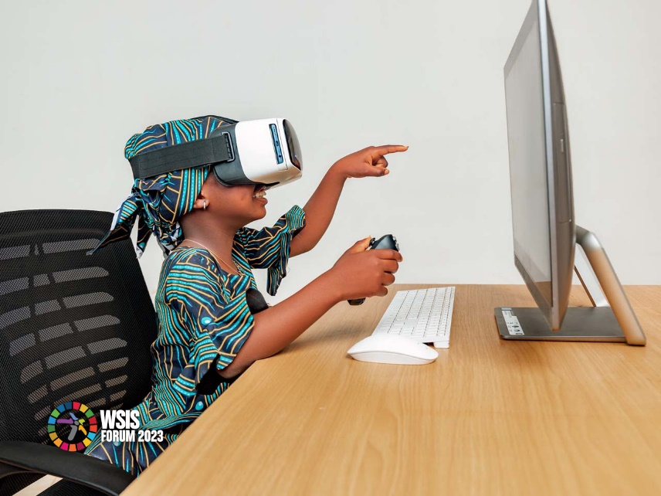](https://www.itu.int/net4/wsis/forum/2023/PhotoContest#photo-6b434956aa0848f19b783ddf58e29832)**#TeachAChildHowToCode #1BillionProject by *Mediahooch Space,* Nigeria**

The #1BillionProject is dedicated to making a positive impact on the lives of one billion people around the world. Our mission is to identify and address pressing social, economic, and Technical challenges facing Startups, Students, Creatives and Local Communities across the globe.

**Klik Dengan Bijak - Be Informed, Be Protective by *Ts. Md Tahir Musa, Malaysia***

[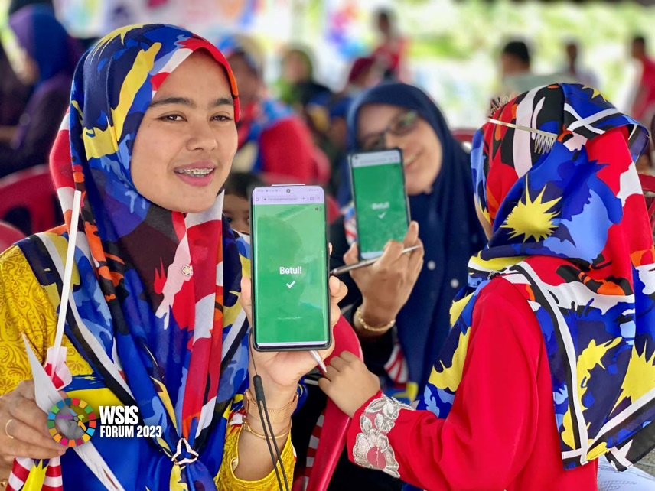](https://www.itu.int/net4/wsis/forum/2023/PhotoContest#photo-8bd3d7fb257a4f3b86a46435743f59cb)The Internet is a virtual world with limitless resources and boundaries, but without sufficient knowledge and precaution, it could pose threats to us in real life. The photo shown a community at rural area in Terengganu, Malaysia attended the online safety and awareness program called Klik Dengan Bijak and participated in MyCybergenius, an advocacy assessment and monitoring system.

[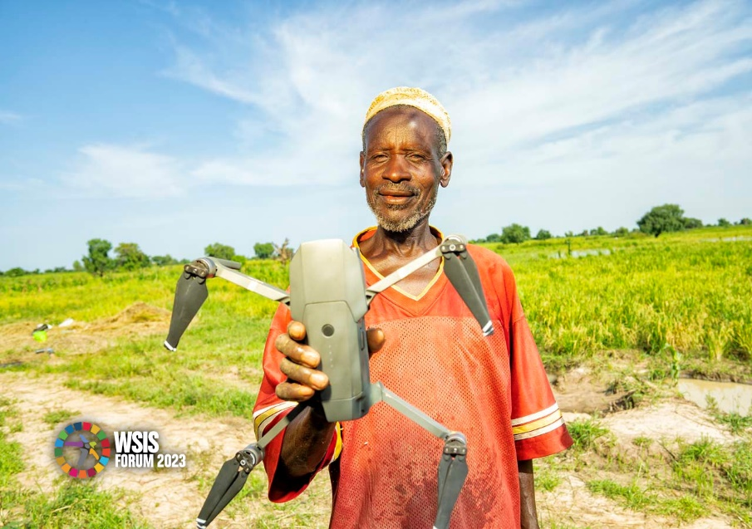](https://www.itu.int/net4/wsis/forum/2023/PhotoContest#photo-6758a96ea66143afbdf0a82e5d4e49dd) **New Discovery by Mohammed Alamin, Nigeria**

 A farmer holds a drone that just took aerial images of his farm. The farmer's surprise was in full display as he couldn't believe his eyes so he had to hold the flying device otherwise known as a drone.

**WSIS Healthy Ageing Innovation Prize**

The WSIS Forum 2023 Special Track on ICTs and Older Persons continued to hold the [WSIS Healthy Ageing Innovation Prize](https://www.itu.int/net4/wsis/forum/2023/en/Home/HealthyAgeing), focused on ICTs that specifically address the needs of people 60+ to achieve and sustain an active and engaged life as they age. The WSIS Healthy Ageing Innovation Prize is an exceptional international recognition of WSIS Stakeholders as leaders for their excellence in supporting innovation that brings sustainable solutions for the ever-increasing global population of older people. Given the identification and release of the UN/WHO Decade of Healthy Ageing’s Action Areas, we continue to encourage innovators from all sectors to connect their submissions to this seminal global effort.

The winner of 2023 contest is [Fibricheck](https://www.fibricheck.com/) from Belgium for their work on transforming the way cardiac care is delivered today. FibriCheck offers a fully certified application capable of detecting and managing cardiac arrhythmias (including Atrial Fibrillation) using an app on a smartphone or smartwatch. By placing a finger on a smartphone’s camera for 60 seconds, FibriCheck’s technology produces a real-time, medical-grade analysis of heart rhythms through its medical artificial intelligence software. Meet all the finalists of 2023 contest [here](https://youtu.be/Vo36TxskfsQ) and promote their success.

Detailed information about the 2024 call for submissions will soon be available at [www.wsis.org/forum](http://www.wsis.org/forum).

**WSIS Stocktaking Repository of Women in Technology**

In 2021, at the request of and in collaboration with the WSIS stakeholders, a new [WSIS Stocktaking Repository of Women in Technology](http://www.itu.int/go/WSISGender) was launched to strengthen the ICTs and Gender Mainstreaming activities on WSIS. The aim of this repository is to identify and connect women leaders and practitioners in all sectors of the ICT industry from all regions and engage them in events, forums (e.g. WSIS Forum) and activities such as various workshops, training courses, networking events, aimed at fostering a dialogue on the use of ICTs as a means for implementing the Sustainable Development Goals. As part of this activity, the group of WSIS Gender Trendsetters was established. As part of the Gender Mainstreaming initiatives, the WSIS Gender Trendsetters contributed to the 67th Commission on the Status of Women by organising a side-event on *WSIS Gender Trendsetters: ICTs for Gender Inclusion*, which took place on 16 March 2023 in New York. Details of the event are available [here](https://www.itu.int/net4/wsis/forum/2023/Agenda/Session/358).

**WSIS x Generation Connect Youth Prize**

Following the activities of the WSIS Youth Campaigners, in collaboration with ITU Generation Connect, AI for Good Summit, [Geneva International Model United Nations](http://www.gimun.org/) and other stakeholders, the new repository was launched in 2023 [WSIS x Generation Connect Youth Prize](https://www.itu.int/net4/wsis/forum/2023/Home/ICTsYouthPrize) and is currently being redesigned to help contribute to the WSIS Forum ICTs and Youth Track, and particularly to the promotion of activities and efforts by youth in advancing SDGs through technology.

The winner is Valentin Gloor from Switzerland, for his idea of The Connect App which aims to bring two important key elements closer to youth in order to achieve the SDGs. Finalists of the WSIS x Generation Connect Youth Prize include Clara Brown and Fiona Brown from Canada for their work on Our Future World, Our Digital Creation; Natalie Tercova from the Czech Republic for her project CyberWise: Effective Cooperation Between Academia and Stakeholders; and Rekik Girmachew from Ethiopia for his innovative photography Inclusion, Ethiopia the hub of East Africa, land of origins, at the Science museum in Addis Ababa.

**WSIS Digital Service Design Prize**

Another innovation is the [WSIS Digital Service Design Prize](https://www.itu.int/net4/wsis/forum/2023/en/Home/DigitalServiceDesign) (since 2023), the new repository launched together with ITU’s GovStack initiative and other stakeholders in line with the implementation of the WSIS Action Line e-Government. The WSIS Digital Service Design Special Prize was developed to recognize governments around the world using DPIs and a whole-of-government approach to Citizen-Centric Digital Service Design to achieve the SDGs. With 50 submissions, the WSIS Special Prize on Digital Service Design gathered best practices from every continent.

[The e-Governance Agency of Moldova](https://www.govstack.global/blog/wsis-special-prize-winner/) won in the prize in 2023. Their framework contains a collection of visual components and integration libraries that enables rapid design and development of digital government services front-offices.

___________________