Revision 1 to
Document C23/INF/12
12 July 2023
English only
Report by the Secretary-General
REPORT ON VOLUNTARY CONTRIBUTION REVENUE 2022
Purpose
This report provides a breakdown of the 2022 voluntary contribution revenue as indicated in the Statement of financial performance presented in the Financial Operating Report for the financial year 2022 (Council document C23/41).
Action required by the Council
This document is transmitted to the Council for information.
__________________
References
Financial Operating Report for the financial year 2022 (Document C23/41)

1 This report provides a breakdown of the 2022 voluntary contribution revenue as indicated in the Statement of financial performance presented in the Financial Operating Report for the financial year 2022 (Council document C23/41).
2 In ITU, extrabudgetary funds are managed as trust funds or voluntary contributions and both are reported as voluntary contributions in the Financial Statements.
- Trust funds are used to execute projects financed by earmarked contributions. They are voluntary contributions with specific and restrictive utilization. In accordance with ITU Financial Regulations and Financial Rules, these contributions generate support cost recovery revenues (AOS) during the execution and implementation of the projects.
- Voluntary contributions (including sponsorships) are received from contributors to complement specific regular budget activities such as for example seminars, working groups, study groups, training and fellowships. Voluntary contributions can finance long-term activities. Voluntary contributions do not generate any support cost recovery revenue.
3 In 2022, ITU received a total of CHF 14.2 million. CHF 12.8 million concern extrabudgetary funds and CHF 1.4 million relate to sponsorships for the new building project. The majority of the CHF 12.8 million extrabudgetary funds (65 per cent) were from Member States (Table 1), followed by Sector Members, Associates and Academia (15 per cent) (Table 2). Table 3 lists the contributors and amounts in CHF received in 2022.
TABLE 1
Extrabudgetary funds from Member States in 2022
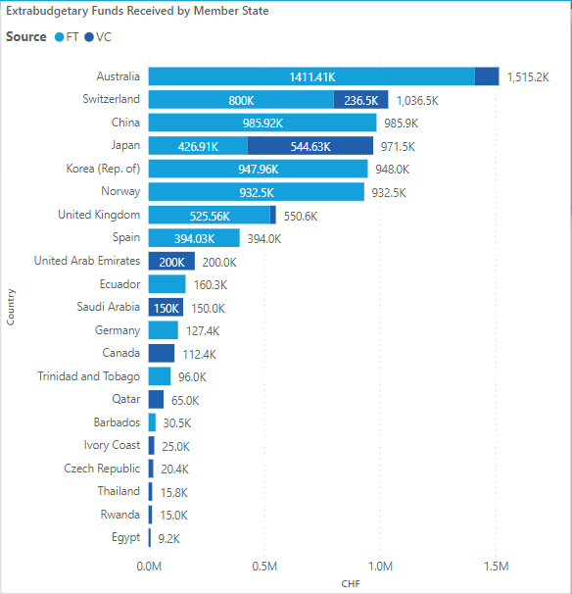

TABLE 2
Extrabudgetary funds from Sector Members, Associates and Academia in 2022
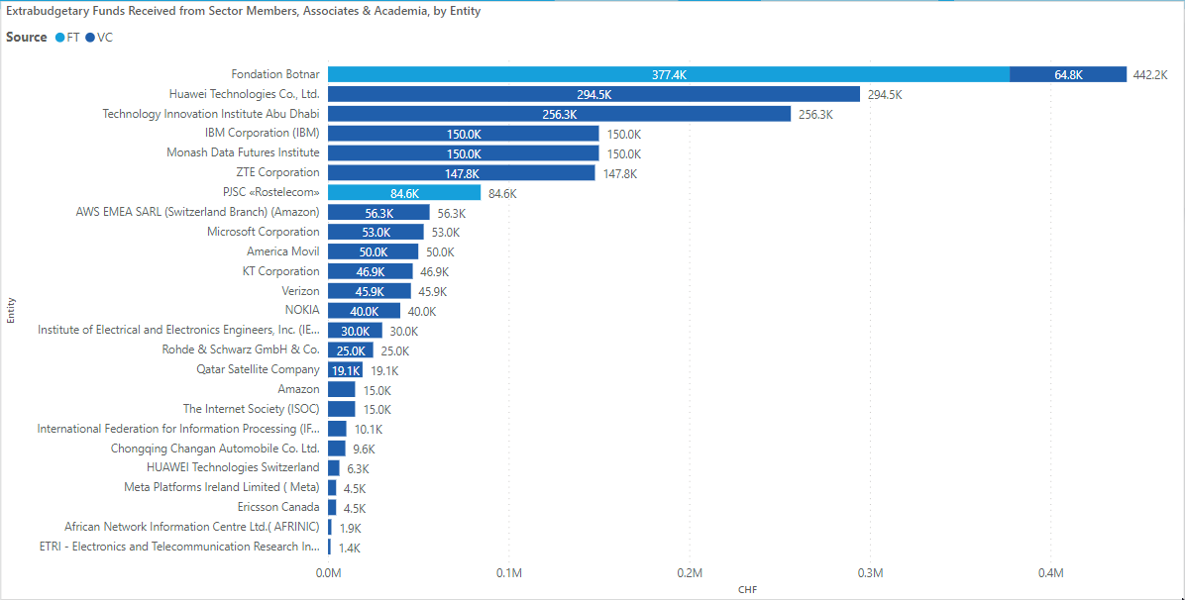

TABLE 3
Details of extrabudgetary funds received in 2022

Country | Type of member | Organization | VC/FT | Sector | Amount in CHF
Australia | Member State | Department of Communications and the Arts (DoCA) | FT | ITU-D | 585’149
 |  |  | VC | ITU-D | 103’829
 |  | Department of Foreign Affairs and Trade Government of Australia | FT | SG | 89’088
 |  |  |  | ITU-D | 520’675
 |  |  |  | ITU-T | 216’497
 | Sector Member, Associate & Academia | Monash Data Futures Institute | VC | ITU-T | 150’000
Austria | Sector Member, Associate & Academia | International Federation for Information Processing (IFIP) | VC | SG | 10’139
Barbados | Member State | Ministry of Industry, Innovation, Science and Technology | FT | ITU-D | 30’508
Canada | Member State | Ministry of Innovation Science & Industry Canada | VC | ITU-D | 112’380
 | Sector Member, Associate & Academia | Ericsson Canada | VC | ITU-T | 4’490
 | Non-member | Youth Culture Inc. | VC | ITU-T | 5’000
China | Member State | Ministry of industry and information technology (MIIT) | FT | SG | 985’924
 | Sector Member, Associate & Academia | Chongqing Changan Automobile Co. Ltd. | VC | ITU-T | 9’600
 |  | Huawei Technologies Co., Ltd. | VC | ITU-D | 205’289
 |  |  |  | SG | 30’000
 |  |  |  | ITU-D | 59’257
 |  | HUAWEI Technologies Switzerland | VC | ITU-T | 6’293
 |  | ZTE Corporation | VC | ITU-T | 100’000
 |  |  |  | ITU-D | 47’800
Czech Republic | Member State | Permanent Mission of the Czech Republic | VC | ITU-D | 20’373
Denmark | Non-member | DTU, Space Technical University of Denmark | VC | ITU-T | 11’436
Ecuador | Member State | ARCOTEL | FT | ITU-D | 160’262
Egypt | Member State | National Telecom Regulatory Authority Egypt | VC | ITU-D | 9’239
Finland | Sector Member, Associate & Academia | NOKIA | VC | ITU-D | 40’000
France | Non-member | Capgemini Service | VC | ITU-T | 30’000
 |  | Secure Identity Alliance | VC | ITU-T | 3’712
Germany | Member State | Büro Führungskräfte zu Internationalen Organisationen (BFIO) | FT | SG | 127’421
 | Sector Member, Associate & Academia | Rohde & Schwarz GmbH & Co. | VC | ITU-T | 25’000
 | Non-member | KUKA Aktiengesellschaft | VC | ITU-T | 10’000
International | UN and other international/regional organizations | Cooperation Andina de Fomento | FT | ITU-D | 35’925
 |  | European Commission | FT | ITU-D | 439’817
 |  | FAO | FT | ITU-D | 174’177
 |  | UNDP MPTF | FT | ITU-D | 697’178
 |  | UNIDO | FT | ITU-T | 33’336
 |  | UNOPS | FT | ITU-D | 430’693
Ivory Coast | Member State | Autorité de Régulation des Télécommunications de Côte d'Ivoire (ARTCI) | VC | ITU-D | 25’000
Japan | Member State | Ministry of Internal Affairs and Communications | FT | ITU-R | 288’543
 |  |  | VC | ITU-D | 514’626
 |  |  |  | SG | 30’000
 |  | Permanent Mission Japan | FT | ITU-D | 138’365
 | Non-member | Santen SA (Santen) | FT | ITU-D | 150’000
Korea (Rep. of) | Member State | MSIT Korea | FT | ITU-T | 124’663
 |  |  |  | ITU-D | 475'764
 |  | Permanent Representative of the Mission of the Republic of Korea | FT | ITU-T | 347’529
 | Sector Member, Associate & Academia | ETRI - Electronics and Telecommunication Research Institute | VC | ITU-T | 1’390
 |  | KT Corporation | VC | ITU-D | 46’900
 | Non-member | ITU-T SG17 Chairman | VC | ITU-T | 828
Mauritius | Sector Member, Associate & Academia | African Network Information Centre Ltd.( AFRINIC) | VC | ITU-D | 1’862
Mexico | Sector Member, Associate & Academia | America Movil | VC | ITU-D | 50’000
Netherlands | Non-member | Shell International B.V. | VC | ITU-T | 50’000
Norway | Member State | The Norwegian Agency for Development Cooperation (Norad) | FT | ITU-D | 932’498
 | Non-member | United Cities AS | VC | ITU-T | 1’910
Qatar | Member State | Ministry of Comm and Information Tech MCIT | VC | SG | 65’000
 | Sector Member, Associate & Academia | Qatar Satellite Company | VC | ITU-D | 19’120
Russia | Sector Member, Associate & Academia | PJSC «Rostelecom» | FT | ITU-D | 84’565
Rwanda | Member State | Rwanda Utilities Regulatory Authority (RURA) | VC | SG | 15’000
Saudi Arabia | Member State | Communications, Space & Technology Commission (CST) | VC | SG | 100’000
 |  |  |  | ITU-D | 50’000
South Africa | Non-member | Arm/(Cortex Hub) South Africa | VC | ITU-T | 10’000
Spain | Member State | Secretaría de Estado de Asuntos Ext. y Globales | FT | SG | 394’031
Switzerland | Member State | Federal Department of Foreign Affairs | FT | ITU-D | 800’000
 |  |  | VC | ITU-T | 220’000
 |  | Office fédéral de la communication (OFCOM) | VC | SG | 15’000
 |  | République & Canton de Genève | VC | ITU-T | 1’500
 | Sector Member, Associate & Academia | Fondation Botnar | FT | ITU-T | 377’412
 |  |  | VC | ITU-T | 50’000
 |  |  |  | ITU-D | 14’835
 |  | The Internet Society (ISOC) | VC | SG | 15’000
 | Non-member | F. Hoffmann-la-roche ag | FT | ITU-D | 150’000
Thailand | Member State | Office of the National Broadcasting and Telecommunications Commission | VC | ITU-D | 15’839
Trinidad and Tobago | Member State | Telecommunications Authority of Trinidad and Tobago (TATT) | FT | ITU-D | 96’000
United Arab Emirates | Member State | Telecommunications and Digital Government Regulatory Authority (TDRA) | VC | SG | 150’000
 |  |  |  | ITU-D | 50’000
 | Sector Member, Associate & Academia | Technology Innovation Institute Abu Dhabi | VC | ITU-T | 256’250
United Kingdom | Member State | Department for Digital, Culture, Media and Sport (DCMS) | VC | SG | 15’000
 |  |  |  | SG | 10’000
 |  | Foreign, Commonwealth & Development Office (FCDO) | FT | ITU-D | 525’555
 | Non-member | Ernst & Young LLP | VC | ITU-T | 5’000
 |  |  |  | SG | 15’000
United States | Sector Member, Associate & Academia | Amazon | VC | ITU-D | 15’000
 |  | AWS EMEA SARL (Switzerland Branch) (Amazon) | VC | ITU-T | 56’250
 |  | IBM Corporation (IBM) | VC | ITU-T | 150’000
 |  | Institute of Electrical and Electronics Engineers, Inc. (IEEE) | VC | SG | 30’000
 |  | Meta Platforms Ireland Limited (Meta) | VC | SG | 4’500
 |  | Microsoft Corporation | VC | ITU-D | 52’967
 |  | Verizon | VC | ITU-D | 45’900
 | Non-member | Drone Deploy | VC | ITU-T | 5’000
 |  | Everguard.ai | VC | ITU-T | 5’000
 |  | Global Coalition on Aging (GCOA) | VC | SG | 4’660
 |  | Mary Kay Inc. | FT | ITU-D | 204’665
 |  | Women's WorldWide Web (W4) | FT | ITU-D | 34’447
 |  | TOTAL |  |  | 12’828’862
_______________

