|  |  |
| --- | --- |
| **Agenda item: PL 1** | **Document C23/52-E** |
| **11 June 2023** |
| **Original: English** |
| Report by the Secretary-General | |
| TRANSFORMATION ROADMAP TO ACHIEVE ORGANIZATIONAL EXCELLENCE | |
| **Purpose**  The case for change on an internal transformational initiative to enhance ITU's organizational excellence.  **Action required by the Council**  The Council is invited **to note** this roadmap and **to approve** the creation of a Chief of Transformation Office position at the D-1 level.  **Relevant link(s) with the Strategic Plan**  ITU Strategic Plan 2024-2027 Enabler – Excellence in human resources and organizational innovation  **Financial implications:**  Financial and human resources will be required to fulfil the objectives of this programme. The investment required is being analyzed and sources of financing being identified, including taking into account efficiency measures and other cost savings. This initial cost of the initiative[1] is to be financed from savings and reprioritization across ITU budgets 2022-2023 and 2024-2025.  __________________  **References**  Council documents [C20/61](https://www.itu.int/md/S20-CL-C-0061/en), [C20/74](https://www.itu.int/md/S20-CL-C-0074/en), [C21/INF/15](https://www.itu.int/md/S21-CL-INF-0015/en), [C22/INF/13](https://www.itu.int/md/S22-CL-INF-0013/en), [C22/40](https://www.itu.int/md/S22-CL-C-0040/en), [C22/57](https://www.itu.int/md/S22-CL-C-0057/en), [C23/36](https://www.itu.int/md/S23-CL-C-0036/en), [C23/50](https://www.itu.int/md/S23-CL-C-0050/en), [C23/62](https://www.itu.int/md/S23-CL-C-0063/en), [C23/INF/11](https://www.itu.int/md/S23-CL-INF-0011/en), [C23/INF/13](https://www.itu.int/md/S23-CL-INF-0013/en), and [UN 2.0 Quintet of Change](https://www.un.org/sites/un2.un.org/files/2021/09/un_2.0_-_quintet_of_change.pdf) | |

1. **Introduction - Case for change on organizational excellence**

The case for change on ITU’s organizational excellence has been highlighted in the ITU Strategic Plan for 2024-2027 and the Plenipotentiary Decision 5, analyzed in several external and internal consultations, and confirmed at the recent Visioning Exercise conducted by the new management team with ITU staff and a number of external parties.

To be fit for the future, 158 years since our creation, and to respond to the rapidly changing operating environment that is expected in the next decade, ITU needs to establish a solid foundation upon which organizational excellence and thought leadership can be built. To position the Union for a more impactful and stable future, immediate investment and efforts are needed for the internal transformation of the organization. This effort is necessary to be able to offer services of the highest quality and efficiency to Membership with emphasis on results, ensuring that the value of the Membership investments is maximised, including by optimizing the cost base, and that ITU operates in accordance to the highest standards of transparency and accountability.

The case for change on organizational excellence, as identified by the visioning exercise, focuses on the key areas of:

1. people and culture;
2. financial management and planning;
3. systems, processes and tools; and
4. oversight, internal controls and governance.

The proposal builds on recent external and internal consultations, as well as studies and recommendations from expert consultants. The Visioning exercise engaged more than 60 ITU staff across the organization, assessing and reviewing these key focus areas, and providing recommendations on the way forward. This work was complemented by informal Member State consultations and was followed up by the ITU senior management retreat and monthly ITU staff Townhall meetings. These documents/reports taken into consideration for this proposal include:

* Accelerating the implementation of the ITU Strategic Plan 2024-2027 ([C23/36](https://www.itu.int/md/S23-CL-C-0036/en));
* Previous External Auditor Reports ([C20/40](https://www.itu.int/md/S20-CL-C-0040/en), [C22/40](https://www.itu.int/md/S22-CL-C-0040/en), [C22/101](https://www.itu.int/md/S22-CL-C-0101/en));
* ITU Accountability Model and Framework ([C22/57](https://www.itu.int/md/S22-CL-C-0057/en));
* ITU Risk Management Policy ([C20/61](https://www.itu.int/md/S20-CL-C-0061/en));
* ITU Culture and Skills Project ([C21/INF/15](https://www.itu.int/md/S21-CL-INF-0015/en));
* Review of ITU’s regional presence ([C20/74](https://www.itu.int/md/S20-CL-C-0074/en));
* World café on revenue generation, reducing expenditures and balancing the Financial Plan ([C22/INF/13](https://www.itu.int/md/S22-CL-INF-0013/en));
* Towards a new "One ITU" resource mobilization strategy ([C23/62](https://www.itu.int/md/S23-CL-C-0062/en));
* Financial Management Transformation Plan ([C23/50](https://www.itu.int/md/S23-CL-C-0050/en));
* Human Resources transformation plan ([C23/INF/13](https://www.itu.int/md/S23-CL-INF-0013/en));
* Assess & Transform: Evaluating Current State and Developing an IT Roadmap for ITU’s Service Excellence and Growth ([C23/INF/11](https://www.itu.int/md/S23-CL-INF-0011/en));
* Proposal for the Creation of an Oversight Unit ([C23/53](https://www.itu.int/md/S23-CL-C-0053/en)); and
* Our Common Agenda, UN 2.0, Quintet of Change   
  (<https://www.un.org/sites/un2.un.org/files/2021/09/un_2.0_-_quintet_of_change.pdf>).

The transformation roadmap outlined below is critical to improve results to be achieved in the implementation of the ITU strategic plan, supported by strategic engagement with the ITU membership, improved resource mobilization, and operational excellence. Change management is of critical importance to ensure successful outcomes and long-term sustainability, while ensuring the benefits for the whole organization, working as One ITU.

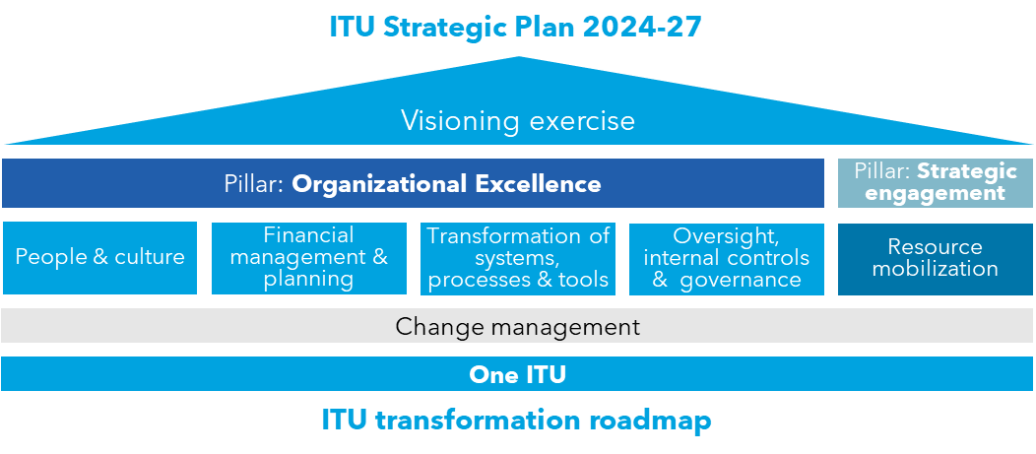

Figure 1. Building blocks of ITU transformation roadmap

1. **Current state**

As highlighted in several of the exercises above, the organization is facing several challenges and deficiencies that impact its current state.

**External factors:**

Externally, the ITU has the potential to increase its value and establish a more prominent role in partnerships. It has demonstrated excellent convening abilities and can further leverage the expertise and resources of its membership to achieve greater effectiveness and more impact in universal connectivity and sustainable digital transformation.

By focusing on ITU’s thematic priorities identified in the strategic plan, while establishing clearer linkage between results thought and its products and services, the ITU can enhance its impact on the telecommunications/information and communication technology landscape.

**Internal factors:**

**Lack of shared vision, need to strengthen "One ITU":** Potential for a stronger, more unified vision and a sense of collective purpose, to avoid fragmented decision-making and limited progress towards common goals.

**Break down silos:** The organizational structures operate independently from each other, and would benefit from greater collaboration, coordination, and the sharing of knowledge, resources, and services.

**Increase flexibility and agility:** The operations and decision-making processes are often slow and rigid, based on out-dated rules and procedures, making it challenging to adapt to rapidly changing technological advancements and evolving needs of its stakeholders. There is potential to streamline and modernize processes.

**Reduce bureaucracy:** The organization needs to eliminate bureaucratic inefficiencies and cumbersome procedures, which can impede its ability to respond effectively to emerging challenges and opportunities. Responsiveness to external needs must be improved and the allocation of resources needs to align with the most pressing priorities.

**Enable organizational excellence**: An enabling environment needs to be in place, for staff to be engaged, accountable and high performing. Financial resources need to be clearly linked with priorities and expected results. Processes, systems and frameworks in place need to support increased organizational efficiency. Lack of organization-wide proper internal controls needs to be addressed.

1. **How will ITU manage the transformation?**

A number of transformative initiatives have already been initiated. Given the significance, complexity, and scope of changes identified in this transformation roadmap, it requires a coordinated effort, an effective governance mechanism, and resources to deliver the expected benefits, in a coordinated, transparent, timely and goal-oriented manner.

Since a transformation program is multidisciplinary, covering different business domains, it requires different competencies such as strategy, process re-engineering, data analytics, and IT delivery. It must be structured as an effort of a dedicated time-bound dynamic team / organization (Transformation Office) which can rapidly activate and mobilize different competencies necessary during particular phases of the programme.

The Transformation Office will be tasked with the following responsibilities:

1. **Programme / project management**. Driving and overseeing the transformation initiatives in the areas above (i.e. people and culture, financial management, systems processes and tools, and internal controls) and acting as a central hub of information for managing and coordinating multiple programmes and projects. Development of implementation plans in these areas, progress monitoring, risk management, making sure that these programs / projects are delivered on time, within budget, and with the expected quality.
2. **Transformation planning**. Ensure that the strategy and detailed transformation roadmap with initiatives in the areas above, milestones, timelines and dependencies are being followed. Making sure that all stakeholders are aligned and share the same understanding.
3. **Set up governance structure**. Establish and follow a clear governance structure which defines roles, responsibilities, and decision-making authority as well as ensures compliance with policies, standards, and regulations. Such governance structure shall ensure strong engagement and ownership of the transformation of both – business owners responsible for the support services, as well as the business users.
4. **Stakeholder engagement and communication**. Facilitate effective communication and engagement with internal stakeholders (in the Headquarters and field) throughout the transformation program. Develop communication plans, establish communication channels, and ensure that stakeholders are informed about the progress, achievements, and upcoming milestones.
5. **Ensure senior leadership sponsorship**. Engagement of the top management team who will champion the transformation, allocate necessary resources, and help remove organizational barriers or resistance to change.
6. **Change management**.Implement change management strategy to facilitate adoption of new processes and technologies and support stakeholders in transitioning to new ways of working integrating with the Change Makers[2] program, as well as to address potential resistance.
7. **Risk management**. Identify, assess, and manage risks associated with the transformation program. Develop risk management strategies, implement risk mitigation plans, and monitor risks throughout the program lifecycle.
8. **Monitoring and progress measurement**. Establish performance metrics and tracking mechanisms to monitor the progress and outcomes of the program.

Transformation Office will reduce the risk of having fragmentated, inefficient, inconsistent approaches, and limited oversight. This function decreases the likelihood of project failures, delays, budget overruns, and achieving desired outcomes.

The Secretary-General and the Deputy Secretary-General will champion this Program in consultation and close collaboration with the Directors of the Bureaux (all part of the Coordination Committee) as well as with the senior managers (the Management Coordination Group). The work of the Transformation office will be supporting the business owners of the respective services and processes where the transformation initiatives will be implemented (e.g. Finance, HR and IS), while a key role will be played by representatives of the business owners defining the business requirements and supporting change (including via the visioning exercise group and the Change Makers). Figure below highlights the key composition of the structures needed during this transformation.

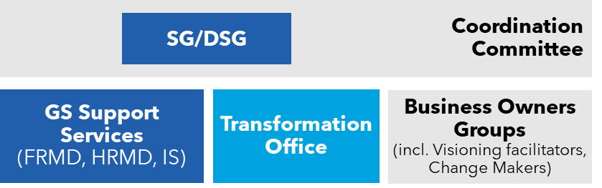

Figure 2. Transformation team and key structures

Annex 1 presents a proposed structure for the Transformation Office and Annex 2 the job description for the Chief Transformation Officer.

1. **People and Culture**

The following key issues were identified as areas for improvement under the ITU Culture and Skills Project and detailed in the Human Resources Transformation Plan ([C23/INF/13](https://www.itu.int/md/S23-CL-INF-0013/en)):

1. **Shared vision and cross-functional collaboration** must be strengthened to better complement sector mandates with cross-sectoral collaboration and work towards a shared vision;
2. **Strategic thinking** is needed for setting inspirational goals, focusing on implementing strategies to empower teams and advance ITU's impact;
3. Stronger **outward focus, innovation and experimentation** is needed to drive progress, innovation, experimentation and risk-taking, in line with the ITU mandate;
4. Enhanced **efficiency and agility of business processes** is needed to facilitate a results-focused and operationally disciplined operating model;
5. Clearly defined roles and delegation of more responsibility for decisions are necessary for stronger **ownership and accountability; and**
6. **Talent and performance management** needs to better recognize and reward our best contributors while acting to address swiftly underperformance or misconduct.

**What success looks like:**

**Enabling environment and management**: ITU's work environment and management culture is more enabling and ensures that staff are engaged, high performing and accountable, with improved performance and under-performance management practices.

**Optimized organizational structure**: The organizational structure and operating model enhances ITU's future strategic positioning and maximizes efficiency in delivering on its value proposition.

**Talent management**: ITU is the employer of choice and able to recruit, support, manage, empower and retain the top talent, including increased flexibility of work and career progression.

**Leadership culture**: Inspirational leadership at all levels steers how we manage, operate, communicate and make decisions to support employees in achieving their goals.

**Policies and frameworks**: HR policies and frameworks are modernized to be fit for the future workforce, including the elimination of obsolete rules and policies and refinement of the competency framework.

**Process modernization**: Streamlined processes, automated and digitized to the extent possible, enable a highly efficient full life cycle recruitment processes, as well as facilitating ITU to bring in and build the best talent pool possible.

Further details are outlined in the ITU’s human resources transformation plan ([C23/INF/13](https://www.itu.int/md/S23-CL-INF-0013/en)).

1. **Financial Management**

The following key issues have been identified in the review of finance functions (as per the instructions to the SG by Council Res. 1412 ([C23-EXT/6-E](https://www.itu.int/md/S22-CEXT23-C-0006/en)), to take measures to strengthen the financial management and report on the measures taken to Council 2023):

1. The **financial regulations and rules** of ITU need to align to latest fiscal management best practices;
2. Financial management framework, processes, and systems, with a view of strengthening **results-based management, transparency, accounting practices** (including IPSAS implementation) and **availability and timeliness of financial information** need to be put in place;
3. The **organizational structure** of the financial management function needs to be aligned to the best practices on processes; and
4. The financial processes need to be fit for purpose, issue timely financial and robust information and **enhance financial management decision making**.

**What success looks like:**

**Alignment with financial management best practices (the financial regulations and rules of the ITU):** This would ensure that financial operations are conducted in a manner that is efficient, effective, and in line with international standards.

**Strengthened results-based management (RBM):** The improvement of a RBM framework would enable the ITU to improve financial decisions and resource allocations which would be guided by clear goals, objectives, and performance indicators, leading to improved accountability and the achievement of desired outcomes.

**Enhanced transparency and availability of financial information:** The establishment of robust financial management practices would result in increased transparency in financial operations. This includes timely and accurate reporting, and accessibility of financial data to stakeholders. Transparent financial information would promote accountability and enable informed decision-making.

**Aligned organizational structure and processes:** This means ensuring clear roles, responsibilities, and reporting lines, as well as efficient and streamlined processes that optimize resource allocation, minimize duplication, and promote collaboration and communication.

**Timely and robust financial information:** The financial processes within the ITU should be capable of generating timely and accurate financial information. This includes timely budgeting, financial reporting, and analysis, enabling informed financial management decision-making at all levels of the organization.

Further details are outlined in the ITU’s financial management transformation plan ([C23/50](https://www.itu.int/md/S23-CL-C-0050/en)).

1. **Transformation of IT Systems and Tools**

ITU capabilities are not digitally enabled enough to deliver on ITU's core mandate and goals in an effective and financially sustainable manner. The following key focus areas were identified under the IT Transformation Roadmap Project ([C23/INF/11](https://www.itu.int/md/S23-CL-INF-0011/en)):

1. **Focus on Operational Excellence** through optimization of processes and increase of fiscal discipline, rationalization of IT tools, ITU-wide IT governance and effective management of risks. Modern digital capabilities are critical to achieving organizational excellence (e.g., availability of data, efficiency of processes, and protection of ITU's assets). This applies to ITU’s HQ and field operations.
2. **Enablement of Resource Mobilization strategy** by engaging and activating existing and prospective members by providing exceptional value through ITU services and products while ensuring an outstanding customer experience. Resource mobilization strategy calls for significant changes in IT solutions to support internal coordinated and effective One ITU account management and business development as well as project a modern One ITU image to external audiences. ITU must address how it engages as an organization with its members, employees, donors, and industry in modern and appealing ways. It must stay relevant and capable of delivering deep technical expertise and exceptional experiences.
3. **Mitigation on Operational Risk**. Several critical IT systems to deliver the core mandate of ITU are running based on obsolete technologies without proper documentation, which poses risks to business continuity and vulnerabilities to cyber threats (concerns have been previously raised by the External Auditors on the use of “shadow IT” systems). Cybersecurity capabilities within ITU need improvement. ITU has placed a lot of focus on the technical side of cyber protection. However, more work needs to be done in the non-technical domains (user training, insider threats, data governance and classification in order to place proper protection to the most valuable assets).

**What success looks like:**

"**How" we do IT**: Comprehensive IT Governance in place, ensuring business and IT work in tandem, resulting in more efficient use of IT resources. IT investments and implementation decisions must be driven by clearly articulated business strategy, justified needs and requirements.

**IT Security:** Appropriate security measures are in place to protect all assets based on data classification and criticality. Always prepared to detect, respond, and recover.

**Member Engagement**: ITU website reflects ITU’s brand values. Members find ITU communities and digital touchpoints easy to use. The event management system, including document management and registration, enables a professionally executed event that meets ITU's specific needs. Easy-to-use tools in place to grow membership and promote engagement.

**Employee Engagement**: The core HR processes (recruitment, performance evaluation and master record) are optimized and simple to use. The data is correct. The organization has the tools to actively manage the employees as if they were customers. Employee engagement is regularly monitored.

**Financial Control**: Trusted, relevant, timely financial data and information is available on a timely manner to assist in decision-making. All cost centre owners and project managers have the financial tools to be accountable for their budget, funding and results. Monthly reporting packs are produced within five working days of the month end. The financial systems are compliant from an audit perspective.

**Core Mandate Systems**: Unique ITU applications that deliver the core mandate are running on a central development platform (where feasible and possible to migrate over time), ensuring compliance, common architecture, cyber protection and a lower total cost of ownership.

**Automation and Simplification**: All key business processes run on a mobile-first digital workflow platform (simplified and automated), and an electronic signature is used.

**Cloud**: Formal position of cloud adoption and strategy, noting UN system approaches, with a clear identification of risks to move responsibly to the cloud is developed and implemented. Dedicated cloud team and formal cloud governance are in place.

**Data and Knowledge Culture**: Timely data is available in easy to consume format to drive fact-based decisions. Data governance is in place. The right foundations for AI adoption are in place. Institutional historical data is valued and protected.

Further details are outlined in the full report on the ITU’s IT transformation roadmap ([C23/INF/11](https://www.itu.int/md/S23-CL-INF-0011/en)).

1. **Oversight, internal controls and governance**

The organization is strengthening the current oversight structures to align with best practices, lessons from the recent incidents in ITU, as well as audit (internal audit, external audit, and IMAC) recommendations. The intended new Oversight Unit will strengthen ITU’s Third Line of defence, bringing together the Audit and Investigations functions under a single unit with the addition of a new Evaluation function (see Proposal for the Creation of an Oversight Unit – [C23/53](https://www.itu.int/md/S23-CL-C-0053/en)). This will ensure better monitoring of internal controls and the three lines of defence defined in the ITU Risk Management Policy ([C20/61](https://www.itu.int/md/S20-CL-C-0061/en)).

Oversight of the risk management and accountability frameworks will also be strengthened as the modernization and streamlining of policies, processes and systems will enable more efficient application of internal controls (see Strengthening Internal Controls systems and measures– [C23/20](https://www.itu.int/md/S23-CL-C-0020/en)).

1. **Roadmap timeline**

The transformation roadmap is outlined below:

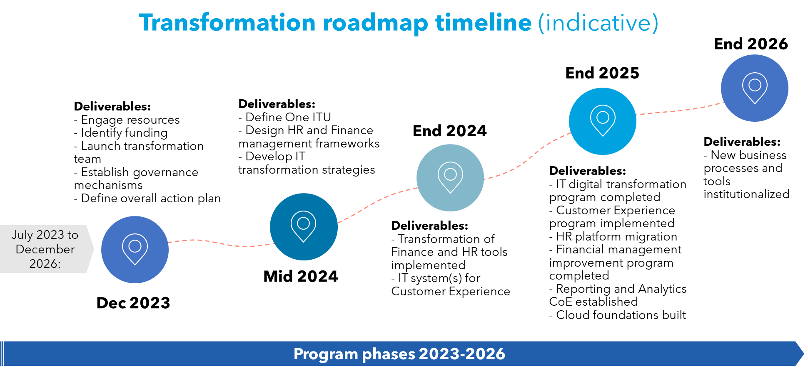

Figure 3. Transformation roadmap timeline

Annex 1

Proposed structure of the Transformation Office

**Composition of the team**

The transformation team plays a critical role in driving business process re-engineering and transformation initiatives. Their functions include activities that facilitate the successful planning, execution, and monitoring of transformation efforts.

The key responsibilities and functions of the Transformation Office are outlined in Section 3 of this document.

The composition of a transformation team can vary depending on the size and complexity, as well as the specific objectives of the transformation initiative. Having consulted with agencies across the UN, the following positions are being considered to be part of the Transformation Office:

Chief Transformation Officer (D1)

The Chief of the Transformation Office will be responsible for overseeing the entire transformation initiative. They will provide strategic direction, coordinate activities, and ensure the successful execution of the transformation plan. Their role includes stakeholder management, resource allocation, and overall transformation programme management.

Project Manager (P4/P5)

The Project Manager will support the Chief Transformation Officer in day-to-day project coordination. They are responsible for project planning, scheduling, and monitoring progress. The Project Manager ensures that tasks are executed according to the project plan, and they coordinate with different team members and stakeholders to ensure timely completion of deliverables.

Process Analyst/Business Analyst (P3/P4)

The Process Analyst or Business Analyst plays a crucial role in assessing and redesigning business processes. They conduct process analysis, gather requirements, and document current and future-state processes. They collaborate with stakeholders to identify process improvement opportunities, define key performance indicators, and provide insights for process optimization.

Data Analyst (P2/P3)

A Data Analyst is responsible for collecting, analyzing, and interpreting data to inform decision-making and measure the impact of the transformation. They ensure data integrity, develop reporting frameworks, and provide insights on key performance indicators. They work closely with the team to identify data-driven improvement opportunities and support evidence-based decision-making.

Other profiles from within the organization to be involved in the project include the specialists in IT, Finance and budget, and HR, the Change Management lead, as well as the Subject Matter Experts from the different areas of the organization.

Annex 2

Job Description of the Chief Transformation Officer

**Chief Transformation Officer (D1) (limited term 2+2 years)**

**Organizational Context**

The Chief Transformation Officer (CTO) will be responsible for providing leadership, strategic direction, and overall management of the Transformation Office. The CTO will be overseeing a comprehensive transformation strategy, encompassing both business and digital realms, over a period of four years.

The CTO will play a vital role in shaping the future of ITU by driving forward its modernization efforts and fostering an environment of innovation and efficiency. This ambitious project aims to revolutionize the agency's operations, optimize processes, and leverage cutting-edge digital technologies to enhance service delivery and impact.

**Duties and Responsibilities**

The Chief Transformation Officer will:

1. Develop and implement a holistic transformation strategy aligned with ITU's mission and goals, focusing on both business and digital transformation.
2. Lead change management efforts by effectively communicating the vision, goals, and benefits of the transformation initiative to stakeholders at all levels, ensuring buy-in and fostering a culture of transformation.
3. Oversee all aspects of the transformation project, including planning, budgeting, resource allocation, and timeline management, to ensure successful and timely completion of deliverables.
4. Collaborate with diverse internal and external stakeholders, such as SG and DSG and other elected officials (Coordination Committee), Chiefs of Depts (Management Coordination Group) across ITU and external vendors, to foster collaboration, gather input, and ensure alignment with transformation objectives.
5. Lead the reengineering or redesigning existing processes to improve efficiency, eliminate redundancies, and increase agility. This will involve adopting new technologies, automating manual tasks, or optimizing workflow management. In addition, identify opportunities to streamline processes, eliminate redundancies, and enhance operational efficiency through the use of digital tools and technologies.
6. Drive the adoption and integration of digital technologies, such as AI, data analytics, and cloud computing, to transform how ITU operates and delivers services.
7. Ensure that the transformation puts the end user at the center by enhancing their experience through personalized interactions, seamless omni-channel engagement, and convenient self-service options. It involves leveraging data and digital tools to understand customer preferences, anticipate needs, and deliver tailored products, services, and experiences.
8. Ensure Operational Efficiency, by streamlining and automating processes, reducing manual effort, eliminating bottlenecks, and improving operational efficiency. This may involve implementing technologies such as robotic process automation (RPA), artificial intelligence (AI), and machine learning (ML) to optimize workflows, enhance productivity, and drive cost savings.
9. Ensure that transformation leverages data as a strategic asset. It involves collecting, analyzing, and deriving insights from large volumes of data to inform decision-making, identify trends, and gain a deeper understanding of customer behavior and market dynamics. Data-driven insights enable ITU to make better informed, proactive, and agile business decisions.
10. Establish metrics and key performance indicators (KPIs) to monitor the progress and impact of the transformation initiative, and regularly report on achievements to senior management and relevant stakeholders.
11. Build and lead a high-performing team, providing guidance, mentorship, and professional development opportunities to maximize individual and collective contributions.

**Requirements**

Education:

* Advanced university degree in business administration, management, or a related field.
* Additional certifications in project management, change management, or digital transformation are highly desirable.

Experience:

At least fifteen years of progressively responsible experience in successfully leading large-scale business transformation initiatives, with at least five years at a senior management level in an international environment or in the private sector. Extensive experience required in digital transformation, including implementing innovative technologies and driving organizational change through digital initiatives. Strong leadership and strategic thinking abilities required, with the capacity to inspire and mobilize teams and stakeholders towards a shared vision. Excellent communication and stakeholder management skills, with the ability to build effective relationships across diverse stakeholders at all levels. Exceptional project management skills, including the ability to set priorities, manage budgets, and navigate complex organizational structures. Demonstrated analytical and problem-solving skills, with the ability to identify opportunities, mitigate risks, and drive data-informed decision-making. A Doctorate in a related field can be considered as a substitute for three years of working experience. Proven experience at a senior level is required, including in staff supervision. Experience within an organization of the UN Common System, familiarity with ITU activities and structure would be an advantage.

Languages:

Knowledge of one of the six official languages of the Union (Arabic, Chinese, English, French, Russian, Spanish) at advanced level and knowledge of a second official language at intermediate level. Knowledge of a third official language would be an advantage. (Under the provisions of Resolution No. 626 of the Council, a relaxation of the language requirements may be authorized in the case of candidates from developing countries: when candidates from such countries possess a thorough knowledge of one of the official languages of the Union, their applications may be taken into consideration).

______________

1. The cost of the position of the Chief Transformation Officer (D1) is 283 K CHF per year, while the estimated cost for the proposed transformation team, including the Chief Transformation Officer, ranges from 807 K to 910 K CHF per year.
2. The Change Makers roles defined within the transformation initiative are to train ITU staff to lead change processes, encourage active engagement, and ensure collaboration across the Bureaux and General Secretariat.