Agenda item: PL 3 | Document C23/24-E
 | 16 May 2023
 | Original: English
Report by the Secretary-General
PRECISE PLACE AND EXACT DATES OF THE 2024 WORLD TELECOMMUNICATION STANDARDIZATION ASSEMBLY AND UPDATE ON PREPARATIONS
Purpose
Resolution 77 (Rev. Bucharest, 2022) of the Plenipotentiary Conference resolves that the World Telecommunication Standardization Assembly (WTSA) shall be held in the last quarter of 2024 in India.
Following the invitation received from the Government of India to hold WTSA-24 at the International Exhibition cum Convention Centre, Pragati Maidan, New Delhi, India, from 15 to 24 October 2024, the ITU Council, pursuant to No. 42 of the ITU Convention, shall determine the precise place and exact dates of WTSA-24 with the concurrence of a majority of the Member States.
The document also reports on the status of preparations for WTSA-24 and the 2024 global standards symposium (GSS-24).
Action required by the Council
The Council is invited to note the report on the preparations for WTSA-24 and to decide on the precise place and exact dates of WTSA-24 by adopting the draft decision contained in Annex 2 to this document.
Relevant link(s) with the Strategic Plan
Convening Platform.
Financial implications
CHF 639 000.
__________________
References
CS No. 114, CV Nos. 23, 24 and 42, Chapter I of the General Rules of Conferences, Assemblies and Meetings of the Union, Resolution 77 (Rev. Bucharest, 2022) and Resolution 111 (Rev. Busan, 2014) of the Plenipotentiary Conference, https://www.itu.int/wtsa/2024/

- Venue and date
1.1 No. 114 of the ITU Constitution stipulates that world telecommunication standardization assemblies (WTSAs) shall be convened every four years; and Nos. 23 and 24 of the ITU Convention stipulate that one WTSA shall normally be convened within the period between two plenipotentiary conferences.
1.2 Resolution 77 (Rev. Bucharest, 2022) of the Plenipotentiary Conference resolves that WTSA shall be held in the last quarter of 2024 in India.
1.3 Resolution 111 (Rev. Busan, 2014) of the Plenipotentiary Conference resolves that the Union and its Member States should make every effort, as far as practicable, in order that the planned period of any ITU conference or assembly not be scheduled during a period which is considered a major religious period by a Member State.
1.4 No. 42 of the Convention and Chapter I of the General Rules of Conferences, Assemblies and Meetings of the Union require that, in the absence of a decision by the Plenipotentiary Conference, the precise place and exact dates of a WTSA be approved by the ITU Council with the concurrence of a majority of the Member States.
1.5 The ITU Secretary-General has received an invitation from the Government of India for the hosting of WTSA-24 in India with the proposed dates of 15 to 24 October 2024, at the International Exhibition cum Convention Centre, Pragati Maidan, New Delhi, India (see Annex 1).
1.6 TSB in coordination with the ITU Conferences and Publications Department plans to make an on-site visit to the International Exhibition cum Convention Centre, New Delhi, India, for the further logistical planning of the assembly.
1.7 The 2024 global standards symposium (GSS-24) is planned to take place at the same venue on 14 October 2024, the day prior to the start of WTSA-24.
2. WTSA-24 regional preparatory meetings
2.1 Regional preparatory meetings are being organized by the regional telecommunication organizations in coordination with TSB. The latest updates on the calendar of all planned regional preparatory meetings are also available on this website.
2.2 Two interregional coordination meetings are foreseen prior to each of the last two Telecommunication Standardization Advisory Group (TSAG) meetings in 2024 to facilitate discussions among the regions, with the dates to be determined.
2.3 Information on interregional coordination will be made available on the WTSA-24 website.
3. TSAG and ITU-T study group preparations for WTSA
3.1 All ITU-T study groups have begun their preparations for WTSA-24.
3.2 TSAG has established and is operating two rapporteur groups that are specifically tasked with preparations for WTSA-24: the Rapporteur Group on ITU-T work programme and study group restructuring (RG-WPR); and the Rapporteur Group on WTSA preparations and review of resolutions (RG-WTSA).
3.3 TSAG has planned two more meetings and a series of rapporteur group meetings to advance preparations for WTSA-24.
4. Deadline for submission of proposals for WTSA-24
4.1 Delegations are invited to submit contributions to WTSA-24 by Monday, 16 September, i.e. four weeks prior to the opening of WTSA-24, bearing in mind that, pursuant to Resolution 165 (Rev. Dubai, 2018) of the Plenipotentiary Conference, there is a firm submission deadline of 21 calendar days prior to the opening of WTSA-24, i.e. Monday, 23 September 2024 at 2359 hours Geneva time.,
5. Fellowships
5.1 Fellowships per eligible Member State for WTSA-24 will be awarded based on available funding to facilitate participation from developing countries. An application must be authorized by the relevant administration of the ITU Member State concerned.
6. WTSA website
6.1 The WTSA-24 website https://www.itu.int/wtsa/2024/ will contain all the above information.
7. Proposal
7.1 The Council is invited to consider the invitation of the Government of India to hold WTSA-24 from 15 to 24 October 2024, at the International Exhibition cum Convention Centre, Pragati Maidan, New Delhi, India, and to decide on the precise place and exact dates of WTSA-24 by adopting the draft decision contained in Annex 2.
Following a decision by the Council, the Secretary-General will carry out a consultation with all Member States on the precise place and exact dates of WTSA-24.

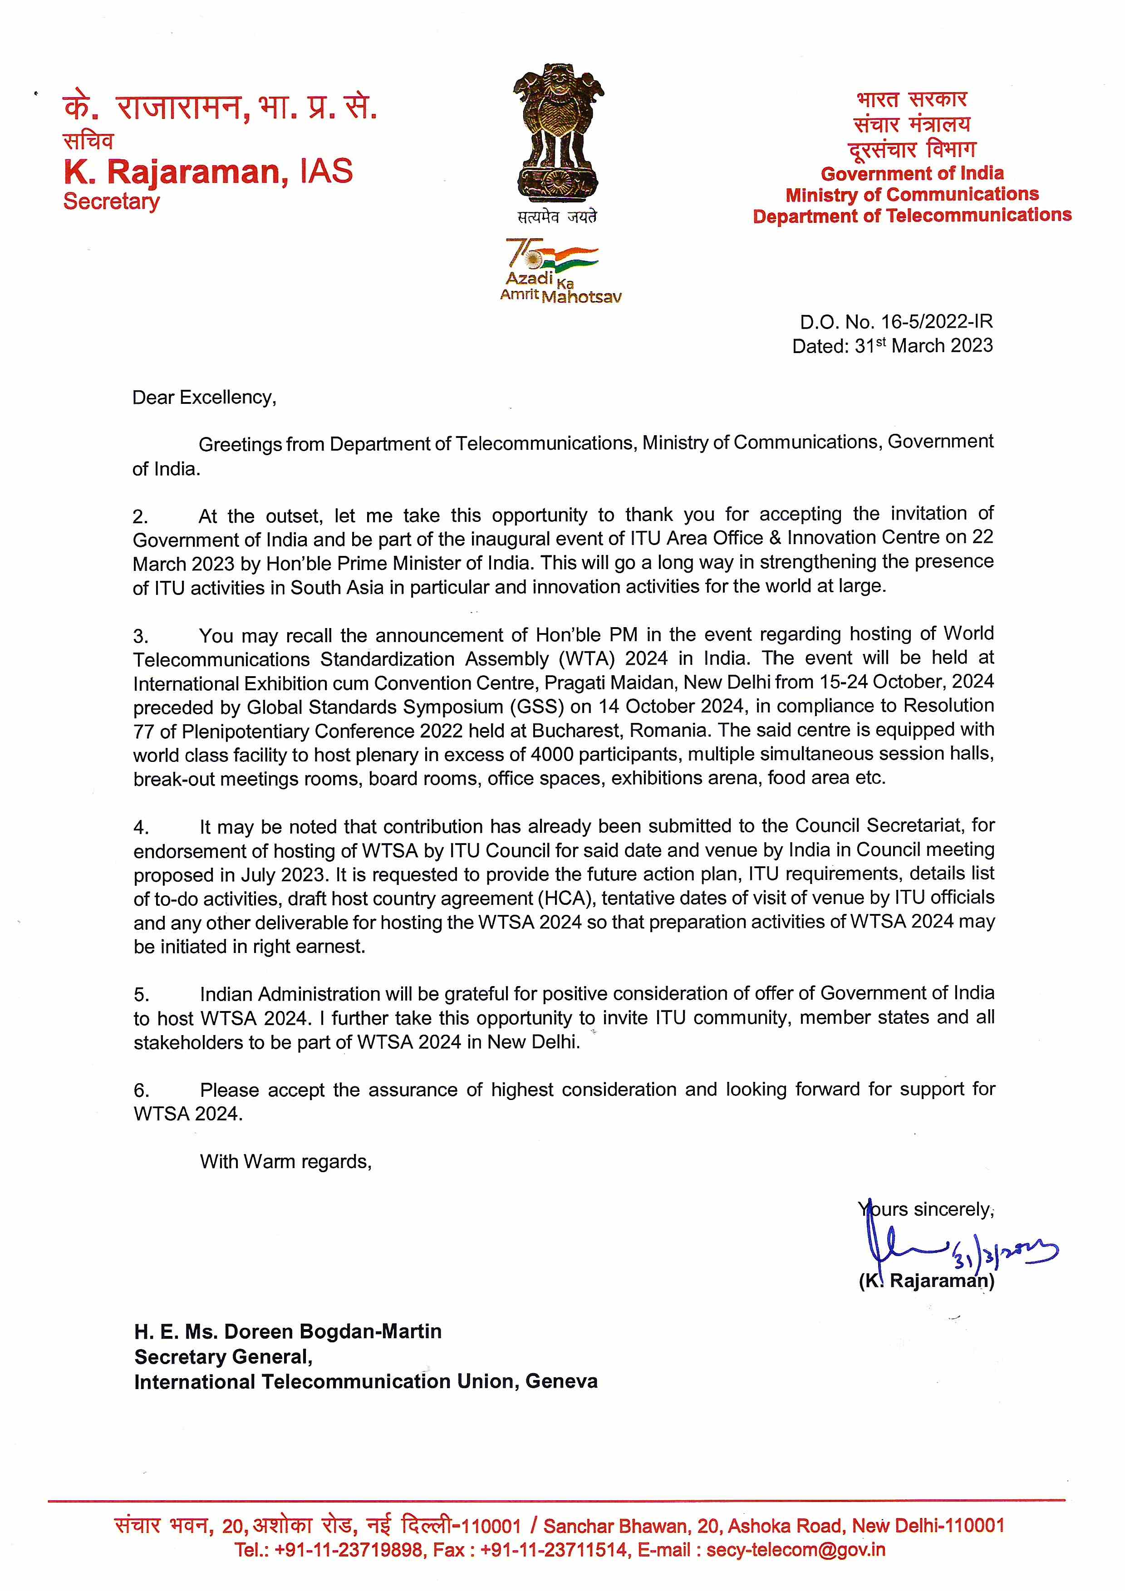
ANNEX 1
Invitation from the Government of India
to host the 2024 world telecommunication standardization assembly

ANNEX 2
DRAFT DECISION [...]
Convening of the 2024 world telecommunication standardization assembly
The ITU Council,
noting
that the 2024 world telecommunication standardization assembly (WTSA-24) is scheduled to be held in India the last quarter of 2024 in accordance with Resolution 77 (Rev. Bucharest, 2022) of the Plenipotentiary Conference, on scheduling and duration of conferences, forums, assemblies and Council sessions of the Union (2023-2027),
decides
that, subject to the concurrence of a majority of the Member States of the Union, WTSA-24 shall take place in the International Exhibition cum Convention Centre, Pragati Maidan, New Delhi, India, from 15 to 24 October 2024,
instructs the Secretary-General
to carry out a consultation with all Member States on the precise place and exact dates of WTSA-24.
___________________

Resolution 165 (Rev. Dubai, 2018) of the Plenipotentiary Conference, on deadlines for the submission of proposals and procedures for the registration of participants for conferences and assemblies of the Union, resolves to establish a firm submission deadline for all contributions, with the exception of the deadlines outlined in recognizing a) and b) above, of no later than 21 calendar days before the opening of conferences and assemblies of the Union, including plenipotentiary conferences, so as to ensure timely translation and their thorough consideration by delegations. (Emphasis added.)
WTSA-20 Resolution 1 (Rev. Geneva, 2022): 6.1 Contributions should be submitted not later than one month before the opening of WTSA, and at any event the submission deadline for all contributions to WTSA, in accordance with Resolution165 (Rev. Dubai, 2018) of the Plenipotentiary Conference, shall be not later than 21 calendar days before the opening of WTSA in order to allow for their timely translation and thorough consideration by delegations. TSB shall immediately publish all contributions submitted to WTSA in their original language(s) on the WTSA website, even before their translation into the other official languages of the Union. (Emphasis added.)
These include least developed countries, small island developing states, landlocked developing countries and countries with economies in transition.

