|  |  |
| --- | --- |
| **Agenda item: PL 2** | **Document C23/8-E** |
| **19 May 2023** |
| **Original: English** |
|  |  |
| Report by the Secretary-General | |
| MEASURING INFORMATION AND COMMUNICATION TECHNOLOGIES TO BUILD AN INTEGRATING AND INCLUSIVE INFORMATION SOCIETY | |
| **Purpose**  The purpose of this report is to update the ITU Council on the status of the implementation of Resolution 131 (Rev. Bucharest, 2022) of the Plenipotentiary Conference, on measuring information and communication technologies to build an integrating and inclusive information society.  **Action required by the Council**  The Council is invited **to note** this document.  **Relevant link(s) with the Strategic Plan**  Provision of data and statistics.  **Financial implications**  None.  __________________  **References**  [*Resolution 131*](https://www.itu.int/en/council/Documents/basic-texts-2023/RES-131-E.pdf) *(Rev. Bucharest, 2022) of the Plenipotentiary Conference* | |

1 Resolution 131 (Rev. Bucharest, 2022) of the Plenipotentiary Conference dictates, *inter alia*, the main steps of the process for developing a new ICT Development Index (IDI) (Annex 1) and the main features of the future index (Annex 2).

2 Member States were informed of this process and timeline via [Circular letter BDT/DKH/IDA/005](https://www.itu.int/en/ITU-D/Statistics/Documents/IDI/D22-BDT-CIR-0005PDF-E.pdf) of 9 March 2023.

3 The process is designed to be transparent and inclusive, providing opportunities for experts and Member States to participate in the development of the IDI, and to ensure a statistically sound and conceptually relevant tool. The process began on 21 February 2023 with a communication to all Members of the Expert Group on Telecommunication/ICT Indicators (EGTI) and of the Expert Group on ICT Household Indicators (EGH), inviting them to comment on a “[zero draft](https://staging.itu.int/en/ITU-D/Statistics/Documents/IDI/IDI2023ZeroDraftDocument_February2023.pdf)” document prepared by the secretariat to facilitate the process, as per *instructs the Director of the Telecommunication Development Bureau* 8 of Resolution 131 (Rev. Bucharest, 2022).

4 The consultations are taking place on a [discussion forum](https://www.itu.int/itu-d/meetings/idi/forum/idi-forum/) dedicated to the IDI, as per EGTI/EGH working methods. Following this initial consultation, the methodology will be revised. In April-May 2023, Member States will be invited to comment. Consistent with the urgency imposed by Resolution 131 (Rev. Bucharest, 2022), the objective is to launch the IDI in 2023, which requires a very compressed timeline. The secretariat has ensured that each consultation last at least four weeks. Following each consultation, the secretariat shall compile and publish all the received comments and its responses.

5 The BDT Director will convene a [virtual joint meeting](https://www.itu.int/itu-d/meetings/statistics/joint-egti-egh-meeting-on-idi-2023) of EGTI and EGH from 13 to 15 June 2023, with a view to resolving any contentious issues and seeking consensus, as per *instructs the Director of the Telecommunication Development Bureau* 9 of Resolution 131 (Rev. Bucharest, 2022). Following this meeting, the secretariat shall revise and finalize the methodology.

6 The process will conclude in August with a final consultation of Member States during which they will be asked: 1) if they approve the index methodology; and 2) if they wish to opt out of the 2023 edition of the IDI, in which case, they will be able to join in subsequent editions. The methodology will be adopted if 70 per cent of responding Member States approve it, as per Resolution 131 (Rev. Bucharest, 2022).

7 A [public webpage](https://www.itu.int/en/ITU-D/Statistics/Pages/IDI/default.aspx) has been launched to provide basic information about the process.

***Annexes: 2***

Annex 1

Main implications of Resolution 131 (Rev. Bucharest, 2022) of the Plenipotentiary Conference for the development of the ICT Development Index and its features

Resolution 131 (Rev. Bucharest, 2022) of the Plenipotentiary Conference describes the following main steps of the process for developing the ICT Development Index (IDI) methodology and some key features of the future index, with the relevant paragraphs of the resolution appearing in brackets:

* ITU shall publish a new IDI “urgently” (*instructs the Director of the Telecommunication Development Bureau* 1);
* The new IDI shall be published without ranking (*resolves* 3);
* ITU should establish a valid structure and methodology for the IDI, working through the Expert Group on Telecommunication/ICT Indicators (EGTI)/the Expert Group on ICT Household Indicators (EGH), and through formal consultations with Member States (*resolves* 3);
* The BDT Director shall facilitate the work of EGTI/EGH (*instructs the Director of the Telecommunication Development Bureau* 8);
* The proposed structure and methodology shall be submitted to Member States for approval and considered adopted if 70 per cent or more of the replies indicate approval (*resolves* 3);
* If adopted, the IDI structure and methodology shall be valid for four editions, namely 2023-2026 (*resolves* 4);
* In each edition, Member States shall have the option to decline to participate (*resolves* 5);
* A meeting of EGTI/EGH shall be convened following a formal consultation of Member States with a view to resolving any contentious issues and seeking consensus (*instructs the Director of the Telecommunication Development Bureau* 9);
* The integrity of all ITU's statistical work shall be preserved, in strict adherence to United Nations principles on good statistics (*instructs the Director of the Telecommunication Development Bureau* 12).

Annex 2

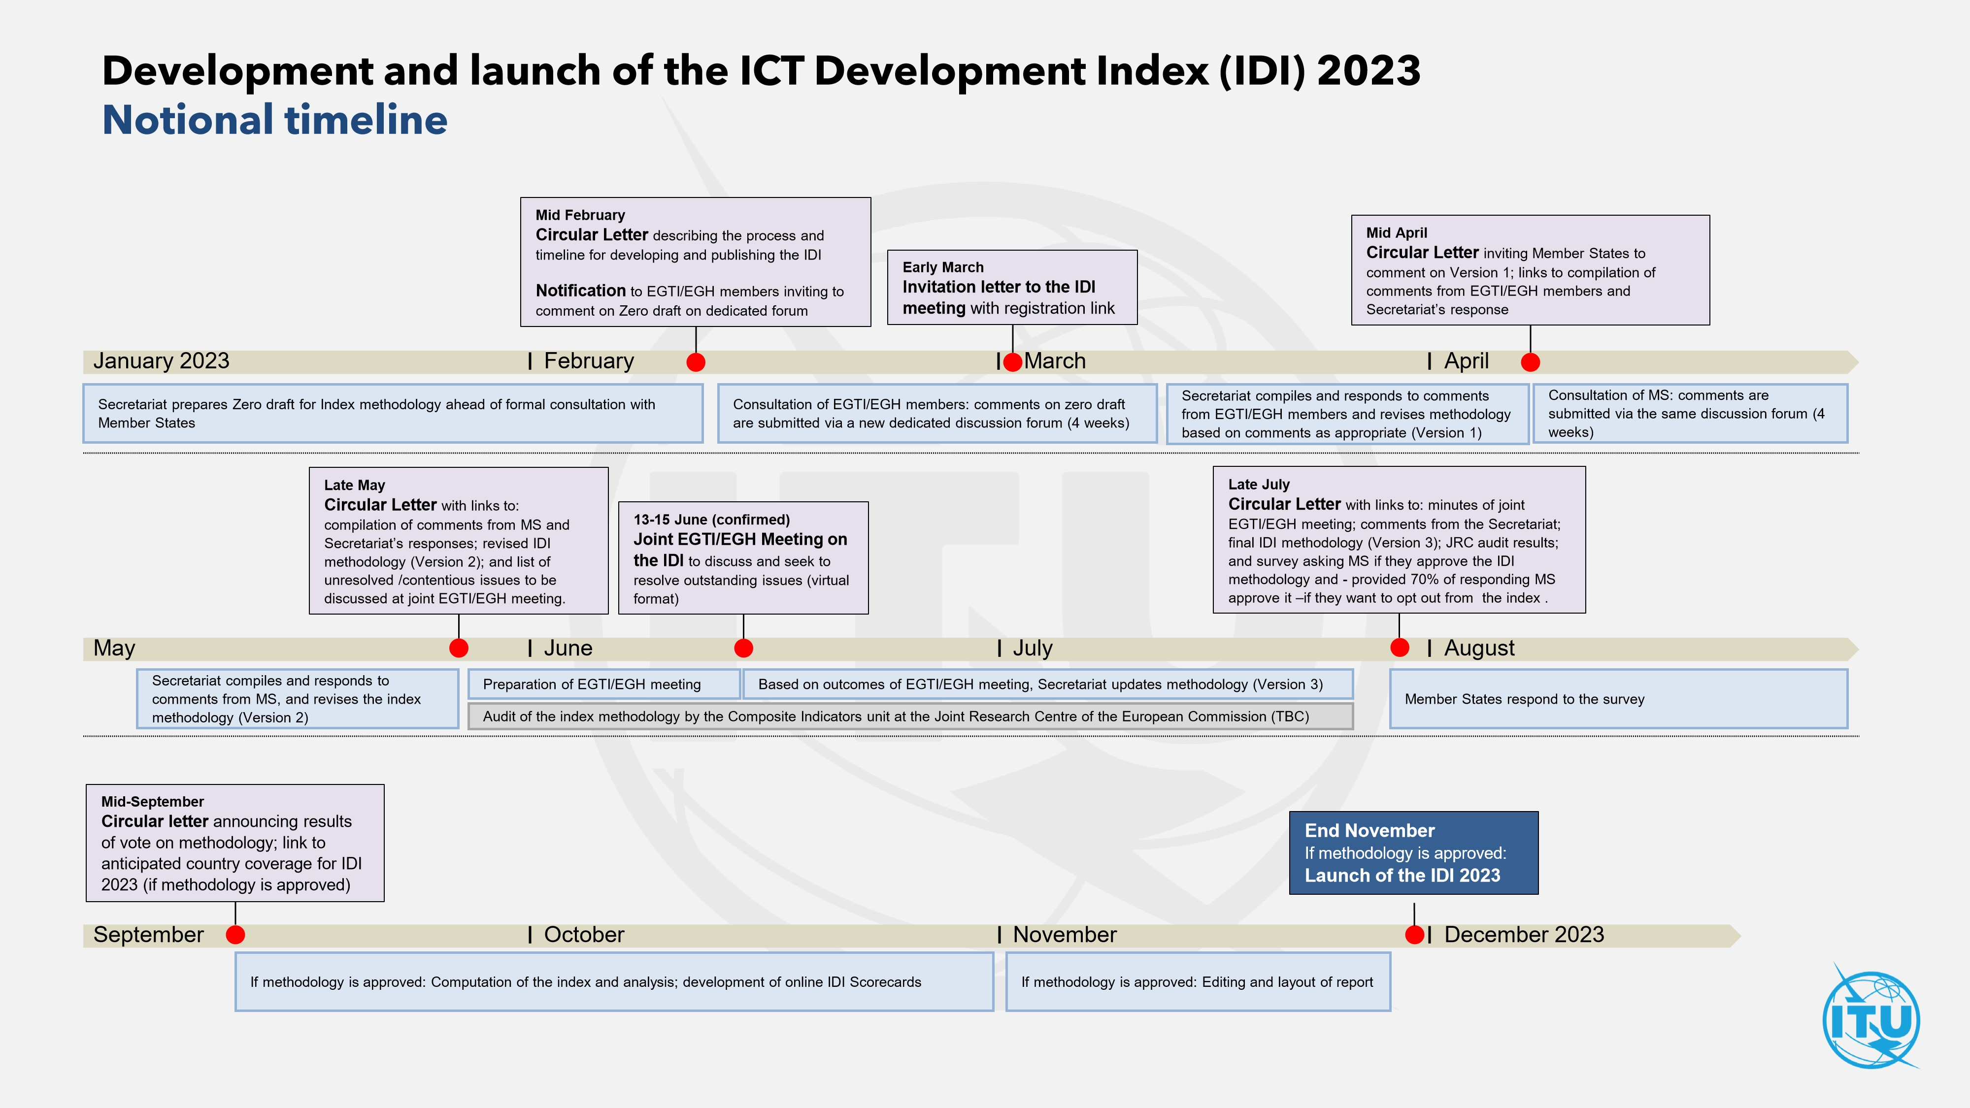Development and launch of the ICT Development Index (IDI) 2023  
Notional timeline

____________________