|  |  |
| --- | --- |
| **Agenda item: PL 2** | **Document C23/6-E** |
| **11 June 2023** |
| **Original: English** |
|  |  |
| Report by the Secretary-General | |
| 25 YEARS OF ITU’S WORK PROGRAMME ON GENDER EQUALITY | |
| **Purpose**  In the context of the 25th anniversary of the initial adoption of Resolution 70 by the Plenipotentiary Conference (Minneapolis, 1998), marking the formal beginning of ITU’s work on gender, this document summarizes ITU’s work programme to advance gender equality, reviewing progress to date and presenting requirements for more sustained impact in the coming years.  Note that the report on Resolution 70 (Rev. Bucharest, 2022) of the Plenipotentiary Conference has been incorporated into document C23/35, containing the report on the activities of the Union, under section 4.6 on digital inclusion.  **Action required by the Council**  The ITU Council is invited **to note** the reportand **to provide any guidance** on the way forward as may be appropriate.  __________________  **References**  [*Resolution 70*](https://www.itu.int/en/council/Documents/basic-texts-2023/RES-070-E.pdf) *(Rev. Bucharest, 2022) of the Plenipotentiary Conference; Council Document* [*C23/INF/2*](https://www.itu.int/md/S23-CL-INF-0002/en)*.* | |

# 25 years of ITU’s work programme on gender equality

**1 Background**

ITU’s mandate includes extending the benefits of new technologies to all the world's inhabitants.[1] Today, where digitalization has permeated nearly every aspect of society, it is increasingly evident that ICTs are no longer a luxury and have become a fundamental necessity. Women and girls make up roughly half the world’s population yet face consistent disparities in access to and use of digital technologies. There is immense potential to improve social and economic outcomes for women, yet the gender digital divide disproportionately limits women’s and girls’ full participation in the social, economic and cultural aspects of modern society.

Twenty-five years ago, the Plenipotentiary Conference (Minneapolis, 1998) (PP-98) first adopted Resolution 70, on inclusion of gender perspective in the work of ITU, effectively formalizing a commitment to include a gender perspective in ITU’s work and activities. The commitment is reinforced across the Union, with resolutions in the Telecommunication Development and Standardization Sectors and a declaration in the Radiocommunication Sector. Their objectives are to reduce inequalities and promote equal benefit from ICTs and to ensure women’s equal contribution to the work of the organization and the inclusion of a gender perspective in all ITU policies, work programmes and information dissemination activities.

In the context of the 25th anniversary of ITU’s commitment to gender, this document presents a snapshot of ITU’s work programme on gender. It probes beyond the positives and pulls out important realities on actual progress and impact. The ITU Council is invited to reflect on current initiatives, persistent gender gaps and suggestions for a more strategic approach and way forward.

**2** **External highlights**

**2.1 Girls in ICT Day**

Launched in 2011, [International Girls in ICT Day](https://www.itu.int/women-and-girls/girls-in-ict/) is an ITU flagship event aimed at empowering girls and young women to pursue careers in the ICT sector. Celebrated annually on the fourth Thursday of April, it is a global initiative offering workshops, competitions and mentoring sessions for exploring diverse opportunities. International Girls in ICT Day is now an official [United Nations international day](https://www.un.org/en/observances/list-days-weeks).

**2.2 EQUALS in Tech**

ITU co-founded the [EQUALS](http://www.equalsintech.org) initiative in 2016 to promote women's access to ICTs, digital skills and leadership. EQUALS in Tech is a dedicated group of partners that works with a variety of stakeholders worldwide to promote gender balance in the technology sector. The annual [EQUALS in Tech Awards](https://www.equalsintech.org/awards) recognize individuals and organizations working towards equal internet access, digital skills and opportunities for girls and women in tech.

**2.3 Girls Can Code**

Girls Can Code is an ITU initiative focused on coding workshops for girls to promote the development of digital skills activities and to provide support to beneficiary countries to review/adopt digital inclusion policies and strategies. The [African Girls Can Code](https://www.itu.int/en/ITU-D/Regional-Presence/Africa/Pages/African-Girls-Can-Code-Initiative-%28AGCCI%29-II.aspx) and [American Girls Can Code](https://www.youtube.com/watch?v=gkYUlpgasoo) initiatives both aim to promote digital skills development for girls and young women in the respective regions.

**2.4 Women in Cyber**

ITU's [Women in Cyber Mentorship Programme](https://www.itu.int/en/ITU-D/Cybersecurity/Pages/Women-in-Cyber/Women-in-Cyber-Mentorship-Programme.aspx) addresses the gender gap in cybersecurity by connecting talented women with mentors and leaders in the industry. The programme offers a comprehensive approach through inspirational webinars, technical and soft-skills training courses and mentorship.

**2.5 World Summit on the Information Society (WSIS)**

ITU has been working to integrate gender equality perspectives in [WSIS](http://www.wsis.org/) strategies. WSIS Forum now features a special track on ICTs and gender mainstreaming. There is the WSIS Stocktaking Repository of Women in Technology and a WSIS Gender Trendsetters initiative to promote the repository.

**2.6 Tech as a driver of women's economic opportunity**

ITU partnered with the Enhanced Integrated Framework (EIF) and the United Nations Office for Project Services (UNOPS) to improve the digital ecosystem for women in the least developed countries of Burundi, Ethiopia and Haiti. The [project](https://www.itu.int/en/ITU-D/Digital-Inclusion/Pages/EIF-Regional-Project-.aspx) evaluates the gender responsiveness of policies, strategies and regulations related to the digital economy and focuses on capacity building for female entrepreneurs.

**2.7 International Gender Champions**

The ITU Secretary-General is a member of the [International Gender Champions](https://genderchampions.com/commitment?CommitmentSearch%5bchampion_ids%5d%5b%5d=230&CommitmentSearch%5bcategory_id%5d=&CommitmentSearch%5bchapter_id%5d=#search-form) (IGC), a network of top-level decision-makers who lead by example with concrete actions for genuine change both in programming and in organizational culture.

**3** **Institutional gender mainstreaming**

**3.1 UN-SWAP**

The United Nations System-wide Action Plan on Gender Equality and the Empowerment of Women ([UN-SWAP](https://www.unwomen.org/en/how-we-work/un-system-coordination/promoting-un-accountability)) is the accountability framework applicable to all United Nations entities to measure, monitor and advance towards a common set of gender equality standards. ITU has been submitting reports since the beginning of UN-SWAP in 2013, with a focus on, *inter alia*, a number of the areas below.

**3.2 Data and the ITU Gender Dashboard**

ITU collects and disseminates information on individuals accessing and using ICTs, disaggregated by gender. The gender digital divide is narrowing globally, but large gaps remain in poorer countries. Information on women’s participation in ITU events, women in ITU staffing, as well as UN-SWAP annual reports, are also available on the [ITU Gender Dashboard](http://www.itu.int/genderdashboard).

**3.3** **Network of Women**

ITU works to increase the participation of women in ITU events, through various Network of Women initiatives: [Network of Women for WRC](https://www.itu.int/now4wrc23/), [Network of Women for WTDC](https://www.itu.int/en/ITU-D/Conferences/WTDC/WTDC21/NoW/Pages/default.aspx), and Network of Women in ITU-T, formerly known as the ITU Women in Standardization Expert Group (WISE). ITU also collaborates with a number of external networks, such as Women in Aerospace (WIA), A+ Alliance and Girls in Quantum. A new Network of Women Digital Ministers, led by the Secretary-General, is being developed, as instructed by Resolution 70 (Rev. Bucharest, 2022).[2]

**3.4** **Equal representation of women**

ITU tracks [representation of women in ITU staffing and committees](https://app.powerbi.com/view?r=eyJrIjoiOWJmNjg1MTktOWM4NC00ZmRmLWFiZTYtYWY3NGNkOGI0MmY4IiwidCI6IjIzZTQ2NGQ3LTA0ZTYtNGI4Ny05MTNjLTI0YmQ4OTIxOWZkMyIsImMiOjl9) and reports to the United Nations-wide Gender Parity Strategy. Women are under-represented in leadership positions and over-represented in General Services and P1 and P2 junior Professional levels. Efforts to address this have focused primarily on recruitment and organizational culture to attract and retain women staff so as to reflect the global constituency that ITU serves.

**3.5** **Organizational culture**

Building an enabling environment is crucial to attracting and retaining top talent, particularly for women candidates highly targeted in the tech sector. An organizational culture that fully supports gender equality has involved strengthening ethics policies to prevent discrimination and zero tolerance of harassment. Member States are committed to ITU as a leading organization in the implementation of gender-equality values and principles.[3] An important step in this direction is ITU’s new parental-leave policy, which implements the United Nations-wide parental-leave framework and allows for a more even distribution of responsibilities between both parents.

**4 Results**

Over the past 25 years, gender issues have become more prominent within ITU's work and the number of efforts to raise awareness and boost the participation of women and girls in the ICT sector has visibly increased. Still, gender equality in the ICT sector remains an ongoing challenge. Data disappointingly reveal that efforts have yielded only limited results and, in some cases, regressions.

While there has been some progress in bridging the gender digital divide globally, developing countries are sliding backwards. The gender gap in Internet use has increased by 20 million people and women non-users now outnumber male non-users by 18 per cent, up from 11 per cent in 2019. Mobile phone ownership remains virtually unchanged from 2019, with women about 12 per cent less likely to own mobile phones than men are. Women not owning phones outnumber men by 39 per cent in 2022.

In terms of participation in ITU’s work, the 2022 Plenipotentiary Conference (PP-22) had 34 per cent female participation, falling short of the 35 per cent target. This reflects improvement from 29 per cent at PP-18 and 24 per cent at PP-14, yet the rate of improvement is dismal, at 1.24 per cent per year. Physical participation in sessions of the Council has similar representation and year-on-year improvement: 36 per cent in 2022, 35 per cent in 2019, 32 per cent in 2018, 28 per cent in 2017, 29 per cent in 2016, 28  per cent in 2015, 27  per cent in 2014 and 28 per cent in 2013. The opening up of the sessions to remote participation during the COVID-19 pandemic prompted an overall 47 per cent participation of women in the 2022 session of the Council. The 2022 World Telecommunication Development Conference had 34 per cent physical female participation, and 36 per cent overall when also including remote participants. The 2020 World Telecommunication Standardization Assembly had 30 per cent physical female participation, and 32 per cent when including remote participants. The 2019 World Radiocommunication Conference, when remote participation was not possible, had 18 per cent female participation.

There are only four women in D1-level positions. This is the most significant shift with women now occupying 21 per cent of D1 posts, but the evolution is not satisfactory, as women occupy 43 per cent of D1 posts system-wide on average. In the previous 10-year period from 2008 to 2017, representation of women in posts in the Professional and higher categories advanced from 33 per cent in 2008 to 36 per cent in 2013 and to 39 per cent in 2017, resulting in a 6 per cent overall increase, averaging 0.6 per cent/year.[4] This is a slight decline when considering all women in the Professional and higher categories over the five years of the United Nations-wide Gender Parity Strategy and compared to the average of the previous 10-year period.

|  |  |  |  |
| --- | --- | --- | --- |
| Professional & higher | 2018 (# female|male) | 2022 (# female|male) | % change |
| D2 | 25% (1|3) | 33.3% (1|2) | 8.3 |
| D1 | 6.3% (1|15) | 21% (4|15) | 15.9 |
| P5 | 30.3% (23|53) | 33.8% (26|52) | 3.5 |
| P4 | 39.3% (46|71) | 40.8% (58|84) | 1.5 |
| P3 | 44.5% (49|61) | 45.6% (62|73) | 1.1 |
| P2 | 50% (29|29) | 53.5% (38|32) | -3.5 |
| P1 | 83.3% (5|1) | 60% (3|2) | -23.3 |
| Total % P&H | 39.8% | 42.5% | 2.7 in 5yrs = 0.54/year |

UN-SWAP has served as an important structural framework and advocacy tool for gender mainstreaming; however, the self-reporting requires greater oversight with feedback loops and higher-level accountability to address shortfalls.

Chart of ITU's UN-SWAP performance by indicator, from 2013-2022

ITU completed its 2022 submission in February 2023 at 47 per cent compliance. The report card is expected later this year. Underpinning overall progress, ITU lacks appropriate resource allocation, as only 1 per cent of the total 2022 budget was allocated to gender equality initiatives and staff costs, mostly from extrabudgetary funds.

**5 Next steps**

In the context of digital pervasiveness, ITU plays a key role in driving gender equality efforts forward; however, there is a clear gap between the efforts and the sustainable change they aim to achieve. Bridging gender gaps necessitates sustained commitment and collaboration from all stakeholders. Improving gender equality in ITU's work requires elevated strategic coherence.

It is crucial to have an effective structure that brings together existing initiatives, fosters synergies and collaboration, facilitates fundraising conversations, and serves as a single point of entry for interested donors.

The secretariat highlights the need for a better coordinated and resourced “One ITU” strategy. Priority areas include:

1. Gender-responsive budgeting and a financial benchmark to support the work;
2. More robust, visible and digestible data and analytics;
3. Online safety, including with new technologies;
4. Capacity development for all stakeholders to better grasp the issue and its implications;
5. Focused approach on achieving transformative[5] results;
6. Improved accountability of leadership;
7. Monitoring mechanisms and effective feedback loops to track results and redress.

Member States may wish to consider allocating funds through voluntary contributions and secondments. The funds would support the gender function, tackle the priorities above and strengthen implementation of Resolution 70 (Rev. Bucharest, 2022) to ensure a gender perspective is incorporated in work programmes, human resources and management approaches of the Union.

The secretariat acknowledges with appreciation past contributions from Member States.

**Annex**: 1

Annex

**Excerpt from** [**Resolution 70**](https://www.itu.int/en/council/Documents/basic-texts-2023/RES-070-E.pdf) **(Rev. Bucharest, 2022) of the Plenipotentiary Conference addressing recruitment and promotion**

*"The Plenipotentiary Conference of the International Telecommunication Union (Bucharest, 2022)*

*…*

*instructs the Secretary-General*

…

*3 to give priority to gender parity for posts in the Professional and higher categories in ITU, particularly in senior positions, in line with the United Nations Secretary-General's gender parity strategy;*

*4 to give appropriate priority to gender parity when choosing candidates who have equal qualifications for a post, taking into account geographical distribution (No. 154 of the ITU Constitution) and gender balance;*

*5 to amend ITU recruitment procedures to ensure that, under the requirements of these procedures, as a target at least 50 per cent of the candidates who move up to the next recruitment stage are women;*

*…*

*7 to report to the next plenipotentiary conference on the results and progress made on the inclusion of a gender perspective in the work of ITU, and on the implementation of this resolution;*

*8 to make sure that each shortlist submitted to the Secretary-General for appointment includes at least one woman among the candidates;”*

**2** **Gender composition of ITU’s statutory committees**

**3** **Gender representation in the recruitment process at the Director level**

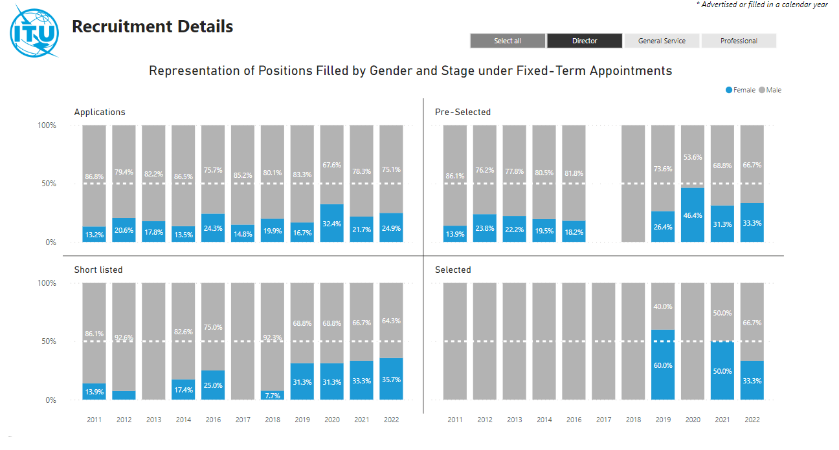

**4** **Gender representation in the recruitment process in the Professional category**

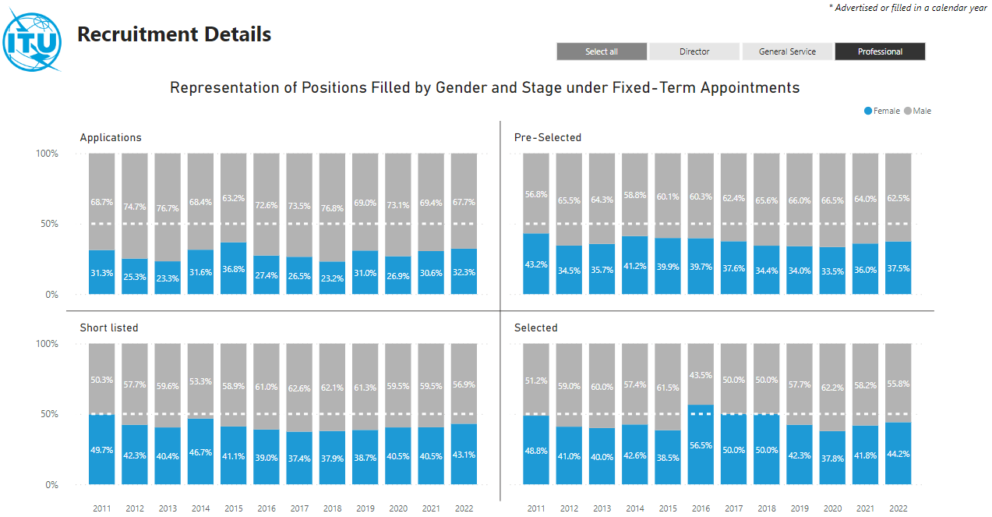

____________

1. [ITU Constitution](https://www.itu.int/en/council/Documents/basic-texts/Constitution-E.pdf), Article 1 d.
2. See *instructs the Secretary-General*, [Resolution 70](https://www.itu.int/en/council/Documents/basic-texts-2023/RES-070-E.pdf) (Rev. Bucharest, 2022).
3. [Resolution 70](https://www.itu.int/en/council/Documents/basic-texts-2023/RES-070-E.pdf) (Rev. Bucharest, 2022).
4. [Representation of women in the Professional and higher](https://app.powerbi.com/view?r=eyJrIjoiOWJmNjg1MTktOWM4NC00ZmRmLWFiZTYtYWY3NGNkOGI0MmY4IiwidCI6IjIzZTQ2NGQ3LTA0ZTYtNGI4Ny05MTNjLTI0YmQ4OTIxOWZkMyIsImMiOjl9) categories, page 4.
5. See [UNDP’s Gender Effectiveness Results Scale](http://web.undp.org/evaluation/documents/guidance/gender/GRES_English.pdf), 2015