|  |  |
| --- | --- |
| **Council Working Group for Strategic and Financial Plans 2024-2027 Third meeting – 21 and 22 February 2022** |  |
|  |  |
|  | **Document CWG-SFP-3/INF-3-E** |
| **11 February 2022** |
| **English only** |
| Note by the Secretariat | |
| Information Document on ITU’s contribution to the UN 2030 agenda for sustainable development and the wsis process | |
|  | |

|  |
| --- |
| **Summary**  This information document accompanies the Secretariat’s input for the development of the draft Strategic Plan for the Union for 2024-2027. Its objective is to present the contribution of ITU to both the Sustainable Development Goals (SDGs) and the WSIS Action Lines.  **Action required**  The document is **for information only**.  ________________  **References**  [Resolution 71 (Rev. Dubai, 2018)](https://www.itu.int/en/council/Documents/basic-texts/RES-071-E.pdf) |

# Introduction

As requested by the CWG-SFP members, ITU secretariat presents the following background information to reflect and explain the linkage between the Union’s draft strategic plan for 2024-2027 and both the UN 2030 Agenda’s Sustainable Development Goals (SDGs) and the World Summit for the Information Society Action Lines (WSIS ALs).

This information could be added to the draft Resolution 71 (Rev. Dubai, 2018) as a separate Appendix or as part of the draft Strategic Plan (Annex 1).

# ITU’s contribution to the Sustainable Development Goals

ITU, as the United Nations specialized agency for Information and Communication Technologies (ICTs), continues to support its membership and to contribute to the worldwide efforts to advance the UN 2030 Agenda for Sustainable Development and achieve its Sustainable Development Goals (SDGs).

The 17 SDGs and its 169 related targets offer a holistic vision for the UN system. The role and contribution of ICTs as essential catalysts to fast-forward achievement of the SDGs is clearly highlighted and have come into focus since the COVID-19 pandemic started. Infrastructure, connectivity, and ICTs have demonstrated their great contribution and potential to accelerate human progress, to bridge the digital divides, and to develop digital societies.

As reflected in the Figure below, ITU has a key role to play, through realizing its mains Goals of Universal Connectivity and Sustainable Digital Transformation, in contributing to achieve the SDGs.

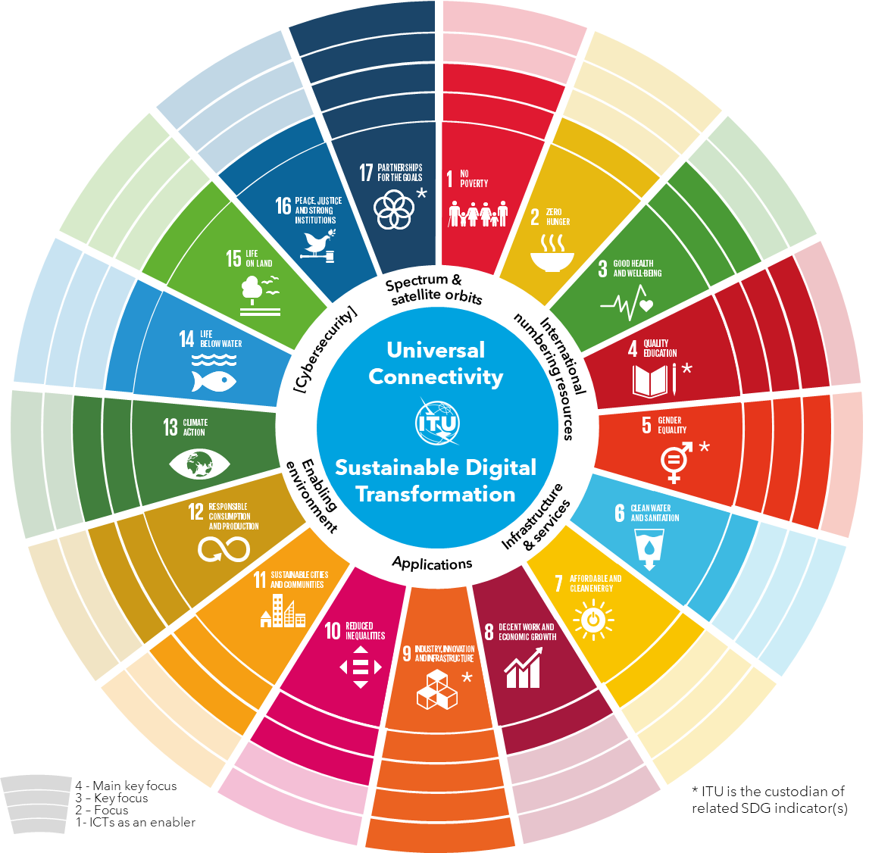

The figure presents ITU’s contribution to the achievement of the SDGs with 4 levels of involvement, presented as concentric rings. These 4 levels of involvement are in alignment with the analysis previously presented via the ITU SDG Mapping tool.

1. **ICTs as an enabler:** ITU can be seen as a contributor to all SDGs through the benefits that ICTs bring to societies and economies.
2. **Focus:** SDGs with no specific reference to ICTs but where ITU has demonstrated to have a clear impact through the benefits ICTs bring to specific sectors and activities (e.g., e-health, digital inclusion, smart cities, e-waste, climate change, etc.). These are SDGs 1, 3, 10, 11, 12 and 13.
3. **Key Focus:** SDGs where ITU has a particularly strong impact due to its initiatives and is custodian of some indicators. These are SDG 4 (Quality Education), with its Target 4b to “…*expand globally the number of scholarships,* *for enrolment in higher education, including vocational training and ICTs, technical, engineering and scientific programmes…”*; and SDG 5 (Gender Equality), Target 5.b on *“…the use of enabling technology, in particular ICTs, to promote the empowerment of women”. And* Indicator 5b.1 on the ownership of mobile phones, by sex.
4. **Main Key Focus:** SDGs where ITUmaximizes its contribution, such as SDG 9 (Industry, Innovation and Infrastructure) and SDG 17 (Partnership for the Goals). Here ITU is also custodian of related Target 9.c on *“…. ICTs to provide universal and affordable access to the Internet…”*; and its Indicator 9c.1 on coverage by a mobile network and by technology. As well as Target 17.8 to *“….enhance the use of enabling technology, in particular information and communications technology”*; and its Indicator 17.8.1 about individuals using the Internet.

# ITU’s contribution to the WSIS Process, including through the implementation of the WSIS Action Lines

ITU plays a leading facilitating role in the WSIS implementation process, in collaboration with more than 30 UN Agencies in creating an environment for just and equal information and knowledge societies. The WSIS framework can be seen as the foundation through which the ITU helps the world in leveraging ICTs to contribute to achieve the UN 2030 Agenda for Sustainable Development, noting the WSIS-SDG Matrix developed by UN Agencies.

The figure below represents ITU’s role in the WISS process, highlighting the varying role along the WSIS Action Lines:

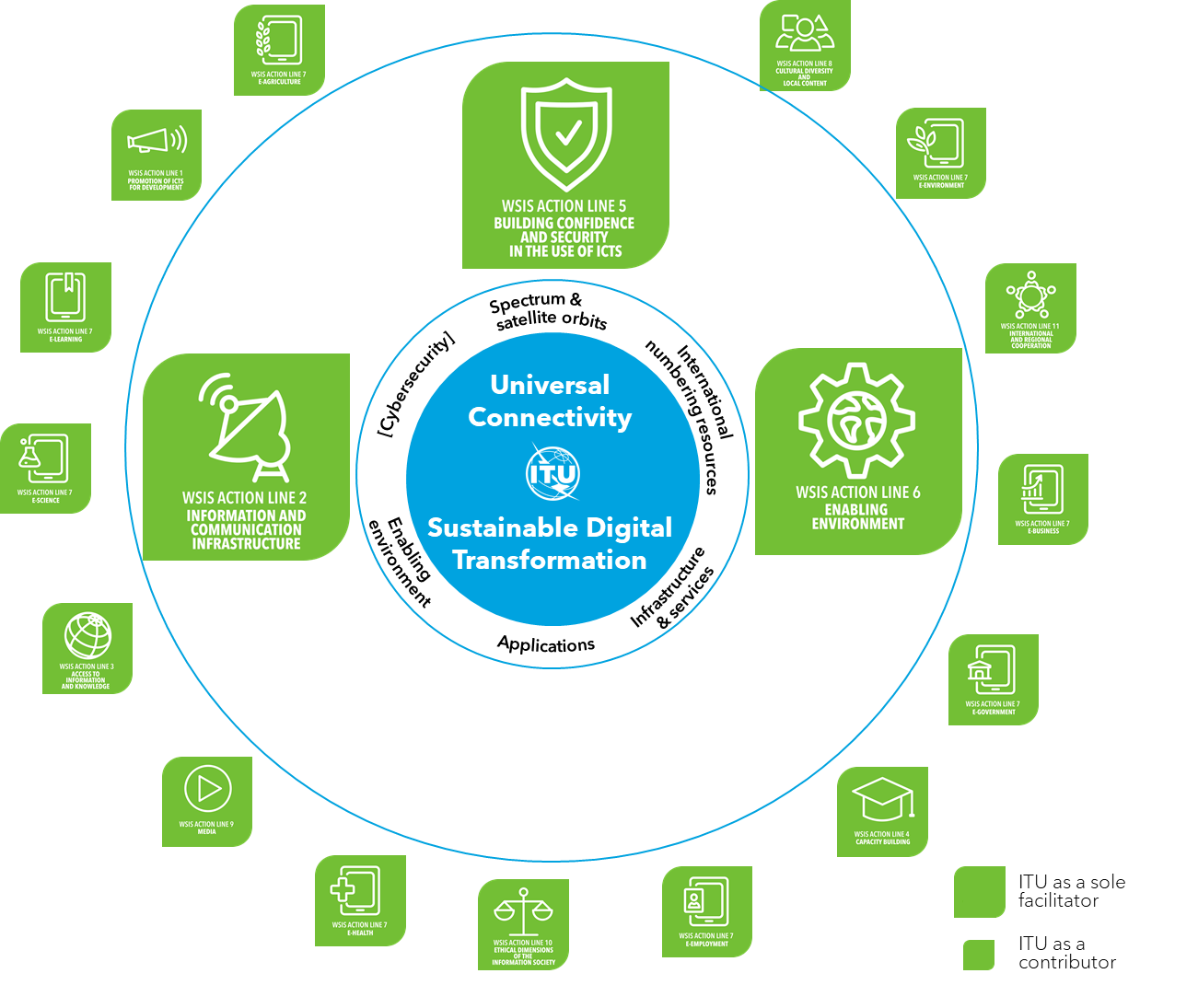

1. **ITU is the sole facilitator** for three different WSIS Action Lines: C2 (Information and communication infrastructure); C5 (Building confidence and security in the use of ICTs) and C6 (Enabling environment).
2. **ITU has also been taking the lead role** in facilitating the WSIS Action Line C4 (Capacity Building).
3. **ITU contributes** to all the remaining WSIS Action Lines that are facilitated by other WSIS stakeholders.

[**ITU’s Contribution to the Implementation of the WSIS Outcomes**](https://www.itu.int/en/itu-wsis/Pages/Contribution.aspx)is an annual comprehensive report on the Union’s activities in the context of WSIS, including initiatives and activities carried out by the three Sectors and the General Secretariat.

______________