Council Working Group for  Strategic and Financial Plans 2024-2027  Second meeting – 13 and 14 January 2022 | 
 | Document CWG-SFP-2/INF-1-E
 | 9 December 2021
 | Original: English
Note by the Secretariat
Information Document on
Secretariat’s input to the Draft ITU Strategic Plan 2024-2027
Summary
This information document accompanies the Secretariat’s input for the draft Strategic Plan for the Union for 2024-2027. Its objective is to facilitate membership’s review of the draft Strategic Plan by providing additional background information on (1) the process through which the Secretariat’s input draft Strategic plan has been developed, following the guidance provided by the CWG-SFP, (2) the key principles followed in the development of the draft plan, and (3) the rationale underlying the content of selected strategic plan components and results indicators.
Action required
The document is for information only.
________________
References
Resolution 71 (rev. Dubai, 2018)

Summary of the draft Strategic Plan development process to date
The ITU Secretariat’s input to the strategic planning process aims to implement guidance from the membership provided in the first CWG-SFP meeting in September 2021. This process included key milestones covered in the figure below.
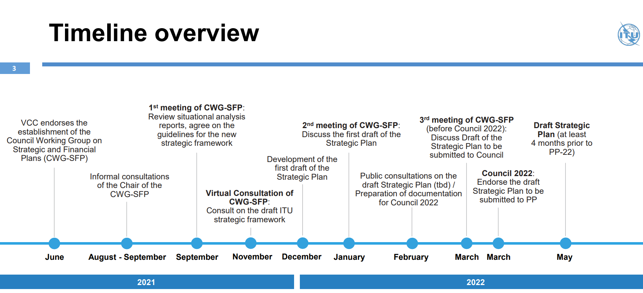
To support the CWG-SFP in developing the draft Strategic Plan, the Secretariat reviewed several documents and implemented several initiatives to provide opportunities for stakeholders to contribute to ITU’s standard strategic planning processes. These included extensive consultations with the membership, as well as dialogues within the ITU General Secretariat and with the Bureaux to gather perspectives on the Strategic Plan and obtain guidance on how to incorporate inputs most effectively. These initiatives included:
Consultations with the membership
- The Informal Consultation, launched by the CWG-SFP Chair in August 2021. The consultation gathered feedback from the membership on how to improve the Strategic Plan. The feedback has been summarized in the CWG-SFP-1/11-E document for CWG-SFP consideration.
- Study Groups’ Survey on the ITU Strategy 2024-27, published in September 2021. All 19 ITU Study Group Chairpersons were surveyed on their perception of ITU’s challenges, trends in the telecommunication/ICT landscape and suggested improvements to the new Strategic Plan. The results were consolidated in the CWG-SFP-1/INF-6-E document for CWG-SFP consideration.
- The CWG-SFP Virtual Consultation in November 2021. During this consultation, suggested adjustments to ITU’s strategic framework and selected Strategic Plan components were presented to the membership, who could provide oral feedback during the consultation and written feedback afterwards.
- Presentations and ongoing consultations with Sector Advisory Groups are taking place since the initiation of the strategic planning process, including the participation of the Chair of the CWG-SFP in the relevant TDAG and TSAG meetings, and will continue until the 2022 Session of the Council with all Sectors. These consultations will aim to facilitate the gathering of inputs from all three Sector advisory groups.
Internal coordination within the Secretariat
- The Strategic Planning Working Group (SP-WG) was established by the ITU Coordination Committee (i.e. the 5 Elected Officials) in order to prepare the Secretariat’s inputs to the process and support the work of the CWG-SFP. The SP-WG is chaired by the Director of BR, Mr. Mario Maniewicz.
- Coordination and consultations with the three Bureaux and General Secretariat were held throughout the process with the leadership of each Bureau’s Secretariat, including the Directors of the Bureaux, as well as the Secretary-General and Deputy Secretary-General to gather Sector-specific and General Secretariat’s feedback on the draft Strategic Plan and ensure it adequately reflects their strategies and incorporates their priorities, expected outcomes of the work of their relevant Sector and the General Secretariat, and the range of products and services they offer to the membership. Consultations with the ITU Staff Council also took place.

Principles and Guidelines followed in the development of the secretariat’s input
The Secretariat’s input applies the principles and guidelines agreed and provided by the membership during the first CWG-SFP meeting (Doc. CWG-SFP-1/12). The draft plan builds on membership’s inputs and feedback obtained during the CWG-SFP Chair's Informal Consultation, as well as the Virtual Consultation of CWG-SFP in November 2021.
Specifically, guidance from the membership to the Secretariat was consolidated into the following key principles, which were applied in the development of the 2024-2027 Strategic Plan as follows (Note that details on the changes to specific components are provided in the subsequent section):
CWG-SFP Guidance | How guidance was addressed in the Secretariat’s input
1. Simplification and clarity  - Request the secretariat to provide inputs and assess them at the upcoming virtual consultation, on how to simplify and clarify the strategic framework, reviewing the linkages and the different elements of the draft Strategic and Financial Plans, to better reflect the strategic priorities of the organization | - Refined the strategic framework to enhance its simplicity and clarity, by proposing the following changes for CWG consideration:  - Simplified and consolidated Strategic Goals and Targets  - Developed thematic priorities that synthesize and replace Sector/Inter-Sectoral Objectives  - Consolidated Sector/ General Secretariat Activities and Enablers into ITU-wide product & service offerings and Enablers
2. Focus  - Request the secretariat to present inputs on how: i) to keep the Strategic Plan at a high level while recognizing the role and mandate of the ITU Sector ii) based on the strategic priorities, to identify the main topics/themes of work, considering cross-cutting themes - where possible, aiming to reinforce synergies across the Sectors | - Drew a sharper distinction between the high-level Strategic Plan and the detailed Sector/ General Secretariat Operational Plans  - Identified and articulated main areas of impact under thematic priorities, to be measured through outcomes that one or several Sectors will contribute to
3. One ITU  - Request the secretariat to further develop inputs to clarify and strengthen the concept of One ITU, and CWG-SFP to then further consider it for the development of the Strategic Plan  - Request the secretariat to leverage cross-sectoral strategic priorities/themes/areas of work and reflect the One ITU concept, while recognizing the contribution of the ITU Sectors, being able to articulate the products and services ITU can provide as an organization  - Request the secretariat to clarify and consider whether there are possibilities on a more flexible allocation of resources across Sectors | - Took into consideration the definition of One ITU, as per the former Strategic Plan: “the Sectors shall work cohesively for the implementation of the strategic plan. The secretariat shall support coordinated operational planning, avoiding redundancies and duplication and maximizing synergies across the Sectors, the Bureaux and the General Secretariat.”  - Strengthened concept of One ITU, by developing a high-level, refined and focused Strategic Plan to reflect ITU-wide contributions and synergies  - Developed thematic priorities that synthesize Sector/Inter-Sectoral areas of impact and replace siloed objectives  - Consolidated ITU-wide product & service offerings and Enablers to reflect One ITU ways of working  - Clarified the distinction between Strategic and Operational Plans, allowing Sectors and the General Secretariat to reflect their specific work
4. Vision and Mission  - Request the secretariat to collect further inputs from members of CWG-SFP, in view of potentially adjusting the wording, in line with ITU’s scope and mandate, taking into consideration the persistent digital divide and ITU’s role to expand connectivity worldwide and the use of telecommunications/ICTs for social, economic and environmentally sustainable development | - Provided alternative options for the Vision and Mission, that reflects ITU’s mandate and simplifies the definition
5. Goals  - Taking into consideration both the results of the Online Consultation and the contributions to the CWG-SFP, to request the secretariat to collect further inputs from members and further analyse the possibility and implications of keeping, adjusting or grouping the current goals; taking into account the ongoing discussions related to the Vision and Mission, and keeping in mind the Constitution and Convention of the ITU | - Proposed consolidation and refinement of the strategic goals to better reflect ITU’s Vision and Mission.  - These were developed to reinforce synergies and create goals that are: i) specific to, and aligned with, ITU’s Vision and Mission, ii) mutually exclusive and collectively exhaustive, and iii) focused on ITU’s impact, as opposed to organizational enablers
6. Targets  - Request the secretariat to present inputs to review the current set of Targets, according to the lessons learned, in particular: Targets to be SMART (specific, measurable, action-oriented, realistic, time-bound) and account for regional and developmental gaps | - Revised Targets to reflect ITU’s ambitions for the 2030 Agenda and contribution to the implementation of the WSIS Action Lines  - Introduced SMART target indicators in the Results Framework, and identified sub-indicators to refine measurement by region/level of development/gender etc.
7. Regional presence  - Agree that the role of the ITU regional presence should be reflected in the new Strategic Plan  - Follow-up on the ongoing discussions among Member States and incorporate conclusions on the role of ITU's regional presence in the new Strategic Plan, keeping in mind the Constitution and Convention of the ITU | - Elevated the importance of ITU’s regional presence in the Strategic Plan, by adding regional presence as an Enabler
8. Linkage with Financial Plan  - Request the secretariat to take into account the following principles, when designing the linkage of the financial with the strategic plans: a. Direct linkage between the strategic priorities, including cross-cutting themes, and the allocation of financial and human resources b. No elements should remain unfunded  (see also request for clarification under point 3 on whether there are possibilities for a more flexible allocation of resources across Sectors) | - Direct linkage between the Strategic Plan and allocation of resources at the level of thematic priorities will be reflected in ‘Appendix A. Allocation of resources’ of the Strategic Plan, ensuring no elements remain unfunded
9. Developments at the UN level  - Request the secretariat to provide updates on the ongoing discussions at the UN level  - Request the secretariat to submit inputs to better reflect the role of the ITU within the UN system (taking into consideration the 2030 Agenda, and ITU's contribution to the SDGs and the WSIS process) | - Reflected ongoing discussions at the UN level in the situational analysis  - Proposed Targets for 2030 to demonstrate ITU’s commitment to the 2030 Agenda and the SDGs, and highlight the role of ITU in the UN system and the implementation of the WSIS Action Lines
10. ITU Results-framework  - Request the Secretariat to continue to develop the ITU results framework taking into account proposals by the membership and considering the need to support implementation of the strategic, financial and operational plans and budget and increase the capability of the membership to assess progress in the achievement of ITU’s goals | - Refined the results framework to include SMART indicators for targets and thematic priorities’ outcomes, that enhance the membership’s ability to measure ITU’s progress
Therefore, to address the aforementioned principles and guidelines, ITU’s strategic framework was reviewed and refined. The following figure shows the evolution from the former strategic framework to the proposed framework for the draft 2024-2027 Strategic Plan.
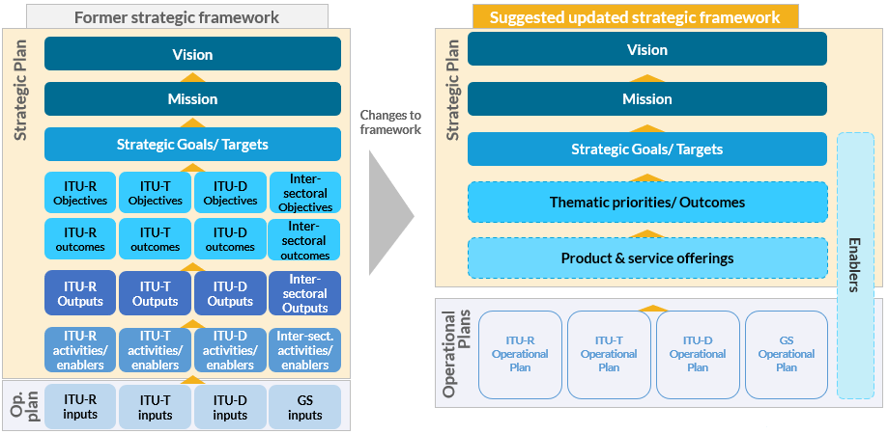

Rationale for Components of the Strategic Framework
The following section provides additional details on the suggested adjustments to specific components of the strategic framework, to address the principles and guidelines agreed at the first meeting of the CWG-SFP. Specifically, it explains the approach adopted to ensure all elements from the former Strategic Plan were considered, how their components were reformulated, the approach adopted to ensure adjustments kept key elements and the rationale for changes. The figure below depicts the key components of the proposed Strategic Framework. These include the components in the draft Strategic Plan (Vision and Mission, Strategic Goals, Thematic Priorities, Products & Service Offerings, Enablers), and the Results Framework (Targets, Outcomes and Outputs), and their corresponding sub-sections in this document (3.1, 3.2, 3.3, 3.4).
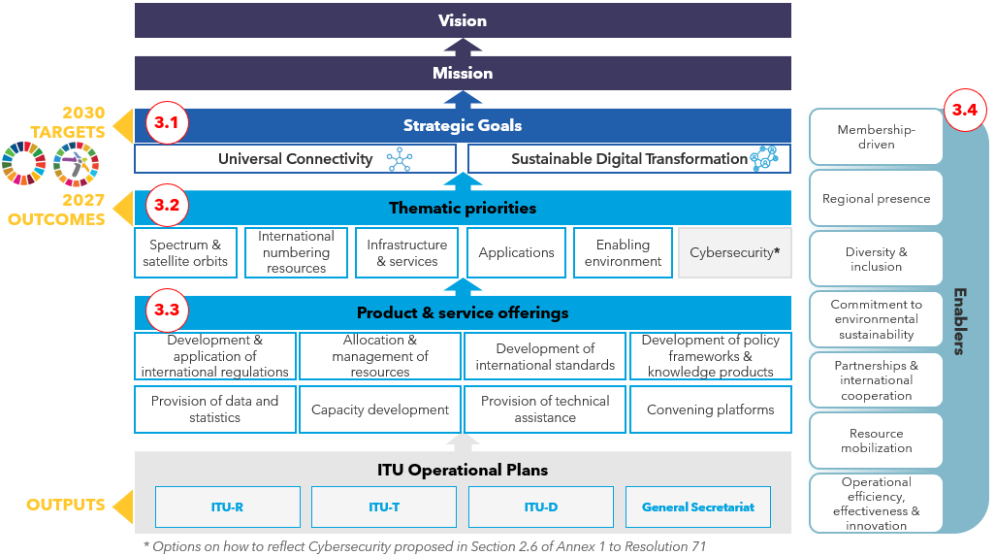
The key components of the Strategic Plan are interlinked in order to drive results. Specifically, product & service offerings are deployed so that ITU can deliver work under its thematic priorities, with the aim to achieve outcomes that contribute towards the Union’s Strategic Goals and 2030 Targets. Enablers simultaneously allow ITU to deliver on its goals and priorities more effectively and efficiently.
Some examples:
- ITU regularly updates the Radio Regulations and Regional Agreements, develops capacities of telecommunication/ICT professionals and fosters stakeholder dialogue through convening platforms. These product & service offerings contribute to the spectrum & satellite orbit thematic priority, which is expected to deliver the following outcomes: i) Radio-frequency spectrum and associated satellite orbital resources are efficiently and equitably allocated and used ii) Harmful interferences are avoided. The successful delivery of these outcomes thereby contributes to the achievement of universal connectivity and sustainable digital transformation, facilitated by the organizational enablers.
- ITU assembles experts from around the world to develop international standards known as ITU-T Recommendations. These product & service offerings contribute to the infrastructure and services thematic priority, which is expected to deliver an outcome on enhanced interoperability and performance of infrastructure and services. The long term impact of this outcome thereby contributes to the achievement of universal connectivity.
- ITU develops capacities of telecommunication/ICT professionals and knowledge resources, and works towards boosting digital literacy and skills of citizens. These product & service offerings contribute to the enabling environment thematic priority, which is expected to deliver an outcome on digital skilled users. The long-term impact of this outcome thereby contributes to the achievement of sustainable digital transformation.

3.1 Strategic Goals and Targets
Strategic goals
In responding to membership guidance to consider adjusting or grouping goals as well as simplify and enhance the focus of the Strategic Plan, the five Strategic Goals in the former plan are proposed to be consolidated into two: ‘Universal Connectivity’ and ‘Sustainable Digital Transformation’. These were drafted to reinforce synergies and create goals that are: i) specific to and aligned with ITU’s Vision and Mission, ii) mutually exclusive and collectively exhaustive, and iii) focused on ITU’s impact, as opposed to organizational enablers.
Based on membership guidance, ITU’s five Strategic Goals were evaluated against criteria to determine if goals were specific to ITU’s mandate, clear, measurable and distinct. To refine the strategic goals, frameworks of other UN entities were also assessed to draw on best practices. Across entities, this exercise found that strategic goals were specific to organizations’ mandates and had limited overlaps between them. While ‘Growth’, ‘Inclusiveness’ and ‘Sustainability’ were specific and measurable, they had overlapping Targets related to access, use and enhanced connectivity. As a result, they were distilled into two goals that incorporated themes from the former ones: the first, ‘Universal Connectivity’, focuses on fostering universal access to affordable, high-quality and secure telecommunications/ICTs, and includes themes from ‘Growth’ and ‘Inclusiveness’. The second, ‘Sustainable Digital Transformation’ enables equitable use of telecommunications/ICTs to empower people and societies for sustainable development, and integrates ‘Sustainability’ and ‘Growth’. Finally, since ‘Partnership’ describes ways of working as opposed to an end-objective, this was moved from the strategic goals and added as an Enabler. Since ‘Innovation’ is inherent across work in the telecommunication/ICT landscape as well as within ITU, this was reflected across the thematic priorities and included as an Enabler as well, namely ‘operational efficiency, effectiveness and innovation’.
Targets
The draft Strategic Plan sets ambitious Targets for 2030, that reinforce ITU’s commitment to enabling the delivery of the SDGs and WSIS Action Lines and delivering on its Strategic Goals. These are based on refined Targets from the former Strategic Plan to assess progress against the Strategic Goals and the ITU Connect 2030 Agenda. They will be measured using SMART (specific, measurable, action-oriented, realistic, time-bound) indicators in the results framework.
The Targets from the former Strategic Plan were reviewed and considered in drafting the new set of Targets to accurately reflect the proposed new goals.
The suggested targets for the new draft strategic plan, their proposed indicators and how these map with the Targets in the 2020-2023 Strategic plan, are included in the table below.
Goals | Suggested Targets | Suggested Target indicators | Mapping with the 2023 Targets
Universal Connectivity | 1.1: Universal broadband coverage | - % of the world population covered by broadband services (also related to SDG Target 9.1.c) | Target 2.7: 96% of the world population covered by broadband services  Target 1.6: 40% of countries to have more than half of broadband subscriptions more than 10 Mbit/s
 | 1.2: Broadband services to be affordable for all | - Cost of entry-level broadband services in developing countries as % of monthly Gross National Income (GNI) per capita. | Target 2.6: broadband services should cost no more than 3% of average monthly income in developing countries  Target 1.3: Internet access should be 25% more affordable (baseline year 2017)  Target 2.5: the affordability gap between developed and developing countries should be reduced by 25% (baseline year 2017)
 | 1.3: Broadband access to every household | - % of households with access to the Internet (per level of development; urban/rural) | Target 1.1: 65% of households worldwide with access to the Internet  Target 2.1: in the developing world, 60% of households should have access to the Internet  Target 2.2: in the least developed countries, 30% of households should have access to the Internet
Sustainable Digital Transformation | 2.1: Universal usage of Internet by individuals | - % of individuals using the Internet (broken-down by urban/rural; aggregated by region, level of development) | Target 1.2: 70% of individuals worldwide will be using the Internet  Target 2.3: in the developing world, 60% of individuals will be using the Internet  Target 2.4: in the least developed countries, 30% of individuals will be using the Internet
 | 2.2: All digital gaps to be bridged (in particular gender, age, urban/rural) | - % of individuals using the Internet (broken-down by age, gender, accessibility) | Target 2.8: gender equality in Internet usage and mobile phone ownership should be achieved
 | 2.3: Universal usage of Internet by businesses | - % of business using the Internet, total and by size | (Inspired from the relevant BBCOM target / based on the availability of data from UNCTAD)
 | 2.4: Universal access to the Internet for all schools | - % of schools with Internet access | (Measured by UNESCO (UIS), as part of SDG indicator 4.a.1)
 | 2.5: Majority of individuals to have digital skills | - % of youth and adults with information and communications technology (ICT) skills, by type of skill | Target 2.10: improve by 40% the proportion of youth/adults with telecommunication/ICT skills
 | 2.6: Majority of individuals to be interacting with government services online | - % of population interacting with government services online | Target 1.7: 40% of the population should be interacting with government services online
 | 2.7: Significantly improve ICTs contribution to climate action | - Global e-waste recycling rate  - Net telecommunication/ICT-enabled Greenhouse Gas abatement  - Total ICTs Carbon footprint (broken-down by type of service/provider) | Target 3.2: increase the global e-waste recycling rate to 30%  Target 3.4: net telecommunication/ICT-enabled Greenhouse Gas abatement should have increased by 30% (baseline 2010)
Current Targets that will be reflected under the Outcomes of the Thematic priorities include:
- Target 1.4: all countries adopt a digital agenda/strategy
- Target 1.5: Increase the number of broadband subscriptions by 50%
- Target 2.9: By 2023, enabling environments ensuring accessible telecommunications/ICTs for persons with disabilities should be established in all countries
- Target 3.1: improve cybersecurity preparedness of countries, with key capabilities: presence of strategy, national computer incident/emergency response teams and legislation
- Target 3.3: raise the percentage of countries with an e-waste policy, legislation or regulation to 50%
- Target 3.5: By 2023, all countries should have a National Emergency Telecommunication Plan as part of their national and local disaster risk reduction strategies
Current Targets 4.1 and 5.1 represent Goals that are more means rather than ends, and their measurement has been provden extremely difficult (were currently measured by proxies).

3.2 Thematic Priorities and Outcomes
Thematic Priorities
In addressing membership guidance to leverage synergies, simplify and sharpen the focus of the Strategic Plan, thematic priorities were introduced to showcase key areas of work the Union focuses on, in which results will be achieved to meet strategic goals. These thematic priorities distil sectoral and intersectoral objectives into one group of priorities that reflect cross-cutting and sector-specific areas, while eliminating overlaps present in the former list of Sector-specific and inter-sectoral objectives.
To create the thematic priorities, the relevant discussions in the Sector advisory groups were followed. Thematic priorities were thereby developed, based on existing sectoral and intersectoral objectives from the 2020-2023 Strategic Plan, which were directly mapped against the thematic priorities. A benchmarking exercise of peer UN entities was also conducted. This found that other organizations articulated unified focus areas to deliver organizational goals. To develop and finalize the thematic priorities, extensive consultations were then held across the Secretariat, with the Sectors to ensure the thematic priorities accurately reflected their main areas of work and cross-sectoral synergies, and avoided duplication.
Outcomes
In responding to membership guidance to simplify the strategic framework, sharpen its focus and enhance ITU’s results framework, the draft 2024-2027 Strategic Plan consolidates the expected outcomes of ITU’s work under each thematic priority. Progress against these outcomes will then be measured in the results framework using SMART outcome indicators. These outcomes serve as the building blocks of the Union’s impact that, if collectively achieved, will enable ITU to achieve its Strategic Goals.
To develop the updated outcomes, outcomes in the former Strategic Plan were mapped to thematic priorities and iterated within the Bureaux and General Secretariat. Since several outcomes in the former Strategic Plan were more granular, these were used to create outcome indicators. The outcome indicators are currently being refined by the Bureaux and the General Secretariat and will be incorporated in the draft Strategic Plan after the endorsement of the framework.

3.3 Product & Service Offerings and Outputs
Product & Service Offerings
To showcase ITU’s combined value proposition and highlight linkages across the full range of its products & services, the draft 2024-2027 Strategic Plan consolidated Sector and General Secretariat offerings, or ‘activities’ into cross-cutting ITU product & service offerings. Meanwhile, to enable the Sectors and General Secretariat to tailor products & services and resource allocation to their specific mandates, detailed information on how the Sectors and General Secretariat deploy their offerings will be included in the Operational Plans.
To develop these overarching products & services, existing Sector activities were grouped and reformulated to highlight common areas of work while reflecting the specificity of existing Sector and General Secretariat offerings.
Outputs
Outputs will be defined in the Operational Plans. These would assess the tangible results and deliverables that are achieved as a result of specific offerings and will be measured by output indicators. Outputs will therefore no longer be included in the draft Strategic Plan, to provide Sectors with the flexibility to define their own product & service offerings and measure those accordingly.

3.4 Enablers
In addressing membership guidance to leverage cross-cutting areas and reinforce synergies, ITU-wide Enablers were developed. These were synthesized to capture consistent ways of working across ITU, that build on existing strengths and address weaknesses, to accelerate the delivery of ITU's products & services, thematic priorities and strategic goals. To respond to membership requests to highlight ITU's regional role, Enablers were also widened to include one focused on Regional Presence. Meanwhile, to recognize the continued contribution of the Sectors and General Secretariat, details on how they incorporate these Enablers in their work and allocate resources were moved to Operational Plans.
To create these Enablers, Bureaux and General Secretariat Enablers were collated and grouped into overarching ITU-wide categories that were mutually exclusive, while collectively exhaustive. These new Enablers were then reviewed and finalized through extensive consultations and inputs across the Secretariat.
______________

