Council Working Group on
Financial and Human Resources
Fifteenth meeting – 11 – 12 January 2022
Document CWG-FHR-15/12
14 December 2021
English only
Contribution by the Secretariat
ITU compliance dashboard
Follow-up on the recommendations of
the External Auditor and IMAC
Summary
The ITU Compliance Tracker and Dashboard have been implemented as the central repository for all recommendations by internal and external oversight bodies.
This Information Document presents the overview of the status (as of December 2021) for all the Recommendations of the External Auditor and IMAC.
Action required
This document is presented to the CWG-FHR for information.
____________
References
Document CWG-FHR-14/8; Council document C21/22

I. Introduction
The ITU compliance tracker and dashboard have been implemented in February 2021. This new tool provides a clear view of the follow-up of all the recommendations issued by the oversight entities and/or company:
- The External audit
- Independent Management Advisory Committee (IMAC)
- Joint Inspection Unit (JIU)
- Internal audit
- Forensics audit
This document presents the status of the recommendations related to External audit and IMAC.
The document CWG-FHR-15/3 presents the status report on the implementation of the forensics audit recommendations.

Below is a summary of the status of the recommendations issued by the External Auditor and IMAC
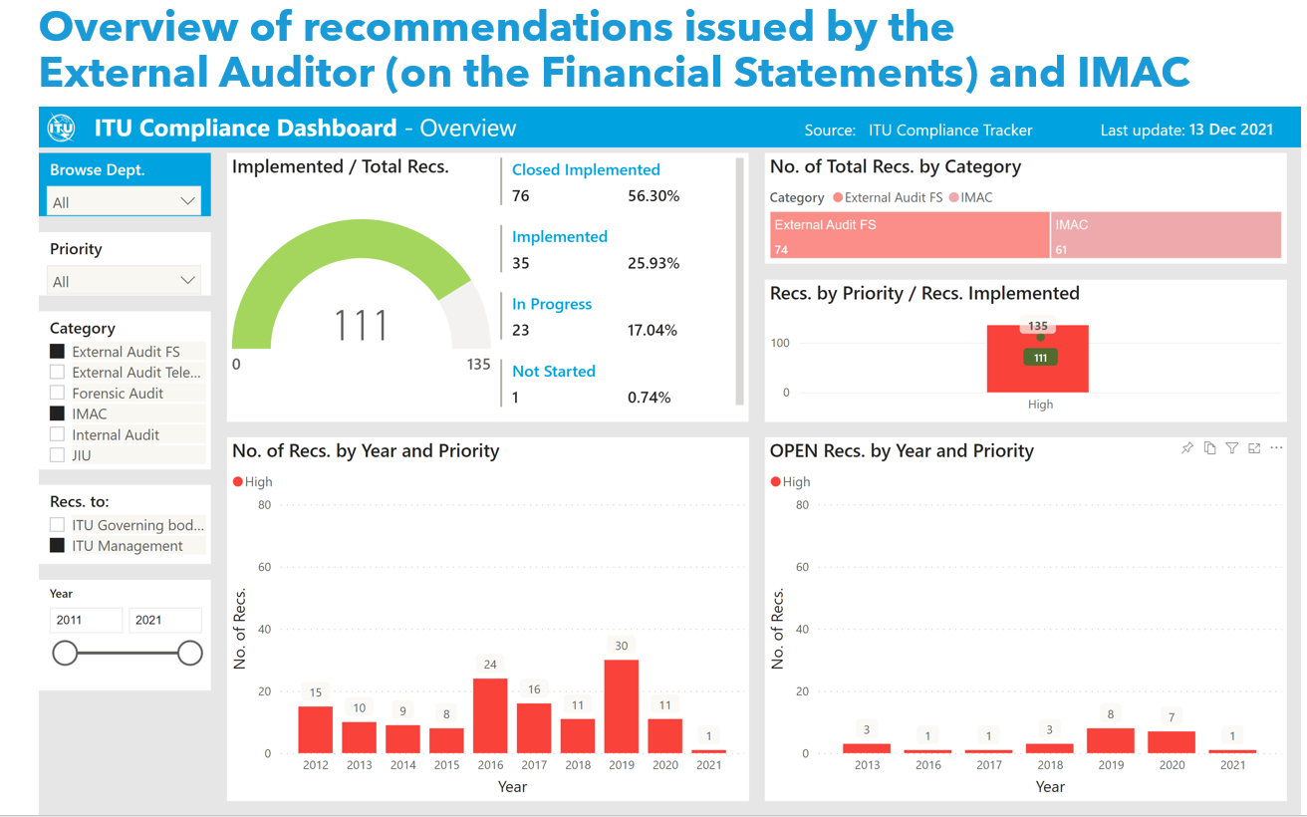

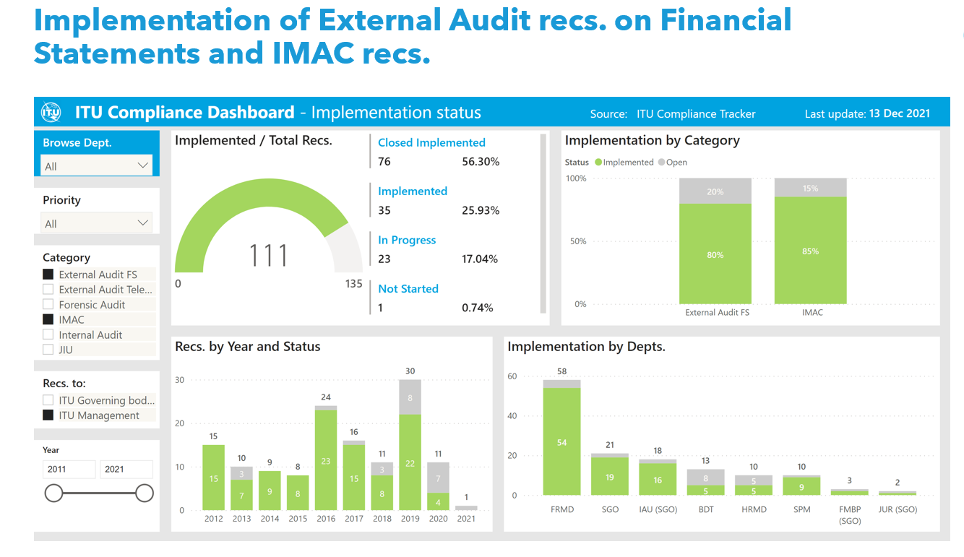
II. External audit
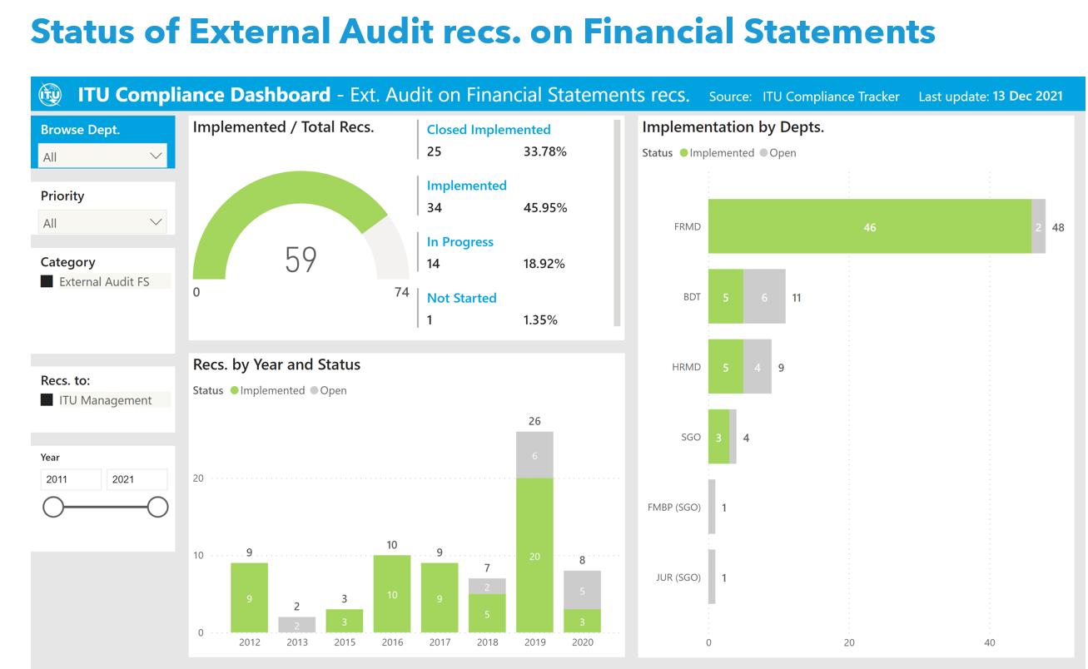
As of end November the report of the external auditors related to the financials statements 2020 has not been received and new recommendations could therefore not be presented.
As shown in the graphics above the rate of implementation of all the External audit recommendations on the Financial Statements reachs 80%. Despite the teleworking in place during all the year 2021 which could caused delays and or difficuties, a lot of work and efforts have been done by the management. Many recommendations are now implemented but still need to be reviewed by the external auditors before being definitely closed.
As soon as the report of the external auditors concerning the financial statements 2020 will be received, the dashboard will be updated accordingly to reflect the status of the all previous recommendations.

III. Independent Management Advisory Committee (IMAC)
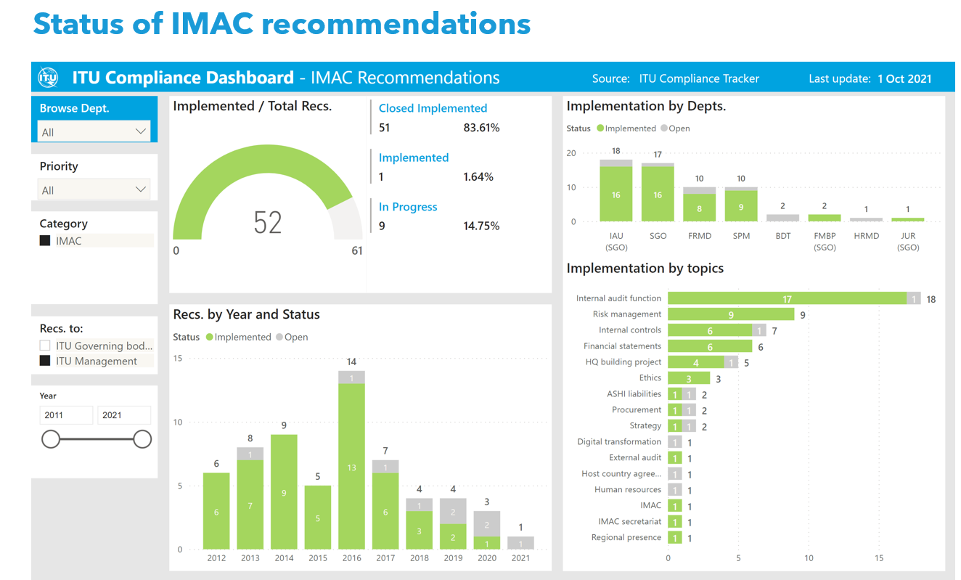
As shown in the graph above, the implementation rate of the IMAC recommendations is ~84%. Out of the 61 IMAC recommendations addressed to the ITU secretariat in total, 51 have been implemented and closed by IMAC, while 9 recommendations (~15%) remain in progress with the secretariat. One (1) recommendation has been reported as implemented by the secretariat and IMAC will review its implementation status at the next IMAC meeting.
__________________

