Council Working Group on  Financial and Human Resources  Fifteenth meeting – 11 - 12 January 2022 |  | 
 |  | Document CWG-FHR-15/9
 |  | 16 December 2021
 |  | English only
 | Contribution by the Secretariat
 | Recruitment process – Reduction of the Advertisement Period
Summary
The period of advertisement for professional positions (P1 to D2) identified for external recruitment on an international competitive basis is currently established in the Staff Rules and Regulations applicable to appointed staff, at 2 months. A shorter period of advertisement would allow ITU to be more efficient in acquiring and deploying talent to deliver on its mission.
The experience gained over the last years of use of an electronic e-recruitment system shows that most of the applications received for vacancy notices are submitted by applicants during the first and last weeks of the period, therefore a reduction in advertising time will not have a detrimental effect in attracting talent. The proposal is to amend the Staff Regulations to reduce this period to 1 month.
Action required
The CWG-FHR is invited to recommend the amendments to the Staff Regulation applicable to appointed staff contained in Annex to this Decision.

Recruitment processes – reduction of the advertisement period
1. The period of advertisement for professional positions (P1 to D2) identified for external recruitment on an international competitive basis is currently established in the Staff Rules and Regulations applicable to appointed staff, at 2 months. A shorter period of advertisement would allow ITU to be more efficient in acquiring and deploying talent to deliver on its mission.
2. The experience gained over the last years of use of an electronic e-recruitment system shows that most of the applications received for vacancy notices are submitted by applicants during the first and last weeks of the period, therefore a reduction in advertising time to one month will not have a detrimental effect in attracting talent. Analysis of data from all external vacancy announcements closed between 2016 and November 2021 confirms this assertion.
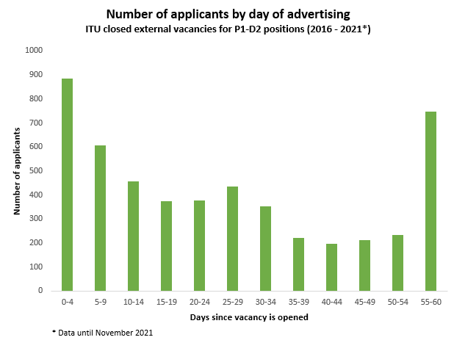
3. A closer look at this data, grouped by two-week periods, shows that 61% of applications occur in the first and last 15 days of the vacancy announcement.
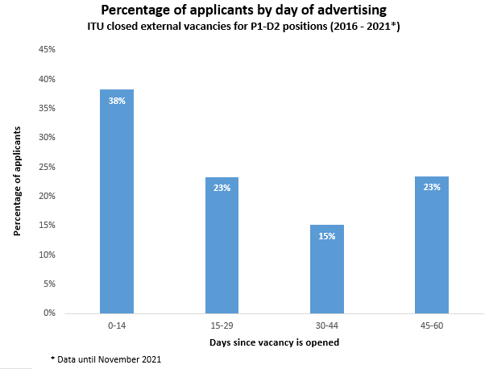
3. Benchmarking with other organizations, based on a UN review where ITU collaborated with the International Atomic Energy Agency, to survey the advertisement time taken by organizations of the United Nations shows that the majority (64%) of organizations advertise externally for a maximum of 4 weeks.
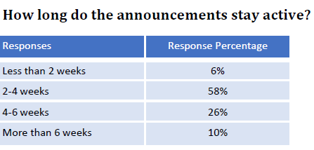
4. It is important to note that, although a reduction in the period of advertisement to one month will not prevent the organization from applying a longer period of advertisement if the job in questions necessitates wider outreach.
5. The cost of not implementing this change is twofold:
- The organization will be less effective in deploying new talent, therefore restricting its ability to deliver on its mission. This is especially critical for project implementation.
- Sometimes the organization loses candidates in a very competitive job market as these professionals accept jobs at organizations where recruitment processes are faster.
6. The specific proposal is to change Staff Regulation 4.8 Appointment of staff members, article f) to read “one month” instead of “two months”.
7. To that effect, an amendment to the Staff Regulation concerned must be adopted by the Council, as Staff Regulations are falling under its authority.
8. The proposed amendment is the following:
Regulation 4.8 Appointment of staff members
f) When vacancies are advertised, in accordance with the provisions of paragraph c) above, applications from outside may be submitted through an Administration, in principle within a minimum period of two months one month; or directly to the Union on the understanding that the Secretary-General would in such cases normally consult with the Administrations of the nationals involved before making a final selection.
The CWG-FHR is invited to recommend the amendments to the Staff Regulation applicable to appointed staff contained in Annex to this Decision.

draft DECISION […]
Amendments to Staff Regulations
applicable to appointed Staff
The ITU Council,
in view of
No 63 of the Convention of the International Telecommunication Union and of Regulation 12.1 of Staff Regulations applicable to appointed staff,
having considered
the report submitted by the Secretary-General in document C22/36 to the Council,
decides
to approve the amendments to the Staff Regulations applicable to appointed staff contained in Annex to this Decision.

Annex to draft decision

STAFF REGULATIONS APPLICABLE TO APPOINTED STAFF
Regulation 4.8 Appointment of staff members
a) Appointment of staff members shall be made by the Secretary-General within the limits authorized by the Council. As regards the staff, of each Bureau, the Director concerned shall select the candidate to be appointed, but the final decision for appointment shall rest with the Secretary-General, who shall however report to the Council any case where his decision was at variance with the recommendation of the Director of the Bureau concerned.
b) The Secretary-General, with the agreement of the Director of the Bureau concerned, where applicable, may decide to fill any vacant post by transfer within the Union.
c) Selection for posts in grades P.1 and above shall be made on an international competitive basis; vacancies identified for external recruitment shall be advertised to the Administrations of all the Members States of the Union, to the United Nations and other specialized agencies and to the staff of the Union, indicating in detail the nature of the post to be filled, the qualifications required and the terms of appointment.
d) For vacancies at the Headquarters in grades G.1 to G.7, recruitment shall be on a competitive basis, from as near a place to Geneva as possible; where this is not possible, vacancies shall be advertised as in paragraph c) above, but recruitment shall be made having regard to its financial implications.
e) For all other duty stations, the Secretary-General shall establish a selection procedure, based on United Nations common system local conditions and practice.
f) When vacancies are advertised, in accordance with the provisions of paragraph c) above, applications from outside may be submitted through an Administration, in principle within a minimum period of two months one month; or directly to the Union on the understanding that the Secretary-General would in such cases normally consult with the Administrations of the nationals involved before making a final selection.
_______________

