Council Working Group on Child Online Protection  18th meeting – Virtual, 12 January 2022 | 
 | Document CWG-COP-18/INF-6-E
 | 21 December 2021
 | English only
Note by Hungary
CHILD ONLINE PROTECTION IN HUNGARY
the Digital Child Protection Strategy of Hungary

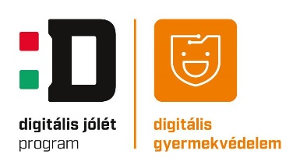
As a part of the Digital Success Program in 2016, the Hungarian Government adopted the Digital Child Protection Strategy of Hungary (DGYS) by the Government Decree 1488/2016 (IX. 2).
The strategy has been drawn up primarily to ensure that children are protected from dangerous and harmful online content and contained methods to prepare children, parents, and teachers for a conscious and productive use of the Internet. In addition to this, priority objectives of the strategy also include regulations and measures to protect children, which should be enforced more than before. To that end, it is important to identify and eliminate the risks and threats to children while using the Internet and thus to prevent or minimize its harmful effects. Additional objectives of the strategy include protection mechanisms available, that should function properly and efficiently.
While the strategy focuses on children, almost all groups of the society are affected. Therefore, in addition to identifying the system of government instruments, the mutual knowledge sharing and teaching; cooperation between various stakeholders is also required to ensure that the strategy is successfully put into practice. To that end, the strategy proposes that all stakeholders, including public education system actors, NGOs, child protection institutions and law enforcement agencies should cooperate by standing up against harmful, dangerous, and illegal online activities.

The main tasks of the Digital Child Protection Strategy of Hungary are:
- Preparation of proposals by experts for the necessary transformations of the regulatory environment.
- Conducting national and international research and observation in terms of child online protection and using the results of the research for develop further plans.
- Providing programs in the terms of media literacy and online safety (peer mentoring program, program for parents, training for teachers).
- Strategic preparation of actions and regulations for child online protection monitoring of measures.
- Monitoring of the actions and regulations.

Research
- Digital Child Protection Index
In order to evaluate Hungary’s level on online children and youth safety, there is a clear need for standardized indicators. The regular measurement of such indicators will allow us to set up a Digital Child Protection Index (DGYIndex), resembling the European Union’s Digital Economy and Society Index (DESI). This index could provide insights to questions on the level of safety, changes in safety levels as the digital environment changes, or because of the applied interventions. Internet safety depends on factors like degrees of risks, media literacy levels or the state of the digital child protection ecosystem.
Since 2020, DGYS did various research phases on the three subfactors of the DGYIndex, for example a deep survey about cyberbullying and online sexual harassment, and detailed information about the work and efficiency on media literacy of civic organizations and schools in Hungary.
- DigiMini
We understand that media literacy education and the facing online risks starts at early childhood. That’s why we conduct research about the digital media knowledge and attitudes on kindergarten /preschool children and their educators.
- Action research at child protection – public care
The aim of this research is to create “digital child protection profiles” and develop specialized interventions for this especially vulnerable group.

Legal expert studies
The refinement and perfecting of the legal frameworks are an important part of Hungary’s Digital Child Protection Strategy’s work. Last year, we worked on observation and proposals.

Educational Programs
- OkosÓvoda (Smart Kindergarten) Program
The "Smart Kindergarten Start Program” (Okosóvoda) provides free website service for 100 kindergarten per year since 2018, which will support the development of digital culture, competence and media awareness in these institutions and serve as a communication channel for the protection and safety of children.
In order to involve all public education actors (including kindergartens) to participate in the digital transformation, the institutions need to be connected to an online network. Connecting the Hungarian kindergartens to the internet requires a website service where parents have access to easy and quick information about cultural, sports and health programs for their children, as well as specialist information on The Digital Child Protection Strategy of Hungary
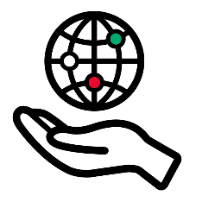
- NETMENTOR Peer Mentoring Program
Knowlegde transform at „eye level” would help younger kids to understand the risk and possibilities of online media use. We train 9th-10th graders to give interactive workshops and direct mentoring for younger kids about the new media enviroment. We trained 500 netmentors in 3 years.
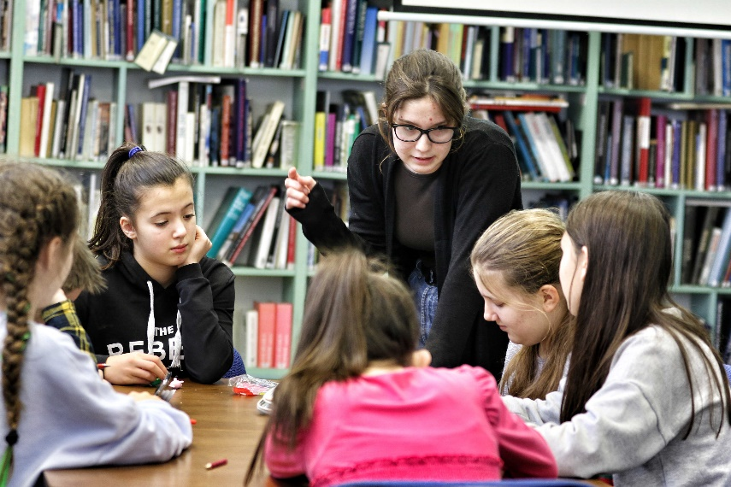

- Digital media literacy for parents
We train local mentors throught Hungary to be able to give workshops on 12 topics from body image to data privacy and give advice about digital parenting. We reached about 5000 parents, families.
For the Digital Media Literacy for Parents Mentors we offer a workshop material to give parent-children workshop based on the “Online with Sango” storybook.
In 2022 we are going to introduce a new MOOC on digital parenting, based on this program, what will be available for free for everybody.
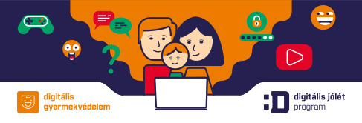

2. Online information, digital media awareness materials: https://digitalisgyermekvedelem.hu
- One pagers for parents about social media platforms
- ITU-COP guidelines and Sango books in Hungarian
- Educational videos on 10 topics
- Interactive educational materials, lesson plans for 8-12th grade

Sango Tour in Hungary
by Katalin Baracsi dr. LL. M lawyer specialized in Family Law and Infocommunication
internetlawyer, social media trainer

- Implementation of COP Guidelines in Hungary
In Hungary, too, it can be observed that at a younger age, smart devices fall into the hands of children and enter the magical world of the Internet. Parents and teachers need tangible, practical guides to bring security to the now growing generation in the online space as well. Political decision-makers and industry players alike need to be involved in this work.
Upon the request of the Member States, the Child Online Protection Guidelines, firstly developed in 2009, have been updated and launched officially in June 2020 in the six UN official languages (Arabic, Chinese, English, French, Russian Spanish). With the aim to create a safe and resilient future for all children, the COP Guidelines and related materials have been translated into Hungarian language. The Hungarian version of the COP guidelines have been translated by dr. Katalin Baracsi, with the cooperation of the Ministry of Innovation and Technology of Hungary and the Digital Success Program - Digital Child Protection Strategy of Hungary. It was officially launched on the 3rd December 2020, virtually.The event retransmitted in live on dr. Baracsi Katalin, az internetjogász Facebook page. Teacher and parent workshops were held at the same time as the translation work. The ITU COP Guidelines were promoted at conferences, press too.

- Sango and Me Competitions
- Internet safety with drawings
Under the Christmas tree in 2020, I wondered if I could introduce Sango to the kids and the adults helping them even better. It was then that the idea for the “SANGO and Me” drawing competition was born, where children between the ages of 9 and 12 used the drawing techniques to show how online Sango’s help comes in handy for them. Better than better drawings came from all over the country. With incredible ingenuity, the kids showed their internet everyday lives and boldly asked Sango for help in resolving the following situations:
- Unknown: Send a picture of yourself now! Sango please help because an unknown wrote to me!
- Sango help, I have a virus on my computer, what should I do?
- Little girl: A stranger wrote to me, what should I do?
Sango: Don’t write back to him, talk to an adult!
- The following text appeared on the little boy's computer: Free money !!! Download
Sango: Don't click on it, it's an internet scam!
- Little boy: Kids, if they want to buy an online game, they look for the cheapest on the internet.
Sango: There are a lot of fake sites and if you shop there you won’t get the product!
- The following message appeared on the little girl's computer: Send your address, your phone number! When are you sending already?
Sango: I'll help. Blocked it and don't reply to it!
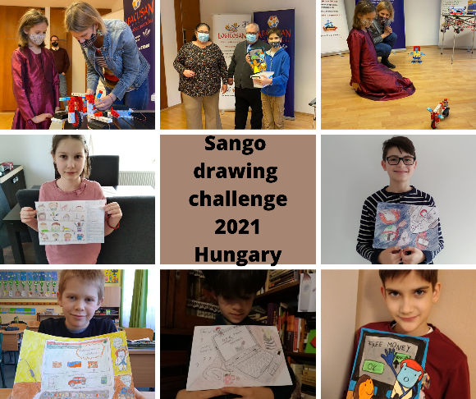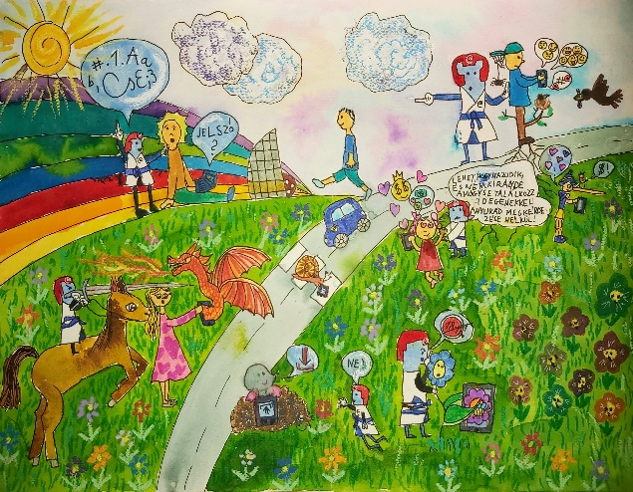

- Internet safety with digital storytelling
According to the pandemic situation I had to be creative to celebrate Children's Day. It was the second step of „SANGO and ME ''. After the drawing competition I made an open call to write or make stories about internet safety in three categories. One of the characters in the story was Sango. It was also a great success. In the „oldest” category (16 years old girl) the winner made a fantastic digital story about strangers on the internet. The title is: „Sango and the magic wand”.
- Sango’s journey
In 2021, in addition to the competitions, there will be more than 50 opportunities for children and adults (parents, teachers) to meet Sango in person and at least as many online. The downloading and daily use of the online Child Protection Guides is growing:
- teacher workshops;
- children's camps - the Malteses - Hungarian Charity Service of the Order of Malta in disadvantaged regions;
- Digital Theme Week special prize;
- Sango on holiday - in cooperation with Hévíz Hotel Europa Fit;
- Researchers' Night.



