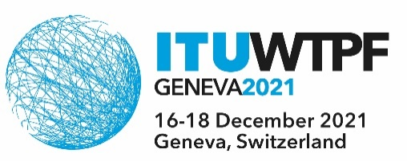 | 
 | Document WTPF-21/5-E
 | 2 December 2021
 | Original: English
Burkina Faso, Ghana, Kenya and Uganda
CONTRIBUTION ON MOBILIZING NEW SOLUTIONS FOR CONNECTIVITY AND DRAFT OPINION 1
Reference is made to Secretary General Report 2.8.6.4 – Mobilizing New Solutions for Connectivity and Draft Opinion 1 on Enabling Environment for the Development and Deployment of New and Emerging Telecommunication/ICT Services and Technologies to advance sustainable development
Background
As much as there may be identified homogenous groups within Member States, telecommunications and ICTs provide a means for them to relate to others in harmony rather than deepening the divide between them. Therefore, connectivity solutions should be open to every person without any discrimination on race, tribe, social class, or preferences. Paragraph 7 of Opinion under “invites Member States, Sector Members and other stakeholders to work collaboratively” seems to contradict prior Paragraph 6 on fostering non-discrimination provision of connectivity solutions. Further to the above, policies, ownership, establishment, and operations of connectivity solutions in a member state is a national matter subject to its laws. Besides, it is not very clear what ‘complementary solutions and networks’ are or what they should be ‘’complementing’ and hence the Opinion should just make reference to ‘connectivity solutions.’
Proposed actions:
- Paragraph (1) under “Is of the View”, there seems to be a typo which makes the entire paragraph not read well. Delete the words “… across….” in the second line and substitute therefor the words “…towards the realization of ….”
- Paragraph (1) under “Invites Member States” delete the words “complementary access solutions ….” and substitute therefor the words “connectivity solutions …. ”
- Paragraph 7 under “invites Member States, Sector Members and other stakeholders to work collaboratively” delete the words altogether and substitute therefor the words: “to encourage innovation and entrepreneurship in the provision of connectivity solutions.”
- Paragraph 8 under “invites Member States, Sector Members and other stakeholders to work collaboratively” should be amended to read: “to encourage applications and services integrating new and emerging telecommunication/ICT services and technologies to address the diverse population needs.”
- Paragraph 10 under “invites Member States, Sector Members and other stakeholders to work collaboratively” should be amended to read: “on an enabling policy environment in accordance with national laws”.
_______________

