|  |  |
| --- | --- |
| **Council Working Group on International Internet-related Public Policy Issues Sixteenth meeting – Virtual meeting, 23 September 2021** |  |
|  |  |
|  | **Document CWG-Internet-16/3-E** |
|  | **9 September 2021** |
|  | **English only** |

**Contribution by the Russian Federation**

PROPOSALS ON THE TOPIC FOR NEXT OPEN CONSULTATIONS

COVID-19 pandemic has rapidly increased the pace of digitalization of all economic and social spheres of life of the society. At the same time the new reality and accelerated digitalization of daily processes have risen new challenges. Firstly, these are the challenges related to Internet security, personal data protection, the spread of fake and intentionally false information and posting illegal information, i.e. challenges related to services and user experience on the Internet. Secondly, and no less important, the challenges related to integrity, stability and resilience of the Internet's public core, i.e. global connectivity.

And here the question rightly arises: is the existing Internet governance system able to cope with potential threats to the integrity and resilience of the network, to give a worthy response to such a global challenge?

"Lawless behaviour in cyberspace has created a new domain for the propagation of crime," – UN Secretary-General António Guterres addressing the opening of the 14th United Nations Congress on Crime Prevention and Criminal Justice in March 2021.[1]

The Russian Federation has repeatedly expressed concern on the lack of reliable guarantees for the Internet development and security at various international platforms. Currently, there is not a single international legal act that would guarantee the integrity and security of the Internet's public core, and without such fundamental instruments, it is impossible to ensure the long-term and productive development of the Internet and its services globally. The COVID-19 pandemic naturally led to increasing the role of state as a mechanism of public organization, as well as the role it plays in the life of society. At the same time, the scale of challenges for global network connectivity is such that neither Internet giants (Big Tech), nor entire sectors of the Internet economy can deal with them properly. In the context of an aggravated international situation, Internet space uncontrolled militarization and cybercriminals significantly increasing their strength for attacking the global infrastructure, it is the states that must act as guarantors of the stability and integrity of the Internet's public core. While fully supporting the need for comprehensive analysis with the help of all stakeholders and receiving comments and proposals from the representatives of the Internet industry, civil society, scientific and expert community, we consider it fundamentally important to conduct open consultations on these challenges and receive stakeholders' feedback on the way forward.

Taking into account the scope of ITU and its mandate as a specialized technical agency of the UN, it is practical to consider threats specifically to the public core' technical infrastructure, leaving the issues of international information security. The Russian Federation proposes to hold the following open consultations with all stakeholders on the topic: **"The role of states in ensuring the integrity, resilience and stability of the public core of the Internet and the need for international legal acts to guarantee the integrity, resilience and stability of the public core of the Internet".**

* What are the global threats to the Internet infrastructure (public core) and operational processes for its maintenance?
* Are systems for managing critical Internet resources, including domain names and Internet addresses, able to withstand the political challenges of modern world?
* What is the role of states in ensuring the integrity, resilience and stability of the public core of the Internet? To what extent do states currently act as guarantors of the Internet's public core security and what steps, if necessary, should be taken in this direction?
* Is there a need for international legal acts to guarantee the integrity, resilience and stability of the public core of the Internet? Should a universal instrument be developed covering all aspects and all constituent parts of the public core or rather several legal documents related to different technological levels of public core:

- Packet routing and forwarding,

- Naming and numbering systems,

- The cryptographic mechanisms of security and identity,

- Physical transmission media?

Which of them have the highest priority for development and adoption?

See the attached document "DEFINITION OF THE PUBLIC CORE" for the definition of the "Public core of the Internet" prepared by Global Commission on the Stability of Cyberspace (GCSC).

Annex

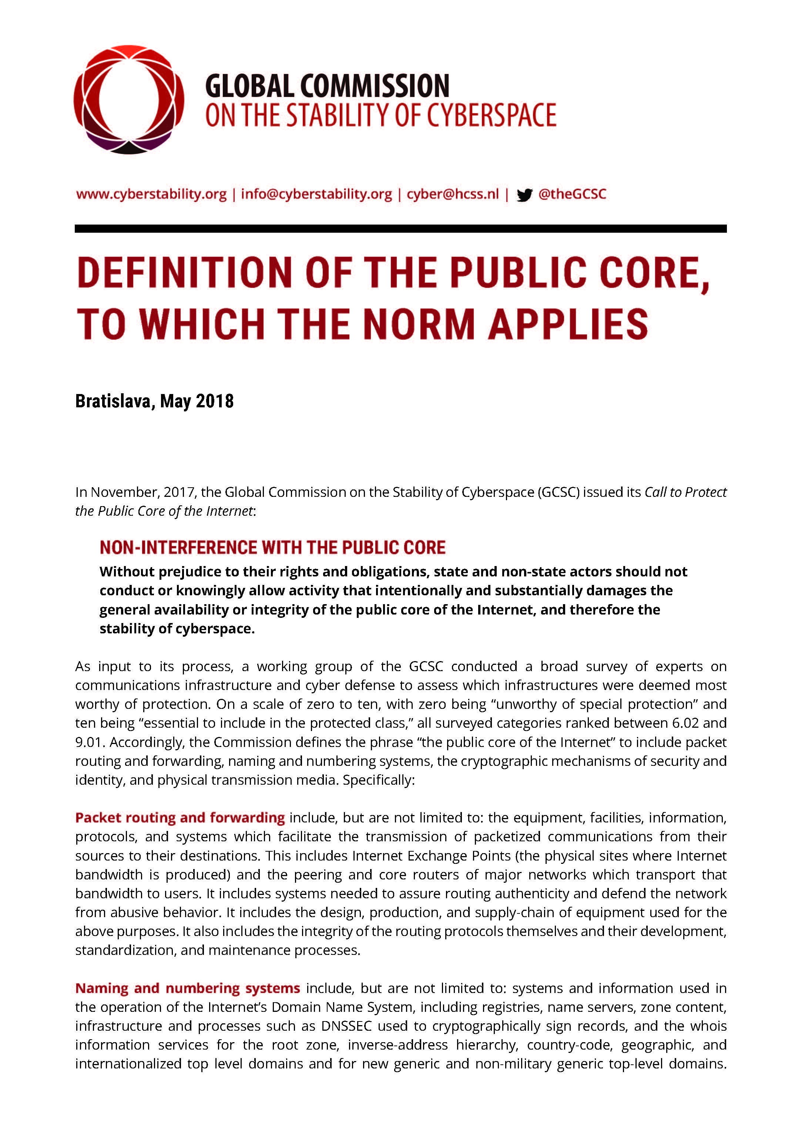

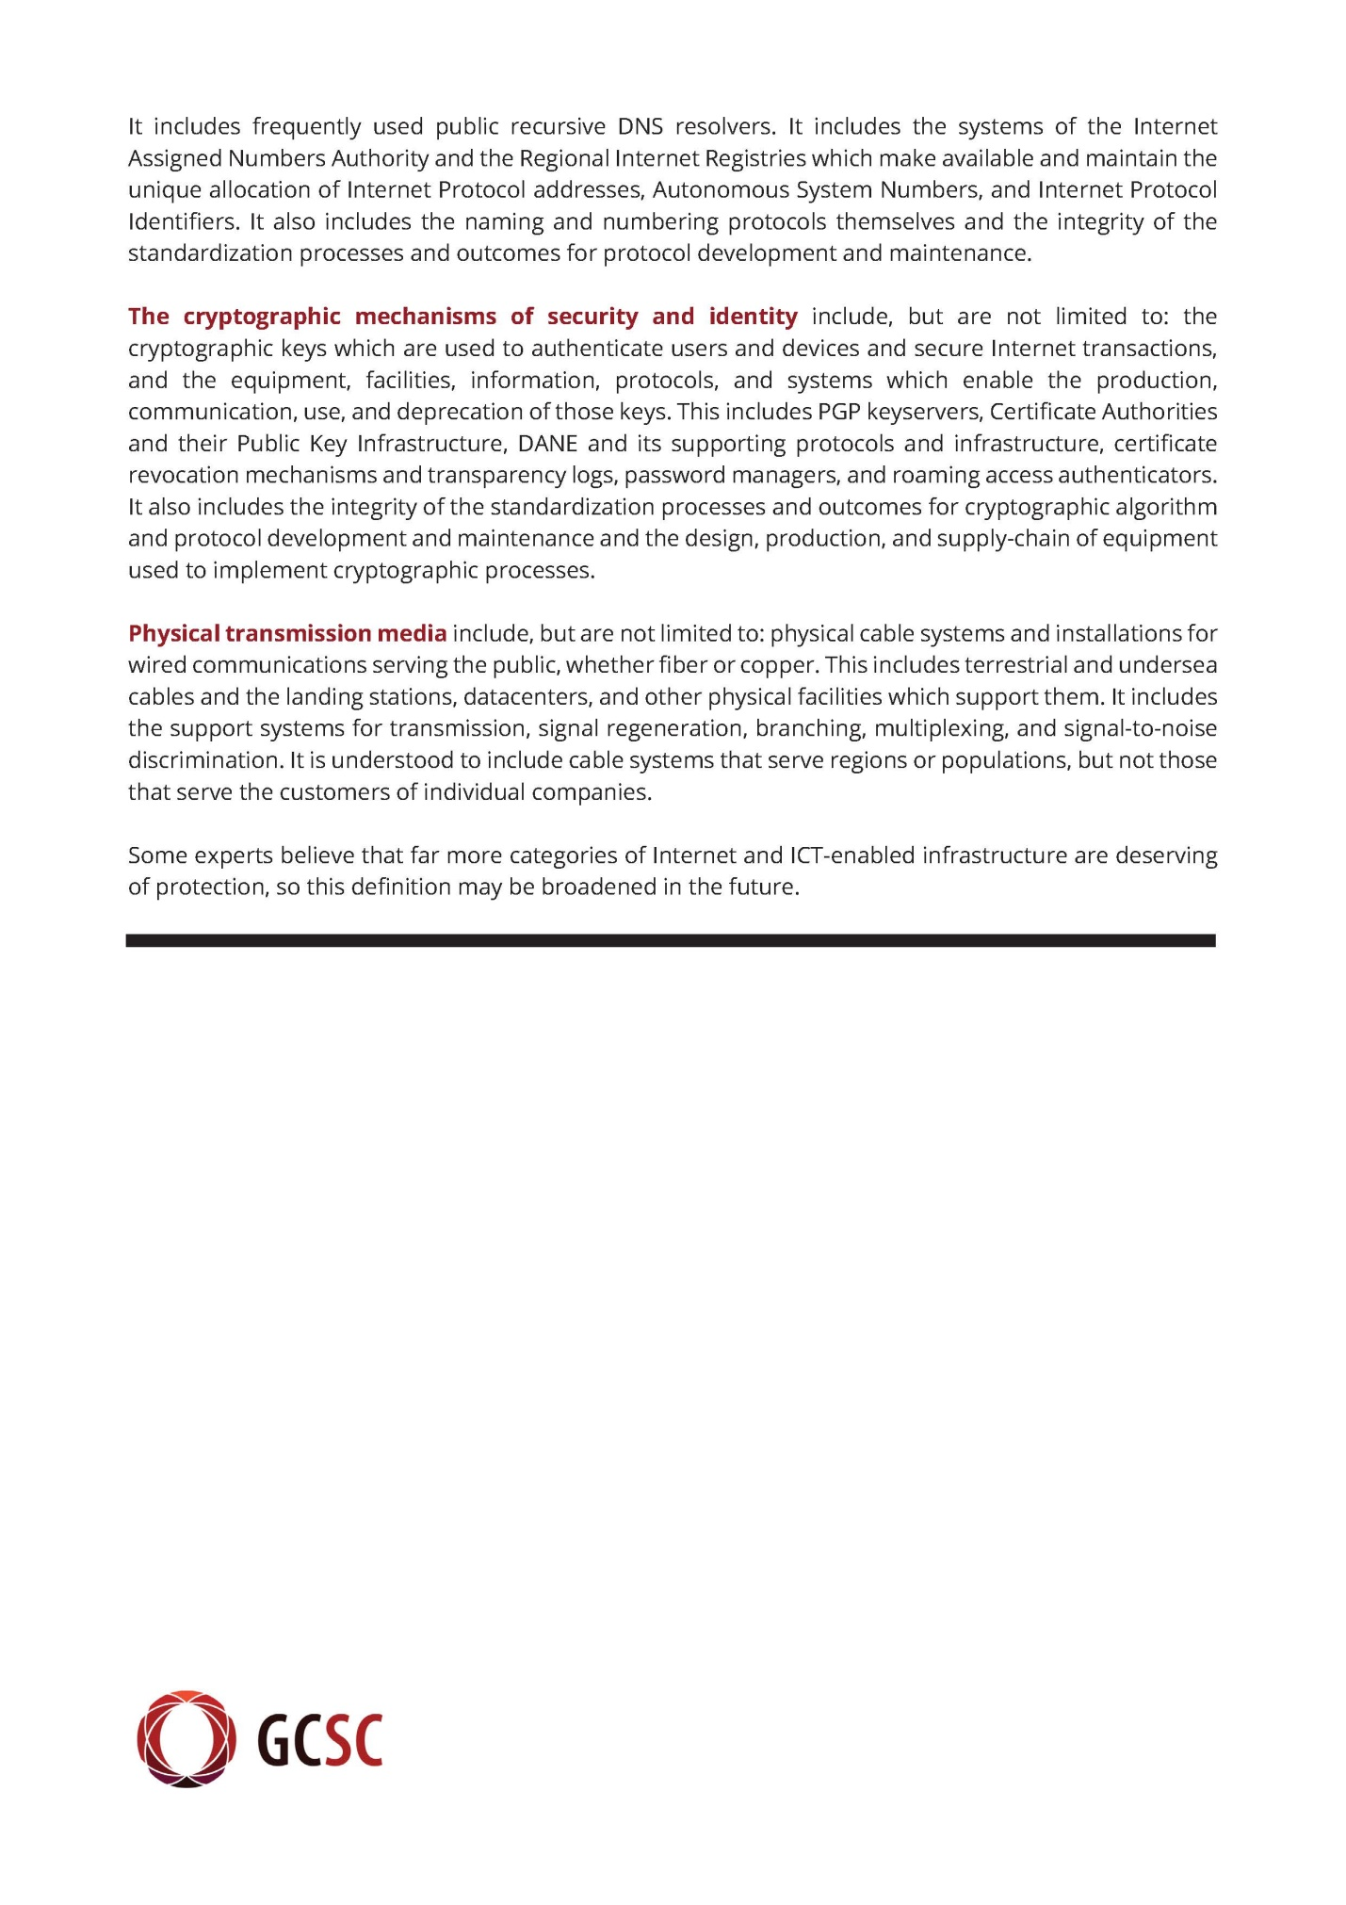

________________

1. <https://www.un.org/sg/en/content/sg/speeches/2021-03-07/remarks-opening-of-14th-un-congress-crime-prevention-and-criminal-justice%C2%A0>