Council Working Group on WSIS and SDG  36th meeting – Virtual meeting, 28-29 January 2021 | 
 | Document CWG-WSIS&SDG-36/17-E
 | 21 December 2020
 | English only
Template FOR REPORTING ON Regional activities towards alignment of wsis and sdg processes

Summary
Following the outcomes of the 35th meeting, this document presents a draft template for the vice-chairs of the regions to report on their contributions to the implementation of the WSIS Outcomes and alignment with the 2030 Agenda for Sustainable Development.
Action required
Members are invited to consider the template.

(Region) Contribution to the Implementation of the World Summit on the Information Society (WSIS) Outcomes and alignment with the 2030 Agenda for Sustainable Development
[YEAR]

- Table of Contents

- Introduction and Overview
(Overall description of the landscape including the achievements, challenges, opportunities and emerging trends)

- Implementation of WSIS Action Lines and SDGs

WSIS Action Lines

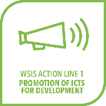 | С1. The role of public governance authorities and all stakeholders in the promotion of ICTs for development
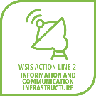 | С2. Information and communication infrastructure
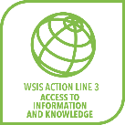 | C3. Access to information and knowledge
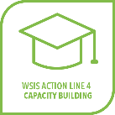 | C4. Capacity building
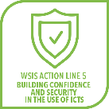 | C5. Building confidence and security in the use of ICTs
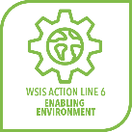 | C6. Enabling environment
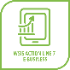  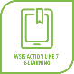  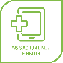    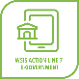  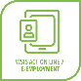  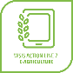   | C7. ICT Applications
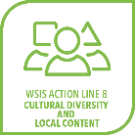 | C8. Cultural diversity and identity, linguistic diversity and local content
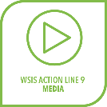 | C9. Media
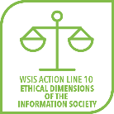 | C10. Ethical dimensions of the Information Society
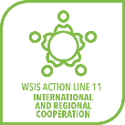 | C11. International and regional cooperation

  - C1: The role of governments and all stakeholders in the promotion of ICTs for development

- Provide general overview of the WSIS Action Line implementation in the region

- In the table below you may provide specific examples

Initiative/Activity | Purpose and beneficiary | Target SDGs met
(Provide name of the project/initiative/activity/ programme and the brief description) | (Specify the aims of the projects and list the tangible results as well as the beneficiaries) | (List the relevant SDGs)

[Elaborate on the activities implemented per country with a short paragraph; kindly put the name of the country in bold]

*We encouraged Member States to include graphs, pictures, photographs, and links of the relevant activities when possible.

- Activities related to COVID Response
- Conclusion

