Council Working Group on  Financial and Human Resources | 
Fourteenth meeting – Virtual, 20 – 21 September 2021
 | Document CWG-FHR-14/INF-1
 | 2 August 2021
 | English only
Contribution by the Secretariat
DESCRIPTION OF THE NEW ITU aCCOUNTABILITY model and fRAMEWORK

Summary
This report presents the description of the new ITU Accountability Model and Framework.

Action required
This report is transmitted to the CWG-FHR for information.
____________

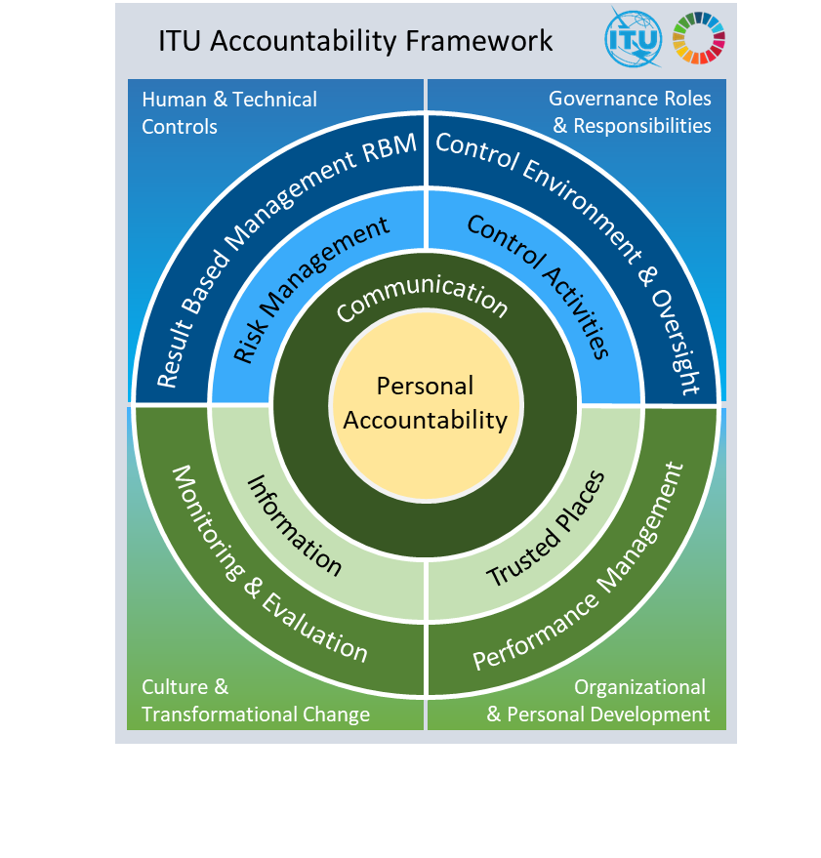


ITU | ACCOUNTABILITY FRAMEWORK - May 2021
The
ITU Accountability Framework
1 Introduction
The ITU Accountability Framework provides a comprehensive view of the components that give assurance of the organization’s system of governance and accountability to its membership. The Accountability Framework is informed by the Joint Inspection Unit’s (JIU) report Accountability Frameworks in the United Nations System (JIU/REP/2011/5).
The concept of accountability is defined in the United Nations General Assembly (UNGA) Resolution (A/RES/64/259) in paragraph 8 as follows:
“Accountability is the obligation of the Secretariat and its staff members to be answerable for all decisions made and actions taken by them, and to be responsible for honoring their commitments, without qualification or exception.”
The ITU Accountability Framework (hereafter “AF”) draws on best practices from the public and private sector. It is embracing overall nine components with 36 elements, such as RBM, development of delegation of authority framework, and risk management to achieve a new level of accountability. ITU will ensure that the AF responds to evolving circumstances and applies best practices from the UN system.
Precisely, the AF has been developed based on three design principles:
1) The elements of three models have been considered to ensure proper accountability and fostering transparency as well as responsibility:
- The 17 benchmarks identified in JIU/REP/2011/5 are fully reflected in the ITU AF. Also, the key components of a robust accountability framework, as identified in the report, have been integrated, namely (i) the political covenant with Member States; (ii) internal controls; and (iii) complaints and response mechanisms.
- The AF draws on the Committee of Sponsoring Organizations of the Treadway Commission (COSO) Internal Control-Integrated Framework, as it is applied within the International Organization of Supreme Audit Institutions’ (INTOSAI) guidelines for internal control standards for the public sector. Specifically, it incorporates the five COSO components, namely: Control environment; risk management; control activities; information and communication; and monitoring. Additionally, the model includes components for planning and ethics.
- The AF is expressed in terms of the Three Lines Model (TLM). Operational managers are the “first line” – those who own and manage risks and controls during implementation (Performance and Risk Management). The “second line” is comprised of the Control Activities, established by the management of the organization to strengthen and monitor the first line of controls. The “third line” refers to an independent and objective assurance and advice on all matters related to the achievement of the objectives.
2) The AF is part of how the organization operates as well as part of its cultural development.
3) The AF is a tool for fostering ITU’s performance and enabling the engagement of all ITU staff.

2 The ITU Accountability Framework Model
The below figure illustrates the ITU Accountability Framework with its 9 components and 36 elements. In the subsequent section, each component and element is described in-depth.

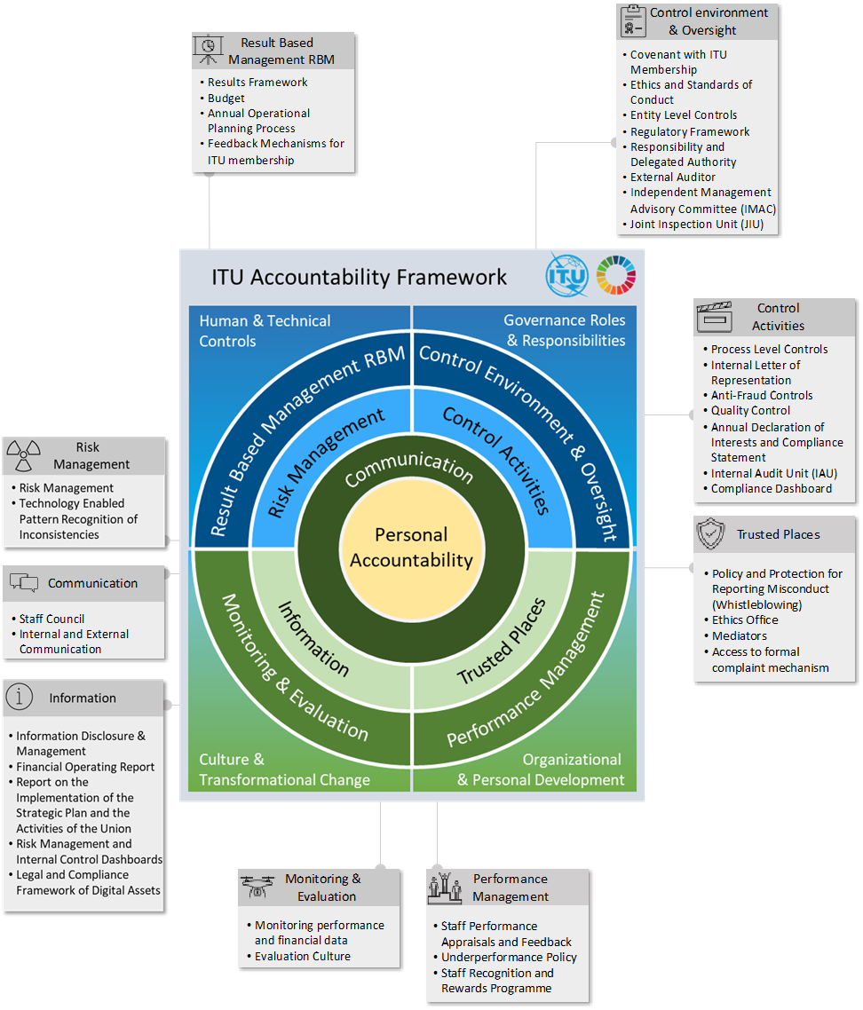

Personal Accountability at the Centre of the ITU AF
Personal Accountability means to be willing to take ownership of tasks, objectives, and the outcome of all involved actions. A person who feels accountable is fully accepting the responsibility for what happens – good or bad. Personal Accountability is a professional mindset which can be trained but should also come from an alignment of one's personal values and the ITU organizational set of values and principles.
Personal
Accountability

Component 1 – Control Environment & Oversight
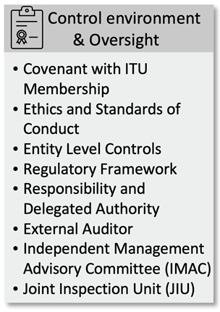
The first component of the Framework comprises the elements Control Environment and Oversight. The Control Environment sets the tone of the organization, influencing the control consciousness of its staff. It is the foundation for all other components of the internal control system, providing discipline and structure. In addition to this internal perspective, Member States also provide oversight of the organization through oversight mechanisms.
- The Covenant with ITU Membership represents the most significant element of the Control Environment and Oversight. The ITU Constitution and Convention establish and define the organization’s mandate and forms the legal basis for the services provided. Furthermore, Resolutions and Decisions adopted by Governing Bodies of the Union also provide instructions on the functioning of the organization.
- Ethics and Standards of Conduct: ITU staff are expected to uphold and promote the highest standards of ethical and professional conduct. The Standards of Conduct for the International Civil Service is applicable to all ITU staff and provides guidance on the standards of conduct expected of staff. Emphasis is placed on the accountability of staff members for their actions and decisions.
The Code of Ethics for ITU Personnel sets out the values and principles to guide the conduct and behaviour of ITU staff. ITU has zero-tolerance for misconduct and has issued related policies which include the ITU Policy on Harassment and Abuse of Authority, the Policy and Protection for Reporting Misconduct (Whistleblowing), the ITU Investigation Guidelines, and the Policy Against Fraud, Corruption and other Proscribed Practices. Ethics training is provided to all staff, and an anti-fraud training course is also provided in order to build on the Policy Against Fraud, Corruption and other Proscribed Practices. In addition, staff must now complete an annual Declaration of Interests and Compliance Statement in accordance with the ITU Policy on Declaration of Interests. Furthermore, Chapter X of the Staff Regulations and Staff Rules describes disciplinary measures.
- Entity Level Controls are recorded in the Risk Management system (ITU risk register) and describe the measures that are in place to provide assurance of good organizational governance.
- The Regulatory Framework includes the Financial Regulations and Financial Rules (FRR), the Staff Regulations and Staff Rules and administrative issuances as well as the Service Orders and the Procurement Manual. The FRR govern the implementation of activities and the financial management of ITU. The Staff Regulations and Staff Rules embody the fundamental conditions of service and the basic rights, duties, and obligations of staff members. They also encompass the broad principles of human resource management. Administrative issuances serve normative and/or informative purposes, as appropriate. As a general rule, office instructions have a binding character and address a wide range of matters, while information circulars and other administrative issuances in principle inform staff of matters of general interest and provide guidance on established policies and practices. These are documented via the Secretariat’s intranet system.
Furthermore, a recruitment policy on restricting hiring of family members and relatives is in place. Additionally, a policy for retirees (ITU applies the UN limitations) and for staff members leaving the organization within an early separation programme has been put in place as well.
- The FRR and the Service Orders provide for delegation of authority that allows the organization to achieve its expected results in an effective and orderly manner. A culture of accountability emanates from the Responsibility and Delegated Authority that is also integrated into the organization’s ERP system.
- The External Auditor provides an opinion on ITU’s financial statements and on compliance with the regulatory framework of the organization. They issue recommendations and monitor regularly their implementation. Their reports are publicly accessible once approved by the Council.
- The Independent Management Advisory Committee (IMAC) is the subsidiary body of the ITU Council. It serves in an expert advisory capacity and assists the Council and the Secretary-General in effectively fulfilling their governance responsibilities, including ensuring the functioning of ITU's internal control systems, risk management and governance processes, as well as its human resources management.
- The Joint Inspection Unit (JIU) is the independent external oversight body of the United Nations (UN) system mandated to conduct system-wide evaluations, inspections, and investigations. The implementation of JIU recommendations addressed to legislative bodies is reported by the Secretariat to Member States.

Component 2 – Result Based Management (RBM)
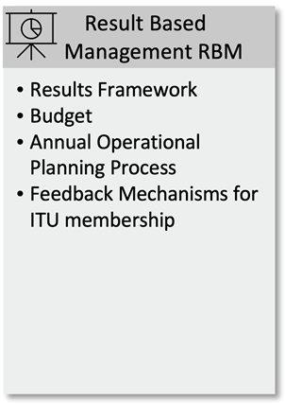
The second component of the Framework encompasses both the proactive planning component Result Based Management (RBM) process, as well as the reactive component Feedback Mechanisms. RBM is operational and coherent with organizational mandates and objectives, and cascades down into unit and personal work plans.
- The ITU Results Framework, presented in the organization’s strategic and operational plans, consists of strategic goals and objectives, their corresponding targets and outcomes and the outputs delivered by ITU. The contribution of the work of ITU is defined through performance indicators which have baselines and targets established. An overview of these indicators is presented through the annual report on the implementation of the strategic plan.
- Member states approve the financial plans as well as the biennial Budget that sets out how resources are allocated for the achievement of the goals and objectives. Implementation strategies and risks are clearly defined for each objective.
- Annual Planning is operationalised through the Annual Operational Planning Process, which is supported by specific planning tools. The annual rolling operational plans operationalise the 4-year strategic plan, guiding the work plans for departments and units, which cascade down to the individual objectives of the electronic Performance Management and Development System (ePMDS).
- Feedback Mechanisms for ITU Membership include all processes that enable direct contact and engagement with the Secretariat, through the meetings of the Council and its Council Working Groups and Expert Groups, the Sector advisory groups, as well as any other formal or informal consultation mechanisms (including the Sector-specific study groups and working parties, focus groups, and other initiatives).

Component 3 – Risk Management
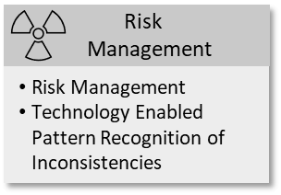
The Risk Management component describes the process of identifying and analysing relevant risks to achieve the entity’s objectives and determining the appropriate response, thereby illustrating the full lifecycle of the management of risks, including financial rules and recognition of inconsistencies.
- Risk Management is performed across all functions of the organization to ensure that results are achieved as laid out in the strategic and operational plans, and in line with the organization’s regulatory framework as well as ethical and integrity standards. The acceptable level of risk is defined in the ITU Risk Appetite Statement and the Secretariat’s risk management processes are defined in the ITU Risk Management Policy. The day-to-day operational details of managing risks and controls at ITU are documented in the Risk Management and Internal Controls Manual.
The Organization Resilience Management System (ORMS) is divided in two components, Business Continuity (BC) and Crisis Management (CM). A Business Continuity Management System has been developed in the context of current international standards and best prac-tice. It comprises a structured group of policy, plans, guidelines and reports which together enable the realization of business continuity, while a holistic approach has been established for effective Crisis Management (CM) of all ITU activities globally.
- New systems, tools, and technologies like Artificial Intelligence (AI) are now able to identify inconsistencies, deviations from the expected pattern and unusual relationships within related documents. AI will be a key feature in the near future to support and enhance human control and supervision activities through technology enabled pattern recognition of inconsistencies. Overall, this can be considered as a cross-cutting component, as AI is extensively used to prevent fraud and improve control mechanisms.

Component 4 – Control Activities
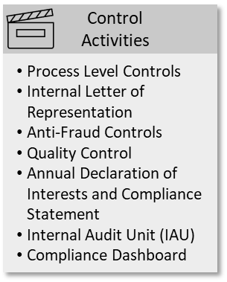
Control activities are performed at various levels of the organization and are established to ensure reasonable assurance regarding the reliability of reporting, the effectiveness and efficiency of operations, compliance with applicable policies, regulations and rules, and the safeguarding of resources. Failure to comply with enforced policies/regulations results in clear consequences. Sanctions shall be clear and proportional and implemented at all levels.
- Process Level Controls are the internal control processes, tools and systems, which are embedded in the various administrative and organizational processes to provide assurance that the processes are performed in compliance with the Regulatory Framework.
- Each Elected official, each Deputy to the Director of Bureaux, all Chiefs of Departments and Heads of Divisions/Units of General Secretariat Departments and Financial Controllers are required to submit an Internal Letter of Representation, which constitutes a written confirmation that they have duly exercised delegated financial authorities and responsibilities. Possible further improvements will be considered in this process, assessing whether this has been proven to be a helpful tool, and how the Internal Control processes can be further enhanced.
- Anti-Fraud Controls are in place to deter and detect fraud. The ITU Policy Against Fraudulent and Other Proscribed Practices outlines the policy and procedures adopted by ITU to prevent, detect and respond to fraudulent and other proscribed practices. ITU staff with information or evidence to support a reasonable belief of fraud, corruption, and other proscribed practices have a duty to report it and will be protected from retaliation related to such reports.
Fraud risk assessments are undertaken periodically, to identify which ITU assets, programmes, activities, and interests are exposed to fraud risk and to assess the level and impact thereof.
- Quality Control activities are undertaken across the organization. However, a more holistic approach is currently under consideration.
19. All ITU staff are required to complete an annual Declaration of Interests and Compliance Statement. As part of their declaration, staff must acknowledge that they are aware of their duties under the Code of Ethics and related policies. In addition, staff must declare if they are aware of any situation or circumstance that would put them in breach of such ITU policies. The Declaration of Interests and Compliance Statement is described in the ITU Policy on Declaration of Interests.
- The Internal Audit Unit (IAU) is an independent function assisting the Secretary-General in fulfilling the internal responsibilities entrusted to the Secretary-General of ensuring that the organization is managed effectively, efficiently and economically, and in conformity with the applicable regulations and rules. This function encompasses the deterrence and prevention of fraud, waste and mismanagement in the ITU's operations and programmes. ITU IAU is an independent, objective assurance and consulting activity designed to add value and improve ITU’s operations. The purpose of ITU IAU is to help the organization accomplish its objectives by bringing a systematic, disciplined approach to evaluate and improve the effectiveness of risk management, control, and governance processes. ITU IAU represents the third line of the TLM and provides assurance as well as assistance to management in the effective discharge of their responsibilities and the achievement of ITU’s Strategic Goals, Objectives, Outcomes, and Expected Results.
Furthermore, the creation of an independent and dedicated Internal Investigation Function has been recently established. The ITU Investigation Guidelines will be completed and updated. Most importantly, a comprehensive review of the disciplinary procedures will occur following the approval of the internal investigations position.
- The ITU Compliance Dashboard has been implemented as the central repository for all recommendations made by internal and external oversight bodies, i.e. Internal Audit, External Audit, IMAC and the JIU. Through the tool, responses to the recommendations are being tracked, follow-up on their implementation is monitored and reports on the implementation are presented to Member States.

Component 5 – Information
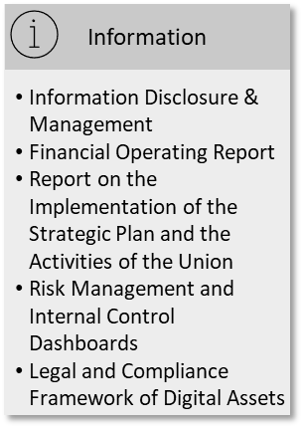
The Information component describes the systems in place to document and report on operational, financial, non-financial, and compliance-related information. The form and timeframe within which such information is provided is particularly critical to ensuring that staff can carry out their responsibilities effectively. It further describes whether staff at all levels have access to relevant, reliable information that supports decision-making in line with their delegated authorities and whether the organization has an internal and external communication system.
- Information Disclosure and Management: As a step towards more transparency and accountability, the ITU Plenipotentiary Conference has approved ITU’s information/ document access policy, ensuring access by the public to select information and data kept, managed or generated by ITU. Consolidated annual reports are presented to the Council and made public upon adoption. Quarterly progress reports are provided to membership.
ITU manages information and knowledge through standardized information management, i.e. Enterprise Resource Planning (ERP), customer relationship management, SharePoint, Microsoft Teams and ITU intranet repositories, the ITU website, file repositories and Business Intelligence (BI) and monitoring and evaluation tools which provide staff, membership and the public access to information based on role and function. The issue of relevant and reliable information to support decision-making is being reviewed, thereby identifying and implementing improvements required in that area.
- ITU publishes annually the ITU Financial Operating Report and the Report on the Implementation of the Strategic Plan and the Activities of the Union, providing performance and financial information for Member States’ information and consideration. The report on the implementation of the strategic plan contains information on the progress achieved towards the ITU strategic goals, objectives and related outcomes, through the monitoring and reporting of key performance indicators. Financial statements are prepared and audited annually, in compliance with the ITU Financial Regulations and Financial Rules and the International Public Sector Accounting Standards (IPSAS). There are numerous annual reports: on Internal Audit Activities, the Human Resources Strategic Plan, as well as the activities of the Ethics Office. Financial Circular Letters are issued quarterly on budget execution and forecasts up to the end of the current year. These Circular Letters also provide information on the debt of Members to the Union.
- Risk Management and Internal Control Dashboards are available to ITU’s Risk Management Focal Points,the Senior Management Team and other staff on an as-needed basis providing up-to-date information to support management decisions.
- The need for a Legal and Compliance Framework of Digital Assets has also been identified. Consequently, information assets need to be protected from loss, damage, or unauthorized disclosure or modification. At the same time, data protection and data privacy are becoming a priority, requiring policies, procedures, and systems to ensure that personal information is captured, stored, and processed in ways that are secure. To address these concerns, ITU is developing an organization-wide data/information classification framework that includes classifying information in terms of both its need for protection from unauthorized access or disclosure (sensitivity) and its need for availability (criticality), and identifying and implementing the protection requirements for each category of information (both sensitivity and criticality) throughout the information lifecycle (creation, storage, use, and disposal).
In parallel with the rapid rollout of tools to enable staff and delegates to work remotely, ITU accelerated the establishment of information governance frameworks adapted to fully digital work processes. ITU corporate systems (e.g., SAP ERP, CRM, Recruitment) are being upgraded not only to ensure continuing vendor support but also to benefit from improved or new functionalities related to data protection, information management compliance, and data analysis based on AI/Machine Learning. The issues of “Device acquisition procedures for forensic investigations” and “legal hold procedures” are being reviewed, and guidelines developed, in connection with the newly established investigation function.

Component 6 – Communication
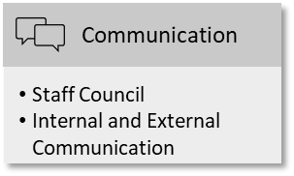
The Communication component is crucial in the AF because it captures the style, conduct and content of all exchanges among staff, the middle and the top management, exchanges with membership, with colleagues from other UN entities and with media, in a two-way relationship as discussions, debates, discourses and mutual promotion. It creates the joint understanding of each other’s standpoint and leads from problems to solutions.
- The ITU Staff Council serves as an official interface between ITU administration and staff. It represents staff in internal statutory committees and staff’s interests in front of the administration. All ITU staff are members of the Staff Council.
- Internal and External Communication supports the Union in achieving its objectives. External communications in the AF means a way of promoting the ITU brand in line with the ITU Constitution, the Connect 2030 Agenda and the Strategic Plan,fostering ITU’s reputation and maintaining trust in ITU’s work. This requires listening to audiences and sound judgement in walking the talk of ITU’s Code of Conduct and balancing risks and benefits for the Union, often on the fly. Monitoring and evaluation tools (e.g. Talkwalker, Power BI) help optimize communication impact and ITU relevance and make more effective use of limited resources. Internal communications in the AF means listening and two-way and multi-way engagement among staff and among staff and leadership. Leadership trust in the communicators’ and staff’s judgement and personal accountability promote agility and thus timely communication, both internally and externally. The communication style of ITU expresses a mindset of openness, collegiality, productivity, mutual support, recognition and turning conflicts into solutions.

Component 7 – Performance Management
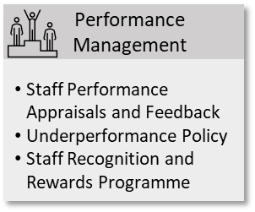
The Performance Management component contains performance appraisals and feedback, based on managing executive heads, senior managers and staff members’ performances.
- Staff Performance Appraisals and Feedback is undertaken through a continuous dialogue between staff members and managers on past and future performances. This dialogue fosters a culture of trust, transparency and honesty, where individuals are held accountable for their performance, recognized for their achievements and mentored to develop their potential. Staff are being held accountable through individual and team workplans in line with ITU priorities and the Strategic and Operational Plans. The dialogue is carried out between staff members and managers and results of performance conversations are recorded in the ePMDS. The implementation of work and learning objectives are conducted annually and reviewed at mid-term and year-end. Furthermore, a frequent dialogue is promoted. Staff members are invited to take action through the establishment of training plans for redressing situations in collaboration with their supervisors.
Up-to-date job descriptions are reflecting duties and responsibilities of the Bureaux or Departments/Units of the General Secretariat.
A 360-Pilot has been implemented to further strengthen leadership and accountability in the managerial population. This feedback mechanism is currently being evaluated for expansion to the whole organization. This has been done not in the context of a performance review but within a developmental plan. Together with management controls, performance monitoring represents the first line in the TLM, where managers are accountable for ensuring that work is undertaken in accordance with approved plans.
- A new underperformance policy is being prepared. It builds on existing procedures to prevent and manage unsatisfactory performance.
- A new ITU Staff Recognition and Rewards Programme recognizes three categories of individual and team performance awards, which seek to acknowledge results achieved through the highest levels of teamwork, innovation and leadership.

Component 8 – Monitoring & Evaluation
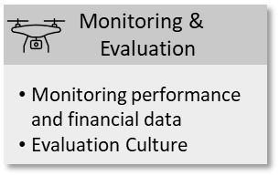
The next component of the Framework encompasses the monitoring and evaluation activities. ITU continues to improve responsiveness to all its Member States. Through the use of performance and financial information data, decisions are made much more consciously and therefore increase the management quality.
- Monitoring performance and financial data: The use of business intelligence/ reporting tools, leveraging the ERP system, allows the monitoring of key performance indicators, to analyse the impact of ITU’s work. Such reporting tools enable ITU management to take corrective actions where necessary. At the level of projects, ITU already reviews on a quarterly basis the performance of projects, with the aim of ensuring the ITU projects achieve the expected results within the defined resources and timeline.
- Evaluation Culture: The Organization is in the process of strengthening an evaluation culture, through the development of an ITU wide evaluation policy and evaluation guidelines, which would enable the Organization to learn from past experience and provide assurance to the donors on the impact of (i) the funded projects and (ii) the regular budget activities.

Component 9 – Trusted Places
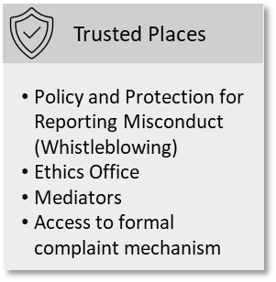
The Trusted Places component represents all measures and places where ITU staff or other stakeholders can go in full confidence and where sensitive issues, which might harm ITU or individual employees, are handled with professionalism and the highest degree of confidentiality. Elements to foster ethical conduct, standards of integrity, anti-corruption and anti-fraud policies complete this component.
- The Policy and protection for reporting misconduct (Whistleblowing) sets out the protections against retaliation for reporting misconduct and for cooperating with duly authorised audits or investigations. It clarifies the rights and responsibilities of ITU personnel with respect to reporting suspected misconduct, in order to encourage ITU personnel to raise concerns which may impact the interests, operations or governance of the organization.
- The Ethics Office fulfils an independent function and is responsible for ethics-related standard setting and policy development, outreach and training, as well as advice and guidance to staff. The Ethics Office provides confidential advice and receives allegations of misconduct.
A confidential helpline has been established so that individuals can contact the Ethics Office anonymously.
- Mediators are ITU staff volunteers selected by the Administration/ Staff Council. They act as impartial third parties to assist in resolving conflicts by using specialized communication and facilitation techniques. They are the first place to go if two parties such as an employee and his/her superior are failing to come to an agreement over a disputed matter.
- Access to formal complaint mechanism: Staff members have access to ILO Administrative Tribunals.
3 The Design of the ITU Accountability Framework
The complex governance and structure of the ITU, its role as the UN specialized agency for Information and Communication Technologies (ICTs), as well as the mixture of highly skilled staff make ITU a unique organization.
Building on the definition of accountability provided by the UNGA, accountability is the basis and justification of decisions and being fully responsible for what is done and the negative or positive consequence it has for ITU.
Every organization can be seen as a dynamic system with structures as the hard backbone while culture serves as an enabler for performance as well as being the professional and social glue. The congruence, the alignment, and balance of both dimensions are key to a remarkable and delivering organization.
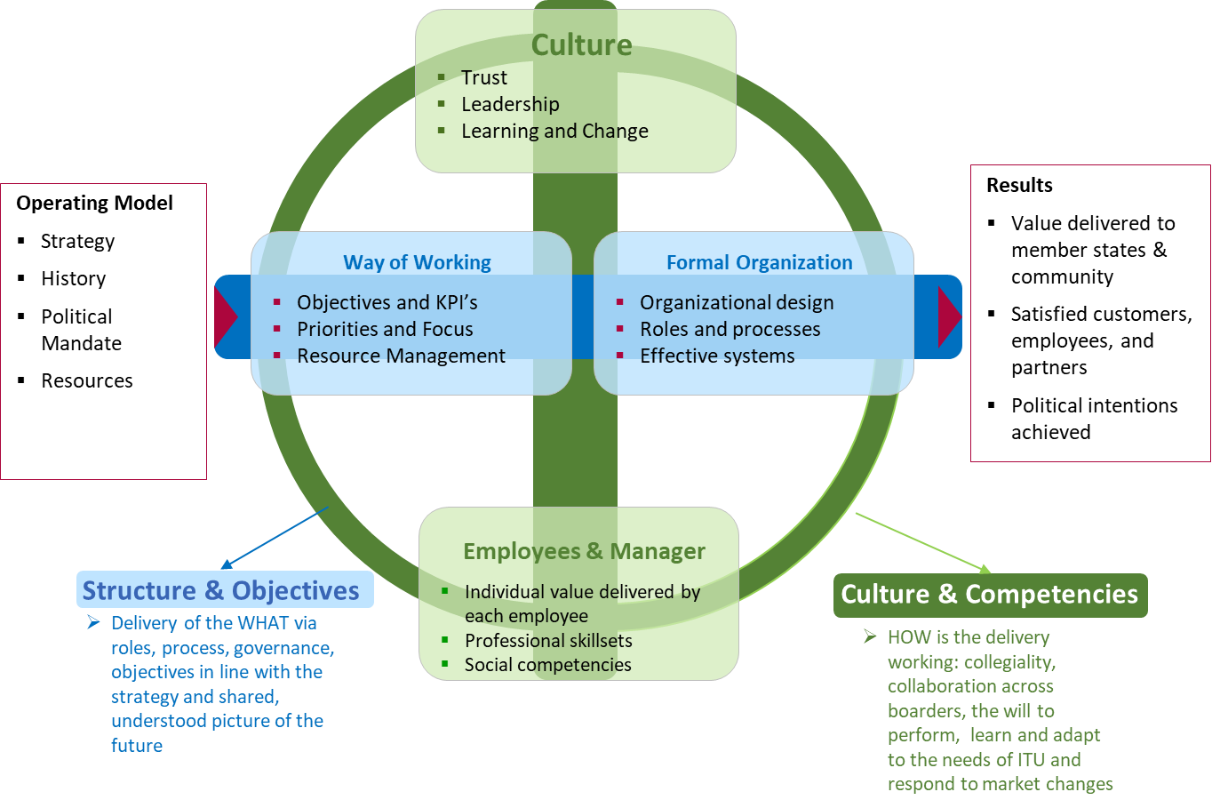
The congruence of structure and culture is key to any well performing organization.

Congruence of structure and culture as the two dimensions of the Framework
ITU’s accountability model is balancing both dimensions, structure and culture. They are enforcing each other. Being given responsibility and acting in a reasonable, transparent, and professional manner is common sense in a well-performing organization. Yet formal control, supervision, and clear steering is still needed.
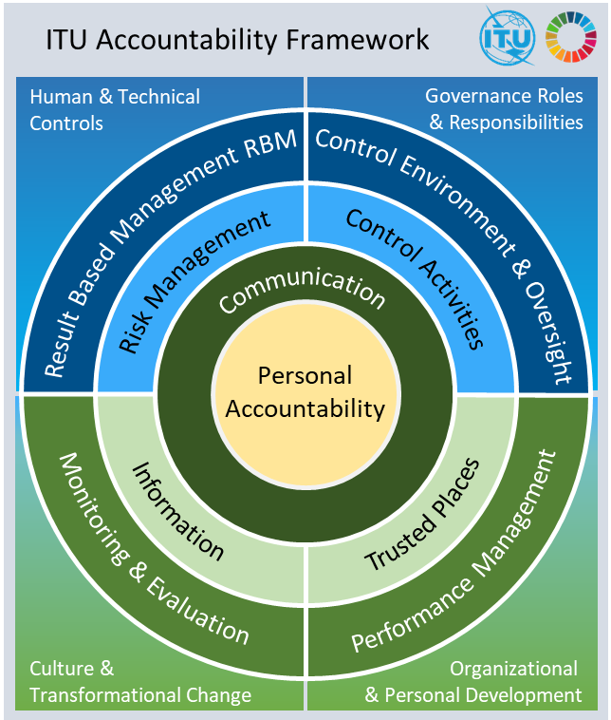
In the ITU AF model, the blue colour is representing the structural, formal, and technically supported processes and roles within the organization. The green colour on the other hand is highlighting all cultural aspects, including personal behaviour and competencies of each staff and manager, mind-set about respect, responsibility, transparency, and openness in collaboration across perceived silos. The congruence of these two dimensions is the pre-requisite for an accountability framework that is serving the formal and structural framework with a strong performance culture in the background and the mindset of staff in the centre.
The four corner elements of the model are not functional elements. However, they are allocating the components together with their elements in a logical and reasonable order.

The Structural Components of the Model

Corner Element 1 – Human & Technical Controls
Overall, the AF aims to be rooted in ITU’s culture. However, mindset and behaviour can be supported by methods, tools and technology which encourage transparency and a strong sense of ownership for delivering value to internal and external stakeholders.

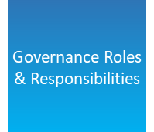
Corner Element 2 – Governance Roles & Responsibilities
The AF is taking into account undisputable formal requirements and rules of compliance on the one hand, as well as each individual staff's behaviour with regards to their competencies, roles, and responsibilities on the other hand. To combine these two points, effective communication and training are key.

The Culture Components of the Model

Corner Element 3 – Culture & Transformational Change
As described in JIU/REP/2011/5, the culture of accountability is a necessity for the framework to move from paper to implementation. To foster a culture of adaptation, innovation, and motivation for all staff, accountability can be used to be one of the permanent drivers for balancing ethics versus professional performance.

Corner Element 4 – Organizational & Personal Development
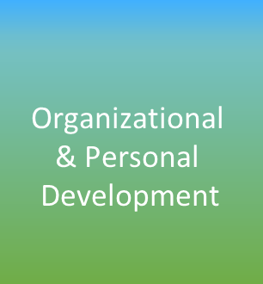
Accountability as part of professional behaviour can only be introduced and kept alive with permanent personal development. It is a pervasive mindset which counterbalances potential wrong-doing and lack of professional behaviour.

4 Appendix – Proposal of New Elements
To further strengthen the AF, the following new elements are proposed. Those elements are currently being considered for establishment and integration in the overall model.

Control Environment & Oversight
Each manager, must be made aware of, and trained in, the practical meaning with the Binding Leadership Guidelines (BLG). These are a set of rules jointly developed by selected groups of leaders, representatives of staff, and the mediators. The BLG contain rules affecting the personal conduct of the manager, the responsibility and accountability which come with the role, as well as caring for staff. Caring is referring to ensuring a systematic personal and professional development as regular part of the assigned role of that manager.

Communication
One of the key motivators for a well performing organization is the appreciation of individual performance. To foster a culture of performance, it is key to make use of learning with the identification of best work practices. They are disseminated in the Leadership Circles (see below). Individuals and teams are recognised for the identification of the most effective way of delivering the ITU services. They are being published and openly communicated with the intention of Recognition: Published Best Work Practices.

Performance Management
The Organizational Health Index is an indicator of the degree to which strategic goals have been achieved as well as a tool to keep the long-term perspective on performance. The Organizational Health Index (OHI) applies analytical rigor including quantitative diagnostics to measure, achieve and sustain long-term performance (source: McKinsey & Company). It could be applied for a limited number of years during a change programme.

Monitoring & Evaluation
Leadership Circles is a group of managers from the three sectors and the General Secretariat who are exchanging their approaches to achieve the objectives and their strategies to get there. For three months, the managers come together each month to share experiences in a structured dialogue in small groups. In this intimate setting, they are also discussing about root causes of failure as well as success. They provide mutual supervision to each other and ensure the exchange across the organization. It becomes clearer how managers in the organization are performing, and with what success. After a certain period of time, new groups are formed.
Team performance tracking is done inherently with every group that is working on strategic issues across the three sectors within ITU. Once the team composition is clear, the members agree on specific rules of conduct and self-contract to a regular informal review (Team Monitor).

Trusted Places
An institution could be established to facilitate potential conflicts , and which does not conduct investigations or keep records, but labors to help managers and staff resolve their workplace concerns informally through facilitation, shuttle diplomacy, conflict coaching and mediation, beyond the “volunteer mediation” currently in place at ITU. An Ombuds would be such a solution and is also a part of the accountability framework in other agencies. Ombuds are paid positions that are selected through the Organization’s recruitment process, they are independent and report to the Governing Bodies of the Organization to ensure the neutrality of the position.

________________

