|  |  |
| --- | --- |
| **Council Working Group on  Financial and Human Resources**  **Fourteenth meeting – Virtual, 20 – 21 September 2021** |  |
|  |  |
|  |  |
|  | **Document CWG-FHR-14/6** |
| **28 July 2021** |
| **English only** |
| Contribution by the Secretariat | |
| STATUS REPORT ON IMPLEMENTATION OF  COUNCIL DECISIONS 600 AND 601 (UIFN, IIN) | |

|  |
| --- |
| Summary  Following the approval of Decisions 600 and 601 at the Council 2017 session, ITU has been in the process of implementing these Decisions. This report summarizes the status of the implementation and the consultations with Member States.  The document C21/47 was already presented to and reviewed at the 2021 session of the Virtual consultation of councillors.  This document presents updated information to [C21/47](https://www.itu.int/md/S21-CL-C-0047/en).  Action required  The Council Working Group is invited to **note** the conclusions provided in section 5.  ____________  References  *Document* [*C17/133*](https://www.itu.int/md/S17-CL-C-0133/en)*;* [*C17/134*](https://www.itu.int/md/S17-CL-C-0134/en)*;* [*C18/100*](http://www.itu.int/md/S18-CL-C-0100/en)*;* [*CWG-FHR 9/1*](https://www.itu.int/md/S19-CLCWGFHR09-C-0014/en)*4;* [*CWG-FHR 9/15*](https://www.itu.int/md/S19-CLCWGFHR09-C-0015/en)*;* [*C19/47*](https://www.itu.int/md/S19-CL-C-0047/en)*,* [*C19/120*](https://www.itu.int/md/S19-CL-C-0120/en); [*C20/47*](https://www.itu.int/md/S20-CL-C-0047/en); [*C21/47*](https://www.itu.int/md/S20-CL-C-0047/en) |

# 1 Background

1.1 Following the approval of Decisions 600 ([C17/133](https://www.itu.int/md/S17-CL-C-0133/en)) and 601 ([C17/134](https://www.itu.int/md/S17-CL-C-0134/en)) at the Council 2017 session, the ITU secretariat has been in the process of implementing these Decisions.

1.2 TSB presented document [C19/47](https://www.itu.int/md/S19-CL-C-0047/en) to Council 2019 which provided updates of the status of implementation of Council Decisions 600 and 601, including the status of the contacts for UIFN service providers and IIN assignees.

1.3 Council 19 approved the recommendations captured in Section 2.2.25 of the summary record of the ninth and last council plenary meeting in document [C19/120](https://www.itu.int/md/S19-CL-C-0120/en).

# 2 Financial updates

2.1 UIFN (Council Decision 600)

In 2018, the invoices for the UIFN annual maintenance fee represented CHF 744 400. An amount of CHF 349 033 has been cancelled per Council 2019 recommendations for entities that are no longer in business. To date 94% of the valid invoices amounting to CHF 395 367 have been paid and CHF 21 700 still needs to be recovered.

In 2019 the invoices sent represented CHF 193 100 and 99% of the payments have been received. The remainder still needs to be recovered.

In 2020 the invoices sent represented CHF 141 400 and ~~68%~~ 98% of the payments have been received. The remainder still needs to be recovered.

As of ~~23.03.2021~~ 26.07.2021, the total amount to be recovered for UIFN maintenance fee for 2018, 2019, and 2020 is ~~CHF 66 400~~ CHF 24 600.

Annex B lists the entities for which TSB has a valid contact, that have been billed in 2018, 2019, and/or 2020 and have not paid their bills to date. The secretariat seeks the assistance of Members States in recovering this debt.

2.2 IIN (Council Decision 601)

~~The invoices for IIN annual maintenance fee for 2018, 2019, and 2020 have not been generated yet as the secretariat continues to seek confirmation of contacts from national Administrations/regulators or authorized agencies for IIN assignees.~~

The invoices for IIN annual maintenance fee for 2018, 2019, and 2020 were not generated as the secretariat was seeking confirmation of contacts from national Administrations/regulators or authorized agencies for IIN assignees.

Registered IINs with confirmed contacts will be billed and given the current rules in force in Finance, only from 2021 and not for previous years. Invoicing technical steps were engaged for these IINs.

The secretariat will continue to seek confirmation of contacts from national Administrations/regulators or authorized agencies for IIN assignees.

# 3 Status of the contacts for UIFN service providers and IIN assignees

3.1 In accordance with Council 19 approved recommendations captured in Section 2.2.25 document [C19/120](https://www.itu.int/md/S19-CL-C-0120/en), this section provides an update on the status of UIFN service providers and IIN assignees:

3.1.1 The list of UIFN service providers in **Annex A** will be marked as “not reachable” in the ITU database. The records for these UIFN service providers are subject to removal from the ITU database and the UIFNs assigned to them are subject for reclamation based on confirmations/notifications from national Administrations/regulators. Among these UIFN service providers, for the ones to whom invoices for the maintenance fee for 2018 have been sent, the invoices will be cancelled.

3.1.2 If the invoices sent to the UIFN service providers in **Annex B** remain unpaid for an extended period, the secretariat will seek assistance from Member States to recover the debt.

3.1.3 National Administrations/regulators or authorized agencies are encouraged to provide assistance in identifying the up-to-date contact or status of the UIFN service providers (e.g., if they are no longer in business) listed in **Annex C**.

3.1.4 ~~The list of IINs for which contact information is pending will be published on ITU website as IINs with the status “assignee not reachable” and will be announced in the ITU Operational Bulletin.~~ ~~National Administrations/regulators or authorized agencies are encouraged to provide assistance in identifying their up-to-date status and/or contact information.~~

As per an announcement in ITU Operational Bulletin No. 1222 (15.VI.2021), the list of ITU-T E.118 IINs for which the assignee contact is still in progress can be found on the following ITU web page:   
<https://www.itu.int/en/ITU-T/inr/forms/Pages/iin.aspx#assignee-contact-not-reachable>

National Administrations/regulators or authorized agencies are encouraged to provide assistance in identifying their up-to-date status and/or contact information.

3.1.5 For the UIFNs and IINs which are still under consultation with national Administrations/regulators or authorized agencies, their status should be confirmed before 31 October 2021. If no objection is received from national Administrations/regulators or authorized agencies, the corresponding UIFNs and IINs will be considered as no longer active and removed from ITU databases.

3.2 As of 15 March 2021, the contact information status of 849 IINs kept in ITU database is shown in the figure below.

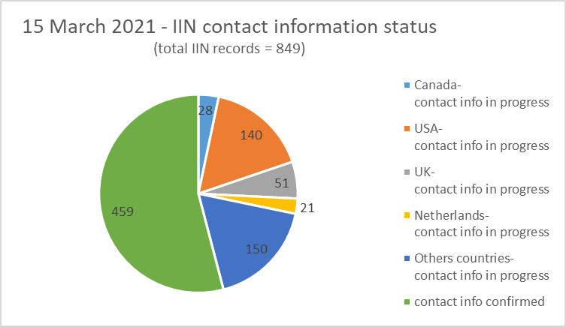

Note: the number of IIN records for the countries listed in the above figure include geographic areas under their Administrations.

**4 Observations**

Based on notifications and responses received from national Administrations/regulators or authorized agencies, the number of IIN record updates per year since 2014 is provided in the table below:

|  |  |  |  |  |
| --- | --- | --- | --- | --- |
| **Year** | **New** | **Deletion** | **Update** | **Total/year** |
| 2014 | 22 | 3 | 12 | 37 |
| 2015 | 24 | 1 | 6 | 30 |
| 2016 | 22 | 1 | 14 | 37 |
| 2017 | 22 | 7 | 83 | 112 |
| 2018 | 35 | 29 | 154 | 218 |
| 2019 | 17 | 7 | 71 | 95 |
| 2020 | 38 | 3 | 8 | 49 |
| As of  15 March 2021 | 7 | 1 | 1 | 9 |

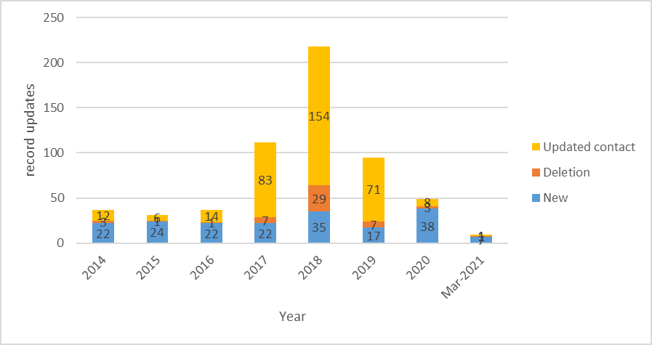

It shows a sharp increase in the number of IIN record updates per year following the approval of Council Decision 601. This process improves the precision of the IIN records kept in the ITU database.

# 5 Conclusion

The secretariat continues the implementation of Council Decision 600 and 601.

In accordance with Council 2019 recommendations captured in Section 2.2.25 of the summary record of the ninth and last council plenary meeting in document [C19/120](https://www.itu.int/md/S19-CL-C-0120/en):

The secretariat seeks the continued assistance of Members States in recovering the debt identified in **Annex B**.

National Administrations/regulators or authorized agencies are encouraged to aid the secretariat in identifying up-to-date status and/or contact information for UIFN identified in **Annex C** and **IIN contacts**.

**Annex A - list of UIFN service providers subject for removal**

None

**Annex B - list of UIFN service providers pending payment for 2018, 2019, and 2020** (with payment updates as of 26.07.2021)

| **year** | **Amount** | **currency** | **UIFN quantity** | **Company's name** | **Country/ Geographic Area** | **note** |
| --- | --- | --- | --- | --- | --- | --- |
| 2020 | 200.00 | CHF | 2 | Telefónica de Argentina S.A | Argentina |  |
| ~~2020~~ | ~~13,900.00~~ | ~~CHF~~ | ~~139~~ | ~~BICS SA~~ | ~~Belgium~~ | (paid on 10.05.2021) |
| 2018 | 100.00 | CHF | 1 | Telecom Itália Móbile S.p.A. (TIM)  (ex-INTELIG Telecomunicações Ltda.) | Brazil |  |
| 2018 | 500.00 | CHF | 5 | Colombia Telecomunicaciones S.A. ESP - Telecom Colombia | Colombia |  |
| ~~2020~~ | ~~300.00~~ | ~~CHF~~ | ~~3~~ | ~~O2 Czech Republic a.s.~~ | ~~Czech Republic~~ | (paid on 07.07.2021) |
| 2018 | 200.00 | CHF | 2 | Telia Eesti AS (formerly Elion Ettevõtted AS) | Estonia |  |
| 2018 | 200.00 | CHF | 2 | Télécom Développement | France | Altice/SFR |
| 2018 | 100.00 | CHF | 1 | TelePassport AG | Germany | acquisition by *mobilcom-debitel GmbH* |
| ~~2020~~ | ~~400.00~~ | ~~CHF~~ | ~~4~~ | ~~PLANinterNET VoIP-GmbH~~ | ~~Germany~~ | (paid on 23.04.2021) |
| 2019 | 400.00 | CHF | 4 | OTEGLOBE S.A. | Greece |  |
| 2018 | 100.00 | CHF | 1 | Empresa Hondureña de Telecommunicaciones (HONDUTEL) | Honduras |  |
| 2018 | 400.00 | CHF | 4 | HKBN Enterprise Solutions HK Limited (ex-WTT HK Limited) | Hong Kong, China |  |
| ~~2020~~ | ~~16,600.00~~ | ~~CHF~~ | ~~166~~ | ~~PCCW - HKT~~ | ~~Hong Kong, China~~ | (paid on 21.07.2021) |
| 2018 | 14,000.00  [partial payment: CHF 2800] | CHF | 140 | Bezeq International | Israel |  |
| ~~2020~~ | ~~6,800.00~~ | ~~CHF~~ | ~~68~~ | ~~Partner Land-Line Communications Solutions LP~~ | ~~Israel~~ | (paid on 26.07.2021) |
| 2018 | 1,000.00 | CHF | 10 | Eutelia S.p.A. | Italy | partially purchased by CloudItalia with no UIFN responsibility, however,  3 UIFNs are reachable |
| 2020 | 100.00 | CHF | 1 | JSC Kazakhtelecom | Kazakhstan |  |
| 2018 | 100.00 | CHF | 1 | SIA LATTELEKOM | Latvia |  |
| ~~2020~~ | ~~400.00~~ | ~~CHF~~ | ~~4~~ | ~~Telia Lietuva AB / TEO LT, AB~~ | ~~Lithuania~~ | (paid on 07.07.2021) |
| 2020 | 2,100.00 | CHF | 21 | Telekom Malaysia Berhad | Malaysia |  |
| 2018 | 100.00 | CHF | 1 | Vodafone New Zealand | New Zealand |  |
| ~~2020~~ | ~~700.00~~ | ~~CHF~~ | ~~7~~ | ~~Cable & Wireless Panamá S.A.~~ | ~~Panama~~ | (paid on 23.06.2021) |
| 2018 | 300.00 | CHF | 3 | Telefonica del Peru | Peru |  |
| 2018 | 100.00 | CHF | 1 | Telecable de Asturias SA | Spain |  |
| 2018 | 900.00 | CHF | 9 | Tele 2 AB | Sweden |  |
| ~~2020~~ | ~~2,700.00~~ | ~~CHF~~ | ~~27~~ | ~~CAT Telecom~~ | ~~Thailand~~ | (paid on 14.05.2021) |
| 2018 | 500.00 | CHF | 5 | Kingston communications/Affiniti | United Kingdom |  |
| 2018 | 300.00 | CHF | 3 | PRIMUS Telecommunications Ltd. | United Kingdom |  |
| 2019 | 100.00 | CHF | 1 | ComoreTel Limited | United Kingdom |  |
| 2018 | 5,600.00 | CHF | 56 | International Telcom Ltd. | United States |  |

**Annex C - list of UIFN service providers requiring further information**

| **year** | **Amount** | **currency** | **UIFN quantity** | **Company's name** | **country/ Geographic Area** | **note** |
| --- | --- | --- | --- | --- | --- | --- |
| 2018 | - | - | 3 | IT-Austria GmbH | Austria |  |
| 2018 | - | - | 1 | AES Comunicaciónes Bolivia S.A. | Bolivia |  |
| 2018 | - | - | 2 | BellSouth Chile | Chile |  |
| 2018 | - | - | 9 | Inclarity PLC (ex ABS Telecom plc) | United Kingdom |  |

_____________________