|  |  |
| --- | --- |
| **Council Working Group on  Financial and Human Resources**  **Thirteenth meeting – Virtual, 3 June 2021** |  |
|  |  |
|  | **Annex 2 to**  **Document CWG-FHR 13/2** |
| **27 May 2021** |
| **English only** |
| Report of the Ad Hoc Group of CWG-FHR on ITU Regional Presence | |
| ANNEX 2 – UPDATE ON STATUS OF PWC RECOMMENDATIONS | |

|  |
| --- |
| Summary  In the Report of the Ad Hoc Group on ITU Regional Presence, the Ad Hoc Group requested that the Secretariat provide an update and workplan for the implementation of the PWC recommendations. The report is posted as document **CWG-FHR 13/2.**  Action required  CWG-FHR is invited to note this Annex 2 to the Report.  ____________  References  [*C21/25*](https://www.itu.int/md/S21-CL-C-0025/en) |

# Introduction

This document sets out the update on the status of the implementation of the recommended improvements and enhancements proposed by PWC, by the Secretariat. PwC recommended an action plan for the strengthening of ITU’s Regional Presence with four implementation streams, broken down into fifteen recommendations and 50 supporting actions.

It should be noted that many of the recommendations have already been implemented or are in the progress of being implemented by the BDT and ITU in pursuit of other efforts at improving ITU’s effectiveness, or addressing recommendations made by previous assessments of ITU, including Audit recommendations, IMAC recommendations or Council decisions.

1. **Workplan**

The Secretariat has created a workplan which plans for full implementation of the sections of the PWC report which are within the Secretariat’s ability to implement (based on the decisions made by the Ad Hoc Group) by the end of 2023.

The proposed workplan is divided into three charts, separating 60 actions derived from the PWC report into the following categories:

1. Actions in progress:
2. Completed recommendations; and
3. Recommendations requiring council decisions.

It should be noted that the third category has not been scheduled, and the timeline for completion will depend on the nature and timeline of Council’s decisions on their subject matter.

The chart below summaries the current status of the actions.

**Chart 1 – Summary status of regional presence actions**

Charts 2 to 4 provide further detail on the recommendations in each category, with Chart 2 providing proposed timelines for implementation.

**Chart 2 – Recommendations in progress**

This chart contains the recommendations that are currently under implementation by ITU and includes currently proposed timelines for implementation of each recommendation.

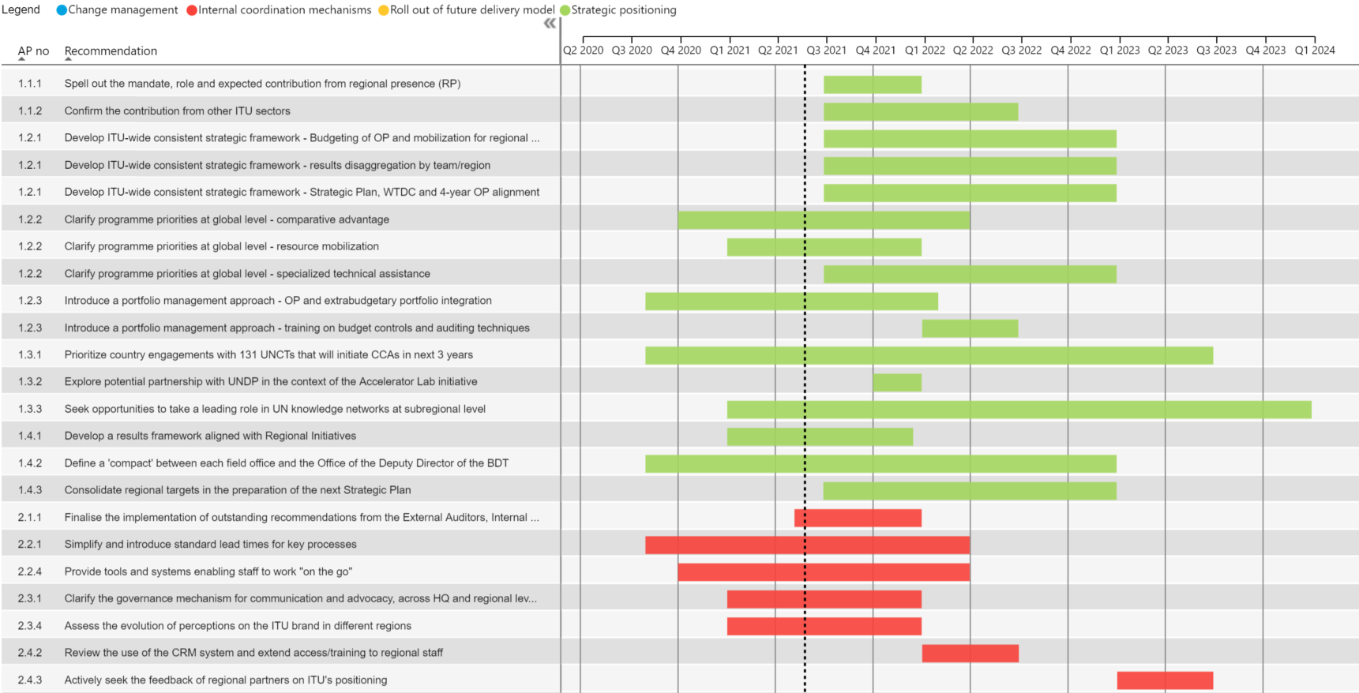

**Chart 3 – Completed recommendations**

This chart contains recommendations that ITU has already fully implemented.

**Chart 4 – Recommendations requiring Council Decisions**

This chart contains those recommendations which require decisions by Council prior to implementation.

___________________