|  |  |
| --- | --- |
| **Council Working Group on  Financial and Human Resources**  **Thirteenth meeting – Virtual, 3 June 2021** |  |
|  |  |
|  | **Annex 1 to**  **Document CWG-FHR 13/2** |
| **26 May 2021** |
| **English only** |

**Report of the Ad Hoc Group of CWG-FHR on ITU Regional Presence**

ANNEX 1 – secretariat reponses to member contributions

|  |
| --- |
| Summary  In the Report of the Ad Hoc Group on ITU Regional Presence, the Ad Hoc Group requested that the Secretariat provide responses by the Secretariat to the specific requests contained in the contributions by Switzerland and Australia.  Action required  CWG-FHR is invited to note this Annex 1 to the Report.  ____________  References |

# Contribution by Switzerland

Switzerland’s contribution (document [CWG-FHR-AH-RegPres-2/5](https://www.itu.int/md/S21-AHGFHR2-C-0005/en)) highlighted the following matters:

**Strategic Planning**

**Switzerland: Switzerland notes that in its comment in *Annex 3* of Document *CWG-FHR-AH-RegPres-1/4, the Secretariat* lays out “*that these matters would require significant revision of Council working methods related to the ITU Strategic and Operational Plans”.* Switzerland sought more information from the Secretariat on how the interplay of strategic and operational planning processes at all levels could be improved, with the aim of supporting a coherent programmatic focus in the Union’s mandate delivery through its regional presence.**

ITU is committed to further integrate and enhance the mandate, role and objectives for the regional presence in the development of the new Strategic Plan. The Secretariat has already begun assessing how the overall strategic and operational planning process can be improved at all levels and will provide this input to Member States within the Council Working Group on Strategic and Financial Plans (CWG-SFP).

The Secretariat agrees that a review of the Strategic and Planning Framework would result in better alignment with the RBM approach already being implemented by BDT, and would make for more effective, focussed and achievable targets for the ROs. From a BDT perspective, the discussions underway by membership in the TDAG Working Group on the ITU-D Contributions to the ITU Strategic and Operational Plans, could help in achieving these reforms. Strategic Planning is conducted ITU wide, and the PwC recommendations propose effective alignment of Strategy not only for the BDT, but for the whole of the ITU.

The process for the development of the new strategic plan -and the framework, will officially be initiated by the 2021 Session of Council (see document C21/64 on the proposal for the establishment of CWG-SFP). Regarding the new strategic framework, indeed the aim of the Secretariat is to review the RBM implementation and lessons learned, and accordingly adjust the components of the overall framework (i.e. review the mission statement, redesign the “architecture” of the framework and the different levels -strategic goals/objectives/targets, including the consideration of any related proposals from the PWC Report -e.g. attaching effective/focused/achievable targets at the RO level), while following best practice and experience from other UN/development agencies as well.

At the BDT level, in line with the strategic priorities recommended by the TDAG Working Groups, BDT has initiated a refinement of its Theory of Change (ToC) model to begin conceptualizing how its results-based management (RBM) framework and service-delivery model will need to reposition for the future. This ToC design will continue adjusting as needed to align with the direction of the CWG-SFP as the future priorities are finalized during the drafting of the new ITU Strategy.

This ToC model is applying an increased client-driven approach to the Thematic Priorities defined by Membership to enhance BDT’s efficiency in focusing products, support and results along these strategic pathways towards the longer-term goals of the [Connect 2030 Agenda](https://itu.foleon.com/itu/connect-2030-agenda/home/). This ToC model for the new Thematic Priorities will serve as the framework for future planning and evaluation, enforcing a common structure between Strategic and Operational Plans.

**Figure 1: TDAG recommendations on Thematic Priorities and corresponding ToC for BDT RBM**

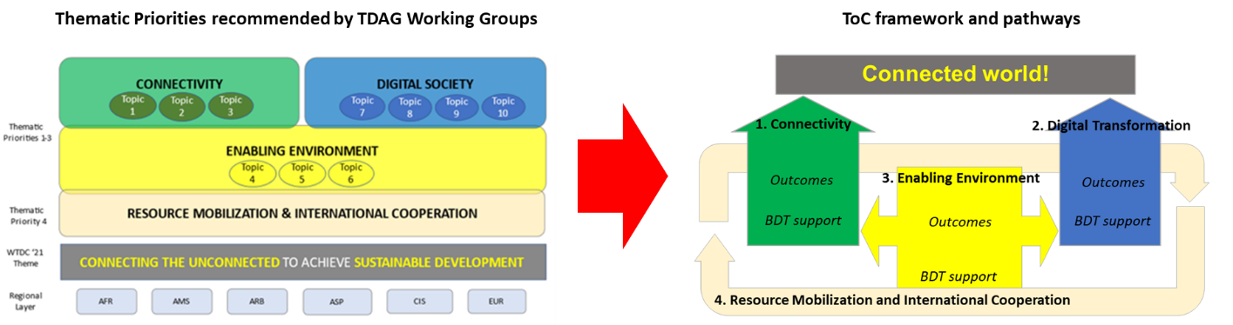

As part of this effort BDT is also refining the sequencing and integration of its products and services, mapping the most logical order for technical support and conditions for success along the new Thematic Priority ToC pathways for more evidence-driven matching of services with need.

Additionally, to strengthen the client-driven focus of BDT’s operational planning, the ToC data model includes more dynamic integration of the country statistics and survey data provided by Members. This innovation will improve BDT’s operational planning through automated data feeds of key trends at regional and country level, as well as by LDC, LLDC and SIDS groups. Through this overlay of data feeds onto the new ToC model’s Thematic Priority pathways, BDT aims to be more agile in adapting our support and service offering to evolving trends and changing needs of our Members.

To further guide coherent programmatic focus in the mandate delivery at all levels and through ITU’s regional presence, the BDT ToC framework is designed for full regional-level synchronization of RBM, Thematic Priority pathways, operational planning, sequenced technical support offerings and portfolio performance assessments. This regional ToC synchronization will help regions to strategically match BDT technical support according to their Regional Initiatives and specific local trends, while also maintaining alignment with the global vision and mission defined in the ITU Strategic Plan.

**Figure 2: Regional ToC synchronization with global vision and mandate**

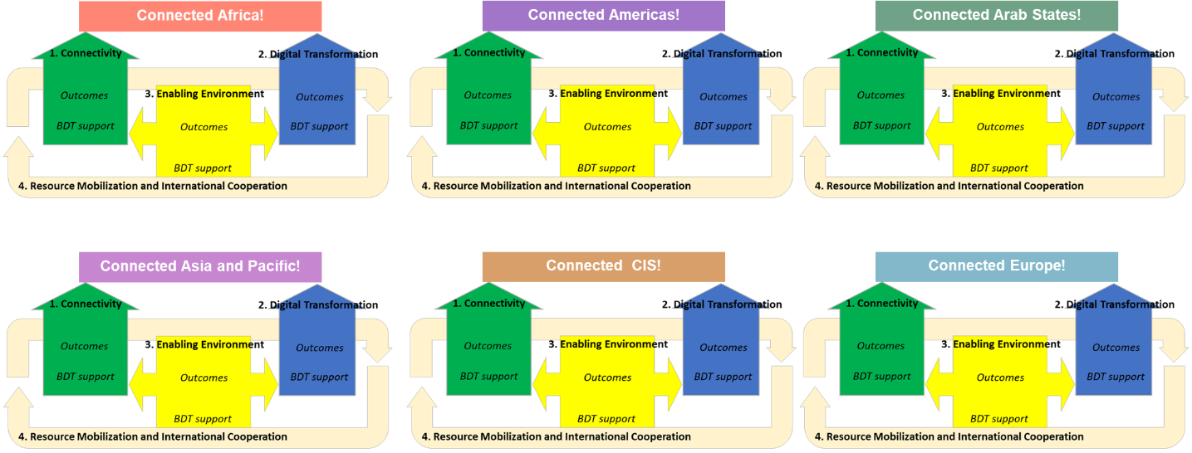

**Opportunities in context of UN processes**

**Switzerland: It is Switzerland’s view that collaboration within the multilateral system and the reform of the UN Development system (UNDS) offers opportunities for increased impact, effectiveness and efficiency. Switzerland would welcome the Secretariat’s views on potential avenues for collaboration as well as opportunities the Secretariat sees in the current UNDS reform for the ITU’s mandate delivery in the regions.**

ITU, through the BDT, has already embarked upon enhanced engagement with the UN Development System.

ITU has developed a phased approach to engagement with UNDCO in which ITU has identified and agreed with UNDCO the ITU offerings by region, shared a joint commitment (between ITU and UNDCO) with all RCs globally, and agreed on a list of focal countries for initial engagement. Awareness of ITU’s work is being raised through webinars with RCs in each region, and we have already begun our engagement through CCAs and Country Frameworks in many of the focal countries.

We have also engaged in the UNSG’s Digital Cooperation Roadmap and we are actively involved in the Roadmap Response Team. Currently BDT is working, through our statistics department to assist the UN in defining the KPIs which will underpin the achievement and measurement of the Roadmap’s targets, and ITU leads two of the focus areas for the roadmap in implementation efforts with UNDCO.

ITU engages on an increasing basis in the various UN level assessments, including the Quadrennial review, but perhaps more importantly, BDT has increasingly begun to use the findings of these reviews as criteria for improved performance through internal monitoring and evaluation.

Finally, the BDT Liaison Office was established in the ITU’s office in New York from 1 May 2021, which will provide an additional layer of coordination and engagement with the UN and significantly strengthen our ability to participate fully in the UNDS globally and will fully connect the web of our regional offices, with the UN system. This office has been specifically focussed on engagement within LDCs, LLDCs, and SIDS, so will also enhance ITU’s effectiveness in providing support to those countries most in need, through better engagement with the UN system.

**Coordination, Coherence and Oversight:**

**Switzerland: While it does not seem advisable to redeploy TSB and BR staff to regional offices, Switzerland is of the view that it is important that field offices can benefit as much as possible from the specific technical expertise at headquarters. Direct contact and communication between staff at regional offices and headquarters should be supported best possibly. A small coordination team could support mandate delivery also in the long-term.**

The issue of more effective collaboration with the BR and TSB within the regional presence is one part of the ongoing efforts to coordinate between the Bureaux across ITU. The suggestions made in the PWC report are noted in this regard and the Secretariat continues to review these options.

The Secretariat notes the comments submitted by Switzerland on the implementation of a One ITU approach to the regional presence. It is noted that the PwC recommendations (1.1-1.3) propose a significant increase in the presence of BR and TSB in regional and area offices, including proposals for the reassignment of members of staff from BR and TSB (a total of 8 staff) to regional offices. The Secretariat has reviewed this proposal, and the BR and TSB consider that the approach would not be practical. There are concerns that it would detract from the highly specialized technical nature of the work and staff of the BR and TSB and would (particularly over-time) result in reducing the effectiveness and added technical value of such assignments to the regions.

The Secretariat considers the form of arrangement proposed by Switzerland of a coordination team being responsible for optimal provision of BR and TSB support to regional offices, may be an appropriate way forward. It is noted that this would essentially be an enhancement of the current methods of working which comprises regular coordination between BDT regional staff, and BR and TSB, and which has been improved over the last year. The Secretariat proposes to develop this concept and fully implement it over the next 12 months, as reflected in the workplan submitted to the Ad Hoc Group.

The Secretariat will consider the following issues in determining the optimal way to implement improvements in this critical area:

* Convening of a coordinating committee, with clear Terms of Reference, an appropriate periodic meeting schedule, and effective electronic monitoring and evaluation methods;
* Ensuring engagement by Regional and Area Offices with member states on needs for assistance on matters pertaining to BR, TSB and the General Secretariat;
* Providing a clear framework for provision of assistance from all Bureaux and the General Secretariat to meet member needs.

The Secretariat will continue to report on progress in this area, together with the other recommendations made by PWC.

# Contribution by Australia

**In its contribution (document** [**CWG-FHR-AH-RegPres-2/4**](https://www.itu.int/md/S21-AHGFHR2-C-0004/en)**) Australia requested that the Secretariat outline its further reflections on how the regional presence can best support mandate delivery in a coherent and coordinated manner.**

The Secretariat considers that the PWC report provides valuable insights on methods for improving mandate delivery by the ITU regional presence and considers that the significant extent to which the recommendations made by PWC had already been commenced by the Secretariat, underscores the Secretariat’s effective positioning to assess and improve delivery of ITU’s mandate. The Secretariat repeats the points made above in the context of the questions from Switzerland and notes that the overall approach by the Ad Hoc Group, to establish the core strategic principles against which implementation should be taken, and to have the Secretariat embark on a process of implementation of the PWC recommendations with frequent reporting to council for advice and review, is perhaps most effective. In that framework, the Secretariat would address implementation of each PWC recommendation considering the relevant strategic criteria based on current and relevant information.

In this regard, the Secretariat notes that where necessary recommendations could be presented for Council and member state consideration on a case-by-case basis where they are outside the Secretariat’s competency or mandate. This would apply, as currently, to matters such as the opening or closure of offices and significant changes in structure or operation of offices.

The implementation plan being developed by the Secretariat (see Annex 2 of the Report of the Ad Hoc Group) provides a clear framework for oversight for Council regarding the recommendations and the efforts to strengthen the regional presence.

__________________