|  |  |
| --- | --- |
| **Council Virtual consultation of councillors, 8-18 June 2021** |  |
|  |  |
|  |  |
|  | **Document C21/INF/12-E** |
| **22 April 2021** |
| **English only** |
| Note by the Secretary-General | |
| Business continuity - new ITU website | |

|  |
| --- |
| Summary  The ITU secretariat is seeking a CHF 2 million investment to give ITU members, staff, and other visitors a secure, mobile-first website which supports content in the six languages of the Union on an equal footing, with a consistent structure and One ITU look and feel across all activities of the Union. A new website is essential to ensure business continuity and security as well as safeguarding ITU’s reputation (and trust) as the United Nations specialized agency for information and communication technology. This document provides background on the progress achieved so far and the requested budget commensurate with the project timeline.  Action required  This report is transmitted to the Council **for information**.  ____________  References  [Resolution 154 (Rev. Dubai, 2018)](https://www.itu.int/pub/S-CONF-ACTF); [Council Document C20/53](https://www.itu.int/md/S20-CL-C-0053/en); [CWG-FHR 12/3](https://www.itu.int/md/S21-CWGFHR12-C-0003/en);  [CWG-FHR-12/17](https://www.itu.int/md/S21-CWGFHR12-C-0017/en); [CWG-LANG/11/5](https://www.itu.int/md/S21-RCLCWGLANG11-C-0005/en); [ISCG/21-1/INF/1](https://www.itu.int/en/general-secretariat/ties/Pages/ISCG-documents.aspx); [C21/49](https://www.itu.int/md/S21-CL-C-0049/en) |

Proposal

The ITU secretariat is seeking a CHF 2 million investment to give ITU members and other visitors a secure, mobile-first website which supports content in the six languages of the Union on an equal footing, with a consistent structure and One ITU look and feel across all activities of the Union.

Background

ITU’s current website is built on a legacy platform that is more than 10 years old and will no longer be supported by the vendor in 2023. The current site also lacks modern security features making it vulnerable to cyber-attacks, which could have a significant disruptive impact during major conferences or study groups, especially as such meetings are now paperless. This exposes ITU to business continuity, security and reputational risks as the UN specialized agency for ICT. Furthermore, while Member States request implementation of 6 language content across the website, the current platform does not allow to take advantage of alternative translation procedures. Furthermore, the organization of information is not consistent across the Sectors and the General Secretariat making it difficult for delegates to find the information they need. It is also not easy to use on mobile devices. Finally, the COVID-19 crisis has demonstrated the importance of a modern, secure website which allows for efficient translation, publishing and work processes.

Objectives

1. Business continuity. Utilizing a modern cloud-based IT platform to reduce business process costs when compared to current on-premise IT hosting and management, making better use limited ITU resources and ensuring 24-hour reliable service for ITU’s global membership and visitors, as well as Regional and Area Offices.
2. Security. Ensuring cyber security (and, therefore, business continuity) as well as security of user data. As the UN’s specialized agency for information and communication technology, the Organization is particularly prone to reputational damage and loss of credibility in case of a security breach that may arise due to a platform that the vendor no longer adapts to rapidly evolving cybersecurity threats ([United Nations suffers major data breach | TechRadar](https://www.techradar.com/news/united-nations-suffers-major-data-breach)).
3. Multilingual. New technologies for more efficient work processes such as Machine Learning and AI for automated translation are coming to the market which ITU cannot integrate on the current platform. New technologies are expected to help control translation costs and offer more content in the six languages of the Union on an equal footing, including timely updates of the pages of the ITU website.
4. Harmonization. A common architecture, look and feel of the General Secretariat and Sector websites helps to improve usability for members and other visitors and convey an image of One ITU.

Progress

The work on a new website began in December 2018 with the establishment of an ITU-wide Web Project Team. Since then, extensive research has led to website prototype iterations 1 and 2. A minimum viable site is planned to go live in Q4 2021/Q1 2022, pending dedicated resources which the ITU secretariat has requested in [Document C20/53](https://www.itu.int/md/S20-CL-C-0053/en).

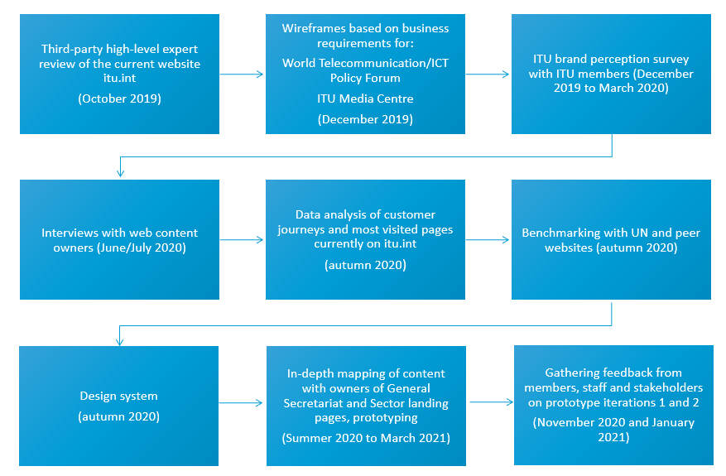

Prototype iteration 3 includes the harmonized homepages of ITU-R, ITU-T, and ITU-D. The video prototype can be viewed [here](https://youtu.be/e3J3JVChBZ0).

Deliverables 2021 to 2025

The table below summarizes the deliverables expected from 2021 to 2025, commensurate with the budget.

|  |  |  |  |  |  |  |  |  |  |  |  |  |  |  |  |  |  |  |  |  |
| --- | --- | --- | --- | --- | --- | --- | --- | --- | --- | --- | --- | --- | --- | --- | --- | --- | --- | --- | --- | --- |
|  | **2021** | | | | **2022** | | | | **2023** | | | | **2024** | | | | **2025** | | | |
|  | **Q1** | **Q2** | **Q3** | **Q4** | **Q1** | **Q2** | **Q3** | **Q4** | **Q1** | **Q2** | **Q3** | **Q4** | **Q1** | **Q2** | **Q3** | **Q4** | **Q1** | **Q2** | **Q3** | **Q4** |
| **1. Business continuity** |  |  |  |  |  |  |  |  |  |  |  |  |  |  |  |  |  |  |  |  |
| 1.1 Migration, hosting, web governance, upskilling, additional staffing |  |  |  |  |  |  |  |  |  |  |  |  |  |  |  |  |  |  |  |  |
| 1.2 Procurement & set-up 24/7 cloud-hosted open-source IT infrastructure |  |  |  |  |  |  |  |  |  |  |  |  |  |  |  |  |  |  |  |  |
| 1.3 Content management system |  |  |  |  |  |  |  |  |  |  |  |  |  |  |  |  |  |  |  |  |
| 1.4 Content deletion, unpublishing, archiving or migration |  |  |  |  |  |  |  |  |  |  |  |  |  |  |  |  |  |  |  |  |
| 1.5 Connecting to existing ITU systems, workspaces and new software/plug-ins |  |  |  |  |  |  |  |  |  |  |  |  |  |  |  |  |  |  |  |  |
| 1.6 Bug-fixing and maintenance |  |  |  |  |  |  |  |  |  |  |  |  |  |  |  |  |  |  |  |  |
| **2. Security** |  |  |  |  |  |  |  |  |  |  |  |  |  |  |  |  |  |  |  |  |
| 2.1 One single user sign-on |  |  |  |  |  |  |  |  |  |  |  |  |  |  |  |  |  |  |  |  |
| 2.2 Multi-factor authentication |  |  |  |  |  |  |  |  |  |  |  |  |  |  |  |  |  |  |  |  |
| 2.3 Identity management |  |  |  |  |  |  |  |  |  |  |  |  |  |  |  |  |  |  |  |  |
| 2.4 ISO certifications: information security ISO/IEC 27001, business continuity ISO 22301 |  |  |  |  |  |  |  |  |  |  |  |  |  |  |  |  |  |  |  |  |
| **3. Multilingual** |  |  |  |  |  |  |  |  |  |  |  |  |  |  |  |  |  |  |  |  |
| 3.1 Proof of concept of machine translation using AI and Machine Learning |  |  |  |  |  |  |  |  |  |  |  |  |  |  |  |  |  |  |  |  |
| 3.2 Optimizing back-end workflow |  |  |  |  |  |  |  |  |  |  |  |  |  |  |  |  |  |  |  |  |
| 3.3ITU policy on multilingualism |  |  |  |  |  |  |  |  |  |  |  |  |  |  |  |  |  |  |  |  |
| **4. Harmonization** |  |  |  |  |  |  |  |  |  |  |  |  |  |  |  |  |  |  |  |  |
| 4.1 Harmonization of ITU visual identity and graphic design for key ITU conferences and events |  |  |  |  |  |  | PP-22 |  |  |  |  |  |  |  |  |  |  |  |  |  |
| 4.2 Harmonized personalization and automated content feeds for delegates and other visitors |  |  |  |  |  |  |  |  |  |  |  |  |  |  |  |  |  |  |  |  |
| 4.3 Harmonization of delegate workspaces for enhanced effectiveness and collaboration |  |  |  |  |  |  |  |  |  | CWG |  |  |  | PP |  |  |  |  |  |  |
| **Budget CHF(000)** | **400** | | | | **200** | | | | **200** | | | | **1200** | | | | | | | |