|  |  |
| --- | --- |
| **Council 2021 Virtual consultation of councillors, 8-18 June 2021** |  |
|  |  |
|  |  |
| **Agenda item: PL 1.11** | **Document C21/72-E** |
| **22 April 2021** |
| **Original: English** |
| Report by the Secretary-General | |
| DRAFT ITU ACCESSIBILITY POLICY FOR PERSONS WITH DISABILITIES | |

|  |
| --- |
| Summary  This document updates the ITU Accessibility Policy endorsed by Council 2013 in the Annex to document [C13/42](http://www.itu.int/md/S13-CL-C-0042/en).  Action required  The Council is invited to **endorse** the draft ITU Accessibility Policy for persons with disabilities.  ____________  References  [*PP Resolution 175*](https://www.itu.int/en/council/Documents/basic-texts/RES-175-E.pdf) *(Rev Dubai, 2018),* [*WTDC Resolution 58*](https://www.itu.int/en/ITU-D/Conferences/WTDC/WTDC17/Documents/WTDC17_final_report_en.pdf) *(Rev. Buenos Aires, 2017),* [*WTSA Resolution 70*](https://www.itu.int/opb/publications.aspx?lang=en&parent=T-RES-T.70-2016)*(Rev. Hammamet, 2016) and* [*RA Resolution 67*](https://www.itu.int/pub/R-RES-R.67) *(2017); Council document* [*C13/42*](http://www.itu.int/md/S13-CL-C-0042/en) |

Introduction

A mandate to enhance accessibility in the UN system was first received with the adoption of the Convention on the Rights of Persons with Disabilities ([CRPD](https://www.un.org/development/desa/disabilities/convention-on-the-rights-of-persons-with-disabilities.html)) in 2006, which has a dedicated section on accessibility (article 9). As a result, the 2010 Plenipotentiary Conference (PP-10) adopted [Resolution 175](https://www.itu.int/en/council/Documents/basic-texts/RES-175-E.pdf) (Rev. Dubai, 2018) (“Telecommunication/information and communication technology accessibility for persons with disabilities and persons with specific needs”). The JIU Report [2018/6](https://www.unjiu.org/sites/www.unjiu.org/files/jiu_rep_2018_6_english.pdf) “Enhancing accessibility for persons with disabilities to conferences and meetings of the United Nations system” points out that among the UN specialized agencies, only the ITU has a specific mandate on accessibility from its legislative body.

Besides the above-mentioned [Resolution 175](https://www.itu.int/en/council/Documents/basic-texts/RES-175-E.pdf) (Rev. Dubai, 2018), other outcomes from sectoral world conferences/assemblies, such as [WTDC Resolution 58](https://www.itu.int/en/ITU-D/Conferences/WTDC/WTDC17/Documents/WTDC17_final_report_en.pdf) (Rev. Buenos Aires, 2017), [WTSA Resolution 70](https://www.itu.int/opb/publications.aspx?lang=en&parent=T-RES-T.70-2016) (Rev. Hammamet, 2016) and [RA Resolution 67](https://www.itu.int/pub/R-RES-R.67) (2019), give a clear mandate to ITU to work on this subject. Furthermore, the [ITU Strategic Plan 2020-2023](https://www.itu.int/en/council/planning/Documents/ITU_Strategic_plan_2020-2023.pdf), adopted by Member States at PP-18 as the [Connect 2030 Agenda](https://itu.foleon.com/itu/connect-2030-agenda/home/), considers accessibility within its Strategic Goal 2 (Inclusiveness: Bridge the digital divide and provide broadband access for all) and its corresponding Strategic Target 2.9 (“By 2023, enabling environments ensuring accessible telecommunications/ICTs for persons with disabilities should be established in all countries”).

ITU is required to align with the [UN Disability Inclusion Strategy](https://www.un.org/en/content/disabilitystrategy/) ([UNDIS](https://www.un.org/en/content/disabilitystrategy/)) and committed to align its work activities to ensure full inclusiveness of everyone. In line with UNDIS, ITU also considers advancing on the following: 1) Twin-track approach: the fact that disability and accessibility it is a cross-cutting issue and require targeted programming; 2) Intersectionality: factors such as gender, age and location inform on individual’s experience and also impact persons with disabilities and their life experiences; and 3) Coordination to ensure coherent approach as an essential factor to accelerate progress, build on each other’s work and achieve inclusion.

The membership’s Inter-Sector Coordination Group ([ISCG](https://www.itu.int/en/general-secretariat/Pages/ISCG/default.aspx)) on issues of mutual interest, composed by representatives of all three Sector Advisory Groups, agreed during its [meeting in March 2021](https://www.itu.int/en/general-secretariat/ties/ISCGDocumentLibrary/1st%20Meeting%202021/ISCG-21-1-07-E-1st%20Meeting%202021-Final%20Report.docx) that Accessibility should be a specific theme to be followed-up within the ISCG and requested the secretariat’s Intersectoral Coordination Task Force (ISC-TF) to present a report on it for next meeting.

For more than ten years, ITU has undertaken a significant amount of work to provide reasonable accommodation to ITU services (which include facilities, events, documents and corporate communication tools, among others) to persons with disabilities. To build upon the lessons learned from these experiences, and to establish well-defined solutions and procedures, the ISC-TF updated the accessibility policy as annex to this document to replace the policy endorsed by the 2013 Session of the Council.

This updated policy accounts for new developments (e.g. *resolves* and *instructs* from Res 175 (Rev Dubai, 2018) and the outcomes of the UNDIS) and goes beyond the internal component to also cover the numerous and important ITU activities aiming to make ICTs more accessible and promoting the empowerment of persons with disabilities through the use of ICTs worldwide.

Annex

Draft ITU Accessibility Policy for persons with disabilities

Goals and objectives

The Goals of the ITU Accessibility Policy are:

* Goal 1: to set up the framework and processes to make ITU an accessible organization for Persons with Disabilities and Persons with Specific Needs including age-related disabilities, by achieving their full participation in all ITU activities, either as staff members[1] and other collaborators (consultants/experts, interns, etc.), delegates/meeting participants, or general public; and
* Goal 2: to build-up on the accessibility-related activities, outputs, and outcomes performed by the ITU Sectors, finding out synergies to better promote and enable worldwide ICT accessibility and access to ICTs for Persons with Disabilities and Persons with Specific Needs.

The Objectives of the ITU Accessibility Policy are:

1. To make ITU facilities accessible, as per recognized international standards and best practices.
2. To enhance staff and management awareness and knowledge on accessibility-related issues.
3. To raise awareness between delegates on accessibility-related matters.
4. To undertake the necessary measures in order to provide accessible accommodations for ITU events. These measures include, but are not limited to:
   1. Providing, when and if required, accessibility facilities (such as real-time captioning and/or remote sign language interpretation).
   2. Expanding the fellowship programme[2] to enable delegates with disabilities and ITU member’s representatives, in particular those coming from LDCs and low-income countries, to participate in the work of ITU.
5. To ensure that structure and contents of ITU websites, videos, publications, and whatever digital documents and digital information are digitally accessible and in line with the accessibility requirements and standards in force; including ensuring that web developers, web masters, and communication officers as well as all relevant staff receive appropriate training for this purpose.
6. To enhance procurement policies in order to ensure that relevant goods and services acquired are accessible or do not create new barriers, as well as ensuring that the procurement process is accessible.
7. To ensure that accessibility is mainstreamed in processes such as recruitment in line with UNDIS.
8. To enhance intersectoral collaboration on accessibility-related issues, leveraging internal knowledge and expertise.
9. To ensure that accessibility is reflected in ITU Strategic Plans and sector specific plans and that relevant data is gathered to assess and monitor performance advance towards ITU accessibility and digital accessibility-related Strategic Target(s).
10. To mainstream accessibility for persons with disabilities in the programmatic activities of the three Sectors and the General Secretariat, by ensuring appropriate resources to support corresponding activities’ implementation, monitoring, and evaluation.
11. To strengthen collaboration on accessibility-related matters within the UN Common System and with relevant organizations representing persons with disabilities, to facilitate related disability inclusion work of ITU and with ITU Membership.
12. To secure a budget line to ensure that the objectives above can be achieved on an ITU-wide basis.

The Framework

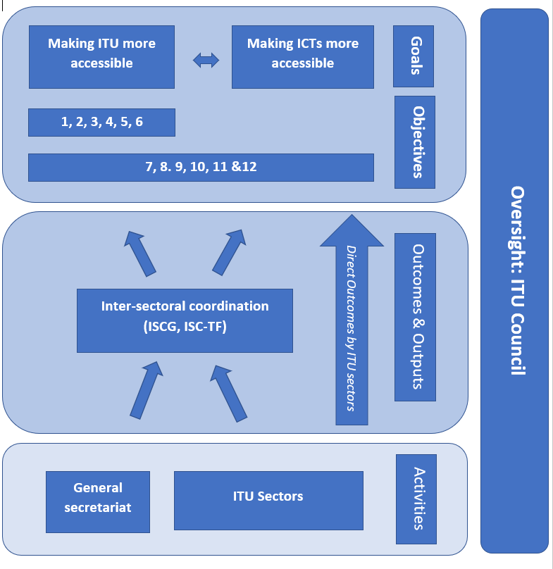

**Figure: The ITU Accessibility Framework**

Methodology and implementation

An ITU-wide Accessibility Strategy aiming to achieve the above-mentioned objectives, with regular monitoring, evaluation, and reporting on the achievements and related implementation, should be developed.

This Strategy should include key performance indicators (KPIs) for implementation of each objective, estimation of the necessary resources, indicate milestones and timelines, expected and achieved results, as well as evaluation of risks and proposed mitigation.

A detailed report on the ITU accessibility policy and framework implementation should be presented to the 2022 Session of the Council, and regular updates should be presented to further Council sessions.

Resources

To ensure implementation of this policy, allocation of necessary funding is key. Currently there is no separate budget for accessibility services. Real-time captioning and sign-language interpretation have been offered in select ITU events for several years but covered by ad-hoc funds (e.g. an event organizers' budget).

ITU membership is further encouraged to contribute to the implementation of the ITU accessibility policy for persons with disabilities through the ITU Accessibility Fund for the Digital Inclusion of Persons with Disabilities, set up by ITU as instructed in Resolution 175 (Rev. Dubai, 2018). The Fund has not been replenished since 2018.

Review

The revised ITU accessibility Policy for persons with disabilities shall be implemented within available allocated resources and shall come into effect as of the date of its endorsement by ITU Council.

The ITU accessibility Policy for persons with disabilities will be reviewed and updated at least every four years after its inception to draw from emerging best practices and lessons learned and also include technology progress in the topic of digital accessibility.

_______________

1. Within the limits fixed by the Mandatory age for retirement.
2. As per SO No. 21/02, Policy for awarding fellowships for events and activities funded through the ITU regular budget