Council 2021
Virtual consultation of councillors, 8-18 June 2021
Agenda item: ADM 31 | Document C21/61-E
 | 30 April 2021
 | Original: English
Report by the Secretary-General
REPORT ON THE IMPLEMENTATION OF THE RISK MANAGEMENT ACTION PLAN

Summary
This document presents a final report and the results of the implementation of the Action Plan to strengthen the ITU Risk Management Framework, as a follow-up to the progress report and recommendations submitted to the second Virtual Consultation of Councillors.

Action required
The Council is invited to note this report.
____________

References
Document CWG-FHR-11/12 (Progress report on Strengthening ITU Risk Management Framework: action plan); Council documents C17/74 (ITU Risk management policy); C17/73 (ITU Risk appetite statement)
Document C20/61 Rev.1

1 Final report on the implementation of the Action plan to strengthen ITU risk management framework
1.1. The project to strengthen the ITU risk management framework took into consideration the HLCM Guidance Note on Embedding Risk Management (CEB/2020/HLCM/4) released in March 2020 and the JIU report on approaches and uses of Enterprise Risk Management in UN system organizations (JIU/REP/2020/5), released in September 2020. The project was supported by an external senior consultant to gain quality and assurance that the implementation of the action plan would capitalize on best risk management strategies experienced by other organisations.
The Table below summarizes the actions and the results of the implementation of the Action Plan.
- All organizational and operational entities to be involved in Risk Management
- All key stakeholders (Bureaux, Regional Offices, Depts. of the General Secretariat, including Finance, HR, IS, Internal Audit) were involved in the exercise and continue to be involved in the risk assessment process.
- Key stakeholders were consulted throughout the implementation of the Action Plan (notably regarding actions #2, #3, #5, and #6 below)
- Workshops delivered in November and December 2020, have included more than 40 distinct participants from all organizational and operational ITU entities.
- The Risk Register contains inputs from all organizational entities.
- Action #1 completed as of December 2020.
- Risk registers to be developed for the whole organization and have those risks assessed and rated
- A new risk register template has been developed, integrating cause and consequences of a risk, as well as the inclusion of controls in place and the confidence in controls effectiveness.
- Operational details of managing risks are now part of a new Risk Management and Internal Control Manual (which was essential to support the training activities included in actions #4 and #8 below).
- Risks have been identified and assessed as of December 2020 using the new risk register overview of risks identified by 5 March 2021 presented in Section 2.
- Action #2 completed as of December 2020 - acknowledging that the assessment of the risks is a continuous process.
- Set up an internal risk governance structure
- Risk management governance structure was strengthened based on the best practices in 25 UN Organisations (HLCM Risk Mgmt. Task Force survey / Mar 2019)
- Roles and responsibilities in overseeing the implementation of risk management were defined, along with the process to review high level risks on a regular basis and take decisions related to risk management, ensuring a clear tone at the top to promote a culture of responsible and effective risk management.
- All of these competencies and monitoring activities are described in the risk management policy and further detailed in the risk management manual.
- Action #3 completed as of December 2020: the establishment of the Risk Management and Internal Controls function, within available budget, was approved by correspondence further to discussion at the VCC-2, and has been included as a post to be funded in the 2022-2023 budget (see Document C21/65).
- Aim to improve staff accountability at all levels for managing risks
- Trainings and workshops on how to integrate risk management and internal controls in the business processes of the organization were conducted.
- Continuous support has been provided to Focal points along the whole project duration, the risk assessment phase and the population of the risk register.
- Action #4 completed as of December 2020 – continuous support provided.
- Establish a more systematic risk management process
- The Risk Management Policy and Risk Appetite Statement have been reviewed to ensure a more systematic process to identify, assess and manage risks and have been endorsed by the Council via the written consultation following the VCC-2.
- They have been focused on their key principles, and all operational details of managing risks are part of the new Risk Management and Internal Control Manual. The manual is structured on a 6-step sequence to help mainly Risk Owners, Focal points and Risk and Internal Control function manage and / or coordinate the risk management process, with reference to 2017 COSO ERM key-principles whenever relevant.
- Action #5 completed as of December 2020.
- Review the effectiveness of the internal controls
- A new risk register template has been developed, integrating controls in place and their effectiveness to assess risk.
- In addition, confidence in control effectiveness is being rated and used for determining monitoring periodicity. The related modalities of how to use existing controls to assess risk and how to rate confidence in control effectiveness are described in the risk management manual.
- Action #6 completed as of December 2020 - acknowledging that the assessment of the effectiveness of internal controls is a continuous process.
- Develop a risk management dashboard utilizing the new risk register
- A risk management dashboard has been implemented (using the business intelligence tool PowerBI) to monitor and communicate information related to risk management, providing to managers a visual interface to navigate the risk registers.
- The dashboard contains a set of interactive pages that provide snapshot views of key risk management indicators (risk score heat map, risk monitoring map, risks by risk owner, mitigation measures by risk response owner).
- The dashboard is easily accessible through MS-Teams and can be further customized to each Bureau / department needs.
- Action #7 completed as of December 2020.
- Strengthen the capacity of staff to manage risks
- Action item has been implemented in combination with point 4 above, leveraging training and risk management workshops to raise awareness and strengthen the capacity of managers to manage risks.
- Action #8 completed as of December 2020.
- Aim to embed risk management in the staff performance management system
- In collaboration with HRMD, options on how to best integrate risk management in the staff performance management were identified. Risk accountability and the ability to factor risk management into day-to-day decision-making in operations have been recalled to be a core aspect of all individual performance management processes.
- The necessary amendments to the job descriptions and to ePMDS objective setting were presented during the workshops, to be implemented in the next performance management cycle.
- Action #9 completed as of December 2020. Implementation of recommendation to be coordinated by HRMD by June 2021.
- Systematically communicate and report on risk information to membership
- The secretariat will continue reporting on risk management arrangements to CWG-FHR and the Council Sessions.
- Action #10 completed as of December 2020

With the successful implementation and follow-up on this project, ITU:

Establishes improved arrangements to assess and oversee internal control mechanisms for more effective supervision;

Implements the related Recommendations from oversight bodies on risk management (including IMAC recommendations and recommendations from the PWC Report);

Implements all 9 Benchmarks from the 2020 JIU Report on Enterprise Risk Management in the UN system (JIU/REP/2020/5).

2 Overview of the Risk Register and Risk Management Dashboard
An overview of the risk management dashboard with a snapshot of the latest information included in the ITU-wide risk register is presented as an Annex to this Report.

ANNEX: OVERVIEW OF THE ITU RISK REGISTER AND RISK MANAGEMENT DASHBOARD
Figure 1: Extract from the ITU Risk Register (rev. 5 March 2021)
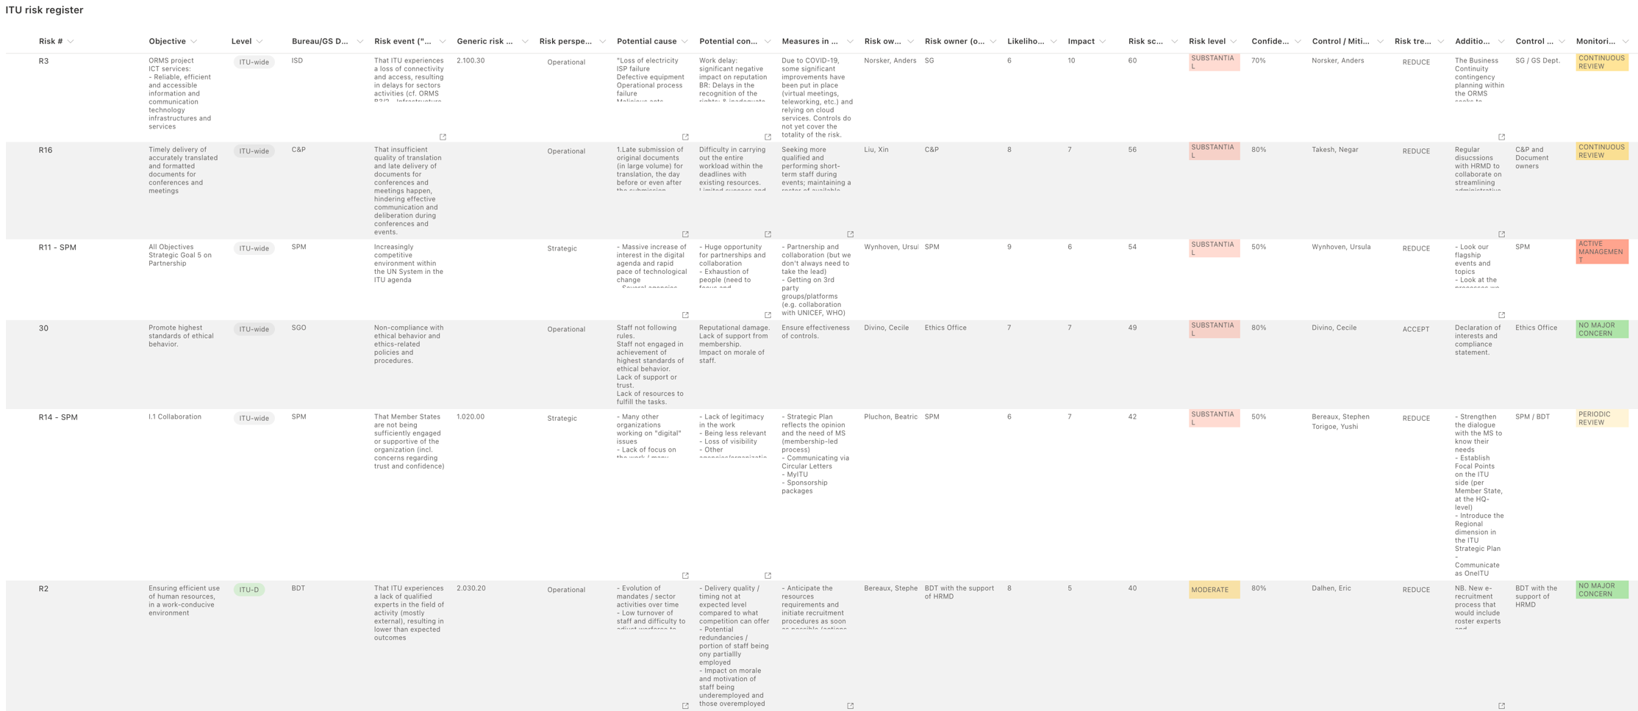

Figure 2: ITU Risk Hear Map (rev. 5 March 2021)
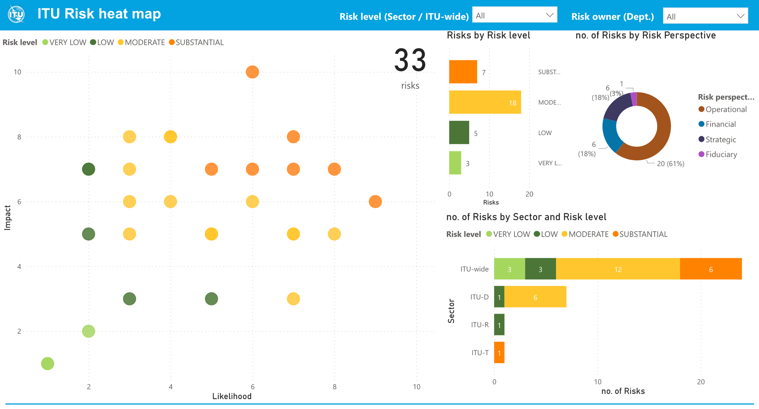

Figure 3: ITU Risk Monitoring Chart (rev. 5 March 2021)



